MERCY INTERNATIONAL ASSOCIATION

Child Safeguarding Policy & Standards

September 2024
Review date: August 2027
Effective Date: September 2024

Policy Title: MERCY INTERNATIONAL ASSOCIATION (MIA)

CHILD SAFEGUARDING POLICY & STANDARDS
----------------------------------------------------------------------------------------------------------------------------------------------------------------------

Introduction

Inspired by the words of Jesus ‘Let the little children come to me; do not stop them; for it is to such as these the kingdom of God belongs’ (Mark 10:14-15) and challenged by Catherine McAuley’s faithfulness to His example, we in MIA commit ourselves to the wholesome development of children in a respectful and life-giving environment. Safeguarding is key to this important task and should be seen, not as a burden, but as an opportunity to embrace and encourage children’s ministry following the example of Jesus Christ. We uphold the safety of the child as paramount and are committed to do all in our power to safeguard the welfare of children to whom we minister or with whom we have significant contact.

Each child is a gift of God. MIA’s ethos commits us to ensure that the fundamental rights of children are respected. In all circumstances we pledge to create a supportive and caring environment where children are listened to, treated fairly, taken seriously and feel safe.

This present Child Safeguarding Policy of 2024 builds on the foundation of past learning and experiences and provides a newer focus on leadership and governance to embed a culture of safeguarding where:
- The Church (including MIA) has an important role to play in creating and maintaining an environment in which children and young people can grow and flourish in their humanity and come to experience the dignity that Jesus proclaimed.
- Children will be welcome and safe.
- Church personnel will uphold the rights of children in line with Gospel values.

MIA is committed to ensuring compliance with best practice in keeping with the civil and legal requirements of the Republic of Ireland, and with canonical requirements, we will adhere to the child safeguarding policy and standards as articulated in this document.

STRUCTURE OF Mercy International Association
Mercy International Association is a corporate entity with limited liability, registered in Ireland and it is also a registered charity with the Charities Regulator in Dublin, Ireland. MIA operates from two offices, one in Dublin and the other in New York.
The CEO, together with the Executive, constitutes the primary focus of unity and leadership within MIA.

MIA adheres to this Child Safeguarding Policy and Procedures in keeping with civil legislation and church regulations. We have our own Designated Liaison Person (DLP).

If you have a concern with regard to the welfare and safety of a child, please contact the CEO at ceo@mercyinternational.ie or the Designated Liaison Person at dlp@mercyinternational.ie

MERCY INTERNATIONAL ASSOCIATION CHILD SAFEGUARDING STATEMENT
MIA is committed to safeguarding and respecting the sacredness of all Life. Our commitment is exercised in accordance with Gospel-based values, our Charism, Constitutions, and the U.N. Convention Guidelines on the Rights of the Child.

We are particularly committed to safeguarding the dignity and fundamental rights of all people in our care especially children and to ensuring their safety and well-being and we will work in partnership with parents/guardians to do this. We recognise each child as a gift from God, and we value and encourage the participation of children in all activities that enhance their spiritual, physical, emotional, intellectual and social development.

All MIA personnel and all those who work with us under our authority have a responsibility to safeguard children through promoting their welfare, health and development in a safe and caring environment that supports their best interests and prevents abuse.

A Safe and Welcoming Church: Safeguarding Children Policy and Standards for the Catholic Church in Ireland, 2024 is endorsed by Mercy International Association as the foundational document underpinning this Child Safeguarding Policy.

A Safe and Welcoming Church: Safeguarding Children: Policy and Standards for the Catholic Church in Ireland, 2024 underpins all practice of safeguarding of children in MIA. The standards of this same document, in tandem with local ecclesial and civil requirements, also inform the practice and delivery of child safeguarding in all of the Irish Regions, and the US Regions. This policy is to be found on www.safeguarding.ie
If you are concerned about the welfare and safety of a child:

You can contact the Designated Liaison Person for MIA:
Anne Lyng RSM + 353 (0) 87 186 5258
Email: dlp@mercyinternational.ie

And/or the Deputy Designated Liaison Person for MIA:
Brenda Drumm + 353 (0) 87 097 7112
Email: dlp@mercyinternational.ie

GUIDING PRINCIPLES

In developing and implementing the MIA Child Safeguarding Policy we are reliant on A Safe and Welcoming Church: Safeguarding Children Policy and Standards for the Catholic Church in Ireland, 2024 and the following foundations:

Gospel
In scripture we note that children have a key place in the heart of Jesus who said: 'Whoever does not receive the kingdom of God like a child shall not enter it'. (Luke 18: 17). This places a sacred obligation on the Church to ensure that children are welcomed, cherished and protected in a manner consistent with their central place in the life of the Church.

Children's Rights, National and International Law, Government regulation and Canon Law
The United Nations Convention on the Rights of the Child (UNCRC) outlines the forty-two fundamental rights to be implemented in national law by signatories to the Convention (this includes the Holy See). Full realization of these rights will ensure that children will be 'brought up in a spirit of peace, dignity, tolerance, freedom, equality and solidarity'.

As Church members, MIA, in keeping with our charism, commits to upholding our moral and legal obligations under the civil and criminal legislation of the jurisdiction in which we minister as well as the requirements of Church law.

- Caring for Complainants
The response to complainants will be pastoral, respectful, caring, compassionate and appropriate.

- Providing a Fair and Just Process for Respondents.

A just and fair process will uphold the rights of the accused individual under civil and canon law, maintaining a presumption of innocence unless there is an admission of guilt or a finding of guilt. In all investigative and canonical processes, MIA will engage with the relevant statutory and canonical authorities to ensure that risk to children is appropriately assessed and managed.

- Acknowledging that Safeguarding is a Core and Important Part of Ministry

The past abuse of children in the Catholic Church is clearly acknowledged. Progress has been made in establishing and responding to the truth of what happened. Today safeguarding must be seen as a core and important part of all ministry, and the Church is committed to continuing this journey of justice, truth, healing and prevention of abuse.

SCOPE OF THE POLICY

This safeguarding policy applies to all MIA personnel and all who work with us in MIA. Those who work and volunteer in MIA are expected to fully comply with the requirements and responsibilities of this policy. An understanding of and adherence to this policy should lead to a deepening in the understanding of, and respect for, the rights of children and young people to participate as people of faith in the life of the Church.

The care and protection of children involved in the activities of MIA is the responsibility of all MIA personnel and is a requirement that applies regardless of the nature of the activity in which the children are involved. Everyone has a role to play in creating an environment in which children can develop and be safe.

The Church in Ireland has adopted a policy of mandatory reporting of all child protection suspicions, concerns, knowledge and allegations that meet the threshold for reporting to the statutory authorities. All priests and religious (male and female) in the Republic of Ireland are considered to be mandated persons, alongside other persons listed in the Children First Act 2015. They are required to notify the relevant Statutory Authorities if they are concerned that a child has or may have suffered harm, or if they have reason to believe there is a danger that a child is or will suffer harm.

MERCY INTERNATIONAL ASSOCIATION STANDARDS

MIA takes its standard for child safeguarding from this Child Safeguarding Policy (itself based on A Safe and Welcoming Church: Safeguarding Children Policy and Standards for the Catholic Church in Ireland, 2024) and comply with the Church and State regulations in the Republic of Ireland.

Where the civil legislation and guidelines are inadequate and not in line with best international practice we adhere to the best practice set out in this policy, and in conjunction

with other concerned groups, actively lobby to change the system.

Reporting of cases is through the Designated Child Safeguarding Person (DLP).

OUR THREE MERCY INTERNATIONAL ASSOCIATION STANDARDS
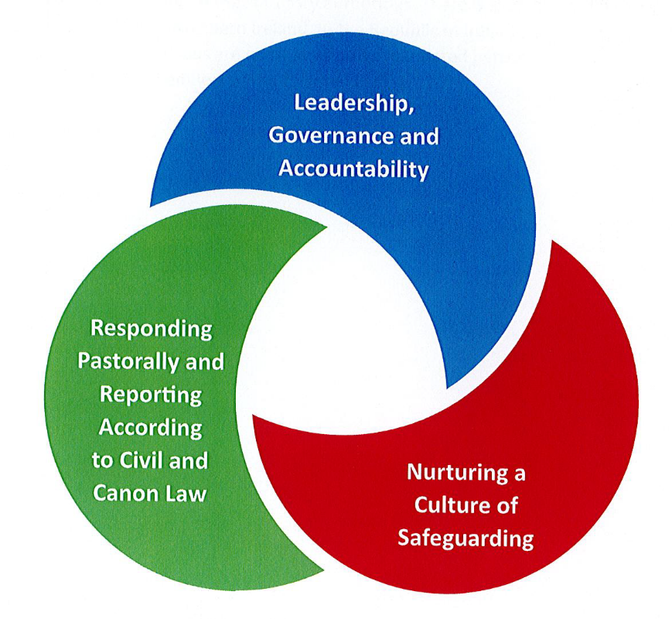

Our three core MIA standards mirror those of A Safe and Welcoming Church: Safeguarding Children Policy and Standards for the Catholic Church in Ireland, 2024.

Standard: Leadership, Governance and Accountability

MIA embodies and imparts the Catholic Church’s vision, principles and values, which are reflected and apparent in the child safeguarding culture, structures and practices at all levels throughout MIA and in our ministries with children and young people. Through words and actions, MIA’s commitment to fulfil the safeguarding mission of the Church is clearly demonstrated and its responsibility to motivate and inspire others to fulfil the vision of the Safeguarding Children Policy is fulfilled.

MIA has a responsibility to embed a culture of safeguarding and together with all those with safeguarding roles, can demonstrate leadership by:

Modelling positive engagement with children and young people.

Showing a personal commitment to promoting good safeguarding practices.

Demonstrating empathy and understanding to those who have been harmed in the Church. All this requires an ability to listen, to respond flexibly, to be confident and transparent, and to accept the challenge of being accountable.

MIA influences all actions to ensure that all personnel fulfil their responsibility to safeguard children.

In practical terms, leadership and accountability involve:

Striving at all times to act with integrity, following the example of Jesus.

Ensuring that adequate structures, personnel practices and resources are provided to embed safeguarding at the core of ministry, and the regular reviewing of these.

Engaging in systematic review of practice (including undertaking annual self-audits and external reviews of practice) to enable learning for continuous improvement.

Being held accountable for compliance with all child safeguarding standards, including the Church’s commitment to keeping children safe and having a zero-tolerance approach to abuse.

Measures to ensure the implementation of this Standard

MIA demonstrates its commitment to safeguarding children through open and transparent communication in relation to safeguarding matters through the dissemination of clear written guidelines, face-to-face meetings, opportunities for training and personal engagement.

MIA puts in place a system of governance that identifies clear procedures, accountability structures and quality assurance, in which roles and responsibilities are explicit.

MIA cooperates with statutory authority personnel, relevant independent organisations and experts in child safeguarding to ensure independent oversight.

MIA takes decisive action. Having sought appropriate advice, the decision on ensuring that someone who harms a child has no role in ministry rests with MIA. MIA must comply with the obligations under Vos estis lux mundi (VELM) to ensure accountability for actions or omissions intended to interfere with or avoid civil or canonical investigations.

Our DLP is an independent contractor and therefore manages her own supports, i.e. training, supervision etc.

Standard: Nurturing a Culture of Safeguarding

This standard ensures the creation and maintenance of a culture of safety, including a safe environment that is welcoming of children. Keeping children safe from harm is an imperative, but more than that, MIA will promote the well-being of children through their participation in the life and mission of the Church. MIA will create and maintain environments that uphold children’s rights and that create nurturing, caring conditions where children will flourish in faith and love. Through fostering a culture of care, children feel safe and looked after and in turn they will be supportive of and respectful to their peers.

This culture of care extends to every person. Children and adults should feel that they can voice any concerns they have, and that these will be respected, listened to and acted on appropriately.

MIA will ensure that:

Those who work with or minister to children are competent and supported in their role.

Environments in which children’s ministries are conducted are safe and risks are managed.

MEASURES TO ENSURE THE IMPLEMENTATION OF THIS STANDARD

Procedures for recruitment, including Garda vetting etc. need to be in place.

Space and commitment need to be given to safeguarding training and induction.

Risk-assess and ensure that measures are put in place to manage risk to children so that they are safe and free from harm while engaged in Church ministry. In the Republic of Ireland there is a legal requirement to complete a child safeguarding statement (Children First,2015). Civil law requirements must be complied with.

Codes of conduct for adults that promote best practice and integrity in ministry.

Procedures to create equal opportunities for all children irrespective of ability, race or background.

Appropriate safeguards for using information technology and social media when engaging with children.

Procedures for dealing with complaints and for whistleblowing.

Procedures for managing all eternals contexts, including visiting clerics, religious, facilitators as well as those ministering in external organisations/groups who use MIA property.

STANDARD: RESPONDING PASTORALLY AND REPORTING ACCORDING TO CIVIL AND CANON LAW

This standard is concerned with allegations of abuse; adherence to civil and canon law; caring for complainants; and ensuring a just process of inquiry.

MIA is committed to timely reporting of all allegations, responding with support and care to complainants of abuse and their families, and ensuring appropriate accompaniment for respondents.

MIA will ensure a fair and just process of inquiry, and equip and support those tasked with responding to allegations, as outlined below:

All allegations, suspicions, concerns and knowledge of abuse that meet the threshold will be reported to civil and canonical authorities within the timeframes for reporting
(cf. Appendices A and B of A Safe and Welcoming Church: Safeguarding Children Policy and Standards for the Catholic Church in Ireland 2024. Appropriate safeguards will be put in place to ensure that children are safeguarded while allegations are being investigated.

A caring, compassionate and pastoral response, which acknowledges the individual circumstances and hurt experienced by the complainant, will be offered.

If appropriate, support will also be offered to the family of the complainant.

The rights under civil and canon law of an accused person will be upheld. A presumption of innocence will be maintained unless evidence of guilt is clear. All respondents will be offered pastoral support.

MIA cooperates with statutory authority personnel, relevant independent organisations and experts in child safeguarding to ensure independent oversight.

MEASURES TO ENSURE THE IMPLEMENTATION OF THIS STANDARD

Reporting

MIA ensures that all reports of child safeguarding suspicions, concerns, knowledge or allegations are reported in line with civil and canon law requirements.

MIA ensures access to appropriately trained and supported staff whose role it is to respond to allegations and report without delay to both statutory and canonical authorities.

Written records reflect that all safeguarding action is taken in line with appropriate data protection and information-sharing protocols.

Caring for Complainants
- A compassionate response will be offered to complainants by MIA, advising on available counselling, independent advocacy and support. This will include an offer from MIA to meet the complainant in person.
- The support needs of the complainant’s family will also be considered with due regard to the right of privacy of those directly involved, and to the administration of justice.

- In order to assess the needs of the complainant, she/he should participate in and inform that assessment.

Following the conclusion of all inquiries, if there is a case to answer, MIA will discuss with the complainant a process of reparation for the harm caused to them.

Just Process for Respondents

Access to appropriately trained personnel whose role it is to listen to, regularly communicate with and represent the needs of respondents and their families throughout the civil and canonical process.

Regular and accessible communication that includes written procedures and information for respondents to advise them that an allegation has been made against them. This will include informing them of their rights to access civil and canon law advice and will describe the process of assessing and managing risk and the situations in which restrictions on ministry are necessary.

A preliminary investigation/collecting of proofs, as provided for in Canon 695, may be required. Where such an investigation is initiated, it will be suspended while the statutory authority agencies conduct their investigations. The Preliminary Investigation will maintain a presumption of innocence unless there is an admission of guilt. The respondent should be advised of the proceedings, kept informed throughout the process and involved where possible.

If, upon conclusion of civil and canon law inquiries, a finding is made that there is no case to answer, a clear process for restoring the good name of the respondent is agreed and implemented.

Risk management arrangements must be in place for the respondent, until and if MIA no longer has responsibility for manging the respondent. The exact nature of the arrangements required will vary and be determined by the conclusion of any civil, criminal and canonical processes.

- As the processes develop, additional assessment, therapy and support services may be offered to the respondent.
- MIA will take responsibility for ensuring that any member of its personnel who is considered to constitute a danger to children is managed according to a risk management plan.
- Respondents can belong to families and religious communities. MIA will be mindful of the need to provide support to members of families and communities affected by the respondent’s changed situation.

Who is responsible for implementing this standard?

MIA has ultimate responsibility for implementing the standard of Responding Pastorally and Reporting According to Civil and Canon law and enlists the support of mandated persons, Designated Liaison Person (DLP); advisors; support people; advisory panel members; and canon law advisors.

Assuring Compliance with the three Standards

MIA,
  - develop a plan of action to assure compliance with the child safeguarding standards and review the plan annually.

  - carry out a self-audit of safeguarding procedures annually and address issues arising.

  - regularly review implementation of this policy.

COMMITMENTS OF MERCY INTERNATIONAL ASSOCIATION

Together with the three Standards and Principles outlined above, MIA, as part of the Catholic Church commit to:

Reporting

All of MIA personnel have a duty to notify the statutory authorities of suspicions, concerns, knowledge or allegations that a child is being or has been abused:
      - physically
      - emotionally
      - sexually
      - through neglect.

Suspicions, concerns, knowledge or allegations may relate to possible abuse by MIA personnel, but they can also relate to incidents in the child's family, or elsewhere in the community.

Caring for the Welfare of All Children and the Adults who Work with Them

We commit to implementing measures to create and maintain environments that are safe for children, that prevent abuse and that create nurturing, caring conditions for children and the adults who work with them. We will continue to strengthen and review practice so that all the environments for children are safe. This will be done through training, support, communications and quality assurance.

Responding Appropriately to Child Protection Suspicions, Concerns, Knowledge or Allegations

Anyone who brings a suspicion, concern, knowledge or allegation of current or past abuse of a child to the notice of MIA will be responded to sensitively, respectfully, actively and in a timely manner, in line with MIA’s Child Safeguarding Policy & Standards, statutory child protection procedures and Church requirements.

All suspicions, concerns, knowledge or allegations that reach the threshold for reporting to the civil authorities will be reported through the appointed MIA representative if it is safe to do so. This will be done irrespective of the status of the person (lay, cleric or religious) who is suspected of having been abusive to a child. If the allegation relates to a lay member of staff or a volunteer, in addition to notifying the statutory authorities, the allegation must be reported to the CEO of the MIA and the DLP for MIA.

If the allegation relates to a cleric or religious from another country, in addition to notifying the statutory authorities, the allegation must also be reported to MIA and the Church authority in the country of origin.

All MIA personnel will co­operate with the statutory authorities.

COMMITMENT OF ALL MIA PERSONNEL

All MIA personnel in ministry with children will be required to read this Child Safeguarding policy and to commit in writing to follow its procedures and these Standards.
(See Appendix for sample form)

COMMITMENT OF MIA EXECUTIVE

MIA Executive commits to:

- Ensuring that MIA is aware of and embraces all aspects of the principles and standards outlined in this Mercy International Association Child Safeguarding Policy.

- Monitoring and evaluating, annually, the actions and plans of MIA in relation to its compliance with these principles and standards.

- Providing/ensuring adequate safeguarding training at all levels of MIA as needed.

REVIEW
These standards and policy will be reviewed every three years, or sooner, if necessary.

Signed: Patricia O’Donovan, RSM
CEO of Mercy International Association

Dated: September 2024

Review date: September 2027

RELATED MIA POLICIES

- Dignity and Respect in the Workplace
- Antibullying
- Pastoral Ministry
- Volunteers
- Data Protection
- Whistleblowing
- Safeguarding Vulnerable Persons
- Anti­Fraud/Anti­Corruption
- Communications Policy
- Conflict of Interest Policy
- GDPR Policy

APPENDIX

[Sample)

MERCY INTERNATIONAL ASSOCIATION

Declaration of Adherence to the Policy

[Name of Policy:] ____________________________________________________________________________________________________

I have read the above­named Policy dated: and have understood my responsibilities in relation to its contents and will abide by the directions of the policy. I will attend all information and training sessions provided in relation to this policy.

Signed:

Position held:

Date:

