DOCX to PDF Renderer Failure Bait
Designed to look stable in Microsoft Word/Interop on Windows, but drift when fonts or image handling differ.
Why this file is useful: The typography is intentionally tight, uses Windows-centric fonts, includes emoji/symbol fallback, a transparent PNG with fine detail, and fixed-width tables that reflow when character widths change even slightly.

Primary heading font: Aptos Display | Bahnschrift metric font: Bahnschrift font in red | Variable UI font: Segoe UI Variable
Expected glyphs: ☑ ⚠ 📌 📎 The converter should preserve symbol choice and spacing.
Section 1 - fixed-width table that changes when fonts are substituted
ID | Text that just fits with Windows fonts | Expected issue if substituted
A1 | Bahnschrift SemiCondensed keeps this product code and note on one line. | wraps if fallback font is wider
A2 | Aptos Narrow or Aptos Display title metrics hold the row height steady. | row height expands and page flow changes
A3 | Segoe UI Variable UI labels stay visually aligned with adjacent emoji icons. | icons and labels drift apart
A4 | 1234567890 ABCDEFGHIJKLMN / invoice-note ref 2026-03 should remain single-line. | digits wrap or clip
A5 | This disclaimer paragraph ends exactly above the image block when widths are correct. | paragraph pushes image lower
Section 2 - transparent PNG with fine detail, scaled down aggressively
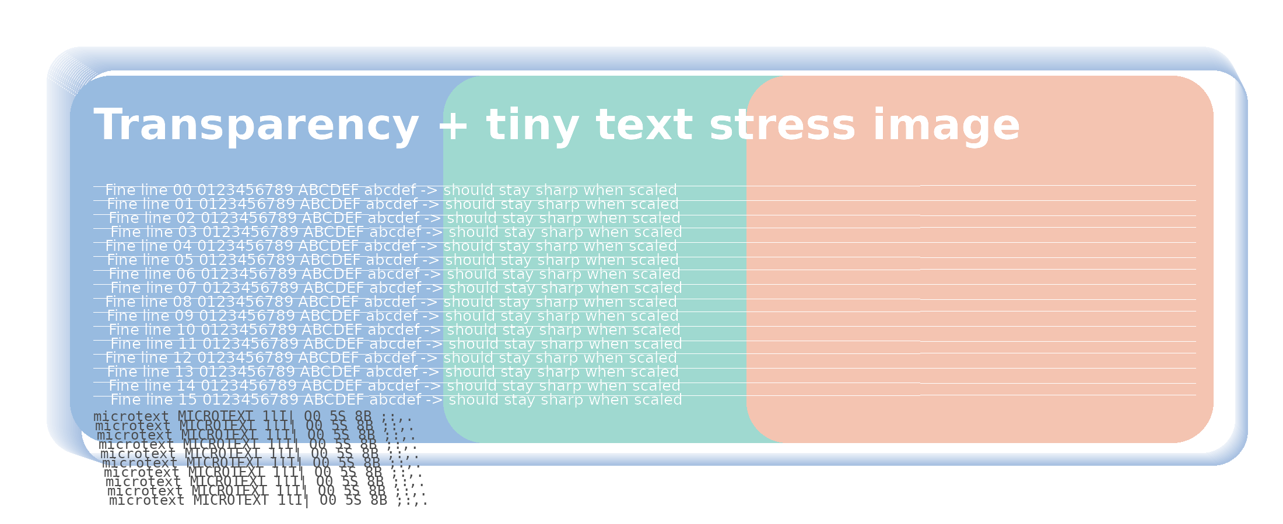
Figure 1. Transparent logo image with microtext, thin lines, and overlapping translucent panels.

Landscape page - line-break and symbol layout block
Checklist expected to remain aligned:  ☑ Metrics stable  ☑ Emoji does not force fallback drift  ☑ Header/footer pagination unchanged  ☑ Transparent image stays crisp | This paragraph is intentionally tuned so that with the named Windows fonts the last sentence ends just above the final margin line. If Converter substitutes wider fonts, the paragraph becomes longer, the final line wraps, and the overall page balance changes in a very obvious way. Add your own brand font here if you want an even more reliable comparison on Linux. Expected stable ending: [END-OF-BLOCK ✅]
How to make this even harsher: replace the Aptos/Bahnschrift names with your own corporate fonts that are present for Word Interop but absent in the Converter host environment.

