Group
boundless.co.uk/Group URL
Edition
Issue

Editi
  - Group Secretary
  - Telephone
  - Email
Add Image

Article 1
Add Text

Article 2
Add Text

Add Image

Upcoming Events

Name of Event
Date of Event

Short description about event

Address of event
Name of Event
Date of Event

Short description about event

Address of event
Name of Event
Date of Event

Short description about event

Address of event
Name of Event
Date of Event

Short description about event

Address of event
Name of Event
Date of Event

Short description about event

Address of event

Your Committee

Chairman Name Tel Email
Secretary Name Tel Email
Treasurer Name Tel Email

Committee Members
Name
Name
Name

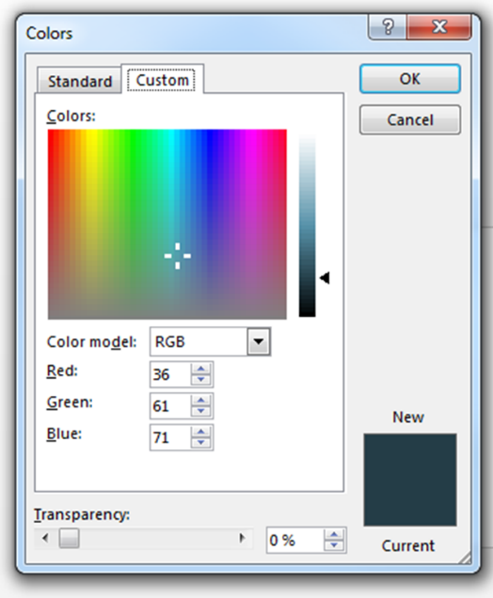
Brand Guidelines Reminder
Please use text boxes above. Delete Image boxes as appropriate. Amend Size as appropriate.
Please amend text box outline colour to ‘no fill’ when completed.
Items to be included
Description of Event, plus photos if available.
Address of event, plus any access suggestions.
How much, include all price variables.
Who should they contact to book (Tel. Email. etc...)
Font: Arial
Core Blue, Red and Dark Blue are the preferred primary colours to use on all collateral. Don’t forget White – we love a bit of space too.
Colour Model: RGB Red- 42, Green-95, Blue 166.
Colour Model: RGB Red- 239, Green-64, Blue 74.
Colour Model: RGB Red- 36, Green- 61, Blue 71.
Hyperlinks/ Email Addresses Colour: Colour Model: RGB Red- 42, Green-95, Blue 166.- Hyperlinks should also be underlined.
Underlining should only be used for hyperlinks. Any other important information ie telephone number should be made bold.

