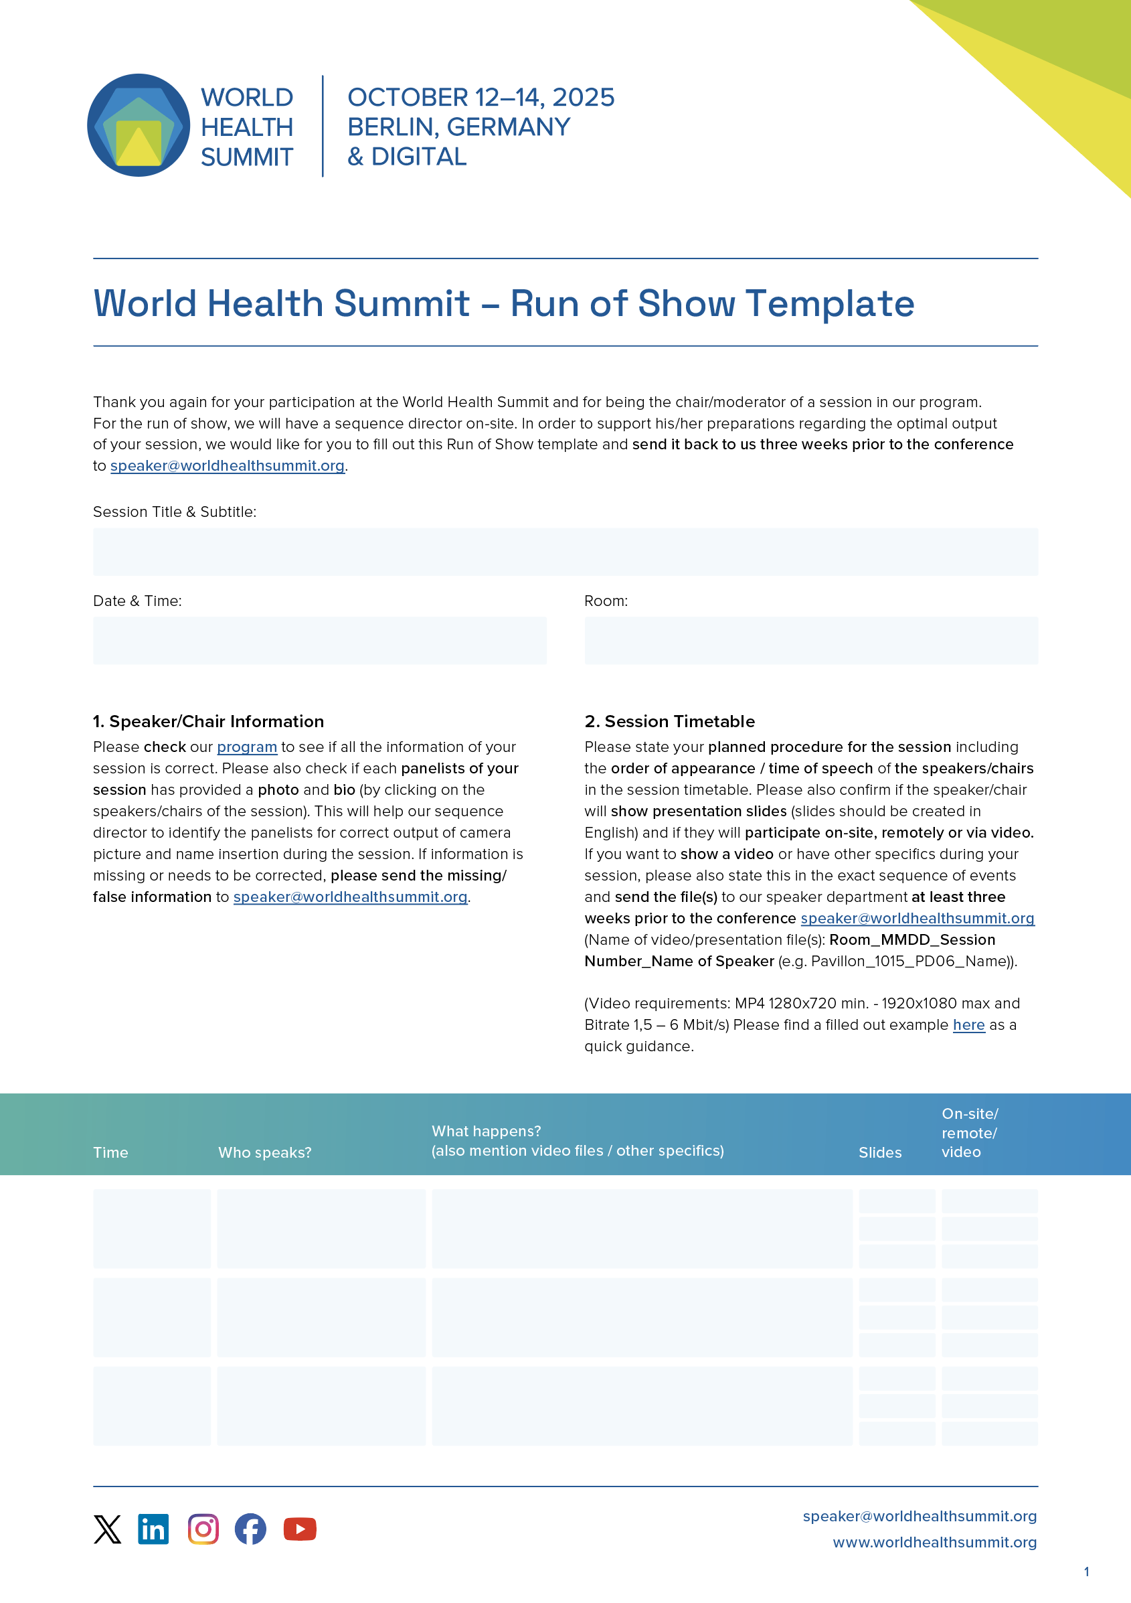

Click here to insert text
Click here to insert text | Please select a room

Click here to insert text | Click here to insert text | Click here to insert text | select | select
Click here to insert text | Click here to insert text | Click here to insert text | select | select
Click here to insert text | Click here to insert text | Click here to insert text | select | select
Click here to insert text | Click here to insert text | Click here to insert text | select | select
Click here to insert text | Click here to insert text | Click here to insert text | select | select
Click here to insert text | Click here to insert text | Click here to insert text | select | select
Click here to insert text | Click here to insert text | Click here to insert text | select | select
Click here to insert text | Click here to insert text | Click here to insert text | select | select
Click here to insert text | Click here to insert text | Click here to insert text | select | select

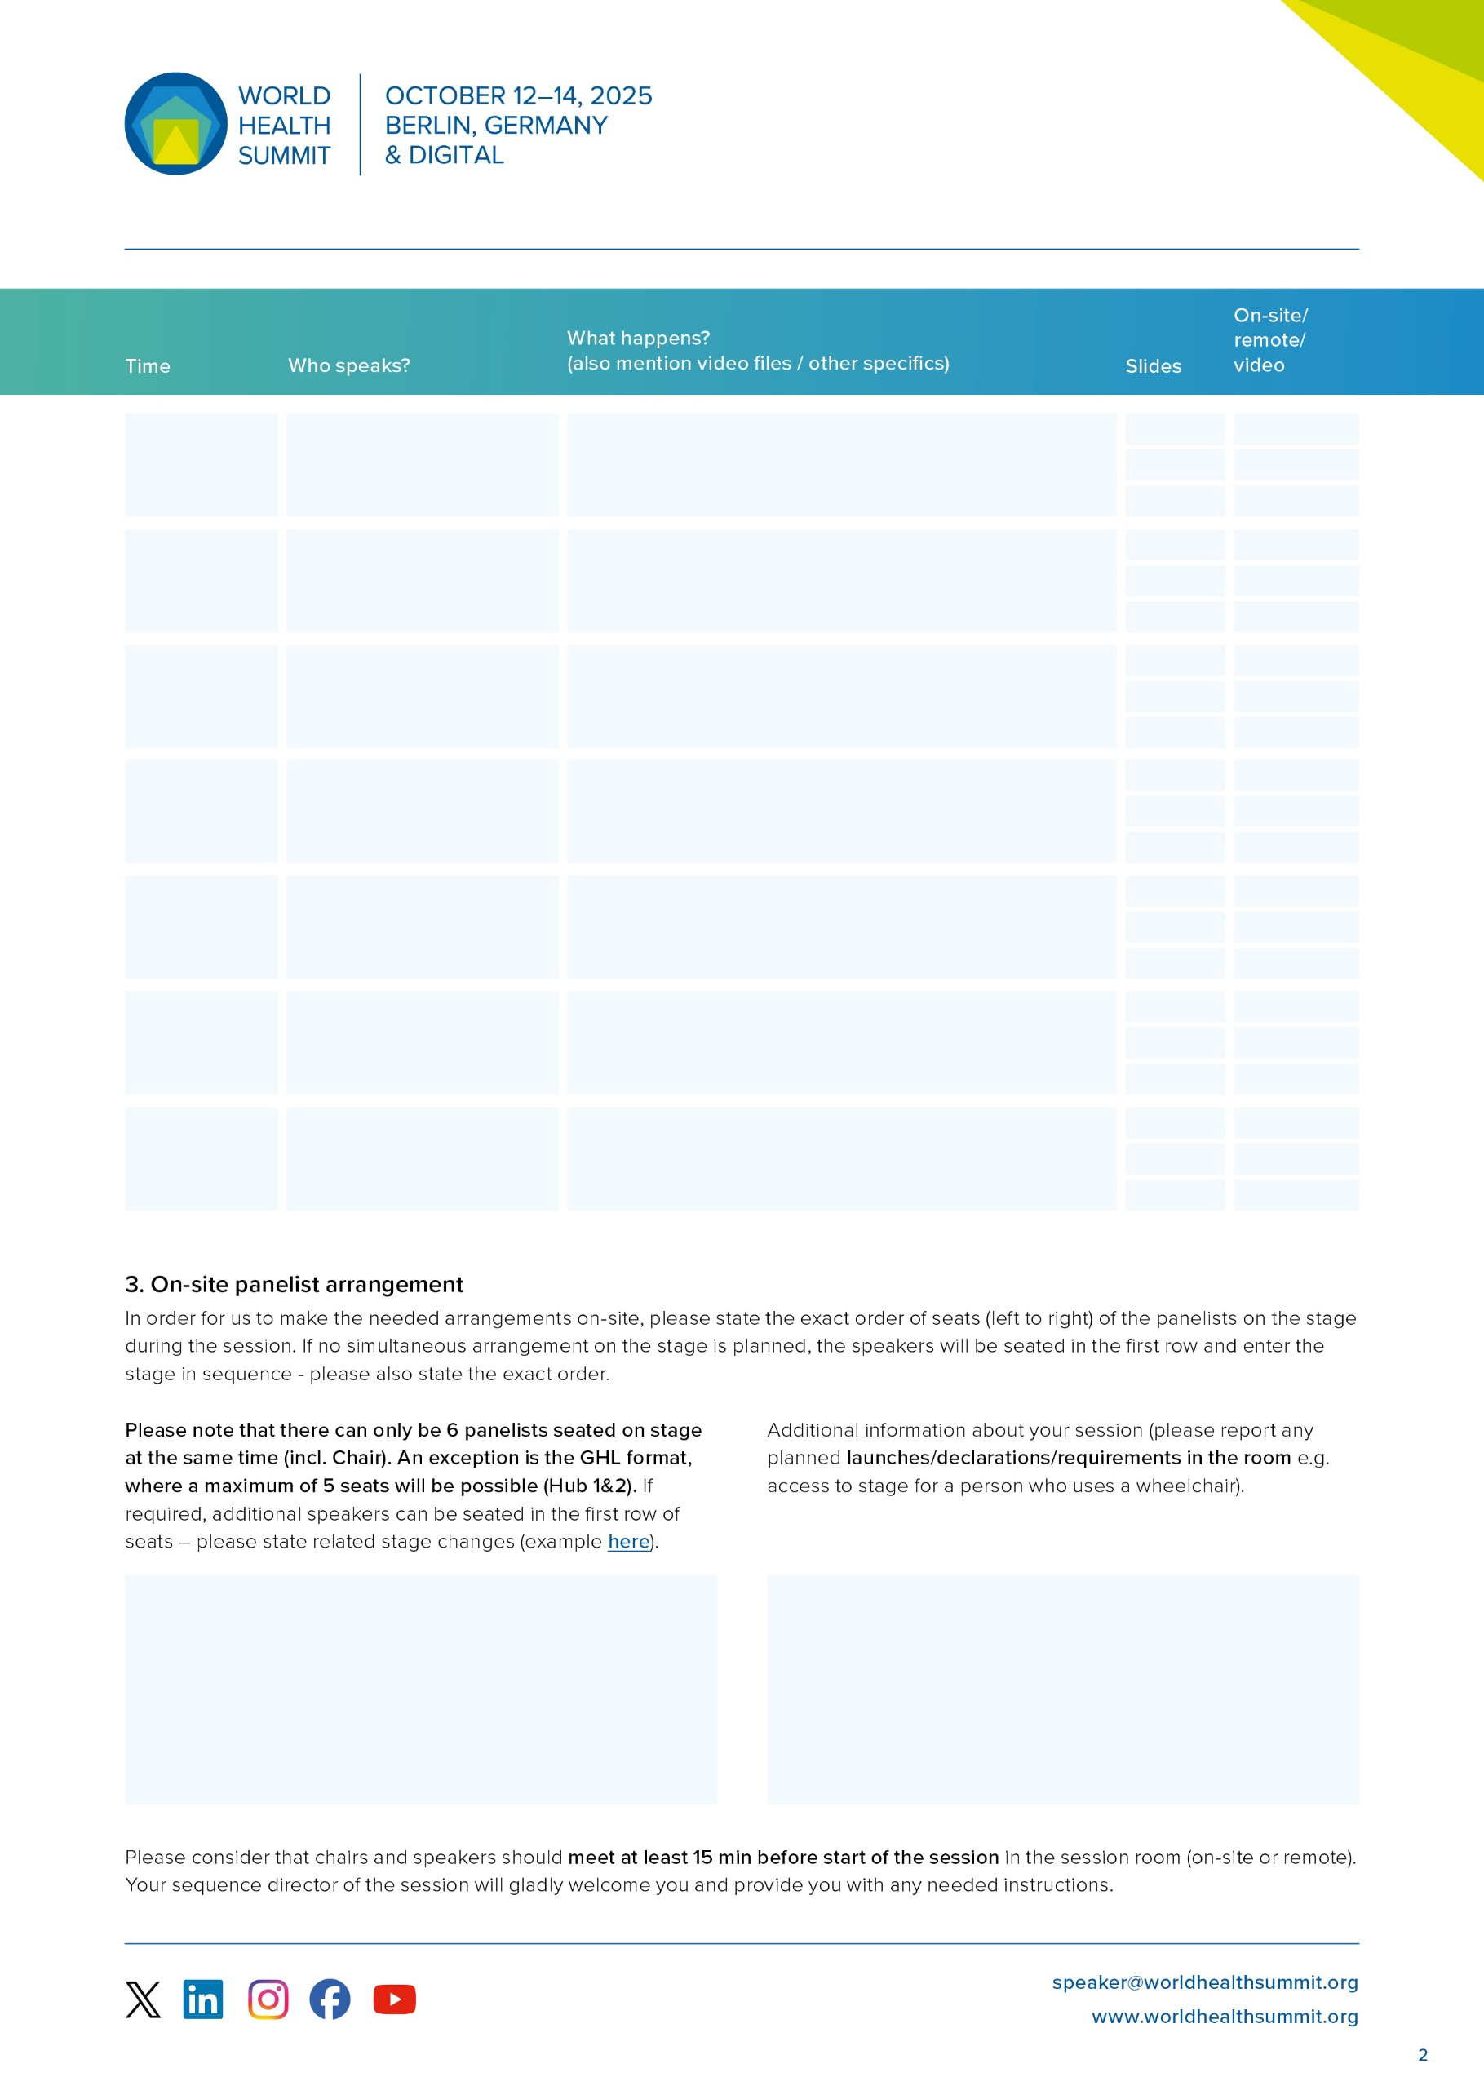
Click here to insert text | Click here to insert text | Click here to insert text | select | select
Click here to insert text | Click here to insert text | Click here to insert text | select | select
Click here to insert text | Click here to insert text | Click here to insert text | select | select
Click here to insert text | Click here to insert text | Click here to insert text | select | select
Click here to insert text | Click here to insert text | Click here to insert text | select | select
Click here to insert text | Click here to insert text | Click here to insert text | select | select
Click here to insert text | Click here to insert text | Click here to insert text | select | select
Click here to insert text | Click here to insert text | Click here to insert text | select | select
Click here to insert text | Click here to insert text | Click here to insert text | select | select
Click here to insert text | Click here to insert text | Click here to insert text | select | select
Click here to insert text | Click here to insert text | Click here to insert text | select | select
Click here to insert text | Click here to insert text | Click here to insert text | select | select
Click here to insert text | Click here to insert text | Click here to insert text | select | select
Click here to insert text | Click here to insert text | Click here to insert text | select | select
Click here to insert text | Click here to insert text | Click here to insert text | select | select
Click here to insert text | Click here to insert text | Click here to insert text | select | select
Click here to insert text | Click here to insert text | Click here to insert text | select | select
Click here to insert text | Click here to insert text | Click here to insert text | select | select
Click here to insert text | Click here to insert text | Click here to insert text | select | select
Click here to insert text | Click here to insert text | Click here to insert text | select | select
Click here to insert text | Click here to insert text | Click here to insert text | select | select

Click here to insert text |  | Click here to insert text

