Retailer Accessibility Factsheet

Introduction
Irish Guide Dogs (IGD) supports people living with vision impairment and the families of children with autism to achieve improved mobility and independence by providing trained service dogs.

We have written this factsheet to give you a better understanding of how you can make your service/shop more accessible to people who use service dogs, specifically guide dogs and assistance dogs.

The aim of this factsheet is to:
- describe what a service dog is;
- identify your legal responsibilities in accommodating the needs of service dog owners;
- provide guidance in identifying a registered service dog; and
- give you practical tips on how to make your service more accessible.

- What is a service dog?

A “service dog” is a generic term for a guide, hearing, or assistance dog specially trained to support disabled people. These dogs are specially trained to perform tasks that make a person’s life easier and safer by helping with everyday tasks and activities. There are several types of service dogs, each trained for specific tasks to support individuals with specific impairments.

The IGD uses Guide Dogs and Assistance Dogs to support (1) individuals who are blind and/or have a vision impairment and (2) the families of children with autism. Guide Dogs assist individuals who are blind and/or have some form of vision impairment, and Assistance Dogs provide support and safety for children who have autism. In this factsheet, we will refer to service dogs to include both guide dogs and assistance dogs.

For an animal to be recognised as a Service Dog, it must be fully trained, accredited, and registered with Irish Guide Dogs (IGD), and owners must carry an official IGD photo identification card.

- What does the law say about service dogs?
Service dogs are allowed into shops if they do not interfere with the merchandise and do not pose a risk to the safety of other customers.
Service dog owners are protected under Irish equality legislation, the Equal Status Acts, 2000-2018. This legislation gives service dog owners the right to access businesses and services without discrimination.
Under the Equal Status Acts 2000 - 2018, retail establishments are prohibited from refusing entry or charging extra servicing and cleaning fees to a person accompanied by a trained and registered service dog.
In addition, retail establishments must make reasonable changes to how their services are provided, where without these changes it would be impossible or unduly difficult for disabled people to avail of those services. This is known as Reasonable Accommodation. For example, retail establishments provide reasonable accommodation when they facilitate service dogs on their premises and by ensuring that all new and existing staff are informed of the legal rights of blind and/or vision impaired and neurodiverse people. Environmental Health Officers Association exempts registered service dogs from Food Hygiene Regulations

Please keep in mind that people who are allergic to dogs cannot lawfully request business owners or staff to refuse service or access to service dog owners who are visiting the same establishment.

For further information on the rights of disabled people, contact the Irish Human Rights and Equality Commission by phone: 01 8589 601, by email info@ihrec.ie or visit their website: https://www.ihrec.ie/.

- How to identify a service dog

A service dog is defined under Irish law as a highly trained dog that is specifically
trained to assist a disabled person. For a dog to be recognised as a service
dog, it must be fully trained and registered with several recognised bodies, including the IGD, which is accredited by both the International Guide Dog Federation and Assistance Dogs International. Training and registration ensure the dog meets the standards required for legal recognition and public access.

Guide Dogs and Assistance Dogs have a yellow sign on their lead and wear a medallion embossed with the Irish Guide Dogs logo on their collar. Their owners carry an official IGDB photo identification card. All service dog owners
are expected to be able to provide sufficient documentary evidence that their dogs
are fully trained and registered and may be reasonably asked to present this.

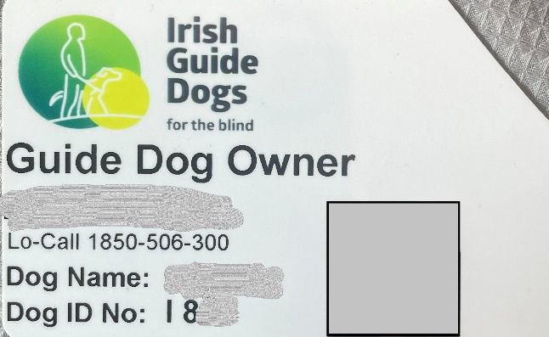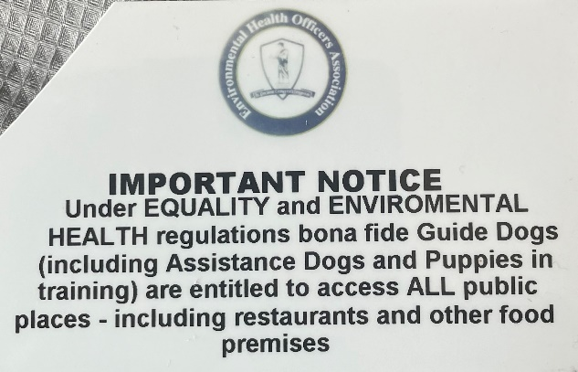
Image: Front & Back of IGD Photo Identification Card

What does a Guide Dog do?
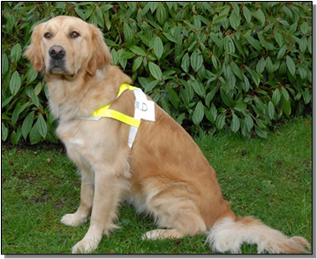
A Guide Dog is a mobility aid for people who are blind or have impaired vision.
The Guide Dog steers their owner around obstacles. It helps their owner to locate street crossings and doorways to buildings. Guide Dogs warn their owner when hazards and changes in ground level are approaching. They wear a harness with reflective markings when working.

Image: IGD Guide Dog in harness

What does an Assistance Dog do?
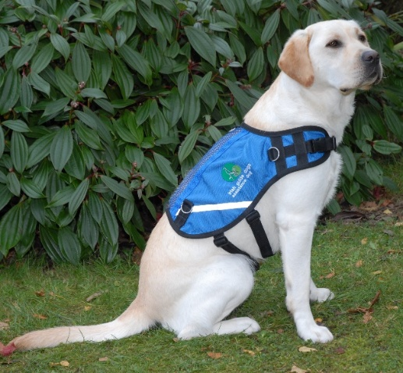
An Assistance Dog is trained to facilitate the needs of a child with autism. The Assistance Dog acts as an essential safety aid, anchoring the child with their family and promoting road safety awareness. The Assistance Dog is a constant companion to the child, promoting calmness on family outings. The parent holds the dog’s lead, and the child holds a lead or uses a waistband. Assistance Dogs wear blue jackets which bear the Irish Guide Dogs logo.
Image: IGD Assistance Dog in harness
- How to make your service more accessible for service dog owners
There are many things that you can do to ensure customers who use service dogs are welcomed in your shop.
Here are our top tips:
- Ensure all new and existing staff are informed on the Equal Status Acts rights of service dog owners.
- Provide training to your staff in engaging with service dog owners. Knowing how to guide a blind person or a person who has low vision is helpful. When you provide guiding assistance, please walk on the person’s opposite side to the service dog.
- Identify yourself – always introduce yourself and inform the person of your name and job title. Always ask the person if they would like any assistance or help and ask them what their name is.
- Do not pet a service dog when they are wearing the harness. If the dog is resting without their harness, ask the owner before you pet the dog and respect the person’s decision if they say no.
- Service dog owners have been taught the most effective ways to control their
dog’s behaviour. Please only help if requested.
- Keep circulation routes free of obstructions and trip hazards. It is important to ensure in-store circulation routes are free of obstructions and trip hazards.

- More Information
Please contact our Client Services team: ClientServicesTeam@GuideDogs.ie or call 0818 506 300 for more information on how your business can help to support our Guide Dog and Assistance Dog clients. Together we are Changing Lives

