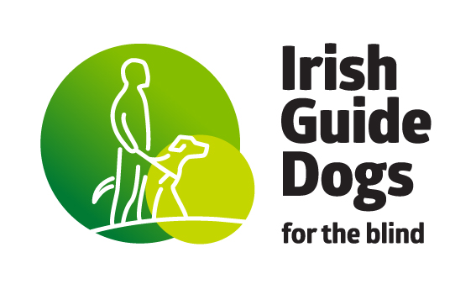

Irish Guide Dogs for the Blind Advocacy Charter
December 2025

Introduction
The Irish Guide Dogs for the Blind is a national organisation, founded in 1976, to support people who are vision impaired. Over the years, the objectives of the organisation were expanded to support families of autistic children and young people to achieve improved mobility and independence.
We strive to provide the highest quality of services in partnership with our clients while planning for the future and valuing clients, volunteers and each other.
This Advocacy Charter sets out our commitment and approach to strengthening the organisation’s impact in using advocacy to influence positive change for our clients.
Our advocacy efforts support the achievement of our core purpose of enabling people with sight loss and families of autistic children to lead better lives, become more independent and more mobile.
This Charter provides clarity and guidance to staff, clients and volunteers on our advocacy efforts. It does this by:
- outlining our vision of what constitutes effective advocacy
- identifying our underpinning principles
- describing our advocacy support services.
This charter was developed by the Client Consultative Committee (CCC) and is the accompanying document to the Client Charter, which sets out our service commitments to providing quality services responding to our clients’ needs and expectations.
The CCC is an advisory and consultative Sub-Committee to the Board and management of Irish Guide Dogs and provides guidance and insight on key issues impacting on our clients’ lives.
Our Advocacy Vision
At the Irish Guide Dogs for the Blind, we support our clients in self-advocacy and collective systemic advocacy.
We work to empower our clients to speak up for their rights and needs while working in collaboration with like-minded organisations to foster greater understanding, improve accessibility, and create intentional societal change.
We understand advocacy to be:
“A means of empowering people by supporting them to assert their views and claim their entitlements and where necessary representing and negotiating on their behalf”.
We understand self-advocacy to be:
“Individuals standing up for themselves on issues that matter to them in order to create positive change in their lives”.
We understand collective systemic advocacy to be:
“A way of working in partnership for long-term social change to ensure legislation, policies and practices support the rights and interests of our clients”.

OUR ADVOCACY PRINCIPLES
Our advocacy principles underpin and inform the nature of our advocacy support work and how we provide this support. These principles, developed by the CCC, are based on our experience to date and draw on best practice guidance from other organisations.

Principle 1: Empowerment
We believe in the power of every individual’s voice. Our role is to support our clients to advocate for themselves — ensuring they are central to every decision.
We commit to supporting clients in developing effective self-advocacy skills.

Principle 2: Client-led
Our advocacy support work is informed by the needs and wishes of our clients.
We commit to facilitating the active and equal participation of our clients in the co-creation of advocacy supports.
Principle 3: Clarity
We commit to ensuring our clients understand the scope and limitations of our advocacy support work.

Principle 4: Rights-Based
Our Advocacy Charter is underpinned by the legal and human rights of all our clients to equal access.
We commit to ensuring clients are aware of their rights and entitlements.

Principle 5: Inclusion
We commit to providing an inclusive advocacy support service to all clients who need support, and that is directed by the wishes and needs of clients.
We commit to providing an accessible advocacy support service that acknowledges clients’ communication preferences.

Principle 6: Accountability
We strive to provide the highest quality of services in partnership with our clients and to ensure clients have clear information about how to get support.
We commit to ensuring our staff are accountable for their actions and decisions.

Principle 7: Collaboration
We commit to working in partnership with organisations that share our values in creating positive, sustainable social change.

Principle 8: Confidentiality
We commit to respecting the privacy of clients.

OUR ADVOCACY SUPPORT SERVICES
What does the Irish Guide Dogs for the Blind offer to clients?
We commit to providing a responsive and effective advocacy support to our clients based on mutual respect and with regard to their lived experience and expertise.
This advocacy support entails the provision of:
1. Information and advice to support clients with regard to access issues;
2. Education and training to support clients in developing practical self-advocacy skills;
3. A complaints mechanism to record clients’ access issues and inform the work of the CCC;
4. Webinars and collective events to inform, discuss and share clients' and staff's experiences of advocacy;
5. Partnership and alliance building with like-minded organisations in the development of issue-based campaigns; and
6. Record and analyse client advocacy issues in the development of policy positions to support systemic change.

How to Contact Us
If you have experienced an issue with access to a business or service, please let us know via the Client Access Issues form or contact the client services team at ClientServicesTeam@GuideDogs.ie.
We are here to help.

Citizens Information Board, ‘Advocacy Service Guide’, May 2015.

