Press release

Preliminary report for Interpack 2026

Ensuring safety through integrated solutions

Bausch+Ströbel is promoting a clear message at Interpack 2026: Safety is not achieved through technology alone, but through a deep understanding of pharmaceutical production processes and solutions that come from a single source. The pharmaceutical industry is under increasing pressure. Ever more potent active ingredients, rising costs, and stricter regulatory requirements are placing greater demands on production. Mistakes are not only costly, but can also have serious consequences for patients. Accordingly, there is a growing need for partners who not only supply machines, but also complete, reliable production environments.

Bausch+Ströbel as a full-service provider

Bausch+Ströbel has been developing systems and services for aseptic filling since 1967. Today, the company positions itself as a provider that oversees the entire process—from the initial inquiry through all phases of the lifecycle to services. Crucial to this is the commitment to understanding each customer's situation precisely and developing solutions that combine technical precision with process reliability.
This approach is intended to enable manufacturers to produce medicines and vaccines reliably, efficiently, and sustainably worldwide—thereby strengthening reliability of supply.

Trade fair presentation at Interpack 2026

At Interpack, Bausch+Ströbel will be showcasing a mix of established systems and new developments that underscore the company's commitment to ensuring safety through integrated solutions. These include an integrated containment system with a line management system designed to increase transparency and efficiency, a new generation of powder filling, precise technologies for labeling and assembling syringes, and digital and service offerings.
This clearly shows how the role of traditional mechanical engineering companies is changing: away from being pure technology providers and toward becoming partners who understand production processes, minimize risks, and create long-term stability. For many manufacturers, this approach is likely to be the deciding factor.
Integrated isolator for maximum safety

Safety is a crucial component in production, especially when processing sensitive or highly potent active ingredients. The filling and sealing machine with integrated isolator exhibited at the trade fair addresses precisely this issue: it combines state-of-the-art filling technology with a tailored containment system. The isolator protects the product, process, operator, patient, and manufacturer alike, thus offering a safe, end-to-end production solution.
The isolator is one of the key elements of a safe overall solution. Through close cooperation with pharmaceutical manufacturers, each system is precisely tailored to the respective production requirements. The result is a stable, compliant, and future-proof solution that not only guarantees safety but also actively promotes it.

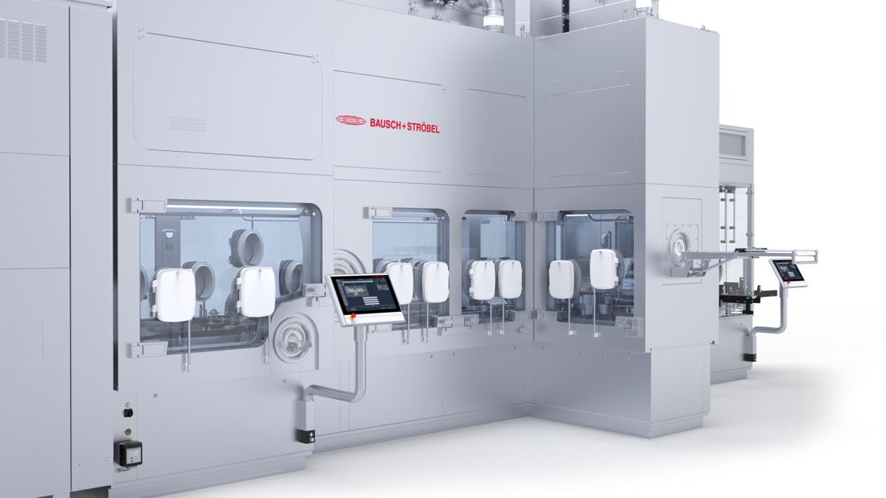

Caption: The filling and closing machine with integrated isolator exhibited at the trade fair combines state-of-the-art filling technology with a coordinated containment system.

Flexible dosing solutions and maximum operator and product safety

With a completely newly developed system for filling powdered pharmaceuticals, Bausch+Ströbel is setting new standards in aseptic powder processing. The innovative transport system gently guides the packaging materials through the system and covers a wide range of formats. This reduces format parts to a minimum. The system is easy to maintain, user-friendly, and meets the highest hygiene standards, including optimized surfaces, wash-down capability, and LF-optimized components.
Several dosing systems are available for different powders, including vacuum pressure dosing and scroll dosing. Numerous other features ensure maximum operator protection and process reliability.
Close consultation with customers results in the most suitable, safe, and high-performance total solution for each product, offering maximum precision in a minimum of space.

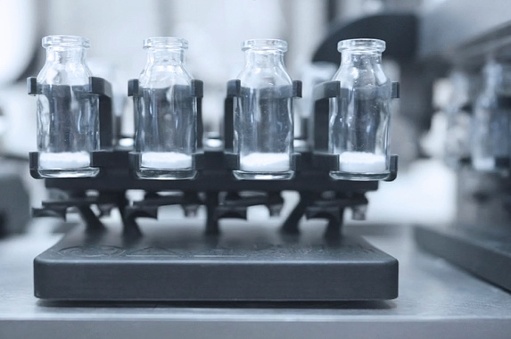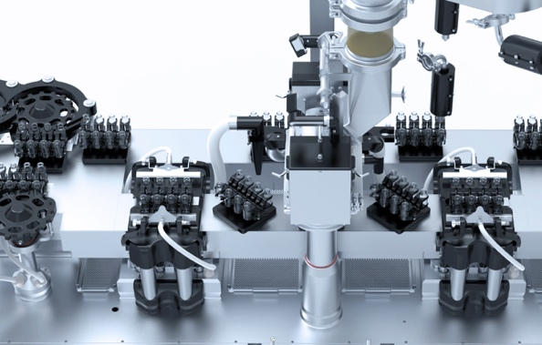

Caption: One of the special features of the new systems for dosing powdered medicines: the new transport system, which gently guides the packaging materials through the system and covers a wide range of formats.

High-performance labeling and assembly machines for syringes:
Precision, traceability, and protection along the entire value chain

Bausch+Ströbel presents a new high-performance machine for labeling and assembling syringes. Secondary packaging plays a central role in safety and compliance: errors in the labeling process can have serious consequences, while increasing requirements for tamper protection and traceability affect the entire supply chain. The modular systems (developed entirely by Bausch+Ströbel) offer maximum flexibility, for example through the integration of different printing systems. Separating the printing and labeling processes using a servo-controlled intermediate transport system improves print quality, reduces waste, and increases process reliability.
Assembly also plays a crucial role in safety: components such as plunger rods, backstops, and needle shields are manufactured with precision and reliability to ensure the functionality of the container and protect operators. Close customer collaboration yields solutions that guarantee precision, safety, and traceability at every step of the process.
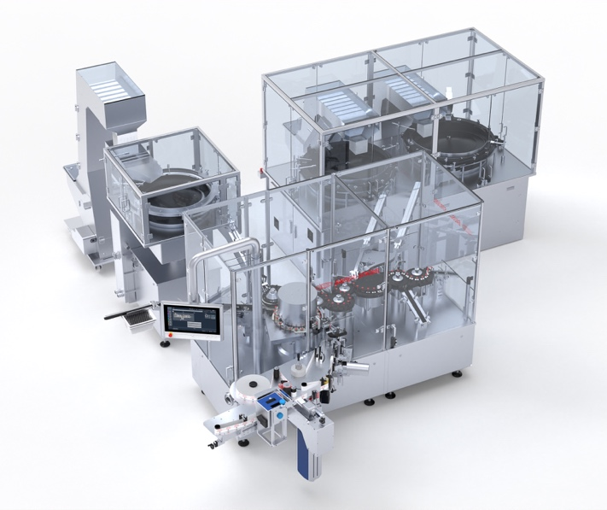
Caption: Bausch+Ströbel presents a new high-performance machine for labeling and assembling syringes.

OMNIA Line Management System (LMS):
Digital transparency and efficiency for modern production environments

OMNIA is the central platform for everything related to Bausch+Ströbel machines. The modular software solution makes systems IoT-enabled and helps users solve problems and resolve errors more quickly. New to the platform is the line management system.
The OMNIA line management system now provides a central platform for monitoring, analyzing, and controlling pharmaceutical production lines. The system is GMP-compliant, modular in design, and can be used both locally and in the cloud. It provides access to real-time data, batch information, and recipes, and enables functions such as line overview, reporting, OEE analysis, and batch and recipe management.
Integrated into the OMNIA platform, the LMS creates transparency, efficiency, and maximum flexibility across all machine types. The software helps users identify errors more quickly, make data-based decisions, and control production processes reliably. Collaborative development with customers results in a digital solution that sustainably strengthens modern production environments and ensures safety at all levels.
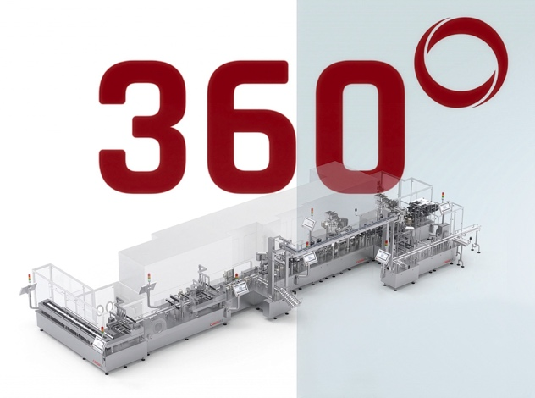
Caption: OMNIA, the central digital platform for Bausch+Ströbel machines. IoT-enabled helping users solve problems and errors more quickly. Featuring the new line management system.

Weitere Informationen erhalten Sie gerne auf Anfrage.

Ihre Ansprechpartnerin: Tanja Bullinger
Director Corporate Communications
Bausch + Ströbel
Parkstraße 1
74532 Ilshofen

Tel.: +49 (07904) – 701 - 3447
FAX: +49 (07904) – 701 - 888
E-Mail: tanja.bullinger@bausch-stroebel.de
2026-03-09 / tab

