 |  |  |  |  |  |  |  |  |  |  |  | Tree nuts |  |  |  |  |  |  |  |  | Gluten containing cereals
Menu item |  |  | Milk (dairy) | Egg | Fish | Crustacean | Mollusc | Sesame | Lupin | Peanut | Soy | Almond | Brazil nut | Cashew | Hazelnut | Macadamia | Pecan | Pine nut | Pistachio | Walnut | Wheat | Gluten | Barley | Oats | Rye | Sulphites
 |  |  |  |  |  |  |  |  |  | 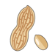 |  | 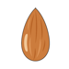 |  |  | 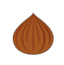 |  | 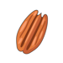 |  | 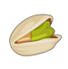 |  | 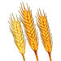 |  |  | 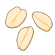 | 