Last name | First name | Role  (staff or camper) | Milk (dairy) | Egg | Fish | Crustacean | Mollusc | Sesame | Lupin | Peanut | Soy | Wheat | Gluten | Almond | Brazil nut | Cashew | Hazelnut | Macadamia | Pecan | Pine nut | Pistachio | Walnut | Sulphites | Other allergies or dietary requirements
Last name | First name | Role  (staff or camper) |  |  |  |  |  |  |  | 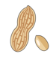 |  |  |  | 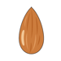 |  |  | 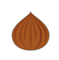 |  | 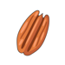 |  | 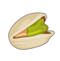 |  |  | Other allergies or dietary requirements

