all about the centre

3 nights, 4 days (escorted)

LONGITUDE 131° AND SEIT OUTBACK TOURS
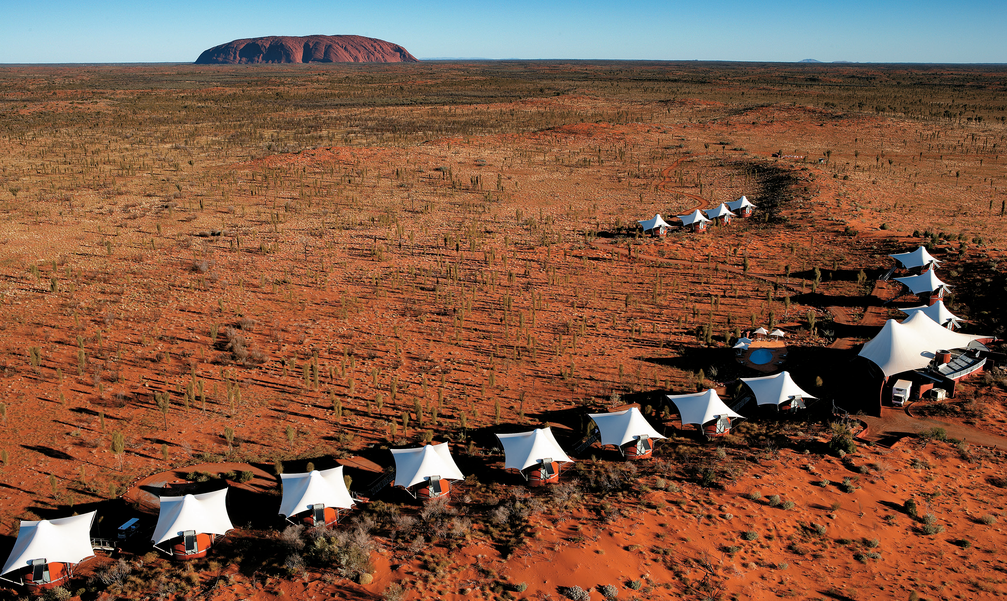

Day 1
Arrive at Longitude 131° to a warm signature welcome. Settle in to your luxurious tented pavilion and savour the magnificent views from your tent as the light shifts and changes over Uluru. Observe the sights and sounds of the desert along one of our circular walking tracks or simply relax by the swimming pool with a refreshing beverage at arm's reach.
LATE AFTERNOON
Uluru Sunset - A drive into the dual World Heritage-listed National Park begins the evening followed by a leisurely walk through the Cultural Centre where the informative and interactive displays provide insight into the spiritual and cultural meanings of Uluru and Kata Tjuta. Continue on to the twilight viewing area where you can take in the iconic sunset over Uluru with a glass in hand as you witness the blazing colours change.
Overnight: Longitude 131° (D)
Day 2
Walpa Gorge & Kata Tjuta - After admiring the mystical red domes from afar with a photo opportunity, it's only once you travel closer that the grand scale of Kata Tjuta becomes apparent. Upon arrival begin your journey with a guided tour of Walpa Gorge, where the natural history of Kata Tjuta is explained in great detail. Learn how eons of weathering and continental upheaval have created what is seen today.
Mala Walk & Kantju Gorge - After arriving at the base of Uluru, our guide leads you on a gentle walk as you learn about the history of the Mala people, ending at Kantju Gorge. Once 'inside' Uluru, enjoy evening drinks and canapés as the sun sets and the glorious colours of Uluru are revealed.
Overnight: Longitude 131° (B, L, D)
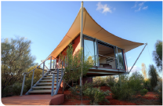
Day 3
Take a day trip from Longitude with SEIT Outback to Mt Conner, located 100Km east of Uluru. This is the quintessential Aussie Outback experience. This fascinating tour will introduce you to life in the desert. Absorb the ambiance of the Red Centre without the crowds as we venture into an extraordinary environment by 4WD.
Mt Conner is situated on a vast, fully operational, privately owned cattle station, called Curtin Springs Station. While the dams on the property were constructed for watering cattle, here you will find the perfect natural habitat for red kangaroos and a vast array of birds and reptiles of the Red Centre. You will discover an ancient inland salt lake and learn about the European history of the region. While you enjoy a glass of sparkling wine, you will be captivated by the spectacular changing colours of sunset over Mt Conner before returning to relish a three-course outback dinner prepared by the cook at Curtin Springs Station.
Pick up and return from Longitude 131°
Overnight: Longitude 131° (B, L, D)
ALTERNATE DAY 3
Depart Longitude for a day tour with SEIT Outback to Cave Hill - an Indigenous cultural experience that will provide visitors with an insight into everyday Aboriginal life. Journey by 4WD, relax and enjoy a trip deep into the desert of the Pitjantjatjara lands of Central Australia.
On arrival we will be greeted by our Anangu host. The Anangu are the traditional owners of Cave Hill, which is the site of the Seven Sisters Tjukurpa (creation time), and are responsible for maintaining only that chapter of the Songline lying within the boundaries of their traditional homeland - a story that has been maintained since the beginning of time.
The highlight of the tour is the magnificent cave paintings - possibly the most significant art site in Central Australia. The drama of the Seven Sisters creation story is graphically illustrated on the ceiling of the cave. Climb to the top of Cave Hill to admire a 360-degree panoramic of the surrounding countryside, including Uluru 100kms away, Mount Conner and the imposing Musgrave Ranges.
You will discuss Tjukurpa and the Songlines and learn their relevance to Anangu life in the desert. You will investigate traditional food gathering and the preparation of desert bush tucker delights. After lunch we head back to Longitude 131° arriving late afternoon.
A helicopter flight is available at an additional cost if you wish to follow the desert trails and enjoy the majesty of Uluru from the air, arriving back at Longitude early afternoon.
Pick up and return from Longitude 131°
Overnight: Longitude 131° (B, L, D)
Day 4
Depart Longitude for your forward travel or return trip home.
