Framework for a modular approach to updating NICE manuals

What is the modular updates framework?
- In January 2022, when the combined process and methods manual for its health technology evaluation programmes was published (NICE technology appraisal and highly specialised technologies guidance: the manual [PMG36]), NICE stated its commitment to adopting a more modular approach to updating its processes and methods.
- A modular update is a review of the processes or methods (or both) that inform NICE’s guidance. It is limited to a specific subject area and may result in an update to NICE’s processes and methods manuals.
- The modular updates framework is designed to ensure that NICE’s processes and methods are flexible and responsive to changes in the health and care landscape. It also promotes consistency in how our process and methods manuals are updated, and provides a structured mechanism for prioritising updates in the areas that matter most. It allows external stakeholders to contribute, including by identifying candidates for modular updates and shaping the content of updates, which helps to ensure that NICE’s manuals meet users’ needs. For examples of recent modular updates, see NICE modular updates.
- The framework also outlines the approach to making corrections and clarifications in process and methods manuals that may be identified as part of the modular updates process (see paragraphs 100 to 105).
- The framework does not cover how existing process and methods manuals are implemented.
- The framework supports NICE’s efforts to harmonise processes and methods across different programmes and directorates and, eventually, to move towards a single guidance development manual. It applies to the following process and methods manuals:
- Developing NICE guidelines: the manual (PMG20).
- NICE technology appraisal and highly specialised technologies guidance: the manual (PMG36).
- NICE HealthTech programme manual (PMG48).
- Interventional procedures programme manual (PMG28).

Sources of modular updates
- There are 3 main mechanisms for establishing the need for, and priority of, modular updates:
- Updates needed to deliver business priorities.
- Updates needed to reflect changes in how NICE operates.
- Updates selected from candidates suggested by internal and external stakeholders.
- Updates that are needed to deliver business priorities are referred to the appropriate directorate by the NICE executive team. For example, the NICE 2024/25 business plan included an organisational aim to develop new methods for addressing health inequalities. This resulted in the publication of a modular update in 2025, which clarified how NICE considers the effects of health technologies on health inequalities.
- Updates that are needed to reflect changes in how NICE operates are initiated by the relevant directorates. For example, in 2024, we introduced an integrated topic prioritisation approach to help deliver our transformational objective to focus on what matters most. The new approach made some sections of the guidance development manuals out of date, and the manuals were updated accordingly.
- Modular updates that fall under the above 2 categories (see paragraphs 8 and 9) proceed directly to the module routing step and are not subject to the earlier steps in the framework. See paragraphs 41 to 43 for details of how these updates will be overseen.
- Details of the steps involved in identifying, shortlisting and recommending stakeholder suggestions for modular updates for prioritisation during business planning are described below (see paragraphs 21 to 30).

Overarching process
- Figure 1 shows an overview of the process. As noted above, the first 2 steps in the process do not apply to updates that are needed to deliver business priorities, or updates that are needed to reflect changes in how NICE operates. The scoping, evidence development and stakeholder engagement steps may not be required for all updates, for example, updates needed to reflect changes in how NICE operates. The project sponsor is responsible for deciding whether these steps are required, engaging with the associate director for the corporate office to determine whether legal advice is required for the modular update, for example, whether a consultation is required (see paragraphs 52 and 60).
- All aspects of the process will be reviewed regularly and updated as required to ensure that the framework is appropriate and proportionate, and that it meets the needs of NICE and our stakeholders.
Figure 1 Modular updates process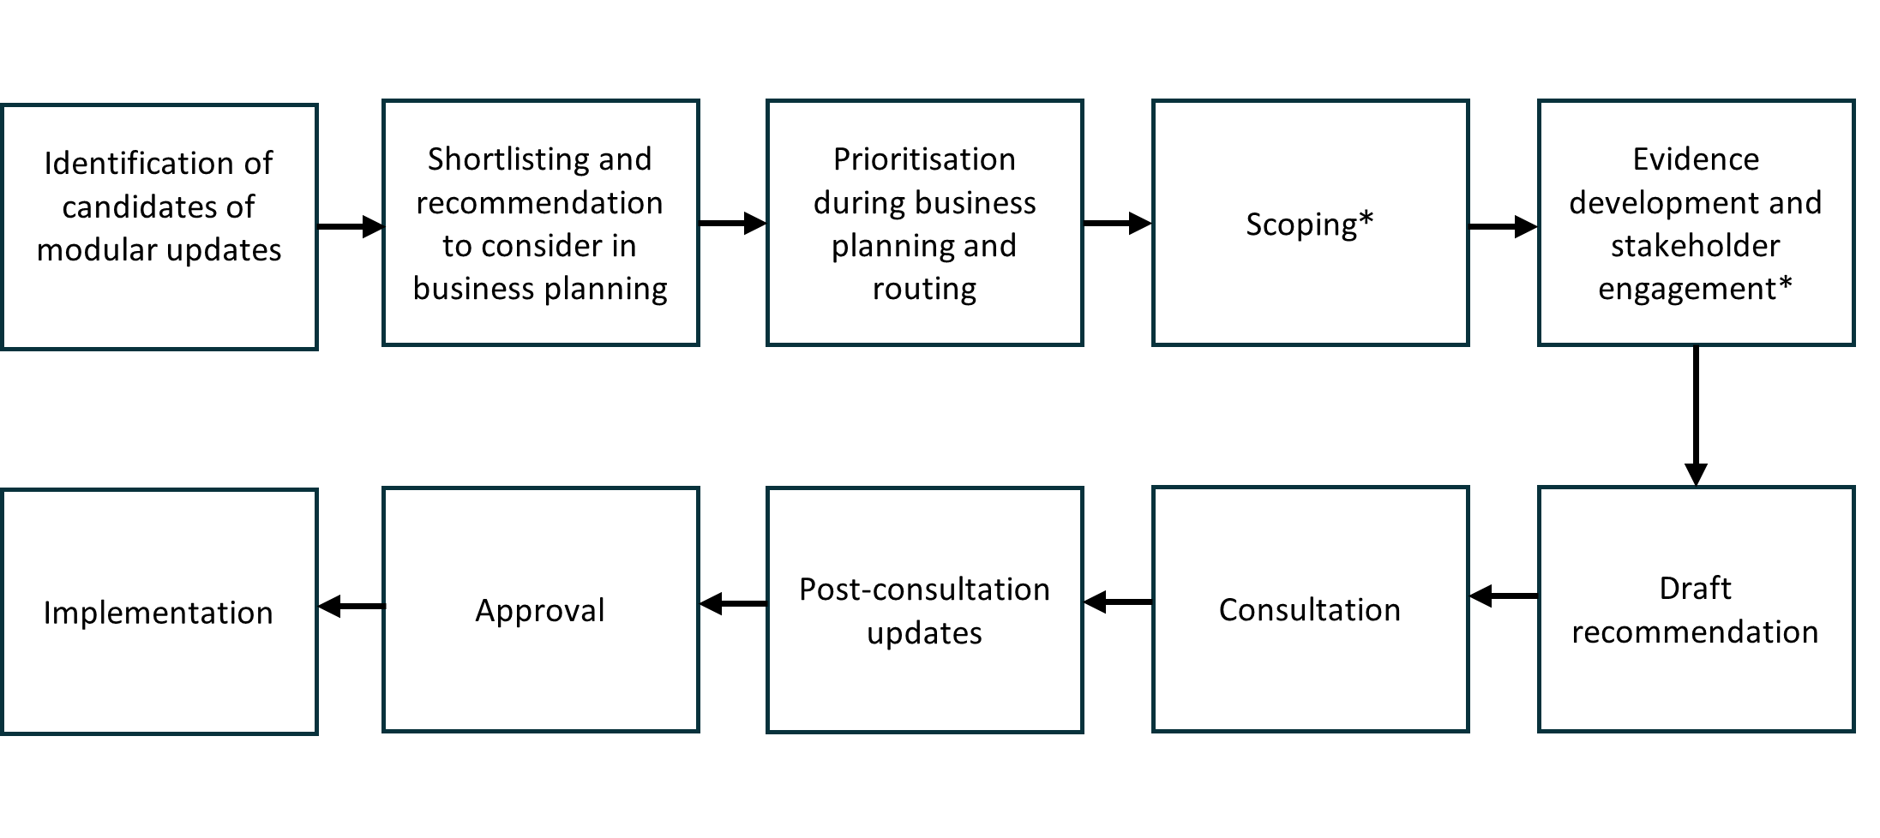
* The scoping and evidence development and stakeholder engagement steps may not be required for all updates, for example, updates needed to reflect changes in how NICE operates. The project sponsor is responsible for deciding whether these steps are required. Further information on the requirement for consultation is provided in paragraphs 75 to 83.

Timelines for modular updates
- The first 2 steps of the modular updates process (see paragraph 12) take place annually and are linked to the NICE business planning cycle. NICE limits the number of modular updates that it selects and works on each year.
- If changes are needed, the manuals are updated periodically, for example, on an annual basis, with multiple modular updates grouped together if appropriate. This is to ensure that the manuals evolve in line with best practice and NICE’s strategic priorities, while minimising instability for stakeholders and NICE staff, committees and faculties. Occasions may arise when updates need to be made urgently, and there is flexibility to update the manuals more frequently if necessary.
- When a candidate for a modular update has been prioritised during business planning, it is routed to the appropriate NICE team for evidence development, consultation and approval. It is acknowledged that this may take longer than a year to complete.

Equality and health inequality impact assessment (EHIA)
- NICE reviews the recommendations for changes to process and methods manuals for any impact on equalities and health inequalities. Health inequalities can affect people grouped by a range of different factors including:
- sharing certain protected characteristics, as outlined in the Equality Act 2010
- socioeconomic status or deprivation
- belonging to vulnerable or excluded groups of society
- geography.
- Health inequalities can be identified and measured through differences in areas such as the prevalence of conditions and mortality, behavioural risks to health (such as smoking), the wider determinants of health (such as housing and employment), access to care, and the quality and experience of healthcare services.
- Impacts on equalities and health inequalities are considered throughout the modular updates process.
- At module routing, the task and finish (T&F) group completes an EHIA form (see paragraphs 47 and 48). The EHIA form is referenced throughout the development process and updated as required, including consideration of potential mitigations for any negative impacts identified.

Identification of candidates for modular updates suggested by stakeholders
- Figure 2 shows the steps involved in identifying, shortlisting (by the modular updates selection and oversight panel [MSOP]; see paragraph 31) and prioritising candidates for modular updates that are suggested by stakeholders.
Figure 2 Identification, shortlisting and prioritising candidates that are suggested by stakeholders for modular updates.
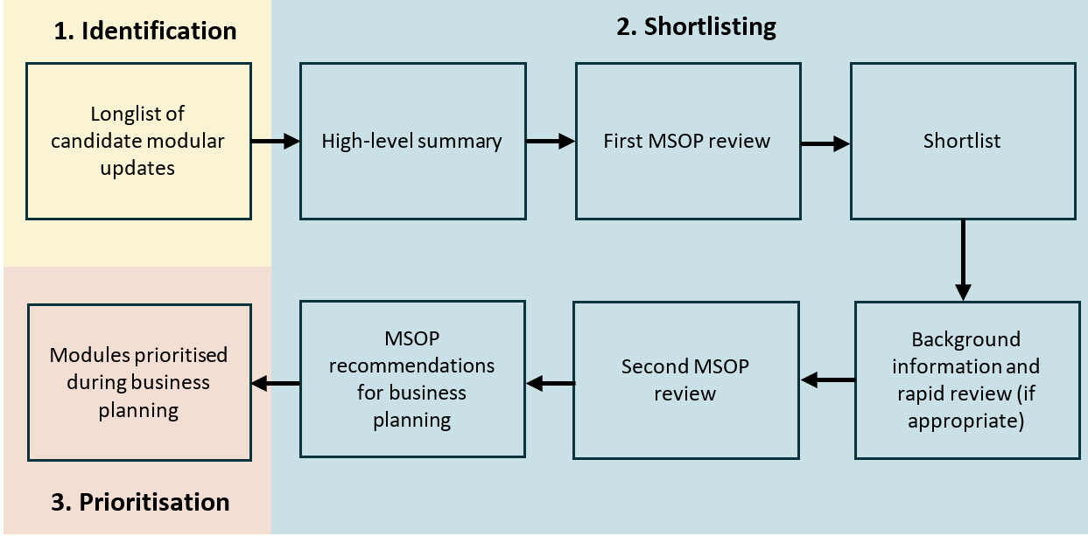
- NICE is responsible for selecting the process and methods areas that might be suitable for a modular update. We are committed to listening to our stakeholders and prioritising modular updates that will ensure that our manuals meet the needs of our users.
- Candidate modular updates can be identified through 2 routes: via an online form and from previous modular update rounds. Candidates for modular updates that are suggested by stakeholders and those from previous rounds are collated, and similar candidates are grouped by the science policy team to form a longlist.
- The online form is available on the NICE website, and any stakeholder can use it to suggest a candidate for a modular update.
- The form is open for approximately 2 months each year, and will be promoted internally and externally.
- Candidates from previous modular update rounds may be included in the longlist as follows:
- Candidates that were previously recommended by the MSOP but were not prioritised during business planning, for example, due to capacity constraints.
- Candidates that the MSOP considered important but did not recommend.
- Where a candidate from a previous round has been included in the longlist, the MSOP chair may use their discretion to defer it if there is agreement that there has not been sufficient change in the area. This will be highlighted at the start of the first MSOP meeting.

Selection of modular updates from candidates suggested by stakeholders
- Once a longlist of potential modular update candidates has been developed, the science policy team collates a summary of the key details of each candidate.
- Any candidates that involve a correction or clarification (see paragraphs 100 to 105) are routed immediately to the appropriate manual lead for approval without the need for review by a panel. Once identified and routed, existing processes are followed for making corrections and clarifications to the manuals.
- The longlist of candidate modular updates (together with the summaries of key details) is discussed by the MSOP (see paragraph 31).

Modular updates selection and oversight panel (MSOP)
- The MSOP is a standing committee with cross-directorate representation. It is responsible for recommending which stakeholder suggestions for modular updates should be prioritised during business planning. The MSOP meets twice a year: the first meeting is to review the longlist of candidate modular updates and decide on shortlisting, and the second is to recommend the modular updates to be prioritised during business planning.
- In exceptional circumstances, an additional meeting may be convened if the MSOP needs to decide whether to recommend work on a modular update and that decision cannot fit within the usual process and timetable.
- A summary of the MSOP’s decisions is published on the NICE website.

Membership
- The MSOP includes sufficient senior representatives to ensure that NICE’s organisational priorities are communicated and reflected at both meetings. Technical and programme management staff from the science policy team provide support to the panel but are not voting members. There are currently no plans to include external members on the MSOP. Input may be sought from representatives from NHS England and the Department for Health and Social Care sponsor teams to inform discussions. External stakeholders may be invited to discuss specific items on an ad hoc basis.

First MSOP review – shortlisting of candidate modular updates
- At the first meeting, the MSOP reviews the longlist of candidate modular updates. The criteria for shortlisting include the following:
- Whether the candidate update is within the scope of NICE’s remit and manuals.
- Whether the update falls under any of NICE’s statutory requirements (for example, if there is a requirement to consult for a minimum time period).
- Whether the update would promote alignment or create misalignment between the manuals.
- Whether the update aligns with NICE strategic priorities and key performance indicators.
- Whether the update aligns with NICE’s principles.
- The anticipated scale of the impact of the update on NICE’s processes and methods.
- Any impact on equalities or health inequalities, for example, whether the update is likely to have a significant impact on any groups with protected characteristics or on wider determinants of health. Any impact will be explored further as part of the EHIA for the delivery of the modular update (see paragraphs 17 to 20).
- As part of this process, the MSOP determines whether there is ongoing work that is directly or indirectly relevant to the candidate modular update, such as NICE-led or externally led research projects or Health Technology Assessment Innovation Laboratory (HTA Lab) projects. This is to avoid duplication of effort, and to identify any existing learning that the suggested modular update can incorporate.
- Outcomes for candidate modular updates at this meeting include the following:
- Include in shortlist and progress to next stage.
- Do not include in shortlist – consider further action if appropriate (for example, develop a position statement).
- Not a modular update – consider further action if appropriate (for example, progress as a correction or clarification, refer to the External Assessment Group management group to propose a technical support document by the NICE decision and technical support unit [DSU], or update supporting documents).
- Candidate modular updates that are not shortlisted are not automatically added to the longlist for subsequent rounds. If they are proposed again, they are highlighted to the MSOP, who decide whether there has been any change since the previous decision. If not, the candidate update is not shortlisted.

Second MSOP review – recommendation of candidate modular updates
- At the second meeting, the MSOP reviews all shortlisted modular updates and decides which should be recommended for prioritisation during business planning. The criteria that MSOP consider at this stage include the following:
- Importance:
  - Further consideration of the anticipated scale of the impact of the update on NICE’s processes and methods.
  - Further consideration of any impact on equalities or health inequalities, for example, whether the update is likely to have a significant impact on any groups with protected characteristics or on wider determinants of health. Any impact will be explored further as part of the EHIA for the delivery of the modular update (see paragraphs 17 to 20).
- Evidence
  - Whether there is a sufficient evidence base to support a modular update including available evidence and any ongoing work in this area.
  - Whether the update is needed to reflect current methodological practice.
- Outcomes for candidate modular updates at this meeting include the following:
- Important, and the evidence base is expected to be sufficient to support a modular update – recommended by the MSOP; progress to business planning for prioritisation and routing.
- Important, but the evidence base is expected to be insufficient to support a modular update – consider further action if appropriate (for example, develop a position statement, refer to the External Assessment Group management group to propose a technical support document by the DSU, refer to the National Institute for Health and Care Research [NIHR] Policy Research Unit in Economic Methods of Evaluation of Health and Care Interventions [EEPRU]), include the candidate in the longlist for the next modular update round.
- Not important (evidence base not considered) – consider further action if appropriate (for example, develop a position statement). The candidate is not included in the longlist for next modular update round.

MSOP oversight of modular updates prioritised via other mechanisms
- The MSOP is not responsible for recommending modular updates needed to deliver business priorities or to reflect changes to how NICE operates (see paragraphs 8 to 10).
- For these categories of modular update, the project sponsor or a suitable deputy is responsible for providing the MSOP with an overview of the required update, and a demonstration that the standard decision-making criteria have been adequately considered (see paragraphs 35 to 40).
- At the start of each MSOP meeting, any modular updates that were prioritised via other mechanisms are noted, discussed if necessary, and recorded in the minutes for transparency.

Prioritisation of candidate modular updates
- Candidate modular updates that are recommended by the MSOP are considered for prioritisation during business planning. Senior representatives from each directorate (who are members of the MSOP, see paragraph 34) discuss which directorate and senior representative are best equipped to lead a modular update, based on expertise and available resources. This includes assessing the resources that would be required by NICE and other stakeholders to implement the modular update, which manuals will be updated and which NICE team(s) the modular update should be routed to.
- A modular update recommended by the MSOP may not be prioritised if there is insufficient resource in the appropriate directorate.
- Outcomes of this process are as follows:
- Prioritised – the candidate is moved to module routing (see paragraph 47).
- Not prioritised – the candidate is included in the longlist for the next modular update round, and further action is considered if appropriate (for example, develop a position statement).

Module routing
- Prioritised modular updates are routed to the appropriate team and assigned a sponsor, who has oversight of the project.
- The sponsor sets up a working group for each modular update (known as the task and finish [T&F] group). T&F groups are internal (NICE-led) groups made up of members of relevant teams and directorates. Group membership depends on the nature of the modular update and includes the sponsor. Representatives are included from any team that may be able to provide useful input into, or be affected by, the outcome of the modular update.

Scoping
- If required, a scope for the modular update is developed using a scoping template. A scope may not be required for all modular updates, for example, for updates that reflect changes in how NICE operates (see paragraph 9). The sponsor is responsible for deciding whether a scope is required.
- The scope:
- summarises the modular update
- lists the areas that will be updated, including specific questions that need addressing
- lists any related areas that will not be covered by the modular update, providing justification if required.
- The draft scope is signed off by the sponsor. There is no consultation of the scope, but the T&F group may engage with internal and external stakeholders if required.
- The T&F group should engage with the associate director for the corporate office during the scoping stage to determine whether legal advice is required for the modular update.
- The scope may be published on the NICE website and shared with key internal contacts via the sponsor.
- The scope is discussed by NICE’s guidance executive (GE), who decide whether the proposed modular update represents a major or minor departure from the existing approach. This determines the approval procedure for the modular update.
- If GE considers the update to be a major departure from the existing approach, the modular update requires approval from NICE’s board. The board can delegate major departures to GE, for example, to expedite implementation.
- If GE considers the update to be a minor departure from the existing approach, the modular update does not require approval from NICE’s board and can be approved by GE. If there is any doubt as to whether the proposal represents a major or minor departure and, therefore, whether board approval is required, advice should be sought from the associate director for the corporate office.

Evidence development and draft recommendation
- The evidence development step involves reviewing the evidence relating to the modular update; this may be informed by primary research. The exact nature of the evidence review will depend on the nature of the modular update, including whether the update relates to NICE’s processes or methods. The evidence development step may not be required for all modular updates, for example, for updates that reflect changes in how NICE operates (see paragraph 9). The sponsor is responsible for deciding whether the evidence development step is required.
- The T&F group is responsible for overseeing the evidence development step of the process. All members should have the opportunity to review and comment on relevant documents.
- The T&F group liaises with external stakeholders who may be able to provide support or conduct work associated with the modular update. The nature of the stakeholder engagement depends on the scope of the modular update.
- The sponsor should also determine whether a consultation is required and, if so, the required length of the consultation period for the proposed modular update, seeking legal advice if required. NICE will follow the National Institute for Health and Care Excellence (Constitution and Functions) and the Health and Social Care Information Centre (Functions) Regulations 2013 in determining whether a consultation is necessary (see paragraph 75). Paragraphs 75 to 87 apply only to modular updates that involve a consultation.
- Once all the appropriate evidence has been assessed, the T&F group summarises the key findings in an evidence development report.
- The evidence development report may include a recommended action as follows:
- Manual does not require updating – existing manual remains up to date and in line with current research.
- Manual does not require updating at this time – further research is required.
- Manual does require updating – a description of the updates required.
- If the recommendation is that the manual does not need updating, further action may be appropriate and should be detailed in the draft recommendation. This may include the following:
- Updates to documents other than the manual, for example, updating company submission templates.
- Development of a position statement.
- Referral to the External Assessment Group management group to propose the development of a technical support document by the DSU.
- Referral to NIHR's EEPRU.
- If the recommendation is that the manual does not currently need updating and further research is required, the evidence development report should include a description of what further research is necessary.
- If the recommendation is that the manual does require updating, the T&F group develops an interim updated manual for consultation, which includes the proposed changes to be implemented. For modular updates that do not require an evidence development step (see paragraph 57), only the interim updated manual is required for consultation.
- The final evidence development report is published on NICE’s website and remains available after the modular update has been completed (see paragraph 95). The interim updated manual is available on NICE’s website during the consultation period, after which it is moved to NICE’s archive.

Pre-consultation approval
- The sponsor reviews the evidence development report and interim updated sections of the manual, quality assures the documents and confirms that the recommendations are appropriate.
- The T&F group should conduct sufficient engagement with all potentially relevant internal stakeholders. It is recommended that this is conducted through:
- sharing the evidence development report for comment
- attendance at relevant team meetings
- email follow-up summarising key messages and highlighting how the changes will impact internal stakeholders.
- All suggested modular updates should be shared for information with all the associate directors, programme directors and directors from affected directorates before consultation.
- Modular updates are approved by GE and, if required (see paragraphs 54 to 56) by the board before consultation. The sponsor is responsible for taking the modular update to GE or the board.
- GE or the board is asked to:
- approve the recommendation in the T&F group's evidence development report that a modular update is required or not required
- approve the proposed changes to the manual (as set out in the interim updated manual) and any supporting documents for consultation
- approve the proposed length of the consultation period.
- The outcome is recorded in the minutes of the meeting.
- At this point, GE or the board can reassess whether future approval is needed by GE or the board.
- If an update does not require consultation, it can now move to the implementation stage (see paragraphs 92 to 99).

Consultation
- The National Institute for Health and Care Excellence (Constitution and Functions) and the Health and Social Care Information Centre (Functions) Regulations 2013 state that NICE must establish procedures for the appraisal of health technologies and highly specialised health technologies, the giving of advice or guidance, the provision of information or the making of recommendations, and must consult such persons as it considers appropriate in establishing a procedure.
- The purpose of the consultation is to seek and obtain views on the proposed changes to the manual, to determine whether all the relevant evidence has been considered and appropriately interpreted, and to identify any additional evidence or issues that may impact the proposed changes.
- The consultation period is typically 28 calendar days. However, this is flexible and a different consultation period may be used if appropriate. For example, a shorter consultation may be appropriate for minor changes, particularly if the subject area has already been clearly addressed in related NICE outputs within the previous 12 months. The length of the consultation is agreed by GE or the board as part of prepublication consultation approval (see paragraph 71).
- NICE should ensure that relevant stakeholders are informed about, and encouraged to participate in, consultations for modular updates.
- The following documents may be shared for consultation:
- The evidence development report and recommendation (for example, ‘modular update required’ or ‘no modular update required’).
- Interim updated sections of the manual (if applicable) and any supporting documents.
- The EHIA.
- NICE publishes the consultation documents and supporting documents online with the facility for stakeholders to comment online.
- At consultation, NICE invites comments on questions that may include whether:
- all the relevant evidence has been considered
- the interpretations of the evidence are reasonable
- the changes to be made to the manual are appropriate
- the proposed changes to the manual meet NICE’s aim of promoting equality of opportunity, eliminating unlawful discrimination, and fostering good relations between people with particular protected characteristics and others.
These questions may be adapted by NICE, and additional questions asked, as required, for each modular update.
- At consultation, stakeholders can also identify any factual inaccuracies and identify any additional evidence not originally reviewed as part of the evidence review. Any consultation comments received that are not relevant to the modular update are not considered.
- In some circumstances, a second consultation may be considered. For example, where significant additional evidence has been identified as part of the consultation that might fundamentally alter the findings of the original evidence review. NICE makes the final decision on whether a second consultation is required.

Post-consultation updates
- The T&F group reviews the consultation comments received, including any additional evidence. A comment is added to the evidence development report highlighting whether the consultation has led to any changes to the proposed update.
- If appropriate, the proposed manual changes are amended. The evidence development report (see paragraphs 57 to 66) is modified to reflect any additional relevant evidence that has arisen from the consultation.
- The T&F group develops a report summarising the consultation comments received, NICE’s responses, and any amendments resulting from the consultation comments. If no changes are required, a justification is provided. The consultation summary report is published on the NICE website at the implementation stage (see paragraph 95).
- The sponsor is responsible for determining the timeframe in which any post-consultation updates to the manual should be completed.

Post-consultation approval
- The sponsor is responsible for obtaining technical approval ahead of approval by GE or the board, depending on the decision made at the scoping stage (see paragraphs 54 to 56) or at pre-consultation approval (see paragraphs 70 and 73).
- All suggested modular updates should be shared for information with all the associate directors, programme directors and directors from affected directorates before final approval.
- Final approval for all modular updates is carried out by GE or the board (see paragraphs 54 to 56 and 70 and 73). The sponsor is responsible for taking the modular update to GE or the board.
- GE or the board is asked to approve the changes to the manual and any supporting documents. The outcome is recorded in the minutes of the meeting.

Implementation
- Once a modular update has been signed off, the manual is updated on the NICE website. The manual’s identification number (for example, PMG36) remains the same following a modular update.
- Each manual has an ‘update information’ section at the end of the manual, which is updated with the following information:
- The date of the manual update.
- A brief summary of the changes to the manual.
- Unless specified otherwise, the updated processes and methods are applied prospectively to NICE guidance – that is, to all topics where the evaluation started after the publication date of the updated manuals. For technology appraisal (TA) guidance and highly specialised technology (HST) guidance, this refers to the invitation to participate, for HealthTech evaluations, this refers to the topic launch, and for NICE guidelines, this refers to topic selection.
- For each modular update, the following documents are published as supporting documents on the manual webpage (if applicable):
- The evidence development report.
- The consultation comments.
- The consultation summary report.
- The EHIA form.
- The previous version of the manual.
- The previous version of the manual remains available for reference on the NICE website. For example, previous versions of NICE technology appraisal and highly specialised technologies guidance: the manual can be found on the manual’s history tab.
- The T&F group should consider whether any updates are required to any supporting documents.
- The T&F group is responsible for arranging training on the modular update for relevant internal and external stakeholders.
- The sponsor should ensure that the implementation of the modular update is monitored, for example, via existing databases (if established) or through regular catch-ups.

Clarifications and corrections
- In addition to modular updates, changes may need to be made to NICE's processes and methods as a result of corrections or clarifications:
- Corrections – can be immediately implemented by the manual owner without engagement, provided they are not substantive, for example, correcting typos, fixing hyperlinks, correcting ‘bugs’.
- Clarifications – need some form of review and potentially targeted engagement before deciding whether a change to the manual is needed. A clarification to the manual should not involve a change to methods or processes.
- Clarifications and corrections may be identified as part of the process for stakeholder suggestions for modular updates (see paragraph 21).
- Stakeholders wishing to notify NICE of a correction to the manual can do so at any time, and do not need to wait for the modular updates online form to be open. Corrections can be submitted via email to nice@nice.org.uk.
- If there is uncertainty about whether a clarification update would involve a change to methods or processes, for example, if there is inconsistency regarding how these processes or methods are currently applied, the manual owner should get approval from GE before any changes are implemented.
- If there is uncertainty about whether a clarification requires some form of review and targeted engagement, the manual owner should consult GE.
- Clarifications should be listed in the ‘update information’ section, whereas corrections do not need to be listed.

Version control
Date | Author | Comment
June 2026 | Laura Flight | Updates made to the framework to reflect the changes to MSOP decision making, clarifying the NICE approval process for a modular update, updating wording relating to consultations and other changes to ensure the framework is appropriate, proportionate and meets the needs of NICE and our stakeholders.

