Modular updates 2025/26 – progress and look ahead report

# Introduction

A modular update is a review of methods and/or processes informing NICE’s guidance development, limited to a specific subject area, that may result in an update to NICE’s manuals.

The [modular updates framework, which was approved by the NICE board in May 2024](https://www.nice.org.uk/get-involved/meetings-in-public/public-board-meetings/agenda-papers-may-2024), keeps our methods and processes flexible and responsive to changes in health and care. It promotes consistency in updating our manuals and helps prioritise updates in areas that matter most. It allows external stakeholders to contribute, including to the identification of candidates for modular updates and the content of updates. This ensures that the manuals continue to meet our users’ needs.

This document reports on modular updates in progress and summarises their progress against the steps in the modular updates framework, summarised in Figure 1. Further details on the modular updates framework can be found on the [NICE modular updates webpage](https://www.nice.org.uk/about/what-we-do/our-programmes/nice-guidance/modular-updates).

NICE set up a standing committee, the Modular updates Selection and Oversight Panel (MSOP), to oversee modular updates, prioritise candidates for modular updates from those suggested by stakeholders and route prioritised updates to the appropriate work programmes. The process for identification of candidate modular updates will normally take place annually, linked to the NICE business planning cycle. NICE limits the number of modular updates it selects and actively works on each year, based on capacity. In addition to candidates suggested by stakeholders, NICE may prioritise modular updates to deliver business priorities or to reflect changes to how NICE operates.

The candidates suggested by stakeholders in 2024 were considered by MSOP in meetings on 18 December 2024 and 24 February 2025. A summary of the key decisions is available on the [[NICE modular updates webpage](https://www.nice.org.uk/about/what-we-do/our-programmes/nice-guidance/modular-updates)](https://www.nice.org.uk/about/what-we-do/our-programmes/nice-guidance/modular-updates).

MSOP selected 2 modular updates from the shortlist of 6 candidates at the 24 February 2025 meeting. The selected modular updates are:

* EQ-5D-5L value set: This update will enable the adoption of the value set from the new UK valuation study for the EQ-5D-5L into NICE’s reference case.
* Surrogate endpoints: This update will provide updated guidance on how surrogate endpoints can be used in cost-effectiveness modelling.

Figure 1: Steps involved in the modular updates framework

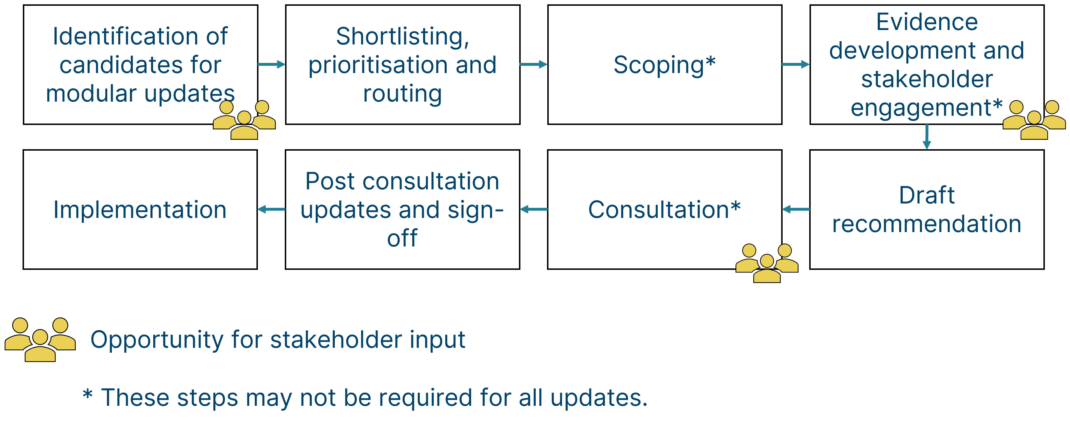

# Modular updates in progress

Table 1: Summary of modular updates in progress

| ****Title**** | ****Description**** | ****Progress**** |
| --- | --- | --- |
| Health inequalities | This methods update provided guidance on how to incorporate health inequalities considerations in technology evaluations. It focused on methods for measuring health inequalities, considering quantitative evidence of how health interventions affect these inequalities, and how best to use this evidence in decision-making. | Complete – updated health technology evaluations manual published in May 2025 |
| HealthTech programme process update 1 | This update will set out a unified process for NICE's HealthTech teams (formerly DAP, MTEP, IP) and clarify this for external stakeholders. This update will also provide updated methods guidance for Early Valuation Assessments (EVAs). | Post-consultation updates and sign-off. Consultation for this update is now closed and the wording for the update is being finalised. |
| HealthTech programme process update 2 | This update will provide further clarification and update to methods used for NICE HealthTech guidance. | Draft recommendation. Consultation for this update is currently estimated to take place in 2025. |
| EQ-5D-5L value set | This update will enable the adoption of the value set from the new UK valuation study for the EQ-5D-5L into NICE’s reference case. | Scoping. This update was prioritised in February 2025. |
| Surrogate endpoints | This update will provide updated guidance on how surrogate endpoints can be used in cost-effectiveness modelling. | Scoping. This update was prioritised in February 2025. |

# ­Look ahead

The 2025/26 modular updates selection round begins in June 2025. Stakeholders are invited to submit candidates for modular updates through an online form which will be made available for 2 months from mid-June 2025 to mid-August 2025 on the [NICE modular updates webpage](https://www.nice.org.uk/about/what-we-do/our-programmes/nice-guidance/modular-updates). Further detail on suggesting a modular update is available on the [NICE modular updates webpage](https://www.nice.org.uk/about/what-we-do/our-programmes/nice-guidance/modular-updates).

# Feedback

General feedback on modular updates and on this report can be provided to [modular_updates@nice.org.uk](mailto:modular_updates@nice.org.uk) but will not be responded to unless clarifications are needed. Any suggestions for modular updates sent to this address will not be actioned and should be submitted via the online form.