Integrated Performance Report (IPR)

Date reported:

7 July 2026

This report sets out:
- Performance against key performance indicators (KPIs) up to the end of May 2026
- A summary of key guidance topics published since the last board meeting
- An update on the current status of the corporate business plan projects
- A finance report for the end of May 2026.
Contents
1 Summary 4
2 Key guidance 5
3 Key performance indicators (KPIs) 6
3.1 Better guidance 6
3.2 Faster access 6
3.3 Stronger NICE 11
4 Corporate projects 12
4.1 Whole lifecycle approach 12
4.2 Planning and scheduling management 13
4.3 Knowledge transformation 14
4.4 Artificial intelligence and data 15
4.5 National HealthTech Access Programme (NHAP) 16
4.6 NICE / MHRA aligned pathway 17
4.7 Common commercial approach 18
4.8 NICE methods manual 19
4.9 Quality and safety 20
4.10 Leadership and culture 21
4.11 Communications 22
5 Finance report 23
5.1 Overview as at Month 2 (end of May 2026) 23
5.2 Analysis 23
6 Appendix A: Chart data tables 25

Summary
This report provides assurance to the NICE Board on delivery of the 2026/27 business plan. This shows that:  - 8 out of 12 of Key Performance Indicators (KPIs) are rated green  - 10 out of 11 corporate business plan projects are rated green  - Financial position rated amber: £0.9m year-to-date overspend but forecast to achieve breakeven position | 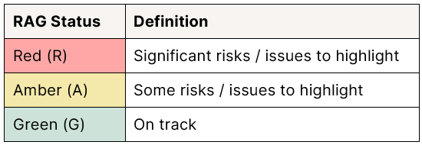

Key performance indicators: | 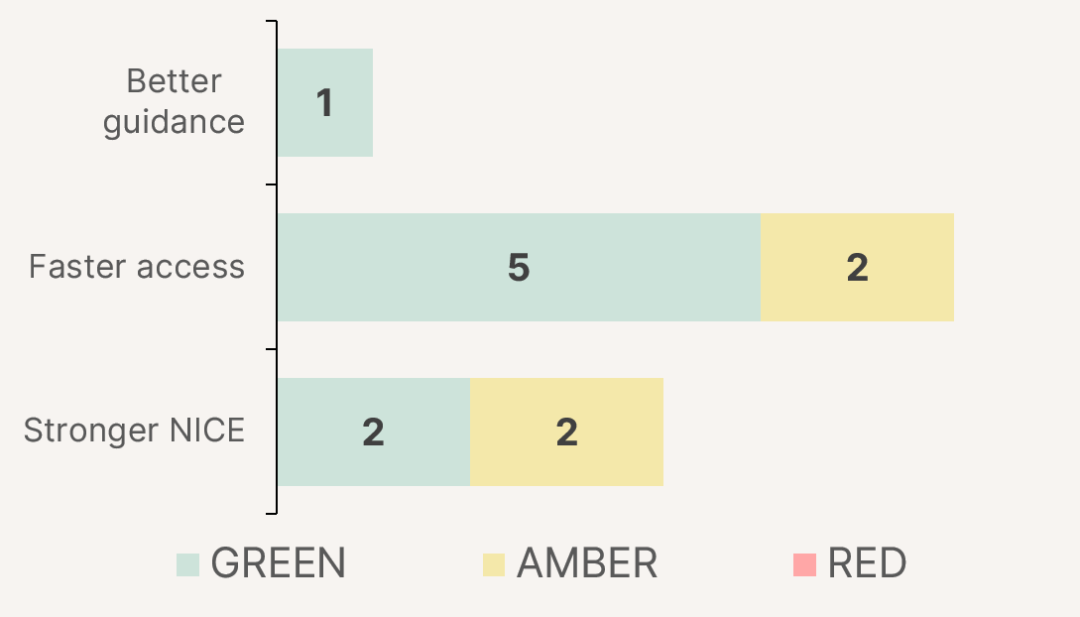
  Better guidance | - No post-publication corrects to guidelines in April – May.  - Guidance outputs continue to support faster access and improved outcomes (see section 2 for details)
  Faster access | - Guidelines and HealthTech on track to meet timeline targets  - Medicines evaluation timeline targets missed for April to May but expected to recover and meet annual target.
  Stronger NICE | - No confidentiality breaches reported in April or May.  - Finance and cyber resilience KPIs are amber

Corporate projects: | Whole lifecycle approach (G) | Planning and scheduling management (G) | Knowledge transformation (A) | Artificial intelligence and data (G) | National HealthTech Access programme (G)
MHRA aligned pathway (G) | Common commercial approach (G) | NICE methods manual (G) | Quality and safety  (G) | Future ready leadership and culture programme (G) | Communications (G)
Note: Project RAG status takes account of the progress, milestones and risks

Key guidance
Since the last board meeting, we have published several notable pieces of guidance that support faster access to innovative treatments, better outcomes for patients and more flexible care for families.
- We have issued new draft guidance recommending pregnancy-specific artificial pancreas technology for women with type 1 diabetes who are pregnant or planning a pregnancy, helping them maintain safer blood sugar levels for themselves and their baby.
- Our updated neonatal infection guidance could allow up to 12,000 babies a year to complete antibiotic treatment at home, where it is safe to do so, helping families leave hospital sooner while staying under neonatal team supervision.
- We have recommended mirvetuximab soravtansine, the first new NHS treatment in over 20 years for some women with platinum-resistant ovarian cancer, offering a targeted option where treatment choices have been limited.
- More than 1,500 people a year are set to benefit from durvalumab, the first immunotherapy recommended for an aggressive form of stomach cancer. Notably, NICE was able to use a simpler assessment process, which meant our guidance was published 17 days after MHRA approval, meaning patients will get access to the treatment faster than if the standard process had been used.
- We have published draft guidance recommending 4 liver preservation machines for routine NHS use, which could help the 600 people waiting for a life-saving transplant by keeping donated livers functioning outside the body for longer.

Key performance indicators (KPIs)

Better guidance
Indicator | Target (26/27) | Apr-May 26 | Status | 25/26 baseline | Commentary
Number of CfG outputs requiring post publication correction | 3 or less | 0 | Green | 3 | No post-publication corrections reported in April or May.

Faster access
Medicines
Indicator | Target (26/27) | Apr-May 26 | Status | 25/26 baseline | Commentary
Proportion of final guidance published within 240 working days of Invitation to Participate (ITP)  Note: this indictor only includes topics where final guidance has been published. | 60% | 100% | Green | 29% | NICE published final guidance has been on 9 topics where the ITP was issued after 1st April 2025.  All 9 were published within the 240 working days of the ITP being issued.  The proportion completed within the target timeframe will start to fall in the next few months but we are on track to meet the 60% target for 2026/27.
Mean time (calendar days) between marketing authorisation and NICE recommendation | 367 | 432 | Amber | 367 | Deterioration on last year (+65 days, 18% slower than 25/26 baseline)  KPI is rated amber due to the recent increase in average (mean) time to publish final guidance topics. This increase was driven by 7 exceptional cases, published in April and May that that have been in progress for more than a year.
Median time (calendar days) between marketing authorisation and NICE recommendation | 232 | 455 | Amber | 232 | Deterioration on last year (+223 days, 96% slower than 25/26 baseline)  KPI is rated amber due to the recent increase in average (median) time to publish final guidance topics. This increase was driven by 7 exceptional cases, published in April and May that that have been in progress for more than a year.
Number of medicines evaluation publications (excluding terminations and reviews) | n/a | 10 | n/a | 55 | -

Chart 1: Mean average time between marketing authorisation and NICE recommendation (medicines) 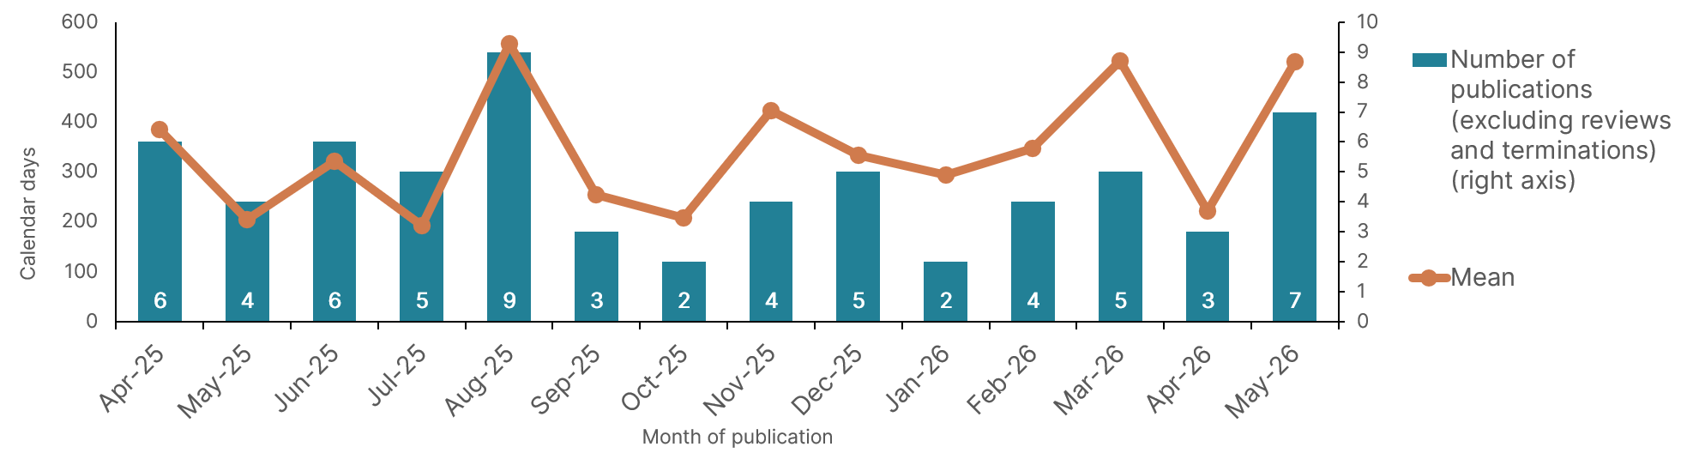
Chart 2: Median time between marketing authorisation and NICE recommendation (medicines)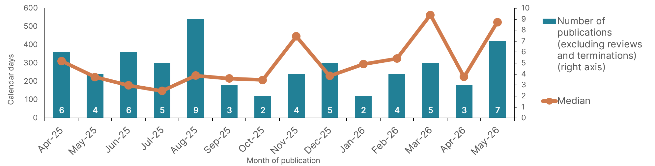
HealthTech
Indicator | Target (26/27) | Apr-May 26 | Status | 25/26 baseline | Commentary
Median number of working days taken for healthtech guidance production, from guidance initiation through to guidance publication | 212 | 210 | Green | 225 | Improvement on last year  (-15 days, 7% faster than 25/26 median)

Chart 3: Median number of working days for healthtech guidance production
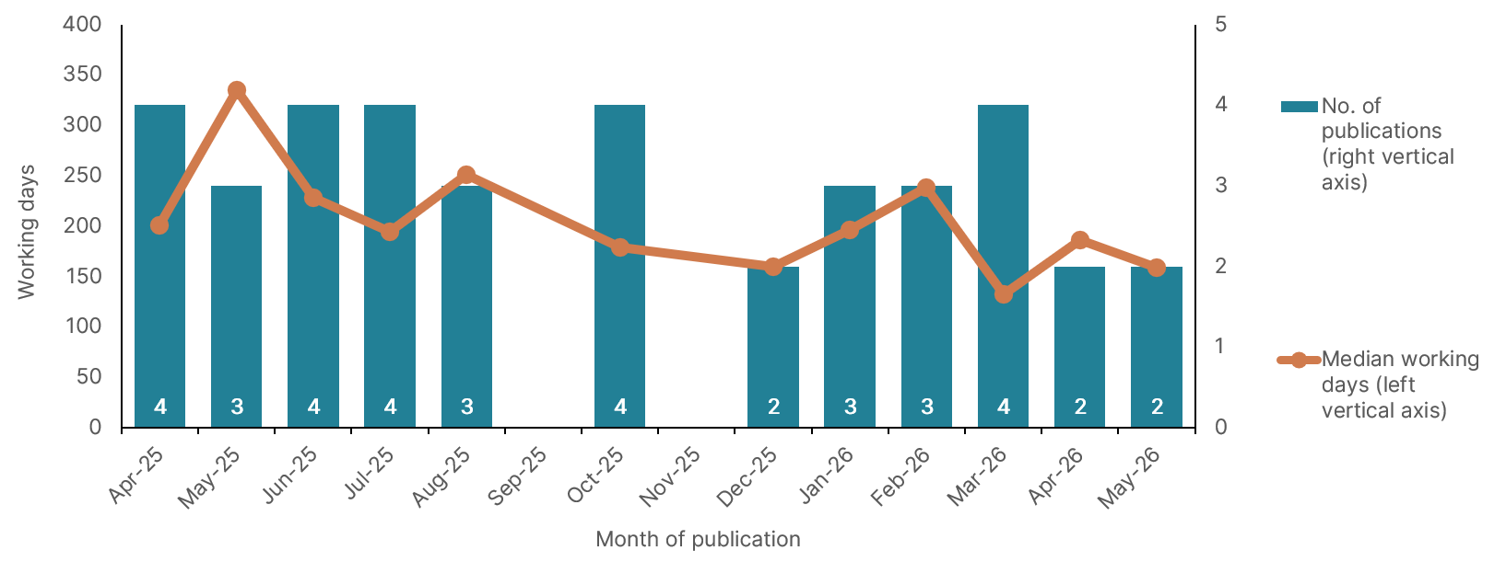
Guidelines
Indicator | Target (26/27) | Apr-May 26 | Status | 25/26 baseline | Commentary
Proportion of small guideline updates published within 154 working days of development starting | 70% | 100 | Green | 100% | Unchanged from last year  1 small guideline published in May and 5 in April. All published within 154 working days of development starting.
Proportion of medium guideline topics published within 286 working days of development starting | 60% | n/a | Green | n/a | No medium guideline topics published April to May 26.
Proportion of new guidelines or large guideline updates published within 396 working days of development starting | 50% | n/a | Green | n/a | No large guideline topics published April to May 26.

Stronger NICE
Indicator | Target (26/27) | Apr-May 26 | Status | 25/26 baseline | Commentary
Full-year financial deficit / surplus | Surplus < £1m, no deficit | Full year forecast = Breakeven | Amber | £0.32m surplus | KPI rated amber because of the year-to-date deficit (£0.90m). Focus on recovery of the income position and cost management controls will be required to achieve a breakeven forecast outturn.
Confidentiality Breaches (HealthTech) | 2 or less | 0 | Green | 1 | No commercial or academic confidentiality breaches between 1/4/26 and 31/5/26.
Confidentiality Breaches (Medicines) | 8 or less | 0 | Green | 8 | No commercial or academic confidentiality breaches between 1/4/26 and 31/5/26.
Cyber Resilience and preparedness score (incorporating cyber posture, business continuity & disaster recovery and sentiment measures). | Green | Amber | Amber | Amber | Composite score rated amber in May, based on the performance of 3 of the underpinning measures (including business continuity and training).

Corporate projects
Whole lifecycle approach | Status: | Green

Project overview
NICE is evolving towards a whole lifecycle approach (WLA) to guidance production to ensure it continues to provide the NHS with useful and usable guidance.

Highlights
Progress and achievements | Key next steps
- WLA definition for guidance production agreed  - WLA revised governance structure 26-27 agreed and being implemented  - WLA project plan for 26-27 agreed, including work with key dependencies. This includes monthly and quarterly monitoring arrangements  - Technology Appraisals (TAs) considered for incorporation into guidelines exceeding targets  - Proposal for 26-27 test cases at an advanced stage, including a systemic approach to capturing and sharing learning.  - Robust collaboration established with the methods manual/s and knowledge platform work  - Joint working with NHSE on Single National Formulary (SNF) commenced | - Develop a shared understanding of the approach to archiving guidance  - Consider the learning from TA incorporation work to date and how will inform business as usual  - Commence work on how best to evaluate off-patent medicines  - Plan the WLA stakeholder panel for 26-27, including a revision of Terms of Reference and membership  - Develop of a corporate WLA communications narrative and plan internal communication activity

Planning and scheduling management | Status: | Green

Project overview
The project will modernise planning and scheduling, strengthen digital maturity, streamline processes, and enable better integration of data and technology. It will create coherent, organisation-wide approaches that support effective decision-making and lay the foundation for a future unified planning and resourcing platform

Highlights
Progress and achievements | Key next steps
- The new Organisation & Contacts System is live for HealthTech and Medicines Evaluation; Centre for Guidelines (CfG) has migrated live topics and Quality Standards cutover is due 22nd June.  - Planner Premium proof of concept is complete, requirements are finalised and data migration options are agreed with each programme  - Data governance is established through Data & Taxonomy Oversight Group and the Data Quality Working Group  - Standard Operating Procedure development and a cross-programme improvement backlog is progressing. | - Develop new templates, incorporating the new business rules and process developments, with business change leads and subject matter experts  - Finalise business change and adoption activity into tailored work packages and identify any additional resources asks.  - Focus on benefits realisation to unlock capacity.  - Continue to work with Organisational Development to consider how we build change into roles with unlocked capacity.

Knowledge transformation | Status: | Amber

Project overview
The project will transform NICE’s knowledge products by replacing inconsistent structures and outdated technology with structured, machine-readable content and modern tools. This will make guidance easier to find, use and trust, and enable syndication into partner systems, including electronic health records.

Highlights
Progress and achievements | Key next steps
- Knowledge platform delivery is progressing in line with agreed scope for phase 1, with search functionality delivered and ongoing testing with internal users shaping development. All lung cancer guidance and a subset of type 2 diabetes and cardiovascular disease guidance have been successfully componentised and added to the knowledge graph (our new data model).  - Guidelines and publishing teams agreed approach to support collaborative, componentised guidance development in preparation for future ways of working.  - A NICE-owned CoPilot Agent has been created ahead of internal testing that will allow trusted, clinically safe access to NICE guidance at the point of need. | - Project reporting amber due to critical point in development and handover of agreed deliverables with AWS.  - Continue co-delivery of the Knowledge Platform phase 1 prioritised scope focusing on classification of new Lung Cancer, type 2 diabetes and cardiovascular disease component types; and integration of the Application Programming Interface (API) with the Componentised Content Management System (CCMS) for search. Component versioning and taxonomies will be explored in more depth in remaining weeks.  - Prepare for handover of minimal viable product into NICE platforms, ensuring appropriate knowledge transfer, training and documentation is in place to allow for onward iteration and maintenance by NICE teams.  - Finalise scope of the proposed authoring tool to proceed to build in phase 1a, subject to estimation, appropriate controls and funding.  - Opportunities prioritised for further proof of concept work to inform further transformation opportunities for guidance development innovation.  - Plan for implementing structured guidance in development
Artificial intelligence and data | Status: | Green

Project overview
A multi-year programme to build the technology and data foundations for swift, safe and successful AI adoption within NICE, deliver robust NHS-facing guidance on AI technologies and advance AI methods in health technology assessment (HTA). This will enable responsible innovation, strong governance, and coordinated regulation across NICE.

Highlights
Progress and achievements | Key next steps
Technology and data foundations  - Approach implemented to ensure data quality and standardisation for planning and scheduling  Evaluating AI technologies  - Draft approach to evaluating fast follower technologies developed  - Commissioned work on exploration of frontier AI completed  - Developed draft approach to evaluating productivity within existing framework  Advancing AI methods in HTA and guidelines  - Completed phase 1 of HTA Lab project The Future of HTA with AI – recommendations made for next steps of exploration.  - Initiated NICE Listens project to explore patient and public perceptions about the use of AI in HTA. | The AI and data project plan is under review and unified governance being established and will be in place for reporting in September IPR to board.  Technology and data foundations  - Co-pilot Premium licence rollout to all staff to support ways of working  Evaluating AI technologies  - Develop draft approach for evaluating dynamic AI technology  - Further develop approach for evaluating productivity as main value proposition  Advancing AI methods in HTA and guidelines  - Develop high-priority principles and use-cases for best-practice guidance on the use of AI in HTA evidence submissions (the NICE AI Methods for Evidence Framework).
National HealthTech Access Programme (NHAP) | Status: | Green

Project overview
A collaborative programme to maximise the impact of the National HealthTech Access Programme by aligning partners on evidence generation, commercial and implementation support, and resolving ecosystem challenges. This will strengthen NICE’s role and how it works within the wider healthtech landscape.

Highlights
Progress and achievements | Key next steps
- Reaffirmed commitment and recognition of NHAP with new senior leadership as a pivotal reform in the HealthTech ecosystem  - Gained approval from NHS England/NICE programme board for cross-partner governance on topic proposals and referrals for NHAP  - Work underway to identify potential NHAP topics for 26/27 with a view to launching at least 4 topics.  - Developed approach for obtaining national pricing from suppliers  - Delivery groups set up to consider implementation of topics | - Request ministerial referral of NHAP topics  - Capture lessons learned from first TAs and ensure they inform BAU approach  - Further streamline BAU topic selection approach  - Develop joint commercial principles

NICE / MHRA aligned pathway | Status: | Green

Project overview
The project aims to minimise delays in patient access to medicines through optional integrated scientific advice and improving alignment between MHRA regulatory decisions and NICE guidance publication.

Highlights
Progress and achievements | Key next steps
- Agreed 3 key areas for development during 26/27:  - Metrics – tracking Aligned Pathway topics and reasons for adherence to inform improvements  - Horizon scanning – improve how information gained through joint NICE/MHRA pipeline meetings links with other HS efforts  - Scoping – efficiencies to scoping process which will contribute to increase in number of potentially optimal topics | - Scoping efficiencies work starting in July 26  - Link with WLA on potential disease scoping work as will have impact on scoping efficiencies  - Comms process for same time publication topics  - 1st joint pipeline meeting of 26/27 in late June

Common commercial approach | Status: | Green

Project overview
NICE undertakes commercial activity and liaison to support its technology appraisal (TA) and Highly Specialised Technologies (HST) programmes. Following developments in the 10-year plan, there is an increasing need for this expertise to be applied to other guidance producing areas, including healthtech via the National HealthTech Access Programme, and guidelines via the Whole Lifecycle Approach (WLA)/Biosimilar Taskforce.

Highlights
Progress and achievements | Key next steps
- Medicines and Medical Devices (MMD) Access Initiative Horizon Scanning Advisory Board (10th June 2026)  - Biosimilar and Health Technology Assessment (HTA) workshop report sent to Medicines UK (28th May 2026)  - Biosimilar guidance product development project kicked-off internally within NICE  - Engagement in US-UK policy sprints which will include a number of short-term pilots and medium-term commitments  - Engagement with guidelines colleagues to provide support for the appropriate use of confidential pricing information | - Continue to engage in Biosimilar taskforce and undertake Continuous Quality Improvement (CQI) commercial workstream to address issues identified in HTA workshop report  - Develop biosimilar guidance process and identify potential candidates  - Continue to engage in US-UK policy sprints and (a) work to implement any pilots (b) support methodological development (c) engage on commercial framework update and 2028 VPAG  - Distribute MMD Access Horizon Scanning report and work on focus areas  - Discussion planned with HealthTech Senior Leadership Team (SLT) around initial learnings from NHAP topics and impact on BAU commercial support

NICE methods manual | Status: | Green

Project overview
Create a single, evidence-based NICE methods manual that unifies core methods across programmes, reduces inconsistency and inefficiency, and supports timely, sustainable guidance updates. We will take a user-led approach while accommodating necessary methodological differences and aligning with NICE’s wider knowledge transformation ambitions.

Highlights
Progress and achievements | Key next steps
- Terms of reference for project in place, working group and engagement group convened regularly and working as intended  - Work on exploring the application of the severity modifier in healthtech and guidelines (health economics and decision modelling team) ongoing  - Internal alignment workshops held, focusing on key areas for alignment (severity, health inequalities, sources for resource use and costs, and uncertainty in decision-making)  - Work on componentisation of content and split between process and methods ongoing with working group  - Legal advice sought on separation of process and methods and content componentisation  - User research work kicked off internally and through heatmaps externally | - Formally launch comms and stakeholder engagement plans  - Kick off targeted user research work (External Assessment Groups, committees and voluntary and community sector)  - Cross-organisational alignment agreement on key areas for alignment  - Continue work on componentisation of content and split between process and methods ongoing with working group

Quality and safety | Status: | Green

Project overview
The project has three main workstreams:
- Modern Service Frameworks (MSFs) - NHS England-led frameworks providing a 10-year blueprint for priority areas. There are 6 core themes identified: Cardiovascular disease, Sepsis, Severe mental illness, Frailty and dementia, End-of-life care and Children & young people. Several frameworks (e.g. CVD, sepsis) are awaiting ministerial sign-off or experiencing delays. NICE’s role is to provide evidence-based guidance aligned to MSFs and support implementation by identifying required new guidance and reviewing and updating existing outputs
- Patient safety work - Patient safety is a cross-cutting, ongoing function rather than a discrete project. NICE’s role is primarily responding to external signals and ensuring safety considerations are reflected in guidance. Governance arrangements include the patient oversight group and reporting to the NICE Prioritisation Board.
- Contribution to the NHS Quality Strategy - NICE has contributed to the NHS England Quality Strategy, now in final draft pending ministerial sign-off. The current phase considered largely complete, subject to potential changes during approval.

Highlights
Progress and achievements | Key next steps
- NICE has contributed to the NHS England Quality Strategy, now in final draft pending ministerial sign-off. The current phase considered largely complete, subject to potential changes during approval.  - All MSF topics have clinical leads assigned to them. The clinical directorate’s management team for MSFs tracks progress across all topics and this is shared across teams within NICE.  - The Patient Safety Team presented their safety update at the May 2026 Board meeting. | - The NHS England Quality Strategy is currently awaiting ministerial sign off.  - CVD and sepsis MSFs are awaiting ministerial sign-off. NICE’s role is to provide evidence-based guidance aligned to MSFs and support implementation by identifying required new guidance and reviewing and updating existing outputs.  - The next patient safety board paper will be presented in December 2026 – all on track.
Leadership and culture | Status: | Green

Project overview
This project will strengthen leadership capability and consistency, address siloed working, and build digital and system-working confidence. It aligns leadership development with the future operating model, cultural expectations, and 26/27 strategic priorities, enabling adaptive, accountable and psychologically safe leadership across the organisation.

Highlights
Progress and achievements | Key next steps
- Current state assessment completed across leadership, culture, learning and workforce capability activity.  - Future organisational capability framework developed, aligning leadership, workforce, skills and culture priorities  - People Strategy design underway to provide a coherent approach to workforce, leadership and capability development.  - Leadership Academy model and future learning pathways developed.  - Early delivery underway through values, engagement and listening activity. | - Finalise and launch the Leadership and Organisational Capability Framework.  - Establish baseline measures for leadership effectiveness, culture and future skills capability.  - Launch the first NICE Leadership Academy cohorts.
Communications | Status: | Green

Project overview
A project to develop and deliver a three-year, organisation-wide communications strategy that clarifies and promotes NICE’s evolving role, ensuring consistent messaging, stronger system influence, and a confident workforce. This will reduce reputational risk and support organisational success during a period of significant transformation.

Highlights
Progress and achievements | Key next steps
- Final draft of three-year communications and engagement strategy developed and shared with approval from Board in May 2026.  - Digital content strategy refresh launched with Communications Directorate  - Development of core narrative and internal communications and engagement plan for NICE 2029 strategy refresh  - Continued events progress including successful delivery of NHS ConfedExpo plans and procurement of NICE conference partner underway  - Directorate development and improvement plan drafted and socialised with support from People team  - Mid-year reputational research ‘dip’ launched with key stakeholders  - Launch of second phase of NICE’s Healthtech marketing campaign  - Developing overarching narrative and key messages explaining our WLA ambitions | - Agreement of strategic engagement framework at NICE Executive Team (ET) and implementation / testing of new approach alongside stakeholder mapping  - Development of refreshed brand strategy underway, considering value proposition, tone of voice and internal relaunch  - Delivery of expanded media and spokesperson training for senior leaders  - Implementation of digital communications improvements including website homepage redesign  - Business continuity and crisis communications plans reviewed and updated

Finance report

Overview as at Month 2 (end of May 2026)
Spend category (Revenue) | YTD budget (£000) | YTD actual (£000) | YTD variance (£000) |  | Annual budget  (£000) | Forecast outturn  (£000) | Forecast variance  (£000)
Pay | 11,387 | 11,444 | 58 |  | 68,746 | 67,859 | (887)
Non-Pay | 4,075 | 3,962 | (113) |  | 23,819 | 25,206 | 1,387
Planned additional budget cover | 0 | 0 | 0 |  | 1,039 | 0 | (1,039)
Total expenditure | 15,462 | 15,406 | (56) |  | 93,604 | 93,085 | (539)
TA-HST income | (2,333) | (1,777) | 556 |  | (14,000) | (14,000) | (0)
NICE Advice income | (757) | (471) | 286 |  | (4,638) | (4,260) | 377
Other operating income | (1,700) | (1,583) | 116 |  | (9,925) | (9,764) | 161
Total operating income | (4,790) | (3,832) | 958 |  | (28,563) | (28,024) | 539
Total net expenditure | 10,672 | 11,575 | 903 |  | 65,041 | 65,041 | 0

Analysis
- The current full-year forecast is for a breakeven position at year-end. This is subject to several risks and dependencies, including income performance and the timing of planned expenditure.
- Year-to-date, the organisation is reporting a £0.9m overspend, primarily driven by under-recovery of operating income from TA/HST Fees (£0.6m) and NICE Advice (£0.3m). While some recovery is anticipated later in the year, income delivery remains a key risk to the overall financial position. Expenditure budgets are currently within plan and this is forecast to continue. The full-year forecast non-pay overspend primarily relates to restructuring costs; however, we made a provision in the 2025/26 accounts relating to this and it is expected that DHSC will provide budget cover to offset the impact on RDEL budgets.
- To reduce the risk of year-end deficit, we are taking steps to control costs, including careful management of headcount and expenditure, and action to mitigate the impact of income under-performance.

Appendix A: Chart data tables
Data table 1: Number of KPIs by RAG status
Aim | GREEN | AMBER | RED | Total
Stronger NICE | 2 | 2 |  | 4
Faster access | 5 | 2 |  | 7
Better guidance | 1 |  |  | 1
All KPIs | 8 | 4 | 0 | 12
Data table 2: Average time between marketing authorisation and NICE recommendation (medicines) and number of publications (excluding reviews and terminations)
Measure | Apr-25 | May-25 | Jun-25 | Jul-25 | Aug-25 | Sep-25 | Oct-25 | Nov-25 | Dec-25 | Jan-26 | Feb-26 | Mar-26 | Apr-26 | May-26
Median | 311 | 224 | 178 | 148 | 232 | 216 | 208 | 446 | 230 | 294 | 325 | 563 | 225 | 524
Mean | 385 | 204 | 322 | 193 | 557 | 254 | 208 | 423 | 334 | 294 | 347 | 522 | 222 | 521
Number of publications | 6 | 4 | 6 | 5 | 9 | 3 | 2 | 4 | 5 | 2 | 4 | 5 | 3 | 7
Data table 3: Median number of working days for healthtech guidance production and number of publications
Measure | Apr-25 | May-25 | Jun-25 | Jul-25 | Aug-25 | Oct-25 | Dec-25 | Jan-26 | Feb-26 | Mar-26 | Apr-26 | May-26
Median working days | 201 | 335 | 228 | 194 | 251 | 179 | 160 | 197 | 238 | 132 | 187 | 159
No. of publications | 4 | 3 | 4 | 4 | 3 | 4 | 2 | 3 | 3 | 4 | 2 | 2

60% target applies to topics with an ITP issued since 1st April 2025.
25/26 performance (29%) reflects the proportion of medicines evaluation final guidance published in 25/26 that was published within 240 working days of the ITP being issued.

