Board meeting

22 July 2025

HealthTech manual update

Purpose of paper

For approval

Board action required

The Board is asked to:

* Consider this manual update and approve it for public consultation
* Delegate to Guidance Executive approval of any subsequent changes to the manual post-consultation and response to consultation comments.

Brief summary

Over the last few years, NICE has transformed its approach to HealthTech and this new manual consolidates the programme developments in design, methods and processes for public consultation. In July this year, we published the first section of the new HealthTech manual that introduced many improvements including our lifecycle approach to evaluation, merging three programmes to one HealthTech programme and setting multi-tech cost-effectiveness evaluation as standard.

This second section of the HealthTech manual includes an updated methods section for HealthTech guidance and methods for assessing HealthTech products in existing use (‘late stage assessment’ [LSA]). Both sections will integrate into the recently published HealthTech manual and replace current placeholder sections (and an interim statement for LSA guidance).

Board sponsor

Mark Chapman, Director of Medical Technology

Nick Crabb, Chief Scientific Officer

Introduction

HealthTech products and interventional procedures can offer significant benefits to patients, such as a quicker diagnosis, faster recovery, and reduced risk. They also have the potential to improve efficiency, such as by streamlining patient flow, tailoring treatments to an individual, and reducing hospital admissions.

HealthTech is vital to delivering the 3 big shifts needed in the NHS, as outlined by government this year: from hospital to community; from analogue to digital; and from treating sickness to prevention.

In light of advances in life sciences and technology, and the different demands on the NHS, NICE has simplified its approach to HealthTech assessment and strengthened its partnership working to enable greater flexibility in assessment and increase its ability to respond to the needs of the NHS and patients.

The new manual describes the methods and processes that NICE follows when evaluating interventional procedures and HealthTech products. The methods and processes are designed to produce robust guidance for the NHS in an open, transparent and timely way, with appropriate contribution from stakeholders.

Background

Updated Methods section

An overarching goal was to provide a simpler methodological outline for companies with little or no HTA experience, with reference to where greater detail can be found in other NICE manuals where appropriate. This should allow greater anticipation of assessment and evidentiary needs for guidance, with a greater focus on HealthTech specific issues.

Key points set out in the proposed manual text are:

* Greater detail on the scoping process, in terms of identifying and articulating value propositions (which can be extremely varied for HealthTech), how technologies are selected for inclusion in scopes (for multiple technology assessments), outcomes selection (including use of outcome prioritisation where needed) and how decisions are made about what lifecycle guidance (early, routine, established) will be produced.
* Greater detail on approaches that can be used when selecting studies for inclusion in reports and when economic models cannot capture the full potential impact of technologies (the value proposition) in cost effectiveness estimates. This includes assessing potential impacts on system efficiencies and capacity.
* The manual also includes specific provisions for digital or AI technologies that rapidly iterate over time, in terms of how guidance can be better future proofed.
* The section on recommendations also includes greater detail on considerations for multiple technologies.
* The manual also sets out requirement to better indicate evidence requirements for newer technologies that become available after guidance is issued, and potentially how HealthTech guidance may be able to inform commissioner considerations about phased roll out of technologies recommended for large populations (for example, pharmacogenomic tests).

Technologies in existing use (Late-stage assessment)

Late stage assessment guidance has been developed as a pilot project using an [interim methods and process statement](https://www.nice.org.uk/about/what-we-do/late-stage-assessment-for-medtech). This includes a statement that: “Learnings from the initial assessments will inform the final design of LSA, which will then be published in a final manual after consultation.”

LSA guidance has now been published, and internal and external after-action reviews (AARs) are in progress. Feedback from the AARs will be used alongside comments received during the consultation to finalise the manual post-consultation.

For late stage assessment manual content, key points set out in the proposed manual text are:

* The manual better links to element of the routine methods for HealthTech that are relevant for LSA (and elements of routine methods have been strengthened in areas highly relevant for LSA). Greater detail on modelling and suggestions for useful analyses is provided (based on experience from the pilot topics).
* Greater emphasis is placed on considering factors which fall outside cost effectiveness estimates.
* The above point includes greater detail on User Preference work that can be done alongside conventional assessment work.
* Recommendation wording reflects what has been developed and agreed as part of the pilots.

Future development

At consultation on the first section of the HealthTech manual, several stakeholders expressed disappointment about the lack of update to methods, and strong opinions that further work was needed to ensure NICE’s approach was suitable for HealthTech. In the Board paper (May 2025 Board meeting; item 9), we stated that: “This new manual sets out the foundations for the HealthTech programme and is the first step in an ongoing iterative process to set out in greater detail the process and methods to be used by the NICE HealthTech programme. Further work to add clarity to methods approaches will be developed in the coming year and form part of an update to the manual following consultation.”

This update to the manual strengthens the methods we use in response to many of the consultation comments. A focused piece of development to continue furthering methods for evaluating HealthTech will also start this business year.

NICE has been working with system partners on the Rules Based Pathway to agree a mechanism to ensure that HealthTech products evaluated through the pathway would be subject to mandatory funding. The Rules Based Pathway is included in the NHS 10-year plan. The agreed funding mechanism to deliver this pathway is through the Technology Appraisal recommendations with associated funding requirement. The existing manual used for Technology Appraisals, PMG36, will therefore provide the processes and methods to develop guidance on HealthTech with mandated funding through the rules-based pathway. We intend to review the PMG36 manual and identify any necessary updates to methods and processes to develop Technology Appraisals for HealthTech. We anticipate bringing the proposed updates to the PMG36 manual to the Board in September.

An overview of manual activities and indicative timescales are shown in figure 1.

**Figure 1 Overview of HealthTech manual activities**

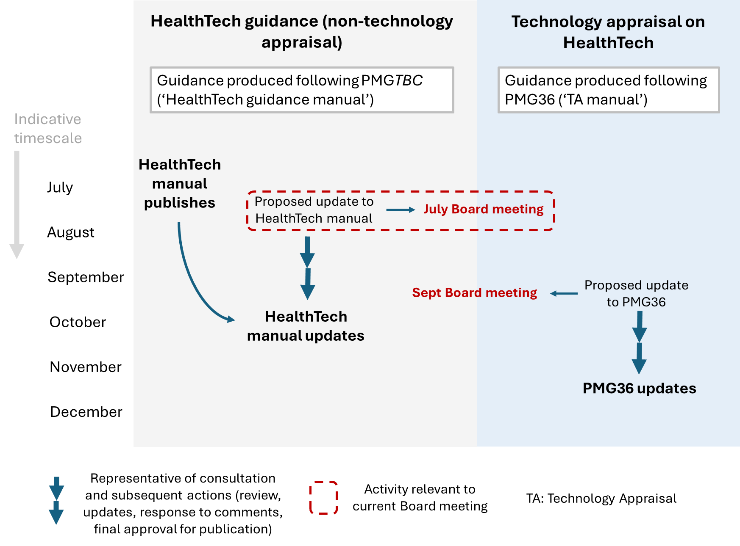

Next steps

Subject to approval, this manual will be released for public consultation for 4 weeks.

Clear communications will be provided for stakeholders to explain our approach to the manual update and an implementation plan will be developed for enacting the changes operationally.

Following consultation, and conditional on addressing consultation comments received, we aim to finalise and publish the final manual as quickly as possible to allow the new processes and methods to be used to develop guidance this 2025/26 business year. To this end, we are proposing that the Board delegates to Guidance Executive approval of any subsequent changes to the manual post-consultation and response to consultation comments to avoid a delay in guidance delivery. An update on the final manual and feedback from consultation will be provided to the Board for information in December.

Cross organisational impact

To prevent any duplication of, or inconsistency with other NICE manuals, minor amendments to PMG36 (‘CHTE manual’) and PMG28 (Interventional Proceedures manuals) are proposed. Some interim documents which will be superseded by the HealthTech manual are also proposed for archiving:

* LSA interim process and methods statement
* Interim addendum on access proposals (from the defunct diagnostics assessment programme).

Board action required

The Board is asked to:

* Consider this manual update and approve it for public consultation
* Delegate to Guidance Executive approval of any subsequent changes to the manual post-consultation and response to consultation comments.

© NICE 2025. All rights reserved. [Subject to Notice of rights](https://www.nice.org.uk/terms-and-conditions#notice-of-rights).

July 2025