Board meeting

11 December 2024

Annual report on patient safety

Purpose of paper

For information and assurance

Board action required

The Board is asked to note the progress reported and planned next steps

Brief summary

This report sets out NICE's role in, and approach to, patient safety. It summarises key progress over the past year and outlines plans to develop NICE's role in patient safety over the coming year to ensure that an effective safety management system (SMS) is in place across the organisation. These steps have been designed to align with, and support the delivery of, the 'what matters most' and creating 'useful and usable advice' strategic objectives of the organisation.

Board sponsor

Professor Jonathan Benger, Chief Medical Officer, Interim Director of the Centre for Guidelines and Deputy Chief Executive

Introduction

1. This report sets out NICE's approach to its role in patient safety and how it interacts with the wider system to address shared safety challenges. The report illustrates how NICE has considered arising safety issues over the past year, where these have implications for NICE and its products. The report also presents work being done to maintain and evolve effective safety oversight across the organisation whilst NICE has undergone its transformation journey.

Background

1. Patient safety is an intrinsic part of the NHS definition of quality in healthcare, alongside effectiveness and patient experience. The NHS has been implementing a Patient Safety Strategy[1] that is set within a health and care landscape of rapid innovation and evolution. As we strive to improve patient outcomes and meet user needs in the context of rising demand for health and care services, the rapid adoption of new care models and emerging products and technologies (particularly digital), pose risks and challenges to maintaining patient safety. These require an effective oversight approach to safety and risk management.
2. NICE is part of a system involving multiple bodies and agencies with varying roles and degrees of influence over patient safety. In 2020, research found at least 17 statutory regulators with a specific remit for patient safety overseeing healthcare institutions, professionals, and clinical procedures. There are also two agencies overseeing the management of medical products and a host of other regulators that operate across all industries to manage hazardous substances and practices such as radiotherapy. NICE is one of more than 100 organisations including HSSIB, Royal Colleges and professional bodies that might exert an influence on the NHS through their regulatory or non-regulatory actions and activities.[2] Whilst NICE doesn’t issue safety-specific recommendations in the same way as bodies that have a safety-specific role, it can be an important enabler for safety through its evidence-based guidance, its influence and its reputation.
3. NICE has important relationships with a variety of bodies that have a safety-specific role, including the Medicines and Healthcare Products Regulatory Agency (MHRA), the Health Services Safety Investigations Body (HSSIB), the Care Quality Commission (CQC) and the Maternity and Newborn Safety Investigations Programme (MNSI).
4. Since our last report to the Board, a new Labour government has come into office with ambitions to reduce waiting lists and improve access to healthcare and treatments whilst ensuring patient safety.
5. Whilst it is early in the life of the new government, it has signalled an intention to improve patient safety in areas including: closing the Black and Asian maternal mortality gap which was highlighted by the work of the Women and Equalities committee last year[3], establishing a Royal College of Clinical Leadership and implementing the recommendations of the Cass Review[4].
6. High-profile investigations and public inquiries into patient safety are ongoing including the Thirlwall Inquiry, to which NICE has submitted a body of requested evidence for consideration, and the investigation into maternity care at Nottingham Hospitals led by Donna Ockenden. The rollout of Martha’s rule, an initiative to improve the identification of deterioration in patients with the involvement of critical care outreach, patients and their families and carers is in a pilot phase across over 140 healthcare Trusts.
7. NICE continues to receive a high volume of patient safety signals and issues from a variety of sources, including Coroner’s report recommendations, HSSIB-issued recommendations, MHRA-issued safety alerts and issues at a system-level. It is expected by partner organisations to contribute towards the development of solutions.
8. Within NICE, patient safety is led by a Patient Safety Oversight Group aiming to deliver a cross-organisational programme. Currently based in the Clinical Directorate, it is strengthening the integration of patient safety considerations into broader clinical leadership and governance across the organisation.

NICE’s role in patient safety

NICE approved the introduction of a cross-Institute patient safety function in September 2021, led by a senior responsible officer (SRO) for patient safety[5]. The SRO leads the Patient Safety Oversight Group (PSOG) whose membership includes key directorates across NICE including the Clinical Directorate, Centre for Guidelines, Centre for Health Technology Evaluation, Office for Digital Health, Science, Evidence and Analytics, Partnerships and Communications (see Figure 1).

**Figure 1. Patient Safety Oversight Group core representation by function**

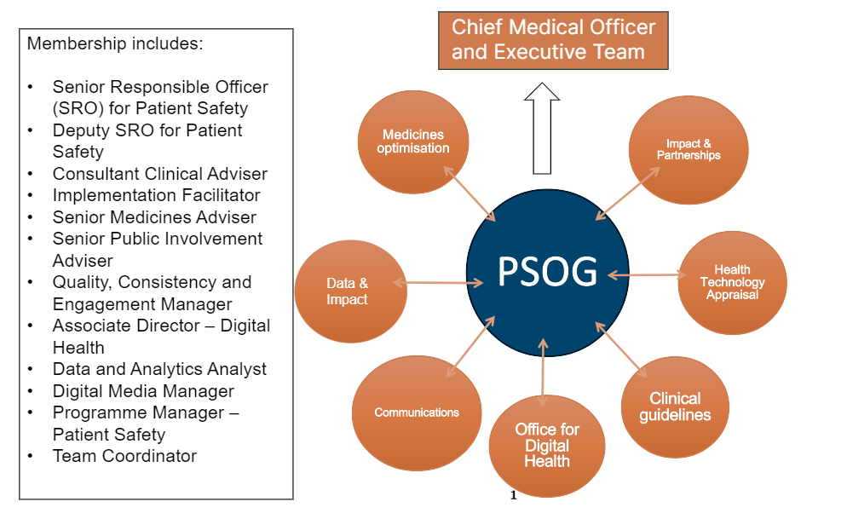

The group provides strategic leadership to NICE's patient safety approach, ensuring safety issues are considered in all NICE products. The work of the oversight group includes, but is not limited to:

* Supporting the development of NICE guidance to ensure that safety considerations are appropriately considered and integrated across the work of the Institute.
* Ensuring that NICE is part of a learning healthcare system by considering how new developments such as real-world evidence, data access and artificial intelligence should be utilised by NICE to enhance patient safety.
* Responding to formal safety recommendations and alerts from the Health Services Safety Investigations Body (HSSIB) and other relevant bodies such as the Medicines and Healthcare Products Regulatory Agency (MHRA).
* Providing specialist advice to develop the response to safety issues raised in Regulation 28 "Prevention of Future Death" reports from HM Coroner and overseeing the completion of any associated actions required by NICE programmes in response to these reports.

1. The group interconnects via its members with other workstreams within NICE and the wider healthcare system to ensure that patient safety is a core consideration. Whilst the oversight group provides strategic leadership to NICE’s patient safety role and approach, it is incumbent on all NICE staff and programmes to have due regard and consideration for patient safety in all areas of the business. PSOG continues to have an awareness-raising role to promote this message across NICE.
2. Whilst NICE does not have a regulatory role in patient safety, PSOG aims to ensure that patient safety is considered throughout the development of NICE guidance. As outlined in this report, we inform and support wider patient safety activities in health and social care led by other bodies, providing feedback to NICE where those activities affect or might affect our guidance products.

NICE’s patient safety model aims to support a system that (i) prevents errors, (ii) learns from the errors that do occur and (iii) builds a culture of safety through collaboration between healthcare professionals, organisations and patients.

### Progress against 2023 objectives

1. In our 2023 report to the Board, we set out our priorities for the coming year.

* Supporting the ambition of the 'what matters most' agenda by closely integrating intelligence-gathering, external engagement and specialist advice functions into the development of systems to: “Increase the relevance of our guidance by developing a practitioner-led, NICE-wide horizon scanning and topic selection function enabled by coordinated stakeholder engagement”.
* Supporting the 'useful and useable advice' objective by contributing to the identification of solutions to patient safety challenges and providing expert specialist clinical input to the development of advice where this can address key patient safety concerns.
* Using the cross-Institute nature of its work to interface with the strategic ambition of learning from data and implementation - to ensure future advice from NICE reflects the latest safety-related learnings from real world information and data.

To achieve against these ambitions, the patient safety team is committed to;

* Embed consideration of patient safety within key NICE guidance development and implementation support processes, reporting identified risk where appropriate such as to the NICE Prioritisation Board and Guidance Executive.
* Develop NICE's relationships with the external safety system, particularly with the MHRA, CQC, and HSSIB, whilst also undertaking a time-limited exchange placement of safety personnel with the latter, to improve organisational understanding of respective processes.
* Ensure that patient safety intelligence is captured and considered within the development of the unified topic selection and prioritisation process
* Ensure that the membership of the PSOG continues to reflect the organisation as a whole.

Over the past year the patient safety team has worked collaboratively to ensure patient safety is a consideration in the assessment and decision-making stages of topics routed through NICE’s single topic selection and prioritisation process. In addition, we have worked closely with newer programmes within NICE, specifically Early Value Assessment (EVA), to support them in building an effective consideration of patient safety issues and risks into their process, ensuring that these are reflected in the monitoring requirements of evidence-generation plans supporting individual EVA products.

Benefitting from closer links between teams in the Clinical Directorate, we have worked to refine and align processes between PSOG and the Medicines Optimisation and Guideline Surveillance teams. This allows better triage and assessment of incoming safety signals such as MHRA Drug Safety Updates and clinically significant medicines supply issue notifications that require input from NICE. A cross organisational medicines safety process has been developed and implemented to underpin this approach. Several MHRA Drug Safety Updates have had a significant impact and required updates to NICE guidance. Examples include new restrictions for [fluoroquinolone antibiotics,](https://www.gov.uk/drug-safety-update/fluoroquinolone-antibiotics-must-now-only-be-prescribed-when-other-commonly-recommended-antibiotics-are-inappropriate) [topiramate](https://www.gov.uk/drug-safety-update/topiramate-topamax-introduction-of-new-safety-measures-including-a-pregnancy-prevention-programme) and [sodium valproate use in men.](https://www.gov.uk/drug-safety-update/valproate-use-in-men-as-a-precaution-men-and-their-partners-should-use-effective-contraception" \l ":~:text=Drug%20Safety%20Update-,Valproate%20use%20in%20men%3A%20as%20a%20precaution%2C%20men%20and%20their,neurodevelopmental%20disorders%20in%20their%20children.)

Members of PSOG are working collaboratively with the [Interventional Procedures Guidance](https://www.nice.org.uk/about/what-we-do/our-programmes/nice-guidance/nice-interventional-procedures-guidance) (IPG) team within NICE and with Professor Jane Blazeby from Bristol Medical School in research[6] which found wide variation in approaches to surgical governance in the NHS. The outcome of this project is the development and implementation of an enhanced governance model for new procedures in hospital settings, including appropriate referral to NICE where a new procedure might require assessment by the IPG team.

We have refreshed the membership of PSOG to keep pace with the evolving structure of the organisation so that key NICE programmes have an input to relevant safety-related discussions. This has included adding representatives from the medicines optimisation team, digital health, CHTE and the people and communities involvement teams to the group.

We have developed an effective relationship with the new Health Services Safety Investigations Body (HSSIB), underpinned by a two-way exchange of personnel for fixed-term periods to better understand each organisation’s processes for safety investigations and guideline and advice development respectively.

Recently we formally updated HSSIB on the positive progress we have made in our clinical guidelines programme against a range of HSSIB safety recommendations made to NICE over recent years. Such recommendations often require the surveillance team to review evidence and the guidelines team to update or clarify guideline recommendations based on the outcome of the surveillance review, where they can support improvement action against safety risks identified by HSSIB.

**Figure 2. Patient Safety key external engagement**

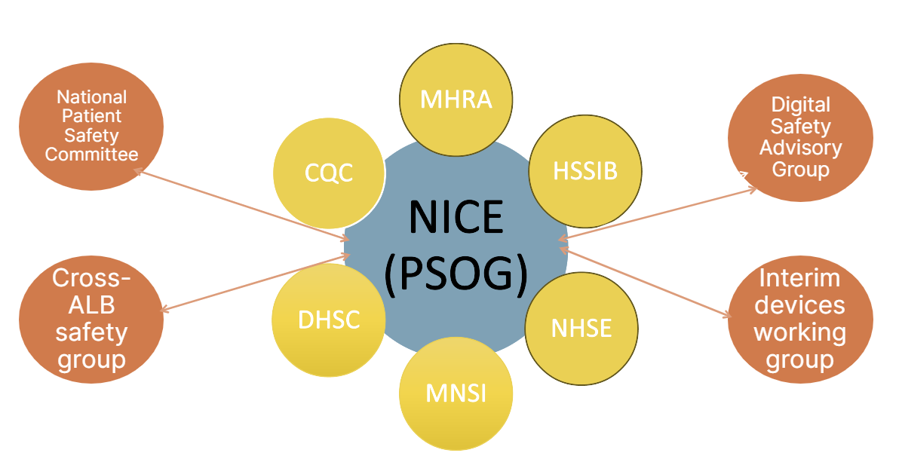

NICE doesn’t issue safety-specific recommendations to the health and care system in the same sense as other public bodies who have a specific, focused regulatory or non-regulatory role in ensuring patient safety. In this context and recognising NICE’s role as an important enabler towards safety, such as through application of its national guidance, we continue to engage with existing and new partners on patient safety, and have made particular progress in establishing an effective intelligence sharing relationship with the new Maternity and Newborn Safety Investigations team, based within the CQC, as well as establishing links with the wider CQC safety policy team.

We have also worked collaboratively with the safety and learning team at NHS Resolution to support development of their resources aimed at reducing safety risks in key areas of litigation. NICE is represented on several cross-system safety-focussed groups alongside partners, including the National Patient Safety Committee, chaired by Dr Aidan Fowler, National Clinical Director for Patient Safety. NICE is also contributing to cross-system work, led by HSSIB and reporting to the National Quality Board, on the development of a common safety language in recommendations while improving the effectiveness of their implementation.

NICE receives a high volume of prevention of future death (Regulation 28) reports from HM Coroners annually. In 2023/24, 25 reports were received and responded to by NICE. The patient safety team work collaboratively with the NICE enquiries team to assess the issues raised and recommendations made by coroners to NICE, and develop responses to these. Where issues raised by a coroner require a coordinated response across more than one body, NICE has engaged constructively with external partners to identify solutions and the appropriate follow-up actions.

The patient safety team also assigns follow-up actions required in response to issues raised to the appropriate developer teams within NICE, primarily the guideline surveillance team and more recently the NICE Prioritisation Board. NICE’s thematic analysis and suggestions for broader system improvement to learning from Regulation 28 reports has been published in the peer-reviewed Journal of Patient Safety and Risk Management[7]. The team has also given evidence on this subject to the Justice Select Committee’s Inquiry into the effectiveness of the Coronial Service, and exchanged best practice information on report handling with the Regulation 28 lead team at the Department of Health and Social Care.

The breadth and increased frequency of the activities described above has required a significant increase in the time devoted to safety related activities by members of the patient safety oversight group. This is not always recognised in an individual’s job plan, and will be addressed during future appraisals and career conversations, thereby supporting ambition four of NICE’s business plan to build an organisation as brilliant as the people in it.

### Introducing a Safety Management System (SMS)

1. The HSSIB has introduced [the concept of a Safety Management System (SMS)](https://www.hssib.org.uk/patient-safety-investigations/safety-management-systems/investigation-report/) for healthcare adoption in England. If implemented, this will help to address inconsistencies in language and methodology towards safety management across healthcare. An SMS working group has been established, led by NHS England, to look at how such a model could be realised across the NHS at a provider-level. Arms-length bodies in healthcare such as NICE are also encouraged to consider how this SMS as a concept would apply to their ways of working.
2. An SMS is a proactive and integrated approach to managing safety. It sets out the necessary organisational structures and accountabilities and is subject to continuous improvement.
3. It requires safety management to be integrated into an organisation’s day-to-day activities. There is no one-size-fits-all SMS, however there are four recognised areas associated with many SMS frameworks. These are safety policy, safety risk management, safety assurance and safety promotion.

**Figure 3. Key components of a safety management system**

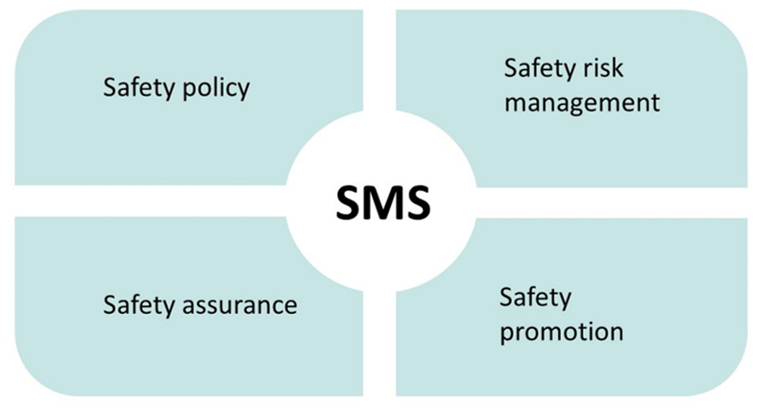

Although NICE does not deliver frontline care, the SMS conceptual model provides a useful framework to ensure we are taking the right oversight approach to managing safety considerations, and identify where we might usefully focus our activities.

Safety policy defines the way the system needs to be organised to meet safety goals. NICE regularly and meaningfully engages with stakeholders across the system who all provide it with a different perspective on what is needed to make the health and care system safer for patients. NICE engaged with key safety stakeholders on its process for integrated topic prioritisation and safety considerations have been built into this approach since it became operational.

Safety risk management is the identification of hazards (things that could cause harm) and risks (the likelihood of a hazard causing harm) and the mitigation of risks. NICE has established mechanisms for responding to safety updates, for example from the MHRA by assessing the implications, if any, that hazards and risks presented in MHRA safety alerts may have on NICE guidance. This may trigger surveillance reviews that help to identify how patient safety risks can be mitigated through updates or amendments to NICE guidance.

Safety assurance involves monitoring safety performance and evaluating the effectiveness of risk controls. In a NICE context, this could be translated as the need for the inclusion of safety indicators, wherever appropriate, during assessment and evidence generation, development of recommendations, and monitoring requirements given to manufacturers of technologies, particularly where new innovation is occurring and the evidence base remains unclear or immature, and where there are known safety risk factors.

Safety promotion involves actions to support a positive safety culture. At NICE we have utilised new communication channels such as having a range of safety-related speakers from HSSIB, MHRA, NHSR and MNSI at NICE’s Clinical Network, regular blogs on NICE Space, PSOG members guest speaking at various team meetings and a cross-Institute all-staff meeting to promote a positive safety message, reinforcing the importance of engagement and alignment with our external partners and the need for everybody at NICE to consider how clinical safety might apply in their everyday work.

We will define how the conceptual SMS model can be applied to NICE and adapt Westrum’s organisational culture model to ensure NICE maintains the proactive approach to safety it is now taking. We will support NICE to become a truly generative organisation in terms of its safety culture and approach to safety considerations more generally. This includes creating and promoting a culture of psychological safety where NICE colleagues feel empowered to raise safety-related issues within their respective programmes. There are best practice approaches for promoting psychological safety among staff, such as that used by Merseycare NHS Foundation Trust, and PSOG has met with colleagues at NICE experienced in this work to better understand how to apply such an approach.

Figure 4. Adapted version of Westrum's typology of organisational culture model (2003)

A diagram visualising an organisational culture model for improving patient safety consideration.

The model includes 5 steps:
1) Pathological: why waste our time on patient safety?
2) Reactive: We take safety seriously and respond when there is an incident.
3) Bureaucratic: We have systems in place to manage risks, respond to incidents and collect data.
4) Proactive: We are always on the lookout for emerging risks and try to anticipate and mitigate problems before they occur.
5) Generative: Patient safety is an integral part of everything we do. We synthesise information from different sources to improve systems continuously. 

Steps we can take to advance this goal include:

* Clearly defining and communicating the boundaries between NICE’s responsibilities towards safety with those that have statutory duties on healthcare safety such as the MHRA and CQC.
* Ensuring that PSOG and its membership continues to keep pace with the changing nature of NICE and its programmes of work.

### Patient Safety Priorities for 2025/26

* We will work with the MHRA to define and implement a process for earlier engagement on arising safety issues. Where safety updates from the MHRA may have an implication for NICE guidance, we will work to ensure our products align with the latest safety advice in as timely a way as possible.
* We will work with external partners including DHSC and HSSIB to advance ways of better learning from prevention of future death reports at a system-level and contribute to the development of mechanisms to achieve this.
* We will define how the SMS can be adapted for a non-patient facing organisation such as NICE and applied within the organisation, including an assessment of any resource impact this may have.
* We will continue to support the embedding of a proactive safety culture within NICE through effective engagement with NICE programmes, offering tailored support where required to ensure safety considerations are built into all processes for the development of NICE products and services.
* We will continue to engage proactively with external stakeholders and partners on patient safety, ensuring that NICE remains an active and constructive partner in arriving at solutions to arising safety concerns and issues.

Cross organisational impact

Staff from across NICE who contribute to the work of PSOG should have the cross-organisational nature of this work recognised in their job role.

This will be progressed with relevant PSOG members over the coming year and captured in future annual appraisals, career conversations and updated role descriptions.

Risk assessment

The team considered potential risks and concluded that this paper does not propose new or substantive changes to current arrangements. Any risk is therefore negligible.

Board action required

The Board is asked to:

* 1. Note the progress made by the patient safety team over the past year.
  2. Note the planned steps for further development of NICE's patient safety role, in alignment with NICE's strategic objectives.

© NICE 2024. All rights reserved. [Subject to Notice of rights](https://www.nice.org.uk/terms-and-conditions#notice-of-rights).

December 2024

1. NHS England. Patient Safety Strategy. Reviewed 2021. Available online at: <https://www.england.nhs.uk/patient-safety/the-nhs-patient-safety-strategy/> (Accessed online 27/09/24)
2. Vincent C, Oikonomou E, Carthey J, Macrae C. Redesigning safety regulation in the NHS BMJ 2020;368:m760 doi: 10.1136/bmj.m760
3. Women and Equalities Select Committee, House of Commons. Black Maternal Health Third Report of Session 2022–23. Available online at: https://committees.parliament.uk/publications/38989/documents/191706/default/
4. [Cass Review – Independent Review of Gender Identity Services for Children and Young People](https://cass.independent-review.uk/)
5. Southall S, Patrick H, Harris K, Bird C. Introducing a systematic and sustainable patient safety oversight function in a U.K. arms-length healthcare body. *Journal of Patient Safety and Risk Management*. 2024;0(0). doi:[10.1177/25160435241282044](https://doi.org/10.1177/25160435241282044)
6. Sian Cousins, Hollie S Richards, Jez Zahra, Harry Robertson, Johnny A Mathews, Kerry N L Avery, Daisy Elliott, Natalie S Blencowe, Barry Main, Robert Hinchliffe, Adrian Clarke, Jane Blazeby, Healthcare organization policy recommendations for the governance of surgical innovation: review of NHS policies, *British Journal of Surgery*, Volume 109, Issue 10, October 2022, Pages 1004–1012, <https://doi.org/10.1093/bjs/znac223>
7. Southall S, Tariq A, Patrick H, Harris K, Bird C. A thematic analysis of National Institute for Health and Care Excellence responses to coroners’ concerns’. *Journal of Patient Safety and Risk Management*. 2023;28(5):222-226. doi:[10.1177/25160435231202597](https://doi.org/10.1177/25160435231202597)