Board meeting

21 September 2023

Annual report on patient safety

Purpose of paper
For assurance and information.

Board action required
The Board is asked to note the progress reported and planned next steps.

Brief summary
This report set out NICE's role in, and approach to, patient safety. It summarises key progress over the past year and outlines plans to develop NICE's role in patient safety over the coming year. These steps have been designed to align with and support delivery of the 'what matters most' and creating 'useful and usable advice' strategic objectives of the organisation whilst also continuing to build on the recommendations from the Independent Medicines and Medical Devices Safety Review (the Cumberlege report).

Board sponsor
Professor Jonathan Benger, Chief Medical Officer

Introduction
This report sets out NICE's approach to its role in patient safety and how it interacts with the wider system to address shared challenges. The report illustrates how NICE has considered safety issues arising over the past year, where these have implications for NICE and its products.

Background
Patient safety is an intrinsic part of the NHS definition of quality in healthcare, alongside effectiveness and patient experience. The NHS is implementing a Patient Safety Strategy that is set within a health and care landscape of rapid innovation and evolution. As we strive to improve patient outcomes and meet the challenge of reducing the backlog in services caused by the COVID-19 pandemic, the rapid adoption of new care models, products and technologies, requires effective oversight of safety and risk management.
The UK Government has established the role of a national patient safety commissioner with the ambition of establishing lasting system change in patient safety culture envisaged by the Independent Medicines and Medical Devices Safety Review (IMMDS) recommendations. The commissioner has called for a single national reporting system, replacing multiple existing systems, to improve patient safety.
The role of the national Healthcare Safety Investigation Body (HSIB) is evolving, with its maternity safety functions transferring to the Care Quality Commission (CQC). In October 2023, HSIB will be formally established in statute as the Health Services Safety Investigation Branch (HSSIB) with strengthened authority to set safety recommendations to which organisations will be required to respond.
A report by Donna Ockenden on the safety of maternity services at Shrewsbury and Telford Hospitals made national recommendations for essential action – underpinned by NICE guidance for local maternity systems. A further investigation on maternity and neonatal care safety at East Kent Hospitals led by Dr Bill Kirkup has recently highlighted challenges around workforce and the need for training. A rapid review of maternity safety at Nottinghamshire Hospitals led by Donna Ockenden is also underway.
The government is continuing to implement actions from its response to the independent inquiry that was set up following the conviction of surgeon Ian Paterson.
The Health and Social Care Select Committee has drawn attention to chronic workforce shortages in a number of areas of NHS care including maternity, which are a risk to patient safety.
The Care Quality Commission (CQC) has proposed a new inspection model to offer a greater focus on safety and harm reduction in healthcare delivery and will include future inspection of all maternity units. The model will replace current inspection methods in 2023.
The DHSC has published the UK's inaugural medical technologies strategy. In May 2023, the MHRA set out the future of medical device regulation in the UK.
A number of key partner organisations in the patient safety ecosystem have undergone changes in personnel including a new interim chief investigator at HSIB and new chief inspectors and deputies at the CQC, and the temporary merger of some posts. Team structures in a number of partners including CQC and the MHRA are also undergoing considerable change.
In January 2023, NICE appointed a permanent Chief Medical Officer, bringing clinical leadership to NICE's work programmes within a new Clinical Directorate that was formally established in April 2023. Patient safety has moved from Implementation and Partnerships to the new Clinical Directorate, strengthening the integration of patient safety considerations into broader clinical leadership and governance across the organisation.

NICE's role in patient safety
Recognising this complex and rapidly evolving landscape, and NICE’s role as an integral part of the health and care system, NICE approved the introduction of a cross-Institute patient safety function in September 2021, led by a senior responsible officer (SRO) for patient safety. The SRO leads the Patient Safety Oversight Group (PSOG) whose membership includes key directorates across NICE including Centre for Guidelines, Science, Evidence and Analytics and Communications.
The group gives strategic leadership to NICE's patient safety approach, ensuring safety issues are considered in all NICE products. The work of the oversight group includes, but is not limited to:
- Supporting the development of NICE guidance to ensure that safety considerations are appropriately considered and integrated across the work of the Institute.
- Ensuring that NICE is part of a learning healthcare system by considering how new developments such as real-world evidence, data access and artificial intelligence should be utilised to enhance patient safety through NICE guidance and related activities.
- Reviewing NICE’s implementation of agreed Actions for Improvement (AfI) as set out in the Government’s response to the Independent Medicines and Medical Devices (IMMDS) review and reporting back to the Department for Health and Social Care on NICE’s progress.
- Responding to formal safety recommendations from the Healthcare Safety Investigation Branch (HSIB) and other relevant bodies such as NHS Resolution (NHSR) and the Medicines and Healthcare Products Regulatory Agency (MHRA).
- Reviewing NICE’s progress against safety-related actions required in response to Regulation 28 "Prevention of Future Death" reports from HM Coroner.

The group interconnects with other workstreams within NICE and the wider healthcare system to ensure that patient safety is a core consideration.
NICE’s patient safety model aims to support a system that (i) prevents errors, (ii) learns from the errors that do occur and (iii) builds a culture of safety through collaboration between healthcare professionals, organisations and patients.
The activities delivered by PSOG are detailed in Figure 1.

Figure 1: Key activities of the patient safety model
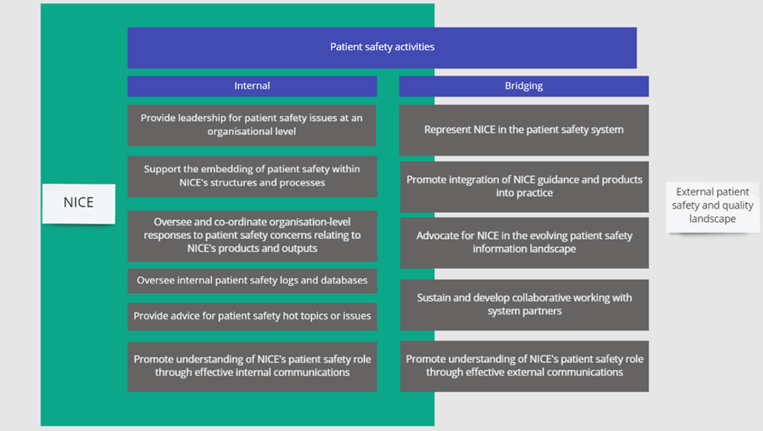
The model is delivered through a small core patient safety team consisting of an SRO and Deputy SRO, a programme manager, supported by a part-time coordinator. The team also draw on ad hoc support from a specialist public health registrar and/or clinical fellow on placement with NICE.

Governance
The safety team reports to the Chief Medical Officer and Executive Team (ET). Ultimate responsibility for patient safety matters affecting NICE remains with the Chief Executive.
When necessary, the SRO will also escalate issues to the CMO, relevant programme directors, ET, or directly to the Chief Executive.

Progress against objectives and issues arising
Over the past year, the patient safety team have been working towards three priorities whilst continuing to align efforts with the broader strategic objectives of NICE:
- Operationalising and embedding the safety model in NICE's standard practices and working culture
- Deepening and strengthening strategic partnerships with other key bodies and groups in the external patient safety system
- Communicating and engaging both internally and externally to embed NICE's role in patient safety.

These priorities underpin an ambition to build for safety at NICE, moving beyond a position of solely responding to risk.

Operationalising the safety model
The safety model has been operationalised with allocated resource. The SRO is currently covered by an interim arrangement, and recruitment is planned for a permanent replacement in autumn 2023. The issue of protected resource for the SRO and Deputy SRO are being addressed currently by the CMO. The CMO has joined the PSOG and is the executive team sponsor of patient safety at NICE.
Since the establishment of PSOG, and referencing an adapted for safety version of Westrum's organisational culture theory model (Figure 2), we can report that NICE has broadly moved beyond being an organisation that is purely reactive to safety issues, however further development is required to become a truly proactive organisation that is continuously horizon-scanning for emerging risks and mitigating these.

Figure 2. Adapted version of Westrum's typology of organisational culture model (2003)
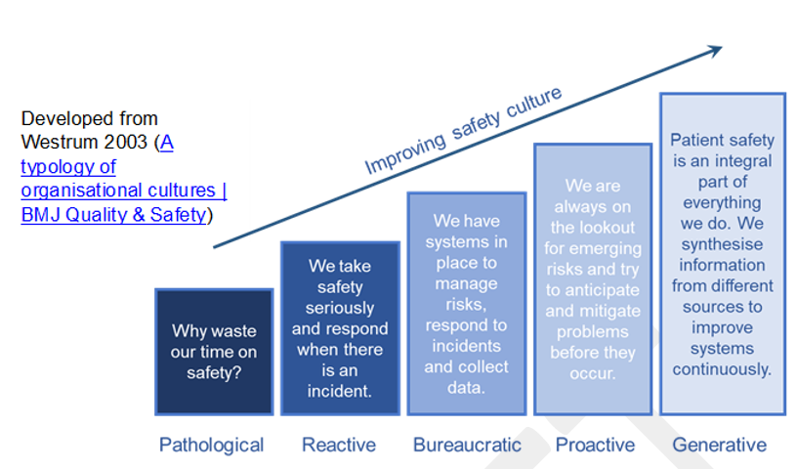
Since it became operational in September 2021, cross-NICE representation on PSOG has benefited from the addition of an implementation support team representative. This has strengthened the group’s ability to consider where implementation support may help to address arising patient safety issues. It also provides a feedback loop for relevant safety intelligence, to inform decisions made by the implementation team on which guidance topics would benefit from additional support.
The PSOG includes a Science, Evidence and Analytics representative with awareness of key developments in the healthcare data and analytics environment that inform the group's work. The group also benefits from close links to the Managed Access and Early Value Assessment programmes, providing specialist advice to these teams on how best to capture safety-related data in evidence generation plans where the evidence is currently immature or incomplete, and also links to the Interventional Procedures Advisory Committee (IPAC) where there is a strong focus on patient safety. The group would benefit from CHTE representation to strengthen its ability to oversee how the organisation responds to safety signals such as recommendations in MHRA Drug Safety Updates where these have implications for published technology appraisals, or those in development.
Over the past year the team have supported the timely response to nine Regulation 28 reports as well as a number of ad hoc requests from coroners at the pre-inquiry stage to better understand how NICE guidance would apply in the circumstances of specific cases that they are investigating.
The PSOG also leads NICE's engagement with HSIB which involves providing specialist input to HSIB's safety investigations where the scope of these cover published NICE guidance, or where their recommendations may suggest the need for new or updated guidance in a particular topic area.
Over the past year PSOG has supported 7 HSIB investigations and agreed the response to three formal and one informal HSIB safety recommendations to NICE, all of which required a guideline surveillance review. The PSOG monitors progress against the actions NICE commits to in response to HM Coroners and HSIB, and has a mechanism to feedback on progress to HSIB. We are actively exploring how to put in place a similar arrangement for HM Coroners.

Strengthening external relationships
Relationships and working arrangements to share upstream intelligence and collaborate on projects have improved across a number of partners. Particular progress has been made in NICE’s relationship with HSIB where it interacts extensively on a range of HSIB's safety-focussed investigations. In 2023 both organisations will undertake a reciprocal short-term exchange of staff to further enhance our understanding of each other's processes and how we can most effectively work together to address key safety issues.
Collaborative work with the GMC has produced a range of clinical case scenarios in key safety areas, including the appropriate prescribing of sodium valproate in primary care. Lines of communication have improved with safety teams at MHRA, Maternity Transformation, NHS Resolution and the national safety team at NHS England.
NICE is represented by the CMO on the National Patient Safety Committee, hosted by NHS England and led by the National Clinical Director for Patient Safety. Its membership provides an opportunity for NICE to engage at a system-level alongside partners in collaborative efforts to address key safety issues as they arise. As an example of work undertaken during the past year, NICE has addressed key safety concerns relating to variation in total bilirubin measurement across different analyser methods used in pathology services by making an editorial change to the relevant NICE Guideline, updating the implementation support tool and raising the issue with relevant partners including the MHRA.
Whilst these efforts provide good foundations, PSOG will continue to develop partnership arrangements with MHRA and CQC around patient safety issues.

Communicating NICE's role in patient safety
Communicating NICE's role both internally and externally is important to drive engagement and awareness of the patient safety model and how both internal teams and external partners can interact with it.
Internally, the team have published a number of NICE Space blogs, attended team meetings in different directorates to promote the approach and also posted a summary of the role and suggested ways to develop it further during the crowdsourcing exercise that NICE undertook in autumn 2022. The crowdsourcing idea secured positive support and good engagement from staff across NICE.
Since joining the Clinical Directorate, further opportunities have arisen to raise awareness through directorate communication channels and the November 2023 Clinical Network meeting will have a patient safety theme led by Dr Rosie Benneyworth, Interim Chief Investigator at the Healthcare Safety Investigation Branch (HSIB) who is a key external partner to the patient safety programme at NICE.
Future submissions are planned to ISPOR Europe, World Patient Safety Day and World Evidence-Based Healthcare Day.
A collaboration between NICE, Bristol Medical School and the Health Research Authority has produced a suggested best practice model for effective governance arrangements managing the introduction of new interventions in hospitals. It would also serve as a useful prompt to support implementation of NICE Interventional Procedures guidance. The model was presented at the BMJ's Quality and Safety in Healthcare conference in May 2023 and a pilot project is in development to implement the model across NHS acute trusts in England.

Developing NICE's patient safety approach for the future
As NICE evolves to meet its strategic objectives, to remain an effective patient safety-focused organisation, our model will evolve further. This will include undertaking work in the following areas:
- Supporting the 'what matters most' agenda by closely integrating its intelligence-gathering, external engagement and specialist advice functions into the development of systems to deliver the golden bar to: “Increase the relevance of our guidance by developing a practitioner-led, NICE-wide horizon scanning and topic selection function enabled by coordinated stakeholder engagement”.
- Supporting the 'useful and useable advice' objective by contributing to the identification of solutions to patient safety challenges and providing expert specialist clinical input to the development of advice where this can address key patient safety concerns.
- Using the cross-Institute nature of its work to interface with the strategic ambition of learning from data and implementation - to ensure future advice from NICE reflects the latest safety-related learnings from real world information and data.
To achieve against these ambitions, the patient safety team will:
- Embed consideration of patient safety within key NICE guidance development and implementation support processes, reporting identified risk where appropriate such as to the NICE Prioritisation Board and Guidance Executive.
- Develop NICE's relationships with the external safety system, particularly with the MHRA, CQC and HSIB, whilst also undertaking a time-limited exchange placement of safety personnel with the latter, to improve organisational understanding of respective processes.
- Ensure that patient safety intelligence is captured and considered within the development of the unified topic selection and prioritisation process.
- Ensure that the membership of the PSOG continues to reflect the organisation as a whole.

The patient safety team will report progress against agreed objectives annually to the Executive Team and NICE Board.

Cross organisational impact
Staff from across NICE who contribute to the work of PSOG should have the cross-organisational nature of this work recognised in their job role.
This will be progressed with relevant PSOG members over the coming year and potentially captured in future annual appraisals and updated role descriptions.

Risk assessment
The team considered potential risks and concluded that this paper does not propose new or substantive change to current arrangements. Any risk is therefore negligible.

Board action required
The Board is asked to:
  - Note the progress made by the patient safety team over the past year
  - Note the planned steps for further developing NICE's patient safety role, in alignment with NICE's strategic objectives.

© NICE 2023. All rights reserved. Subject to Notice of rights.
September 2023

