Modular updates 2026 – progress and look ahead report

Introduction
A modular update is a review of the methods or processes (or both) that inform NICE’s guidance. It is limited to a specific subject area and may result in an update to NICE’s manuals.
The modular updates framework is designed to ensure that NICE’s methods and processes are flexible and responsive to changes in the health and care landscape. It also promotes consistency in how our methods and process manuals are updated, and provides a structured mechanism for prioritising updates in the areas that matter most. It allows external stakeholders to contribute, including by identifying candidates for modular updates and shaping the content of updates, which helps to ensure that NICE’s manuals meet users’ needs. The latest version of the framework can be accessed on the modular updates page of the NICE website.
The process for identification of candidate modular updates takes place annually, linked to the NICE business planning cycle. NICE limits the number of modular updates it selects and actively works on each year, based on capacity.
Following feedback and learning from the first two rounds of applying the modular updates framework, updates have been made to ensure it is appropriate, proportionate and meets the needs of NICE and our stakeholders. Notably, the modular updates selection and oversight panel (MSOP) now recommends candidates for modular updates, with prioritisation taking place during the business planning process to better reflect NICE’s strategic and resourcing considerations. This means that some candidates for modular updates recommended by the MSOP may not be prioritised for delivery. In addition to candidates suggested by stakeholders, NICE may prioritise modular updates needed to deliver business priorities or to reflect changes to how NICE operates.
This document reports on modular updates in progress and summarises their progress against the steps in the modular updates framework, shown in Figure 1.
Figure 1: Steps involved in the modular updates framework
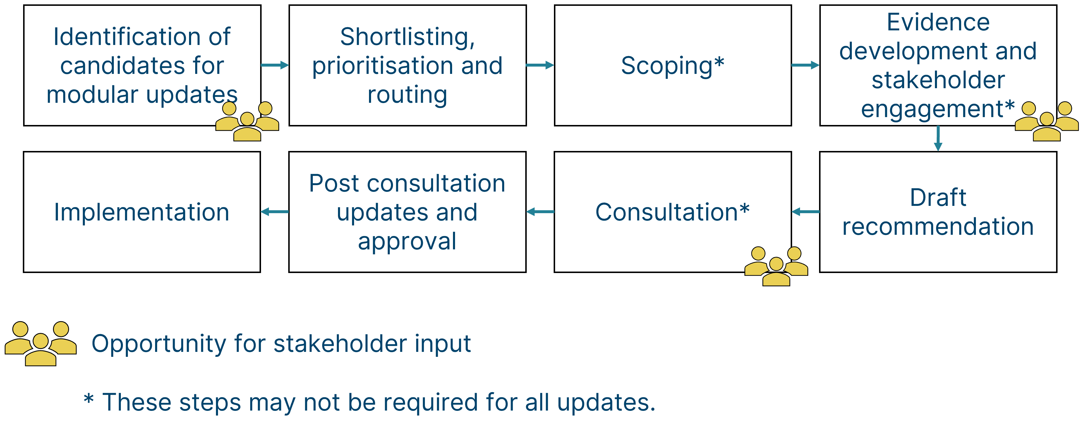

2025 modular updates round
The candidates suggested by stakeholders in 2025 were considered by the MSOP in meetings on 15 September 2025 and 8 December 2025. The minutes from these meetings, summarising key decisions and actions, is available on the NICE modular updates webpage.
MSOP considered a shortlist of 3 candidates at the 8 December 2025 meeting and recommended 2 modular updates:
- Carer health-related quality of life: This update will provide updated guidance on when and how carer health-related quality of life should be incorporated into economic analyses. This modular update was prioritised and work will begin in 2026/27.
- Capacity/system efficiency: This update will consider how benefits not captured in economic modelling could be assessed, quantified and incorporated into evaluations and how committees will consider these outcomes in decision-making. This update was recommended by MSOP but was not prioritised during business planning. This update will be considered again during the 2026 MSOP meetings.
Additionally, MSOP approved the restarting of work on the surrogate endpoints modular update, that had been paused earlier in 2025. See table 1 for more information.

Modular updates in progress
Table 1: Summary of modular updates in progress
Title | Description | Progress as of April 2026
EQ-5D-5L value set | This update will enable the adoption of the value set from the new UK valuation study for the EQ-5D-5L into NICE’s reference case. | Consultation for this update took place between 15 April and 27 May 2026.
Funding variation requests | This update will set out NICE's updated process outlining how it considers and approves funding variation requests. | Consultation for this update will take place between 11 May and 19 June 2026.
Developing NICE guidelines: the manual updates | This update will reflect recent organisational changes within NICE. | These updates are due to be published in the manual during 2026.
Carer health-related quality of life | To provide updated guidance on when and how carer health-related quality of life should be incorporated into economic analyses. | Work on this update will start in 2026/27.
Surrogate endpoints | This update will provide updated guidance on how surrogate endpoints can be used in cost-effectiveness modelling. | This update has been restarted during 2026/27.

Completed modular updates
Table 2: Summary of completed modular updates
Title | Description | Progress as of April 2026
Health inequalities | This methods update provided guidance on how to incorporate health inequalities considerations in technology evaluations. |  | Complete
HealthTech programme updates | This update provided a unified process for NICE's HealthTech teams (formerly DAP, MTEP, IP) in the HealthTech programme manual and updated guidance on methods for Early-use and Existing-use HealthTech. | Complete
HealthTech guidance in PMG36 | The NICE technology appraisal and highly specialised technologies guidance manual was updated to reflect that a separate HealthTech programme manual now exists. | Complete
Thresholds | This update increased the thresholds that NICE can use in technology appraisals to £25,000 - £35,000 per quality-adjusted life year gained. | Complete

Look ahead
The 2026 modular updates selection round begins in June 2026.
Stakeholders are invited to submit candidates for modular updates through an online form which will be made available for 2 months from mid-June 2026 to mid-August 2026 on the NICE modular updates webpage. Further detail on suggesting a modular update is available on the same page.

Feedback
General feedback on modular updates and on this report can be provided to modular_updates@nice.org.uk but will not be responded to unless clarifications are needed. Any suggestions for modular updates sent to this address will not be actioned and should be submitted via the online form.

