Board meeting

10 December 2025

Annual report on patient safety

Purpose of paper
For information and assurance

Board action required
The Board is asked to note the progress reported and planned next steps and to alert the authors if they consider that there are any areas of NICE work relevant to patient safety that need further consideration.

Brief summary
This report sets out NICE's role in, and approach to, patient safety. It summarises key progress over the past year, and outlines priorities for NICE's role in patient safety over the coming year. These priorities have been designed to align with and support the delivery of our strategic objectives to produce timely, high-quality guidance that is relevant and useable and our delivery ambitions, aligned to the NHS 10-Year Plan.

Board sponsor
Professor Jonathan Benger, Chief Medical Officer and Deputy Chief Executive

Introduction
- This report sets out NICE's approach to its role in patient safety and how it interacts with the wider system to address shared safety challenges. The report illustrates how NICE has considered arising safety issues over the past year, where these have implications for NICE and its products. The report also presents work being done to maintain and evolve effective safety oversight across the organisation as new programmes and functions emerge.

Background
- Patient safety is an intrinsic part of the NHS definition of quality in healthcare, alongside effectiveness and patient experience. As we strive to improve patient outcomes and meet user needs in the context of rising demand for health and care services, the rapid adoption of promising new treatments and emerging products and technologies (particularly digital), pose risks and challenges to maintaining patient safety. These require an effective oversight approach to safety and risk management where the safety profile of some NICE assessments is higher.

- NICE is part of a system currently involving multiple bodies and agencies with varying roles and degrees of influence over patient safety. To date, NICE has been one of more than 100 organisations including, MHRA, Care Quality Commission (CQC), Health Services Safety Investigations Body (HSSIB), Royal Colleges and professional bodies that might exert an influence on the NHS through their regulatory or non-regulatory actions and activities. Whilst NICE doesn’t issue safety-specific recommendations in the same way as bodies that have a safety-specific role, it can be an important enabler for safety through its evidence-based guidance, it’s influence and its reputation.

- The NHS 10-Year Health Plan prioritises patient safety through structural reforms, digital transformation, and cultural shifts. It aims to simplify and streamline the patient safety landscape, making it easier for patients, carers, and staff to navigate and influence the system.

- The plan has been informed by the review of patient safety across the health and care landscape, produced by Dr Penny Dash. This focused on six organisations that were established to either assure or contribute to improving the safety of care, while also making reference to the wider landscape of organisations influencing quality of care.

- NICE is recognised in the Dash Report as a contributor to setting standards for care, and its influencing role in the quality landscape.

- Whilst acknowledging serious, successive safety-related incidents in the delivery of NHS care, the NHS 10-Year Plan and Dash Report refer to a regulatory ‘tsunami’ producing a large number of safety recommendations from multiple safety-related bodies and successive public inquiries, in an uncoordinated way and without implementation funding in support.

- The 10-Year Health Plan positions safety as a sub-theme of quality alongside efficiency, equity, patient and user experience. This quality agenda will be led and overseen by an enhanced National Quality Board (NQB), of which the NICE Chief Medical Officer is a standing member.

- The Dash Report recommends the National Quality Board (NQB) apply a requirement to see the likely benefit, cost and cost-effectiveness of safety recommendations before they are prioritised for implementation. This will underpin the development by NQB of a strategy to improve quality of life and ensure resources are allocated to maximise life expectancy and quality of life.

Key structural reforms to safety under the 10-Year Plan and Dash Report include:
- Standing down HSSIB as a separate safety investigations entity and incorporating their functions as a descrete independent investigation function within the CQC.
- Enhancing the role and remit of the NQB to include assessment and approval of topics for safety investigation. A repository for safety recommendations will inform the NQB’s work and be hosted by DHSC.
- Moving the Patient Safety Commissioner into the MHRA with the aim of improving linkage between patient voice and the safety of medicines and medical devices.
- Healthwatch England and the specific patient safety commissioner’s functions (related to patient experience) will be merged under a new National Director of Patient Experience, hosted within DHSC.
- The government has commissioned a national maternity safety inquiry, to work at pace and with interim findings by the end of 2025 and recommendations by Spring 2026. This will include synthesising the findings and recommendations of all other maternity-facing reviews to recommend one set of national actions to drive the improvements needed to ensure high quality care.
- A Maternity and Neonatal taskforce will be established and chaired by the Secretary of State for Health and Social Care, to inform the development of a new maternity and neonatal action plan, which government will co-produce with bereaved families.
- These reforms highlight the importance of work by the Patient Safety Oversight Group to collaborate with colleagues across healthcare to ensure that NICE output is informed by, and informs the work of organisations working more directly on patient safety assurance.

NICE’s role in patient safety
- NICE approved the introduction of a cross-Institute patient safety function in September 2021, led by a senior responsible officer (SRO) for patient safety. The SRO leads the Patient Safety Oversight Group (PSOG) whose membership includes key directorates across NICE including the Clinical Directorate, Centre for Guidelines, Centre for Health Technology Evaluation, Office for Digital Health, Science, Evidence and Analytics, Partnerships and Communications (see Figure 1).
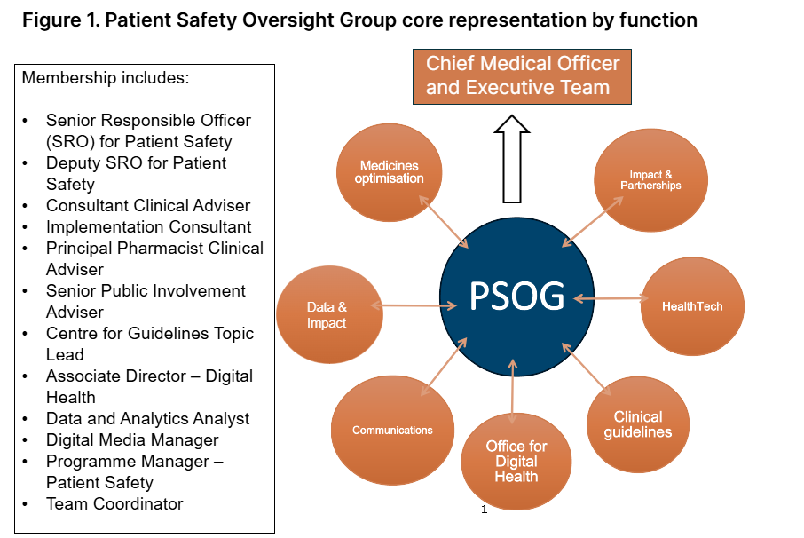
- Based within the Clinical Directorate, the group strengthens the integration of patient safety considerations into broader clinical leadership and governance across the organisation. It provides strategic leadership to NICE's patient safety approach and aims to ensure that safety issues are considered in all NICE products. The work of the oversight group includes, but is not limited to:

- Supporting the development of NICE guidance to ensure that safety considerations are appropriately considered and integrated across the work of the Institute.

- Ensuring that NICE is part of a learning healthcare system by considering how new developments such as real-world evidence, data access and artificial intelligence should be utilised by NICE in a way that considers and enhances patient safety.

- Responding to formal requests, safety recommendations and alerts from the Medicines and Healthcare Products Regulatory Agency (MHRA), public inquiries on safety matters, and other relevant bodies, including recommendations issued to NICE from Domestic Abuse Related Death Reviews (DARDRs)

- Providing specialist advice to develop the response to safety issues raised in Regulation 28 "Prevention of Future Death" reports and pre-inquest enquiries from HM Coroner and overseeing the completion of any associated actions required by NICE programmes in response to these reports.

- To effectively deliver its internal role and functions, PSOG engages externally with key system partners who also have a role in safety. This facilitates knowledge and safety intelligence-sharing to inform relevant internal teams. This is particularly important for teams working on guidance that has a potentially high safety risk profile.

- PSOG provides strategic leadership to NICE’s patient safety role and approach, it is incumbent on all NICE staff and programmes to have due regard and consideration for patient safety in all areas of the business. Through its cross organisational membership, PSOG continues to have an awareness-raising role to promote this message across NICE.

- To underpin NICE’s ambition of providing timely and relevant guidance to support the system, the need to engage with these partners is reinforced by the proposals set out in the 10-Year Health Plan and Dash Report.

- NICE continues to receive a high volume of patient safety signals and issues from a variety of sources, including Coroner’s report recommendations, MHRA-issued safety alerts and recommendations from the care sector where these span transition between health and care. Additionally, NICE receives safety signals through our system implementation team and directly from clinicians and members of the public. In total, the team have considered and responded to over 40 such signals during 2025. NICE is expected by partner organisations to contribute towards the development of solutions to arising safety issues.

- NICE’s patient safety model aims to support a system that (i) prevents errors, (ii) learns from the errors that do occur and (iii) builds a culture of safety through collaboration between healthcare professionals, organisations and patients.

Progress against 2025/26 objectives
- In our December 2024 report to the Board, we set out our priorities for the coming year:

- We will work with the MHRA to define and implement a process for earlier engagement on arising safety issues. Where safety updates from the MHRA may have an implication for NICE guidance, we will work to ensure our products align with the latest safety advice in as timely a way as possible.
- We will work with external partners including DHSC and HSSIB to advance ways of better learning from prevention of future death reports at a system-level and contribute to the development of mechanisms to achieve this.
- We will continue to support the embedding of a proactive safety culture within NICE through effective engagement with NICE programmes, offering tailored support where required to ensure safety considerations are built into all processes for the development of NICE products and services.
- We will continue to engage proactively with external stakeholders and partners on patient safety, ensuring that NICE remains an active and constructive partner in arriving at solutions to arising safety concerns and issues.
- We will define how the SMS can be adapted for a non-patient facing organisation such as NICE and applied within the organisation, including an assessment of any resource impact this may have.

Progress against these objectives.
Working with the MHRA
- During the course of the year PSOG has worked to build better collaborative relationships with the safety surveillance and monitoring function within the MHRA and has worked with MHRA colleagues to help realise their own ambition of improving safety engagement with NICE. This has resulted in earlier opportunities for NICE to consider and comment on Drug Safety Updates and assess their implications for published NICE guidance, enabling more timely alignment between MHRA advice and relevant NICE guidance. Our Medicines Optimisation team safety lead and wider Medicines Optimisation team work closely with MHRA to agree the guideline changes and wording used. We have received positive comments from partner organisations e.g. NHSE on the clarity given in the updates.

- Improved engagement has also resulted in NICE representatives being invited to input into earlier stages of MHRA’s safety advice development, for example it’s Expert Working Group (EWG) on antidepressant risk minimisation. Any future MHRA advice is likely to have a significant impact on many NICE products, so the early and continuous involvement enhances NICE’s ability to respond/update appropriately, and in a timely way.

- The relationship is underpinned by now standardised information pathways for medicines safety issues to facilitate more agile consideration and response to arising queries. The teams from both organisations meet quarterly, with chairing shared by both NICE SRO and an MHRA Deputy Director to encourage co-ownership and provide opportunities to reflect on and refine operational processes further as well as have in-depth discussion topic items.

- This has been facilitated by an ongoing reciprocal exchange of staff from both organisation’s safety teams to learn about and better understand the opportunities to further harmonise our processes where these can lead to more efficient working and timely alignment of safety advice in both NICE and MHRA advice products.

- In addition, the clinical directorate hosted a technical ‘Learn about MHRA’ session in September for both clinical and healthtech teams covering regulation matters for medicines and medical technologies, evidence standards and post market surveillance. Improving knowledge around these topics supports our wider NICE strategic ambition for better parallel decision-making between NICE and MHRA.

- The Medicines Optimisation Team attend and represent NICE at the MHRA-led Safer Medicines in Pregnancy and Breastfeeding Consortium meeting.

- The SRO for patient safety attends the monthly MHRA Interim Devices Working Group as an observer.

- One of our Public Health Registrars has worked with the MHRA to explore key issues in the production, regulation and evaluation pipeline of bacteriophages as novel antimicrobials against antimicrobial resistance.

Embedding a safety culture within NICE
- Over the past year PSOG has worked collaboratively to ensure patient safety consideration is built into newer programmes within NICE where products under assessment may have a higher risk profile, specifically Early Value Assessment, to support them in building an effective consideration of patient safety issues and risks into their process, ensuring that these are reflected in the monitoring requirements of evidence-generation plans supporting individual EVA products.

- PSOG continues to work closely with the medicines optimisation and surveillance teams. This allows better triage and assessment of incoming safety signals such as MHRA Drug Safety Updates and clinically significant medicines supply issue notifications that require input from NICE. A cross organisational medicines safety process has been developed and implemented to underpin this approach. Several MHRA Drug Safety Updates have had a significant impact and required updates to NICE guidance. Examples include Fluroquinalone antibiotics safety advice on topiramate, valproate use in men, prolonged release opioids and nitrofurantoin.

Engaging externally with system safety partners
- NICE doesn’t issue safety-specific recommendations to the health and care system in the same sense as other public bodies who have a specific, regulatory or non-regulatory role in ensuring patient safety. In this context and recognising NICE’s role as an important enabler towards safety, such as through application of its national guidance, we continue to engage with existing and new partners on patient safety (See Figure 2).

Figure 2. Patient Safety current key external engagement
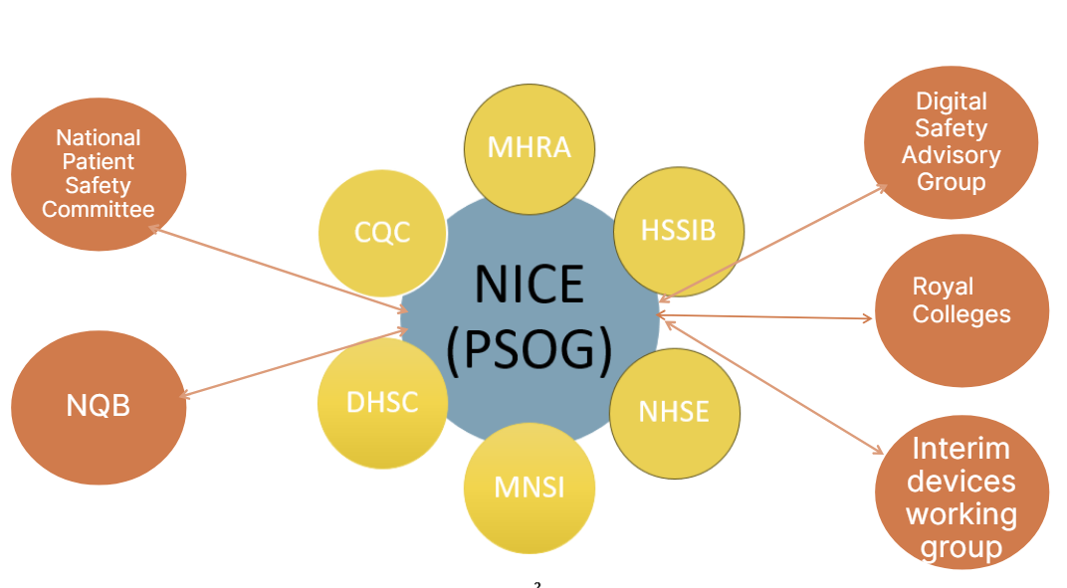
- Over the course of 2025 PSOG members have worked alongside representatives from other arms-length bodies, royal colleges and professional bodies to provide expertise in the development of a national repository for safety recommendations. Under the plans set out by the Dash Report this recommendations hub will form a key tool used by the NQB to effectively track implementation oversight of prioritised safety recommendations. Work by the group is currently being taken forwards by HSSIB, supported by DHSC.

- We have made particular progress in establishing an effective intelligence sharing relationship with the new Maternity and Newborn Safety Investigations (MNSI) team, based within the CQC, as well as establishing links with the wider CQC safety policy team. This enables us to address clinical queries from CQC in the course of their general safety investigatory work and queries from MNSI in relation to our maternity guidance. We also obtain MNSI advice on maternity-related issues raised by Coroners and other safety signal sources. We are supporting MNSI by presenting at their clinical team development day, giving a session on understanding the NICE guidance development processes.

- Members of PSOG are working collaboratively with the Interventional Procedures Guidance (IPG) team within NICE and with Professor Jane Blazeby from Bristol Medical School in research which found wide variation in approaches to surgical governance in the NHS. The outcome of this project is a paper (in development) analysing the use of Hospital Episode Statistics as a tool to monitor the use of procedures subject to recommendations for further evidence generation, and input to plans for an enhanced governance model for new procedures in hospital settings. Work is also being done on strengthening consent procedures for new interventional procedures.

- PSOG has also worked collaboratively with the safety and learning team at NHS Resolution (NHSR) to support development of their resources aimed at reducing safety risks in key areas of litigation. We have hosted two learning sessions on how NICE guidance features in NHSR’s work around clinical negligence which were popular and well attended by NICE staff. NICE is represented on several cross-system safety-focussed groups alongside partners, including the National Patient Safety Committee where PSOG presented on its work during 2025.

- NICE receives a high volume of prevention of future death (Regulation 28) reports from HM Coroners annually. Since our last report to the Board, at the time of writing 11 reports were received and responded to by NICE. Our enquiry handling team were also requested to provide NICE input to an additional 4 DHSC-led responses to Coroner's reports. Input for these externally led responses will typically include providing reference to any relevant NICE guidance and Quality Standards.

- These reports covered a wide range of topics including perioperative care, maternity safety and mental health care. Several reports have prescribing and medicines safety elements and require engagement with the MHRA to understand and align positions taken in response to them.

- PSOG works effectively and collaboratively with the NICE enquiry handling team to assess the issues raised and recommendations made by coroners and to develop responses to them. Where issues require a coordinated response across more than one body, NICE has engaged constructively with external partners to identify solutions and the appropriate follow-up actions.

- PSOG also assigns follow-up actions required in response to issues raised to the appropriate developer teams within NICE, primarily the guideline surveillance team and centre for guidelines. We have sent nine supplementary responses to coroners’ reports in 2025, detailing outcomes following actions suggested in our initial response to the Coroner.

- PSOG has recently completed an internal audit of all Coroner’s reports received by NICE between 2021 and Spring 2025, including reviewing progress of any actions proposed in response to the coroner’s report. The review considered 70 reports, approximately half of which required follow up action by NICE. This often included a surveillance review and, depending on the outcome of review, amendment or updates to guidance. Other actions included considering steps that might improve implementation of NICE guidance for particular topics and more recently, collaborating with external partners to develop joint solutions to issues raised.

- The review has produced recommendations for further improving our response to coroners reports and the oversight of actions where these are required. PSOG has begun proactive outreach to coroners with the aim of improving their awareness and understanding of NICE, its outputs and limits to its remit. We have also invited a regional lead coroner to present an interactive session with NICE’s clinical network around the topic of a coroner’s perspective on patient safety matters.

- The breadth and increased frequency of the activities described above has required a significant increase in the time devoted to safety by members of PSOG. This is not always recognised in an individual’s job plan and will be addressed during future appraisals and career conversations, thereby supporting ambition four of NICE’s business plan to build an organisation as brilliant as the people in it.

Considering the application of a Safety Management System (SMS)
- The HSSIB has introduced the concept of a Safety Management System (SMS) for healthcare adoption in England. If implemented, they suggest this will help to address inconsistencies in language and methodology towards safety management across healthcare. An SMS coordination group has been established, led by NHS England, to look at how such a model could be realised across the NHS at a provider-level. Arms-length bodies in healthcare such as NICE are also encouraged to consider how this SMS as a concept would apply to their ways of working.

- An SMS is a proactive and integrated approach to managing safety. It sets out the necessary organisational structures and accountabilities and is subject to continuous improvement

- It requires safety management to be integrated into an organisation’s day-to-day activities. There is no one-size-fits-all SMS, however there are four recognised areas associated with many SMS frameworks. These are safety policy, safety risk management, safety assurance and safety promotion.

Figure 3. Key components of a safety management system
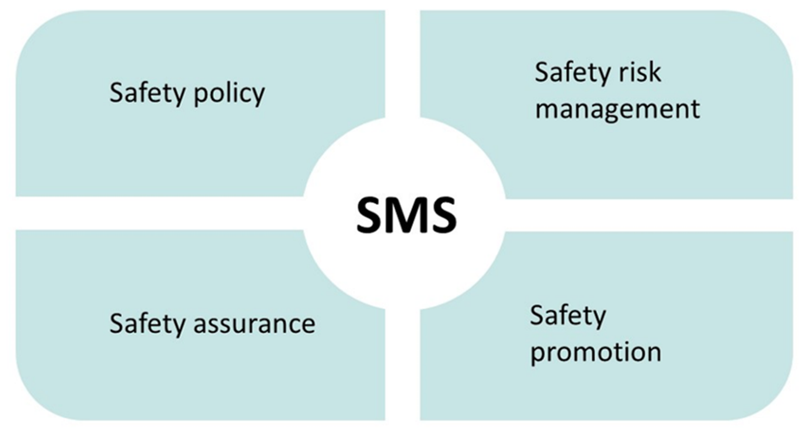

- During 2025, PSOG have considered the application of an SMS model in NICE within the context of the elements of an SMS that already exist under NICE’s Patient Safety Oversight Group model. The group concluded that the current safety oversight model incorporates many of the key features of the SMS model against all 4 domains but does not extend to be a wholesale SMS as might be found in a frontline healthcare organisation. This is a tailored and pragmatic solution, proportionate to NICE’s role and remit and we consider this sufficient to maintain ongoing effective safety oversight.

- PSOG will continue to monitor the effectiveness of the current model, iterating and adopting best practice where these are beneficial to ensure continued effective safety oversight within NICE. We will also monitor whether an SMS model is applied by other similar organisations who we are in regular contact with and the SMS Coordination Group led by NHSE to ensure that our approach is consistent with them.

Promoting a culture of safety within NICE
- PSOG will continue to support NICE to become a truly generative organisation in terms of its safety culture and approach to safety considerations (see Figure 4).

Figure 4. Adapted version of Westrum's typology of organisational culture model (2003)

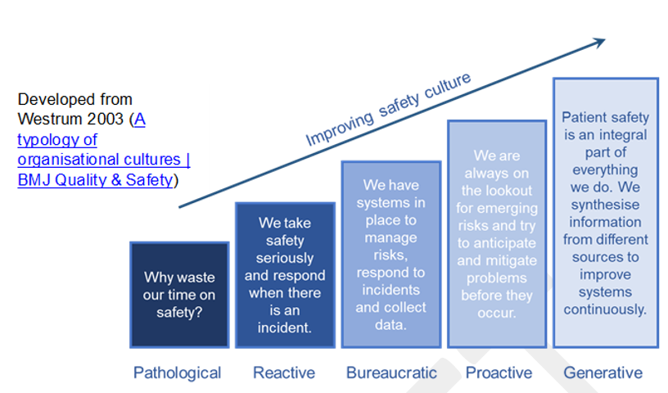
- This includes creating and promoting psychological safety where NICE colleagues feel empowered to raise safety-related issues within their respective programmes.

Steps we can take to advance this goal include:
- Clearly defining and communicating the boundaries between NICE’s responsibilities towards safety with those that have statutory duties on healthcare safety such as the MHRA and CQC.
- Ensuring that PSOG and its membership continues to keep pace with the changing nature of NICE and its programmes of work.
- Building on our internal communications work during 2025 which has showcased and promoted patient safety through all-staff meetings, dedicated learning sessions with key external stakeholders and through our clinical network.
- We will continue to ensure safety receives a high level of visibility in our internal communications and that PSOG members are accessible to colleagues for wider advice and support.

Patient Safety Priorities for 2026/27

- The changes and enhancements to the profile of safety – alongside other elements of improving quality as set out in the NHS 10-Year Plan and Dash Report are reflected in PSOG’s priorities for the year ahead.

- PSOG will keep its terms of reference and current engagement under review and update to reflect the new landscape, as changes set out in the 10-Year Plan are implemented, identifying where new relationships need to be established both internally and externally to maximise NICE’s role and impact.

- PSOG will support the NICE representative on the National Quality Board, to be an influential, active and constructive participant, as the NQB takes on an enhanced role in the quality and safety landscape. NICE can use its membership of the NQB to further influence and align these efforts with its own work on topic prioritisation, guidance and advice development. In the short-term NICE will provide particular expertise to the NQB as requested, to support the assessment of cost effectiveness of patient safety recommendations. PSOG will provide oversight of this work.

- PSOG will maintain and enhance existing strong relationships with key safety partners, including the safety monitoring team at MHRA, in support of NICE’s ambitions of better aligned pathways for medicines and new technologies. It will support the continuation and development of two-way safety intelligence flows and facilitate any remedial action needed by NICE in response to shared information.

- PSOG will support NICE to engage, where requested with the national inquiry into maternity and neonatal care and with the maternity and neonatal taskforce. This will ensure NICE guidance and standards are reflected appropriately in the outputs of the inquiry, including any enabling role it may play in improving future maternal and neonatal care quality and outcomes.

- We will undertake proactive engagement with the coronial system in England, to improve Coroner’s understanding of NICE’s role and remit by providing a dedicated briefing session to all Coroners. We will invite a senior Coroner to lead a learning session for NICE staff at our internal Clinical Network meetings. We will audit our performance against actions committed to in response to Coroners reports annually.

- PSOG will support NICE guidance development teams with the inclusion of safety consideration steps in their processes and provide advice and input where requested, including reviewing how new steps such as enhanced safety consideration in EVA are applied and working. Externally we will continue to support work led by Professor Jane Blazeby on strengthening governance nationally for interventional procedures guidance.

Cross organisational impact
Staff from across NICE who contribute to the work of PSOG should have the cross-organisational nature of this work recognised in their job role.
This will be progressed with relevant and new PSOG members over the coming year and captured in future annual appraisals, career conversations and updated role descriptions.

Risk assessment
The team considered potential risks and concluded that this paper does not propose new or substantive changes to current arrangements. Any risk is therefore negligible.

Board action required
The Board is asked to:
  - Note the progress made by the patient safety team over the past year.
  - Note the planned steps for further development of NICE's patient safety role, in alignment with NICE's strategic objectives.

© NICE 2025. All rights reserved. Subject to Notice of rights.
December, 2025

Vincent C, Oikonomou E, Carthey J, Macrae C. Redesigning safety regulation in the NHS BMJ 2020;368:m760 doi: 10.1136/bmj.m760
Southall S, Patrick H, Harris K, Bird C. Introducing a systematic and sustainable patient safety oversight function in a U.K. arms-length healthcare body. Journal of Patient Safety and Risk Management. 2024;0(0). doi:10.1177/25160435241282044

