|  |
| --- |
| **2022 AFA Scholarship**  **Promotion and Selection Process** |

**Promotion:** Share the online application with students, counselors, and agriculture instructors by directing them to [www.agfuture.org/scholarships](http://www.agfuture.org/scholarships). Applications are due **Wednesday, March 9, 2022**.   
 *Note: When a student enters the online application, they will be asked to create an account on the AFA website.*

**Selection:** When a student from a participating community completes the online scholarship application, community coordinators will automatically receive an email confirmation, notifying them of the submission. This includes both high school and collegiate applicants.

* + - * This email will include the student’s completed application and can be used for the review process. (AFA utilizes the community boundaries provided on the Annual Partnership Agreement).
    - This email will come from Johnna Wallingford at johnna.wallingford@agfuture.org. If you haven’t already, please add this address to your “Safe Sender” list.
  + After the scholarship deadline, AFA will provide community coordinators a final list of all students in the applicant pool that are eligible for the community scholarship within a week of the deadline. From there, coordinators can print the email confirmations for the review committee, or simply forward for review.

*Note: Any student who applies online will automatically be considered for AFA’s various national scholarships (if completed by March 9). If a student is awarded a community scholarship, they will be removed from consideration for national awards, as the community award is the most beneficial opportunity.*

**Questions?**

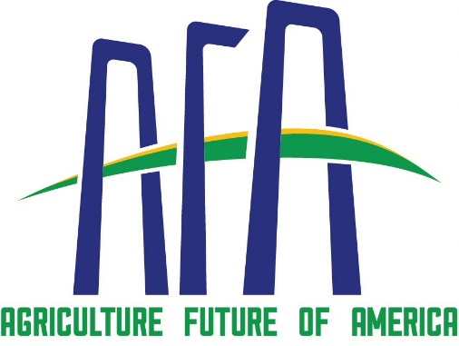Contact Johnna Wallingford at johnna.wallingford@agfuture.org or 816-406-1929.