Design Criteria for Outdoor Signs & Related Products

Introduction
This document will give some technical insight into the calculations and methods used to determine proper sheet sizes, hole opening sizes and edge engagement configurations for signs. The same information also applies to many skylights and glazing applications. The coefficient of thermal expansion and/or contraction for all grades and colors of AcryClear™ acrylic sheet ranges from 0.000038 to 0.000042 in/in/°F (0.000068 to 0.000076 cm/cm/°C). For calculations, the average, 0.000040 in/in/°F (0.000072 cm/cm/°C) will be used throughout this bulletin.

Sheet Size Calculations
Example #1. An acrylic sign face 8' (2.44 m) long by 4' (1.22 m) wide by any thickness is assembled at room temperature of 75°F° (24°C). It is expected that this sign face will reach a maximum temperature of 150°F (65.6°C) in the summer and a minimum temperature of -20°F (-29°C) in the winter. How much will it expand in the summer (A) and how much will it contract in winter (B)? Also, what is the total dimensional change (C)?

Maximum Expansion (A).
- Length:0.00004 x (150°F - 75°F) x 96" = 0.29". (0.00007 x (65.6°C - 24°C) x 244 cm = 0.73 cm)
- Width: 0.00004 x (150°F - 75°F) x 48" = 0.14". (0.00007 x (65.6°C - 24°C) x 122 cm =0.36 cm)

Maximum Contraction (B).
- Length:0.00004 x [75°F - (-20°F)] x 96" = 0.36". (0.00007 x [24°C - (-29°C)] x 244 cm = 0.91 cm)
- Width: 0.00004 x [75°F - (-20°F)] x 48" = 0.18". (0.00007 x [24°C - (-29°C)] x 122 cm = 0.46 cm)

Total Dimension Change (C).
- Length: A + B = C or 0.29" (0.73 cm) + 0.36"
(0.91 cm) = 0.65"(1.64 cm).
- Width: A + B = C or 0.14"(0.36 cm) + 0.18"
(0.46 cm) = 0.32" (0.82 cm).
Often a simpler "rule of thumb" expression is used in lieu of the above calculations. It is: the combined expansion/ contraction movement (C) is approximately 1/16" per foot (.52 cm per meter). Using this for the above example the results would be:
- Total dimensional change (C) for the length.
8' x 1/16" = 0.500" (2.44 m x .52 cm = 1.27 cm)
- Total dimensional change (C) for the width.
4' x 1/16" = 0.250" (1.22 m x .52 cm = .63 cm)
As can be seen, the "rule of thumb" technique which is an approximation yields slightly smaller numbers for this example.

Hole Size Calculations
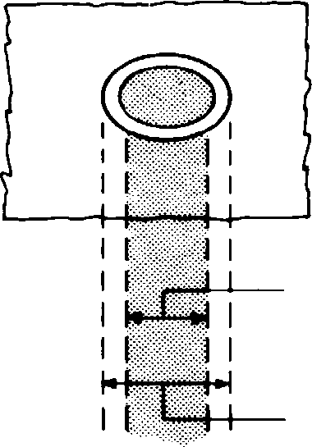
For bolt sizes up to 1/2" (12.7 mm) in diameter, drill the hole 1/8" (3.2 mm) larger in diameter. (See Figure 1). It is equally important not to tighten down on a bolt to the point that expansion/contraction cannot occur. Use rubber washers or grommet where possible, and only tighten the nuts finger tight.

Bolt Size
Hole Size
Figure 1
Edge Engagement
Figure 2 gives recommended Aristech Surfaces acrylic sheet thicknesses based on the long dimension of the sign and the specified maximum wind load in lbs./ft² (kg/m²). Table 1 gives approximate wind velocities for a specified wind load in lbs./ft² (kg/m²).

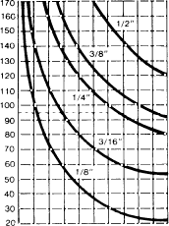Figure 2
170 " (432 cm)

160" (406 cm)

150" (381 cm)

140" (356 cm)

130" (330 cm)

120" (305 cm)

110" (279 cm)

100" (254 cm)
1 (
90" (229 cm)

80" (203 cm)

70" (178 cm)

60" (152 cm)

50" (127 cm)

40" (102 cm)

30" (76 cm)

20" (51 cm)
(lbs/ft2) (kg/m2)
UNIFORM LOAD
1/8"
(3.2 mm)
3/16"
(4.8 mm)
/4"
6.4 mm)
3/8"
(9.5 mm)
1/2"
(12.7 mm)
Table 1
Approximate Wind Velocity (MPH) | Uniform Load (lbs/ft²)
75 (121 km/hr)  90 (145 km/hr)  100 (161 km/hr)  130 (209 km/hr) | 20 (98 kg/m²)  30 (147 kg/m²)  40 (195 kg/m²)  50 (244 kg/m²)
Example #2.
The sign face in Example 1 must withstand 30 lbs./ft² (147 kg/m²) wind load. Determine the proper sheet thickness, the expansion/contraction clearances and the recommended edge engagement dimension using Table 2 and Figures 2 and 3.

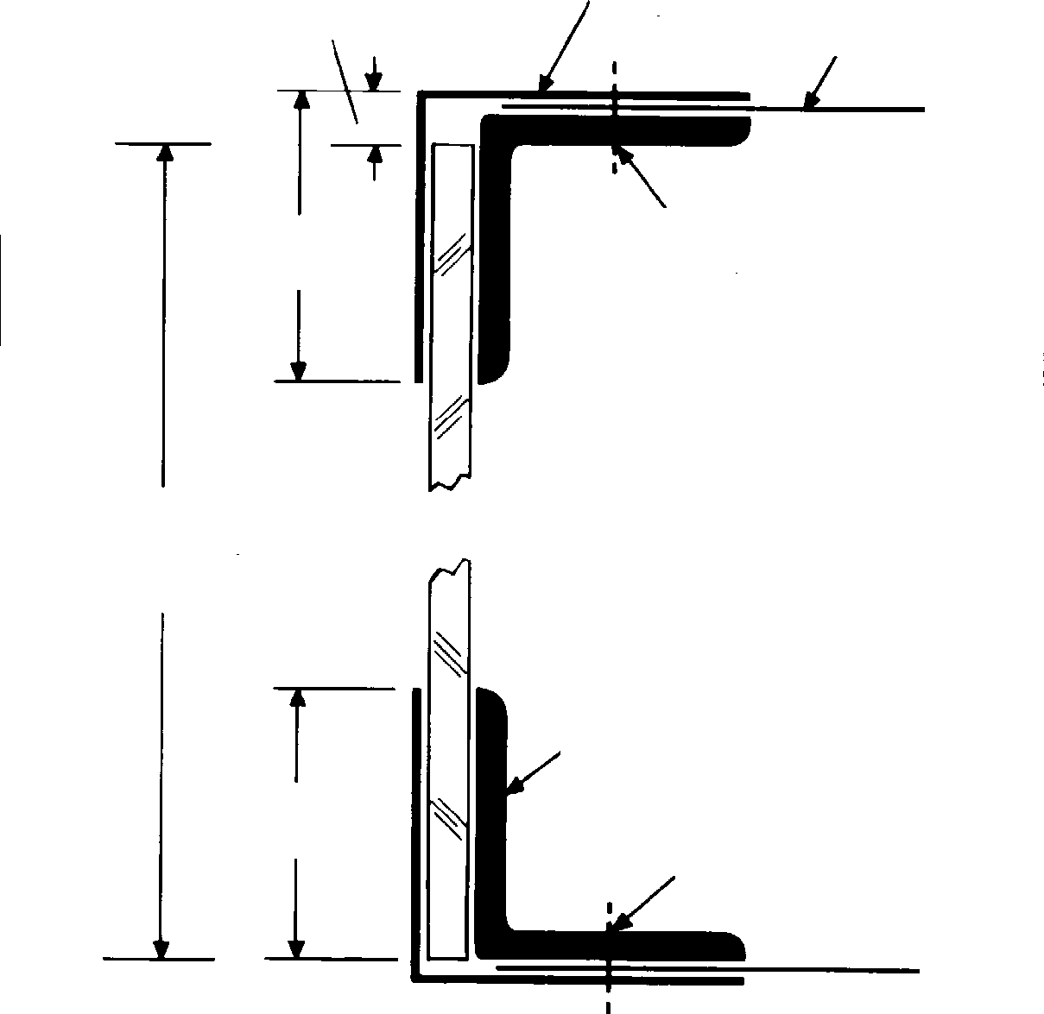Figure 3
Expansion Clearance
Metal Retaining Angle
Sign Cabinet
Edge Engagement
Through Fastener
Dimension of Acrylic
Edge Engagement
Sign Structural Frame- work
Through
Fastener

table 2
Short Dimension | Expansion Clearance | Edge Engagement (Includes Expansion Clearance)
Up to 42"  (Up to 107 cm) | 1/8"  (3.2 mm) | 1.250"  (31.8 mm)
42" to 72"  (107 to 183 cm) | 1/4"  (6.4 mm) | 1.250"  (31.8 mm)
72" to 96"  (183 to 244 cm) | 1/4"  (6.4 mm) | 1.500"  (38.1 mm)
Over 96"  (Over 244 cm) | 0.3% of short  dimension | 1.6% of short  dimension
Note: These values are approximate.
1. From Figure 2 the recommended thickness is 0.250" (6.4 mm).
2. From Table 2 the expansion clearance is 0.250"(6.4 mm). This compares
to the total width calculation (C) from example #1 of 0.32" (0.82 cm).
3. From Table 2 the edge engagement dimension is 1.250" (31.8 mm).

Other Design Considerations
- Thermal coefficients of expansion/contraction for other materials.
Table 3 gives some coefficients for other materials including metals used in sign housings. These numbers can be used in a calculation such as Example #1 if the sign housing composition is known. The movement of the housing will be in the same direction as the acrylic and therefore should be subtracted from the acrylic expansion/contraction dimension.

table 3
Comparison of Coefficients of Thermal Expansion of Acrylic and Other Building Materials
Material | In/In/°F (cm/cm/°C)
Acrylic | .0000410 (.000074)
Aluminum | .0000129 (.000023)
Copper | .0000091 (.000016)
Steel | .0000063 (.000011)
Plate Glass | .0000050 (.000009)
Figure 4 illustrates some typical edge engagement configurations.
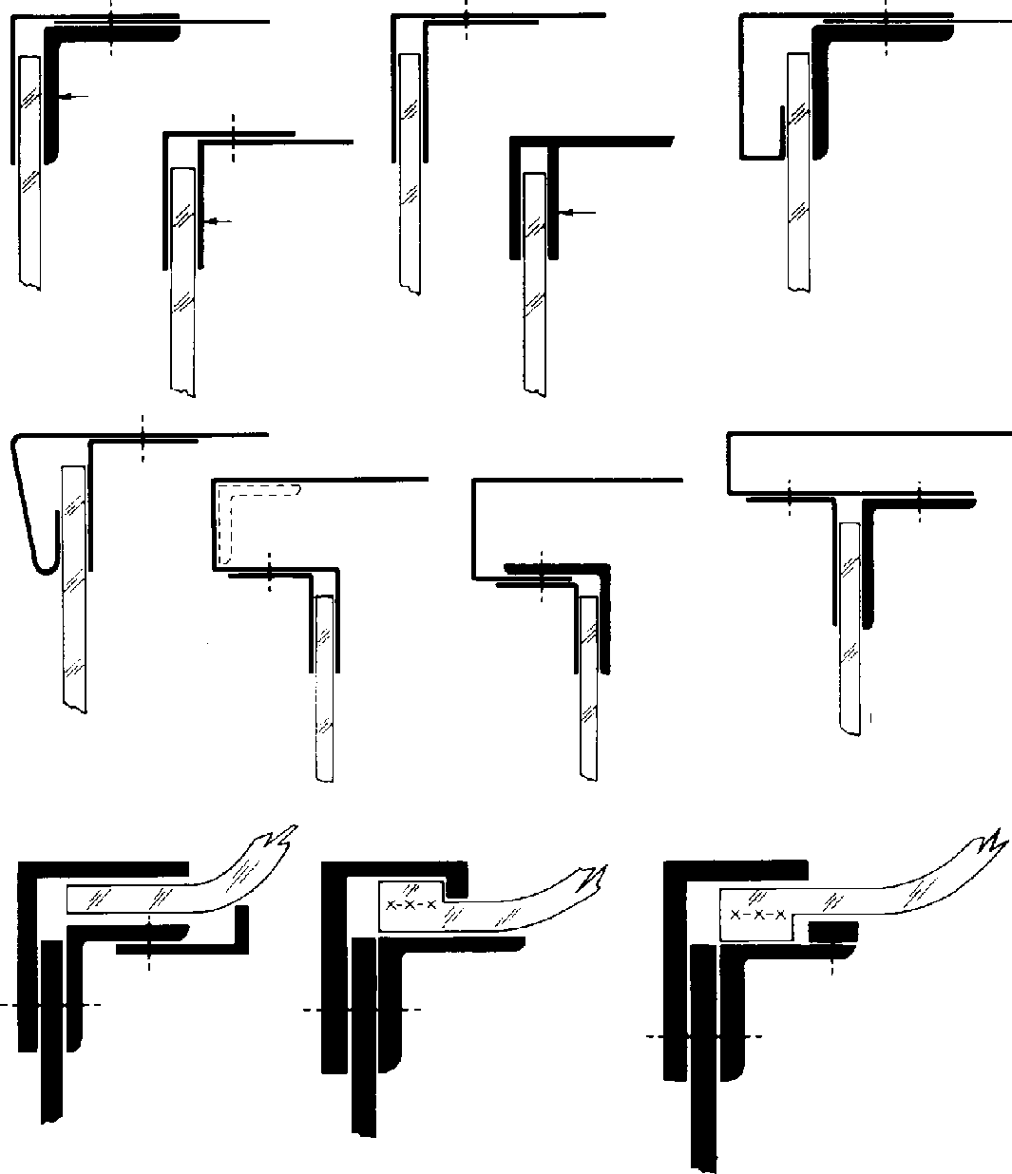
Steel Angle Framing

All Sheet Metal Sign Cabinet
DETAIL C
Aluminum Extrusion
DETAIL E
DETAIL D
DETAIL F
DETAIL I
DETAIL G
DETAIL H
DETAIL K
DETAIL L
DETAIL M
Figure 4

2. Hanger Bars.
Certain sizes, shapes and thicknesses will tend to sag or bow due to their weight. Hanging the AcryClear™ acrylic sign face from the top edge will overcome this tendency. (See Figure 5) for some typical hanger bar configurations. Certain sizes, shapes and thicknesses will tend to sag or bow due to their weight. Hanging the Aristech Surfaces acrylic sign face from the top edge will overcome this tendency. (See Figure 5) for some typical hanger bar configurations.
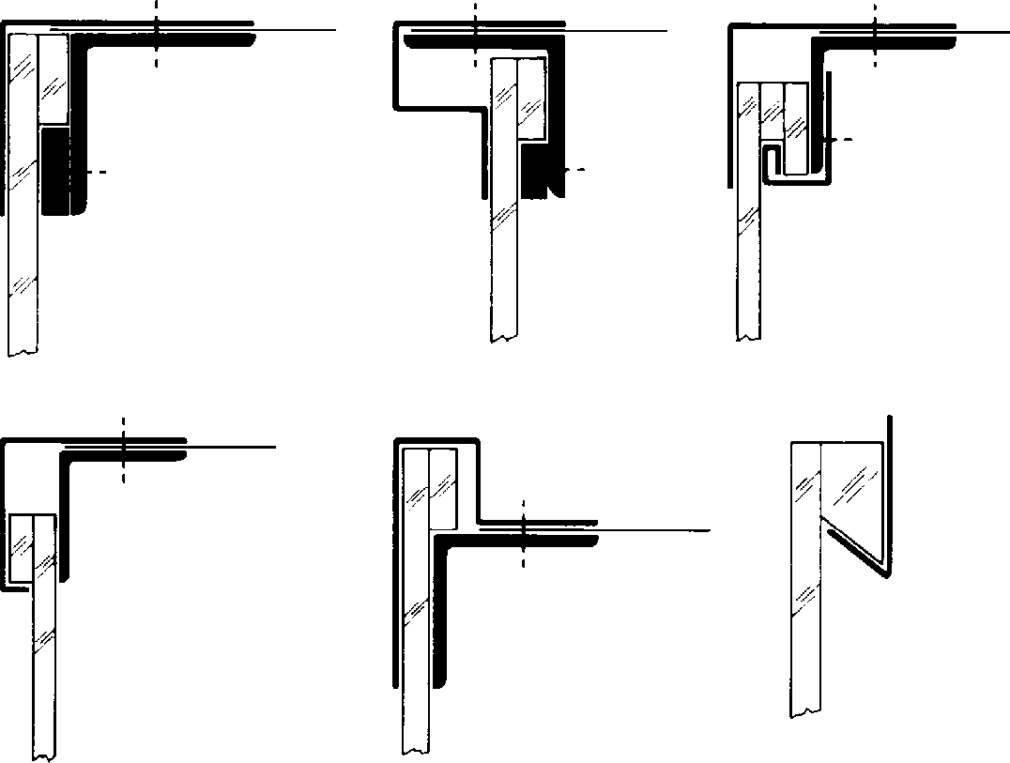
DETAIL A
DETAIL B
DETAIL C
DETAIL F
DETAIL D
DETAIL E
Figure 5

3. Tie Bars
For extremely large signs or if other design or environmental problems cause “blow-out” problems, internal tie-back braces are a solution. See Figure 6 for a typical tie-back bar. This is a complicated area and will not be covered in this bulletin in great detail. For further information contact the AcryClear™ acrylic sheet unit’s technical service department at Florence, Kentucky.
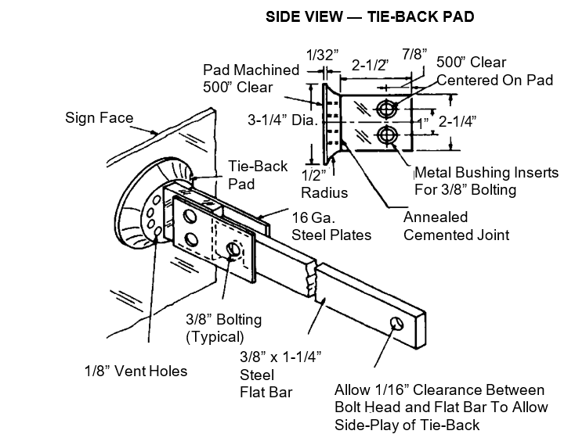Figure 6

4. Testing For Wind Load Or Resistance.
This is covered in detail in AcryClear™ Technical Information Sheet #2 which is available upon request.
Note: for cautions and information on exposure to any Aristech Surfaces’ product, please see the applicable material safety
data sheet.
Information contained herein is: a) based on Aristech Surfaces’ available technical data and experience; b) intended only for individuals having applicable technical skill, with such individuals assuming full responsibility for all design, fabrication, installation, and hazards; c)to be used with discretion and at one’s own risk, after consultation with local codes and with one’s independent determination that the product is suitable for the intended use; and d)not to be used to create designs, specifications, or installation guidelines. Aristech Surfaces makes no representation, or warranty, express or implied, and assumes no liability or responsibility as to: i) the accuracy, completeness or applicability of any supplied information; ii) results obtained from use of the information, whether or not resulting from Aristech Surfaces’ negligence; iii) title, and/or non-infringement of third party intellectual property rights; iv) the merchantability, fitness or suitability of the product for any purpose; or v) health or safety hazards resulting from exposure to or use of the product. Aristech Surfaces shall not be liable for x) any damages, including claims relating to the specification, design, fabrication, installation, or combination of this product with any other product(s), and y) special, direct, indirect, or consequential damages.

