Forming and Fabrication Guide
Bulletin 139
07/24/2021
Fabrication and finishing

Machining
The usual rules of good machining practice apply to the machining of Aristech Acrylics® Acrylic Sheet. An experienced machinist will have no difficulty handling the materials as its working properties are similar to those of brass, copper, and fine woods. Tools should be held firmly to prevent chattering. Standard metal or wood working equipment can be used: such as,milling machines, drill presses, lathes, planers, and shapers. In general, machine tools should be operated at high speeds with slow feed rates, Aristech Acrylics® Acrylic Sheet being a thermoplastic material, softens when heated to its forming temperature of 320 to 380°F (160 to 195°C). The frictional heat generated by machining tends to soften the acrylic in the immediate vicinity of the cut and can cause gumming and sticking of the tool, unless proper speed, feed rate, and cutters are used. Properly machined surfaces will have an even, semi-matte surface that can be brought to high polish by sanding and buffing. If tools are sharp and properly ground, coolants are seldom required for machining. They may be desirable for an unusually smooth finish or for deep cuts. If coolants are employed, only detergent in water or 10% soluble oil in water should be used.

Routing and shaping
Woodworking shapers and overhead, or portable routers are used in edge finishing operations and for cutting flat thermoformed parts. For edging small parts, the table router is convenient. (see Figure 1.)
A portable router is useful when the part is too large or awkward to bring to the machine. (See Figure 2.)
These machines should have a minimum no-load spindle speed of 10,000 rpm. Higher speeds are desirable and should be used if they are available. Two or three flute cutters, smaller than 1.5” (38 mm) in diameter, running at high speeds, produce the smoothest cuts. At slower spindle speeds, the cutter should have more flutes, or may be larger in diameter to produce the necessary surface speeds. The cutter should be kept sharp and should have a back clearance of 10° and a positive rake angle up to 15°.

Figure 1 - Trimming Formed Part with Table Mounted Router
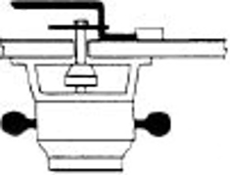

Figure 2 - Edging with a Portable Router
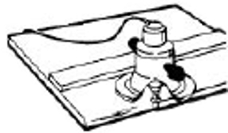
Drilling
When drilling Aristech Acrylics® Acrylic Sheet, best results are obtained when using standard twist drills which have been modified as follows:
- High speed steel drills should be selected, having slow spirals and wide polished flutes.
- Drills should first be ground to a tip angle of 60° to 90°.
- Modify the standard twist drill by dubbing-off the cutting edge to zero rake angle.
- Grind the back lip clearance angles to 12° - 15°.

Figure 3 - Alterations to Drill Bits for Drilling Aristech Acrylic
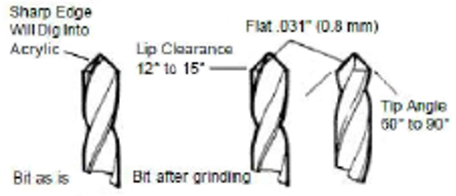
Aristech Acrylics® Acrylic Sheet may be drilled using any of the conventional tools: portable electric drills, flexible shafts, drill presses or lathes. In general, drills should rotate at high speed and feed should be slow but steady. Use the highest available speed with a drill press, usually 5,000 rpm. An exception to this rule should be made when drilling large holes where the drill speed should be reduced to 1,000 rpm. The drill should always run true, since wobble will affect the finish of the hole.
When drilling holes which penetrate a second surface, it is desirable to back up the surface with wood and slow the feed as the drill point breaks through. For accuracy and safety, the acrylic should be clamped during drilling.
Cutting
As a general rule, a power saw is the best method of cutting Aristech Acrylics® Acrylic Sheet. It is sometimes advantageous to cut thin material at an elevated temperature with rule and blanking dies. Cold punching and/or shearing should not be used since these methods will fracture the material.
The type of equipment selected should be based on the work to be done. Circular saws are preferred for straight cutting. Jig saws and saber saws are suggested for cutting small radii curves and thin materials.Band saws are suggested for large radii curves and for straight cuts in thick acrylic. Routers and wood working shapers can be used for trimming the edges of formed parts.
Tempered alloy steel saw blades are the least expensive to buy, give reasonable service, and are discarded when worn out. Carbide tipped blades are more expensive, give longer service, and can be resharpened. The following table can be used as a guide in selecting the proper circular saw blade:

Figure 4 - Cutting Aristech Acrylics® Sheet on Table Saw
Thickness of Acrylic Sheet Inches (mm) | Blade Thickness Inches (mm) | Teeth per Inch (cm)
.080 - .100  (2.0 - 2.5) | 1/16 – 3/32  (1.6 – 2.4) | 8 – 14  (3 – 8)
.100 - .187  (2.5 – 4.7) | 3/32 – 1/8  (2.4 – 3.2) | 6 – 8  (2 – 3)
.187 - .472  (4.7 – 12.0) | 3/32 – 1/8  (2.4 – 3.2) | 5 – 6  (2 – 3)

Figure 5 - Cutting Aristech Acrylics® Sheet with Saber Saw

Figure 6 - Cutting Formed Aristech Acrylic Sheet Part on Band Saw
Circular saws should:
- Be run at 8,000-12,000 RPM.
- Be hollow ground to aid cooling.
- Be slotted to prevent heat warping the blade.
- Have teeth with a uniform rake angle of 0° - 10°.
- Have a slight set to give clearance of .010” to .015” (.254 mm to .381 mm) and
- Have teeth of uniform height.
An 8” (20.3 cm) diameter blade is used for light work and a 12” (30.5 cm) blade for heavy work. A two horsepower motor is suggested for driving these blades.
Masking tape applied over the area to be cut will reduce the tendency to chip during cutting. Acetone, toluene, or methylene chloride can be used to clean blades. Tallow or bar soap applied to the blade, helps to prevent gum build-up on the blade when cutting sheet masked with adhesive backed paper.
Traveling saws cutting at 10 to 25 feet (3 to 7.6 meters) per minute are recommended for making straight cuts longer than 3 feet (91 cm) and for cutting sheets when it would be undesirable to slide them across the saw table.

Figure 7 - Typical Saw Blade for Cutting Aristech Acrylics® Sheet
Aristech Acrylics® Acrylic Sheet, backed with fiberglass reinforced plastics, are best cut by diamond abrasive wheels. Carbide tipped blades will do a good job but require frequent resharpening. Small diameter disposable alloy steel blades on high speed air powered saws are also effective, especially in portable situations.
Variable speed band saws, which can run at 5,000 feet (1524 m) per minute and have a 28” to 36” (71 to 91 cm) throat, are best suited for production work. Metal cutting blades are the best type for cutting Aristech Acrylics® Acrylic Sheet. The following table can serve as a guide for selection of a blade:
Min. Radius To Be Cut Inches (mm) | Blade  Width  Inches (mm) | Blade Thickness Inches (mm) | Teeth per Inch (cm)
1/2 (12.7) | 3/16 (4.7) | 0.028 (.71) | 7 (3)
3/4 (19) | 1/4 (6.3) | 0.028 (.71) | 7 (3)
1-1/2 (38) | 3/8 (9.5) | 0.028 (.71) | 6 (3)
2-1/4 (57) | 1/2 (12.7) | 0.032 (.81) | 5 (2)
3 (76) | 5/8 (15.9) | 0.032 (.81) | 5 (2)
4-1/2 (114) | 3/4 (19) | 0.032 (.81) | 4 (1.5)
8 (203) | 1 (25.4) | 0.035 (.89) | 4 (1.5)
12 (305) | 1-1/4 (31.7) | 0.035 (.89) | 3 (1.5)
20 (508) | 1-1/2 (38.1) | 0.035 (.89) | 3 (1.5)
The blade speed should be approximately 4,500 RPM for Aristech Acrylics® Acrylic Sheet thicknesses from .125” to .375” (3.2 to 9.5 mm) thick. Fine teeth with no set will produce a smooth cut if fed slowly. Sheets should be fed continuously and with even pressure to prevent the blade from binding and breaking. The blade should enter and leave the work slowly to prevent chipping. Should a burr form on the cut edge due to overheating, it can be removed with a scraper or other straight edged tool. This is particularly important if the sheet is to be silk screened.

Laser cutting and engraving
Lasers, when in expert use provide the most precision, high quality cutting and engraving of acrylic sheet. The only real difference between cutting and engraving is that in cutting you go all the way through the sheet and in engraving you manipulate the speed and power of the laser to go a set depth into the sheet. While there are other types of industrial lasers, CO2 lasers are the workhorse type for this application. The power requirements of the laser depend upon the thickness of the sheet, its pigment content, and the required processing speed. Low power lasers tend to be used for engraving while the higher power lasers are needed to cut sheet with a crisp polished edge.
When the laser cuts into acrylic, it thermally depolymerizes the acrylic to methyl methacrylate vapor. This vapor is highly flammable, so it is necessary to have a gentle stream of air or nitrogen to blow it away from the cutting point and prevent ignition. This stream should be optimized to prevent frosting at the newly cut edge. Excellent ventilation is a must in the cutting area. While cutting, the equipment should never be left unattended.
Cast acrylic is most suited for laser fabrication due to its high molecular weight. It can be laser cut to provide a high gloss edge with no further fabrication required (other methods require a secondary step in the process to give a polished edge). Laser etched cast acrylic sheet offers optimum engraving definition. Both of these benefits make cast acrylic sheet particularly suited to LED light coupling for edge illumination for lighting and signage applications. Often fabricators won’t laser cut extruded sheet because odor and melt lip. Melt lip occurs while the laser operates. While the laser operates, the extruded acrylic melts and on the bottom side creating a lip or burr that fabricators then must remove. Additionally, the engraving definition on extruded sheet is very poor due to its low melting point.
You should look to the laser manufacturer for detailed guidance on specification of the laser for your application. It is understandably desirable to get the lowest power system that can still give you a quality result. This must be carefully balanced as laser system costs increase dramatically with the power density. For general specification, the rule of thumb is for every 10 Watts of power you will be able to cut 1mm / 0.04 inch of material. That ratio will give you a system capable of both good production speed and a smooth flame polished edge. Start with high frequencies from 20 to 25 kHz for a smooth flame polished edge, backing off until you reach an optimum suitable for the quality of your application. Some applications merely require that the material be cut but do not require a flame polished edge. In that case, you can start at frequencies as low as 9 to 12 kHz. Cutting speed is optimized in similar fashion. Focal length should be from 2 to 2.5 inches. Also note that power and speed need to be adjusted to the any particular design to reduce stress when there is an abrupt directional change or cutting sharp angle.

Finishing
The original high-gloss surface of Aristech Acrylics® Acrylic Sheet can usually be restored by a series of finishing operations. Finishing often involves an initial sanding operation, followed by buffing, then finally a polishing operation. During all of these operations, heat should be avoided. The plastic should be kept in constant motion with a minimum of pressure against the finishing wheels. Air cooling devices can be used to reduce frictional heat.

Sanding
Minor and shallow scratches on a clean Aristech Acrylics® Acrylic Sheet surface can be filled with a paste wax to improve the appearance. Hard automobile paste wax should be used, applied in a light even film with a soft cloth. The surface should then be polished to a high gloss with a clean, dry, cotton flannel cloth. Hard or rough tex-tured cloth such as cheesecloth and muslin should not
be used. Deeper, yet light, scratches may be removed or reduced by hand polishing, using a soft cloth and a rub-bing compound (see source list). Do not “sand” acrylic unless surface blemishes are too deep to remove by light buffing. When it is necessary, usually 320-A wet-or-dry paper is as coarse as will be required and may be fol-lowed by a 400-A or finer paper. Soak the sandpaper in water for a few minutes before using and use plenty of water while sanding. Sanding of large areas should not be attempted unless power buffing equipment is available. Final sanding should be in one direction only to prevent distortions and/or “bulls eyes.”
Machine sanding can be done with belt, disc, vibrator or drum sanders. Large optical grade jobs require expensive, precision grinding equipment. In all cases, when sanding acrylics, keep the tool, or the work, moving and use water freely.

Figure 8 - Final Sanding (Use back and forth motion and liberal amounts of water)

Buffing and polishing
An abrasive wheel may be used first, which consists of wheel buffs made of stitched cotton or flannel, and an abrasive compound of very fine alumina or similar abrasive combined with tallow wax binders. The abrasive wheel should run at about 1,800 surface feet (548 m) per minute.
After reducing most of the scratches on the abrasive wheel, a wheel buff to which only tallow has been applied may be used to remove any remaining imperfections. Speed of the buff should be between 1,800 and 2,200 surface feet (548 and 671 m) per minute.
Next, the acrylic part is given a high polish on a finish wheel on which no abrasive or tallow is used. As an alternate method, a coat of wax can be applied by hand.

Figure 9 - Buffing Aristech Acrylics® Sheet on Power Driven Buffer
The finish wheel should be very loose and made of imitation chamois or flannel 10” to 12” (25.4 to 30.5 cm)
in diameter, running at a speed of 2,000 to 2,400 surface feet (610 to 732 m) per minute. This is the recommended procedure for finishing edges.

Flame polishing
Edges and inaccessible areas can be polished with a hydrogen-oxygen flame. However, flame polishing cannot be fully recommended because it can cause “crazing” which may not show up for several weeks. The tendency toward crazing can be substantially reduced if you have a good, clean saw-cut to start with, if the saw-cut has been properly wet-sanded or jointed, and if the flame is applied correctly.
The risk of crazing can also be reduced by annealing the pieces in an oven for approximately 2 to 4 hours at a temperature of 170 to 180°F (77 to 82°C) . Use a welding torch with a No. 4 or No. 5 tip. Set the hydrogen pressure at 5 psi (.35 kg/cm2). Ignite the hydrogen first, then turn on the oxygen and adjust the flame.
The flame should be bluish, nearly invisible, approximately 4” (10 cm) long, and narrow. Hold the torch so that the tip of the flame touches the edge of the Aristech Acrylics® Acrylic Sheet. (See Figure 10) Move the torch along the edge at a speed of approximately 3 to 4” (7 to 10 cm) per second.
Overheating and bubbling may occur if the flame is moved too slowly. If the first pass does not produce a completely polished edge, allow the piece to cool; a second pass will often improve the surface finish

Figure 10 — Flame Polishing Edge of Fabricated Part.

Cementing
Strong transparent joints can be obtained in bonding actions of Aristech Acrylics® Acrylic Sheet together, by giving careful attention to preparation of the mating surfaces, proper choice of cement and following correct cementing techniques.

Prevention of internal stresses
Heat generated by machining operations, and/or thermoforming at reduced temperatures, will often induce internal stresses which make the material susceptible to crazing after contact with solvents and certain cements. Such stresses can be avoided by the proper choice of thermoforming or machining conditions, or can be relieved by heat treating. Refer to the Annealing Section in Technical Bulletin 135 for proper heat treating conditions.

Joint preparation
Surfaces to be jointed should be clean and fit together with uniform contact throughout the joint. In order to obtain close fitting edges, which is especially important, it may be desirable to accurately machine the mating surfaces.
Edges to be cemented should never be polished, as this tends to round the corners and decrease the contact area in the joint. There are several types of joints that may be used (see Figure 11) the selection of which will usually depend upon the end use application.
For the best strength in a cemented joint, the contact area should be as large as possible. Where two curved surfaces are to be joined, each should have the same radius to provide uniform contact over the entire joint area.

Safety precautions
Most solvents are highly flammable, toxic, and may be irritating to the skin and eyes. As a safety measure, cementing operations should be carried out in a well ventilated area away from open flame. Eye protection and respiratory items should be afforded. See section on Material Safety Data Sheets for more information.

Types of cement
Sections of Aristech Acrylics® GPA, GPM, IGP or IMA can be bonded together with one of three general types of cement commercially available—the solvent type, the monomer-polymer-solvent type or the monomer- polymer-catalyst type.
Aristech Acrylics® I-300, Acrysteel M, Altair Plus, Quarite and Quarite Plus, Quarite Select and Quarite Plus Select can only be joined together with the monomer- polymer solvent type or the monomer-polymercatalyst type, since these products are highly solvent resistant partially crosslinked continuous cast acrylic sheet.

1. Solvent type cements
Solvent-type cements are the easiest and most convenient type to use. The solvent cements soften the mating surfaces so that complete fusion can be achieved at the interface of the joints which then harden into a transparent bond by diffusion and by evaporation. Ordinarily, the joints require no post-treatment.
Several types of satisfactory solvent cements are Weld-On 3, Weld-On 4 and Methylene Chloride. Acetone, Glacial Acetic Acid, and Chloroform are used, but are not recommended because their strong solvent action on acrylics can cause crazing. Solvent cements allow rapid assembly, yield medium strength joints and have only fair to poor outdoor weathering resistance.

2. Monomer-polymer-solvent type cements
These types of cements usually consist of methyl methacrylate monomer, methyl methacrylate polymer and assorted solvents. M-P-S type cements available are Weld-On 16 and Weld-On 1802. M-P-S cements do not allow rapid assemblies. Usually 15 to 30 minutes after cement is applied, part can be handled very carefully. High to medium strength joints are obtained which have good to fair weathering resistance.

3. Monomer-polymer-catalyst type cements
These type cements consist of methyl methacrylate monomer, Methyl Methacrylate Polymer (Part A) and a catalyst (Part B). M-P-C cements available are Weld- On 10, Weld-On 28, and Weld-On 40. These type cements yield excellent bond strengths, and weathering resistance. Assembly times are slow.

Figure 11 - Joint Selection

Cementing techniques
Solvent cements can be applied to parts fabricated from Aristech Acrylics® Acrylic Sheet GPA, GPM, IGP or IMA by a soak, dip, syringe or a brush method. The best method depends on type of joint to be mated, physical configurations of parts, personal preference, etc. Temperature and humidity can affect the quality of cemented joints: Aristech Acrylics® Acrylic Sheet should not be cemented at temperatures below 65 °F (18 °C), over 95 °F (35 °C), or when the relative humidity is over 60 percent. Excessive moisture can cause cloudy joints which are usually weaker than normal.

1. The soak method
This Method can be used with the solvent-type cements. Pieces of acrylic to be bonded are actually immersed in the solvent cement. The immersed section should be masked to prevent areas adjacent to the joint from being etched by the solvent cement. A cellophane adhesive tape or any other strippable coating through which the solvent cannot penetrate may be used as masking. In cementing curved or complicated sections, the area can be masked by a coating of a thick gelatin solution made from 15 parts (by weight) dry-hide glue, 10 parts glycerine and 9 parts of water. When allowed to dry, this gelatin film can be cut with a razor blade and stripped from the areas to be cemented.
The masked parts should be soaked until the surface is suitably softened. Excessive soaking times will prolong the time required for the part to set and harden. After the soak period, the two parts should be rapidly assembled and the joint held gently together for about thirty seconds before applying pressure. The part should then be fitted into a jig which will apply a uniform pressure throughout the cemented surfaces while the bond is setting. The success of a cementing job depends on a properly fitting jig which will provide a uniform pressure sufficient to squeeze all the air bubbles from the joint and to assure good contact of the surfaces to be bonded.
The pressure, however, should not be so great that the part will be flexed or stressed as crazing may result from the solvent action of the cement. Suitable jigs can often be made with pressure devices such as springs, clamps or clips. See Figure 12 for typical soak method set-up.

Figure 12 — Typical Soak Method Procedure

2. The dip method
The masking operation necessary in the soak method can be eliminated if one edge of the joint can be conveniently dipped into the cement. This method requires greater skill but is much quicker than the soak method. Care must be exercised to avoid spattering or dripping cement on other areas of the sheet. It is sometimes helpful to use spring clamps to hold the piece steady and in an upright position while it is being dipped. Pieces of wire are also at times useful for uniform support of the edge being dipped. After the edge has softened sufficiently for bonding, the piece should be removed from the cement and placed in a holding jig as mentioned in the technique for the soak method. See Figure 13 for typical dip method set-up.

Figure 13 - Typical Dip Method Procedure

3. The syringe method
In those cases where the mating surfaces are well matched, the joint may be secured in a jig and the cement introduced to the edges of the joint by means of a hypodermic syringe, eye dropper or squeeze bottle. In this manner, the cement will spread throughout the joint area by capillary action. In the event a thicker coating of cement is desired, fine wire may be inserted into the joint as it is assembled in the jig. Thus spaced, the joint is ready for the cement to be introduced into it. The syringe should always be cleaned after use to prevent adhesion of the plunger to the walls of the syringe. See Figure14 for typical syringe method techniques.

Figure 14 - Syringe Method Technique

4.the brush method
If the cement is sufficiently viscous, it can be brushed on the surfaces to be joined. Viscosity of solvent or monomer type cements can be increased by dissolving acrylic chips or shavings in them. The solvent is then brushed on and allowed to soften the surface of the acrylic sufficiently for formation of a cohesive bond. The joint is then placed in a jig until hardened, as is the case in other methods.
Cemented joints should reach full hardness in 24 hours, provided the proper techniques have boon used and the cementing operations have been carried out in a suitable temperature and humidity environment.

Venting
When hollow articles are cemented, enclosed areas should be vented to prevent entrapment of solvent vapors which could promote crazing of the acrylic.

Filling voids
Before a cement sets, small crevices or voids can be filled by inserting cement with a hypodermic syringe.

Clamping
For maximum bond strength, jigs or clamps should be used to hold the joint together with uniform pressure, no greater than 6 psi (.4 kg/cm2), while the cement is setting. No part of the jig or clamp should be allowed to touch the joint, for the reason that capillary action will draw the cement under the jig resulting in its being attached to the joint.

Polishing or machining
The cemented joint should be thoroughly hardened before polishing, sanding or machining. Thermoforming should be done prior to cementing operations whenever possible. If thermoforming must be done on precemented joints, a monomer-polymer catalyst type cement should be used and the joint annealed to provide maximum bond strength during the forming operation. A close fitting “V” joint generally gives the best cemented bond for thermoforming.

Cementing Aristech Acrylics® acrylic sheet to other materials
Often it is desirable to cement parts made from Aristech Acrylics® Acrylic Sheet to other materials such as metal, wood, other plastics, etc. Industrial Poly-Chemical Service, manufacturer of Weld-On Cements, has a complete line of products for these types of jobs. Consult IPS for recommendations.

Annealing
When plastics parts are molded, fabricated or formed in any fashion these processes inherently induce stress into the part. Just like glass, ceramic and metals, this stress can be relieved by a process called annealing. In annealing we heat the part heating to near the glass transition temperature, maintaining this temperature for a set period of time, and then slowly cooling it to room temperature.
A part undergoing annealing should be completely supported. If it is simply a sheet it can be laid flat in the oven. More complicated parts can require jigs to ensure that the part is not distorted during the annealing process.
For acrylic, the typical temperature that it is heated to is 80°C and then cooled slowly. Generally, you heat the sheet one hour for each millimeter of thickness. It is critical that the sheet be cooled at a controlled rate. If you took the part out of the oven after it achieved 80°C and cooled it under running water you would build more stress into it rather than relieve it. Specially configured annealing ovens can program the annealing schedule. Most ovens will require that you reset the temperature at intervals. The part does not have to be cooled all the way to room temperature before removing it from the oven. It can be removed once the temperature goes below 60°C.
If the part has been cemented it must be allowed to cure at least five hours before annealing. Rapid solvent evaporation can cause bubble formation.
Thermoformable polyfilm can remain in place during annealing. Any other paper masking, tape, etc must be removed.

Annealing schedule
Thickness | Heating Time (hours) | Cooling Time (hours) | Heating Rate (degrees C˚ per hour)
2.0 | 2 | 2 | 15
2.5 | 2.5 | 2 | 15
3.0 | 3 | 2 | 15
3.2 | 3.2 | 2 | 15
4.5 | 4.5 | 2 | 15
6.0 | 6 | 2 | 15
9.5 | 9.5 | 2.5 | 12
12 | 12 | 3.5 | 11

Thermoforming
Several types of acrylic sheets are produced at Aristech Surfaces in Florence, Kentucky. The three most common thermoformable sheets are GPA (General Purpose Acrylic), Acrysteel I-GP (Impact Resistant Acrylic), and I-300 (Crosslinked Acrylic). All three products have very good thermoformability, which is one of many important and useful properties offered by Aristech Surfaces. With many products available, there is an Aristech Acrylics® Acrylic Sheet to satisfy most needs and application requirements.
GPA is ideally suited for all types of outdoor signs,skylights,and general fabrication. This weather-resistant acrylic is solvent cementable and is inventoried in many colors, thicknesses and sizes.
lGP Impact Resistant Acrylic offers the same high performance qualities as GPA plus additional impact resistance to reduce breakage in handling, manufacture, and transportation.
I-300 is a partially cross-linked Aristech Acrylics® Acrylic Sheet with unparalleled performance for the more demanding thermoforming application requiring stain and chemical resistance. This product is most commonly used in the plumbingware and spa markets.
Good formability is one of the most important and useful properties of Aristech Acrylics® Acrylic Sheet. When Aristech Acrylics® sheet has been properly heated, it feels like a sheet of soft rubber. In this state the material can be formed to almost any desired shape. On cooling, the acrylic becomes rigid and retains the shape to which it has been formed. Forming thermoplastic sheet is probably the simplest type of plastic fabrication. The cost of molds and equipment is relatively low. Both two and three dimensional forming of Aristech Acrylics® Acrylic Sheet can be accomplished by a number of different methods. The selection will depend on the shape, thickness, tolerance and optical quality required for the formed part as well as the equipment available and number of parts to be made.
It is imperative that all of the above Aristech Acrylics® Acrylic products be heated properly for thermoforming. Using temperatures that are too low on these products will leave stresses in the formed part that could possibly be relieved by solvents in reinforcing resin, paint and decorating materials causing cracks or crazing. Too high forming temperatures can cause sheet blistering.
While continuous cast acrylic sheet is used in a wide range of thermoforming applications, the most common use is baths and spas. Following is the narrative of a tub or spa being produced:
- An acrylic “shell” is thermoformed. Acrylic is expensive so the producer starts with a sheet that is as thin as possible while insuring good finished parts. The acrylic only forms the interior and deck “skin” of the vessel. It provides no structural support.
- The back side is “sprayed up” with FRP (polyester and fiberglass composite) or polyurethane* to create a rigid support body. This is often supplemented with wood or plastic secondary supports that are buried in the spray up.
- Once cured, the part is trimmed and drain and fitting holes are drilled.
- Fittings are installed.
*Note that polyurethane spray up is usually only used on ABS backed acrylic, but can be sprayed directly to acrylic using specific chemistry.

Thermoforming temperatures and cycles
The following curves (Figures 15 & 16) were derived from tests performed at Aristech Surfaces. Due to the large variety of heating equipment available, heating times may vary. The following heating cycles should be used as a starting point only in obtaining optimum forming temperature times and cycles. The temperature and cycle times depend upon the thickness of acrylic sheet as well as the type of heating and forming equipment used.
Surface temperatures should not exceed 380 °F (194 °C). It is common practice, especially in high production operations, to allow surface temperatures to exceed 380 °F (194 °C). Higher temperatures can be tolerated up to 30 seconds depending on sheet thickness in most cases. But due to blistering potential, it is not recommended to exceed 380 °F (194 °C).
Figure 16 outlines the heating cycles when using electric infra-red radiant heaters on one or two sides. Again, heating times can vary depending on the type of heating equipment used, percentage times, distance between sheet and heaters, and heat loss factors.

Figure 15 - Forced Air Circulating Oven at 350˚F (177 ˚C)

Figure 16 - Electric Infra-Red Radiant Heating
Several other methods can be used to determine if a sheet has been sufficiently heated. The most common is the ripple method by which the operator shakes the heated sheet with a non-combustible object (See note). When the sheet ripples uniformly across the surface, it is ready for forming. Another commonly used technique is the “sag method”. By trial and error the amount of sag in a hot sheet can be correlated with the optimum time to be thermoformed. The best procedure for determining when the sheet is ready for forming is to accurately control the temperature by the use of heat sensors and/or temperature indicating stickers. The actual cycle, temperature settings and techniques most suitable for a particular forming job are best determined on one’s own equipment.
Note: Care must be taken to make sure the operator does not endanger him/herself due to exposure to electricity, hot oven components, or hot sheet.

Heating equipment

1. Forced air circulating ovens
Forced air circulating ovens generally provide uniform heating at a constant temperature with the least danger of overheating the acrylic sheet. Electric fans should be used to circulate the hot air across the sheeting at velocities of approximately 150 ft./minute (46 m/minute). Suitable baffles should be used to distribute the heat evenly throughout the oven. Heating may be done with gas or electricity. Gas ovens require heat exchangers to prevent the accumulation of soot from the flue gas. Electric ovens can be heated with a series of 1000-watt strip heating elements. An oven with a capacity of 360 ft3 (10 m3), for example, will require approximately 25,000 watts of input. About one-half of this input is required to overcome heating losses through the insulation, leaks and door usage. An oven insulation at least two inches thick is suggested. Oven doors should be narrow to minimize heat loss, but at least one door should be large enough to permit reheating of formed parts which may require reforming. The oven should have automatic controls so that any desired temperature in the range of 250 to 450 °F (121 to 232 °C) can be closely maintained. In addition, temperature recording devices are desirable, but not essential. Uniform heating is best provided when the sheet is hung vertically. This can be accomplished by hanging the sheets of acrylic on overhead racks designed to roll along a monorail mounted in the oven roof or in a portable unit. Precautions should be taken so that the sheet cannot fold or come in contact with another. A series of spring clips or a spring channel can be used for securely grasping the sheet along its entire length.

2. Infra-red heating
Infra-red radiation can heat Aristech Acrylics® Acrylic Sheet three to ten times faster than forced-air heating. This type of heating is often used with automatic forming machines where a minimum cycle time is important. Temperature control, however, is much more critical and uniform heating is more difficult to obtain by this method. Acrylic plastic absorbs most of the infra-red energy on the exposed surface, which can rapidly attain temperatures of over 360 °F (182 °C). The center of the sheet is heated by a slower conduction of heat from the hot surface. This usually causes temperature gradients across the thickness. The gradient is more severe with infra-red heating from one side only. (See Figure 17). Infra-red radiant heat is usually supplied with reflector backed tubular metal elements, resistance wire coils or a bank of infra-red lamps.
More uniform heat distribution can sometimes be accomplished by mounting a fine wire-mesh screen between the sheet and the heat source. ATemperature Controlled technology, such as a solid state PLC or percentage timer on older apparatus should always be used for consistent results. Top infra-red heaters should be approximately 12” (30 cm) from the sheet. Bottom heaters can be 18 to 20” (45 to 50 cm) away.

Types of infra-red heating
- Gas: Can be open flame (less common) or gas catalytic. Economical to run but poor control of the heat, impossible to control the heat profile.
- Calrod: Electrical resistance elements such as the type used in domestic ovens. It is a nichrome wire surrounded by an silicon or mica insulator.
- Nichrome Wire: An exposed nichrome wire without insulation usually set into channels in a ceramic or other insulative panel.
- Ceramic Heating Elements: A nichrome wire embedded in an insulator and then sheathed in a ceramic tube.
- Infrared Panel Heaters: Tungsten wire elements mounted in channels within an insulator panel.
- Quartz Heating Element: The most common type of heating. You can better control the heat profile either by screening off sections or if the system has it, automated control of each heating zone. They use a tungsten wire element encased in a quartz tube.
- Halogen: Like the quartz heating element, this heat source is a tungsten wire encased in a quartz tube but the tube is sealed and filled with an inert halogen gas preventing oxidation of the element. This allows the element to go to much higher temperatures without burning out. The very best control of heat profile and heat flow. There are not as common because these systems are comparatively more expensive.

Bending
Strip heating is sometimes used for specialized forming jobs. For example, a strip heater can be used to make simple bends in Aristech Acrylics® Acrylic Sheet. Strip heaters can be purchased from plastics suppliers or can be constructed from “Nichrome” heating elements encased in ceramic or “Pyrex” tubing. To prevent distortion or damage to the sheet surface, the Aristech Acrylics® Acrylic Sheet should be kept at least 1/2” (13 mm) away from the hot tube. See Figure 18 for typical strip heater arrangement.

Figure 17 – Bending

Three-dimensional forming
Techniques for three-dimensional forming of plastic generally require vacuum, air pressure, mechanical assists or combinations of all three to manipulate the heated sheet into the desired shape. The basic forming techniques used for Aristech Acrylics® Acrylic Sheet are illustrated in the following drawings and described below.
1. Vacuum forming | 2. Drape vacuum forming
 | 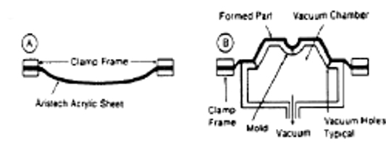
- Heated sheet in clamp frame.  - Mold is mechanically positioned to heated sheet, forming a seal. Vacuum is then applied to form part. | - Heated sheet in clamp frame.  - The mold is forced into the sheet to a depth that forms a seal around the periphery. Vacuum is then applied to form the part.

3. Vacuum/snap-back forming
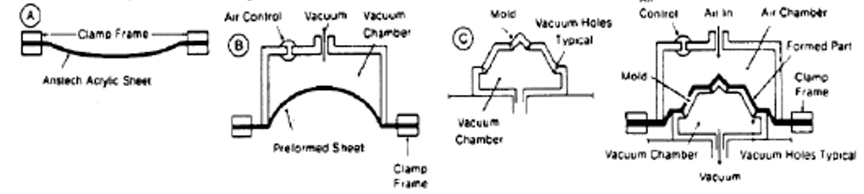
- Heated sheet in clamp frame.
- Position vacuum chamber to heated sheet to form seal. Apply vacuum to form bubble to predetermined height.
- Insert mold into heated/prestretched sheet to form seal. Air control relieves vacuum in preform vacuum chamber. Apply vacuum to mold to form part.

4. Pressure bubble/snap-back forming
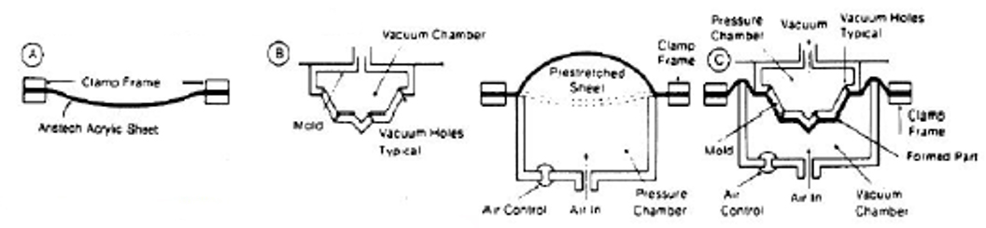
- Heated sheet in clamping frame.
- Position pressure chamber into heated sheet to form seal. Apply pressure to prestretched sheet to controlled height.
- Insert mold into prestretched bubble at a controlled rate. Insert to depth required to form a seal.

5. Pressure bubble/snap-back forming
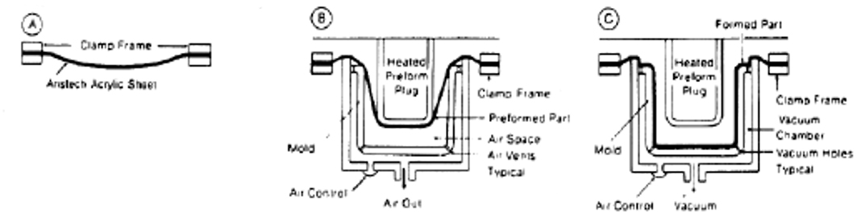
- Heated sheet in clamping frame.
- Position mold into heated sheet to form seal. Insert heated plug at controlled rate to the depth required for preforming.
- Apply vacuum to form part.

6. Pressure Bubble/Plug Assit/Vacuum Forming
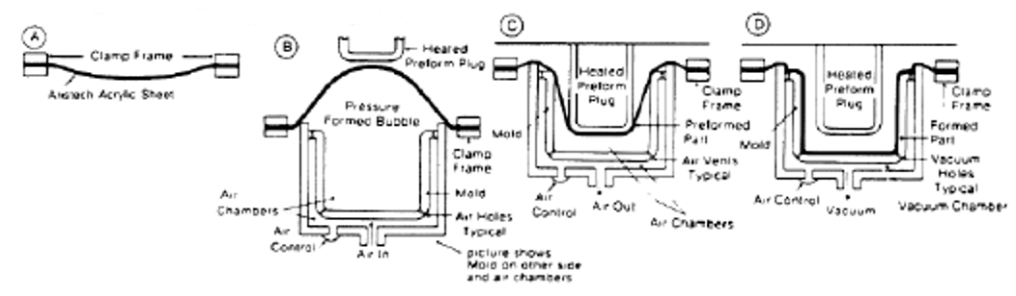
- Heated sheet in clamping frame.
- Position mold into heated sheet to form pressure seal. Apply pressure to prestretch sheet to controlled height.
- Insert heated plug into bubble at a controlled rate to the depth required for preforming.
- Apply vacuum to form part

Molds
WOOD—Wooden molds are easily fabricated, inexpensive and can be altered readily. Wood molds are ideal for short production runs where mold markoff is not important and for prototyping.
EPOXY—Epoxy molds yield the least amount of mold markoff of any of the mold materials used. Epoxy molds can be used for medium production runs and have good durability provided they are properly fabricated.
ALUMINUM—Aluminum molds are used in high production operations. Aluminum moIds will last indefinitely with little maintenance required.

Thermoforming troubleshooting guide
Problem | Probable Cause | Corrective Action
Blistering | • Sheet to hot. | • Reduce time heaters or reduce voltage.  • Move heater farther away.  • Use screening if localized.
Poor definition of detail.  Incomplete forming. | • Sheet too cold.  • Low vacuum.  • Sheet too thick.  • Low air pressure. | • Increase heat input to sheet.  • Check for leaks in vacuum system.  • Increase number and/or size of vacuum holes.  • Add vacuum capacity.  • Use thinner caliper sheet.  • Increase volume and/or pressure.
Excessive thinning at bottom of draw or corners. | • Poor technique.  • Sheet too thin.  • Drawdown too fast. | • Change forming cycle to include billowing or plug assist.  • Use screening to control temperature profile.  • Use thicker sheet.  • Decrease rate of drawdown.
Extreme wall thickness variations. | • Uneven sheet heating.  • Mold too cold.  • Sheet slipping.  • Stray air currents. | • Check temperature profile.  • Change heaters to provide higher uniform mold surface temp.  • Check cooling system for scale or plugs.  • Adjust claming frame to provide uniform pressures.  • Provide protection to eliminate drafts.
Excessive sag. | • Sheet too hot. | • Reduce time or temperature.
Pits or pimples. | • Vacuum holes too large.  • Vacuum rate too high.  • Dirt on mold or sheet. | • Use smaller holes.  • Decrease vacuum rate or level.  • Clean mold and/or sheet.
Part sticking to mold. | • Rough mold surface.  • Undercuts too deep.  • Not enough draft. | • Polish mold.  • Reduce undercuts.  • Change to split mold.  • Increase draft of mold.
Mark-off. | • Dirt on sheet.  • Dirt on mold.  • Dirt in atmosphere.  • Sheet too hot. | • Clean sheet.  • Clean mold.  • Clean vacuum forming area.  • Isolate area if necessary and supply filtered air.  • Reduce heat and heat more slowly.
Distortion in finished part. | • Part removed too hot.  • Uneven heating. | • Increase cooling time before removing part.  • Check cooling system.  • Check temperature profile.  • Correct mold design — stiffen to eliminate.

Thermoforming with polyethylene film

Temporary Polyethylene Film Barrier
Polyethylene film (polyfilm) is used as a temporary protective film on the top surface of the Aristech Acrylics cast acrylic sheet. Some processors may choose to leave the polyfilm on the acrylic surface during thermoforming. Aristech Surfaces does not recommend or oppose the use of this procedure, however some manufacturers use this procedure very successfully. Leaving the film on during thermoforming can cause problems if not done properly. For example, if the acrylic surface is overheated, the film may bond so tight that it is virtually impossible to remove it. Also, film left on a finished part will gradually bond tighter and tighter as time goes by. Film left on for more than one (1) year probably cannot be removed.
It is recommended that if the sheets have been sitting unwrapped or exposed for an extended period of time, to remove the polyfilm masking prior to forming. Since the protective film can absorb moisture, it could possibly transmit the moisture to the sheet when heating and cause blisters in the finished part.
Damage to the film may make it desirable to remove the film prior to thermoforming. Rough handling may scratch, tear or partially remove the film. Forming with the film damaged may leave unwanted marks on the acrylic surface. Once the film is removed from the sheet, it cannot be laid back on the surface. Air or other contaminates can become trapped under the film and cause markoff on the finished product.

Note: for cautions and information on exposure to any Aristech Surfaces’ product, please see the applicable material safety data sheet.
Information contained herein is: a) based on Aristech Surfaces’available technical data and experience; b) intended only for individuals having applicable technical skill, with such individuals assuming full responsibility for all design, fabrication, installation, and hazards; c)to be used with discretion and at one’s own risk, after consultation with local codes and with one’s independent determination that the product is suitable for the intended use; and d)not to be used to create designs, specifications, or installation guidelines. Aristech Surfaces makes no representation, or warranty, express or implied, and assumes no liability or responsibility as to: i) the accuracy, completeness or applicability of any supplied information; ii) results obtained from use of the information, whether or not resulting from Aristech Surfaces’ negligence; iii) title, and/or non-infringement of third party intellectual property rights; iv) the merchantability, fitness or suitability of the product for any purpose; or v) health or safety hazards resulting from exposure to or use of the product. Aristech Surfaces shall not be liable for x) any damages, including claims relating to the specification, design, fabrication, installation, or combination of this product with any other product(s), and y) special, direct, indirect or consequential damages.

