Trexel becomes part of the ENGEL Group:
A strong future for physical foaming

Schwertberg, Austria / Wilmington, Massachusetts, USA – October 2025
Injection moulding machine manufacturer ENGEL is further expanding its technological leadership in foaming and, from early October 2025, acquires its long-standing partner Trexel Inc., headquartered in Massachusetts, USA.

Trexel is globally recognised for the development and commercialisation of MuCell® technology, a microcellular foaming process in injection moulding. With this acquisition, the company gains the stability and long-term perspective needed to advance its technology successfully. “Trexel is a pioneer in physical foaming. We are convinced that this technology holds tremendous potential. With ENGEL in the background, Trexel can operate independently while benefiting from the global strength of our group,” says Stefan Engleder, CEO of the ENGEL Group.

Trexel remains independent
As part of the ENGEL Group, Trexel will continue to operate independently — with its own sales, service and R&D. For injection moulding customers, this means continuity in support and delivery capability, regardless of the machine brand they use. In addition, the company will continue its commitment to the footwear segment without change. All partners will continue to be served with the same high quality as before.

Foaming as a strategic field for the future
ENGEL has long been a leading name in foaming and has collaborated with Trexel for many years. Alongside initiatives in chemical foaming, the combination with Trexel further strengthens ENGEL’s leading role in physical foaming. “Through this acquisition, we are accelerating the further integration of MuCell® into the injection moulding process. We also now have the ability to scale more easily — because we are convinced that foaming is a growth market,” Engleder adds.
The technology is also a key building block for greater sustainability: foamed products are lighter, require less raw material and help reduce the carbon footprint.

Integration into the ENGEL Group
Going forward, Trexel will operate as Trexel GmbH, headquartered in Austria. Levi Kishbaugh will remain responsible for market and customer relations, safeguarding continuity. He will be joined on the management team by Johannes Kilian. Sites in the USA, Germany and China will remain unchanged to continue providing sales and service for the global customer base.

Images: ENGEL
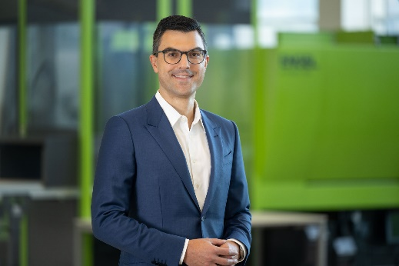
Stefan Engleder, CEO, ENGEL Group

ENGEL AUSTRIA GmbH
ENGEL is one of the leading companies in the plastics machinery industry. Today, the ENGEL Group offers all technology modules for plastics processing from a single source: injection moulding machines for thermoplastics and elastomers and automation, whereby individual components are also competitive and successful on the market. With twelve production plants in Europe, North America and Asia (China, Korea and India) as well as subsidiaries and representatives for over 85 countries, ENGEL offers its customers worldwide optimal support to be competitive and successful with new technologies and state-of-the-art production facilities.

Trexel Inc.
Founded in 1995, Trexel is headquartered in Wilmington, Massachusetts, USA. The company is a global leader in microcellular foaming technologies for the plastics industry. In addition to subsidiaries in Germany and China, Trexel collaborates with a worldwide network of distributors and partners.

MuCell® technology
MuCell® is a microcellular foaming process in injection moulding. A supercritical fluid — typically nitrogen or CO₂ — is introduced into the polymer melt, creating a fine foam structure in the part that reduces weight and material usage while improving component properties.

Contact for journalists:
Anna Sterrer, Deputy Head of Group Communications, ENGEL AUSTRIA GmbH, Ludwig-Engel-Straße 1, A-4311 Schwertberg/Austria
E-Mail: anna.sterrer@engel.at
Contact for readers:
ENGEL AUSTRIA GmbH, Ludwig-Engel-Straße 1, A-4311 Schwertberg/Austria,Tel.: +43 (0)50/620-0, Fax: -3009, E-Mail: sales@engel.at
Legal notice:
The utility names, trade names, product descriptions and the like mentioned in this press release may be trademarks and protected as such even without special marking.
www.engelglobal.com

