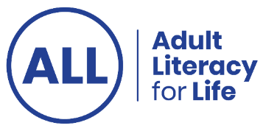
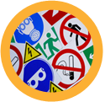
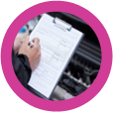


Let's talk about community and inclusion this September

Welcome to our community and inclusion interactive literacy calendar. This free interactive calendar brings together a wide range of resources that support inclusion, participation and lifelong learning. Throughout the month you can click on a different calendar entry each day to discover new information, practical tools, inspiring stories, videos, courses and learning resources.

We created this calendar for anyone who wants to build more inclusive communities and learning environments. It will be useful for adult learners, educators, tutors, community organisations, employers, volunteers, public service staff and anyone interested in inclusion.

The calendar includes resources developed by and for diverse communities. We’ve covered topics such as accessible information, plain language, universal design for learning, assistive technology, family learning, workplace inclusion, learner voice, community participation and literacy-friendly services. We hope this calendar helps you discover new ideas, useful resources and practical ways to support inclusion in your work, your learning, and your community.

Thank you for exploring our Community and Inclusion Interactive Literacy Calendar.
Enjoy discovering a new resource each day.

Ctrl + click on the heading beside each number to view the resource.

- Introductory video to this month’s calendar resource A video explaining why we created this calendar, who it’s for and introducing some of the topics covered in the resources.

- Who are we now: Traveller women today
A video where Traveller women share who they are now and their experiences.

- Self-directed Universal Design course, from AHEAD
- Let’s chat ADHD - individual chatting about their ADHD
- Down Syndrome Ireland Book Clubs
- ALL awareness courses
- Down Syndrome Ireland (DSI) media literacy resources
- Down Syndrome Ireland transport resources
- Family learning resources to use at home or with families
- Skills for work videos, exercise and more, from DSI
- Learn with NALA
- Webinar: Introduction to Learn with NALA 11 November 2026
- Universal Design for Learning and Beyond the Classroom
- Assistive Technology resources - AT Hive
- Accessible information resources - Inclusion Ireland
- Online course: Substance Use and Neurodiversity
- Creating accessible documents - NDA
- Aontas learner stories
- Dyslexia and adult learning
- Autism and inclusive learning - As I Am
- Resources and supports for deaf and hard-of-hearing people
- Deafblind awareness training - Anne Sullivan Centre
- Age positive workplace training - Age Action
- AI Ready - AI made simple for everyone
- Digital library of accessible reading materials - Vision Ireland
- Neurodiversity in higher education
- Work ready programme - employment ready modules
- Webinar: Being literacy friendly with Pavee Point Traveller and Roma Centre
- Financial literacy guide for adults with ADHD
- JAM Cards – for you and for business
- Inclusion Ireland Resource Hub
- Libraries Ireland Skills for Life
- Map of Family Resource Centres

- Reading material developed by and for the Traveller Community
- Free resources to develop English language skills

