Case Study – Smile Project
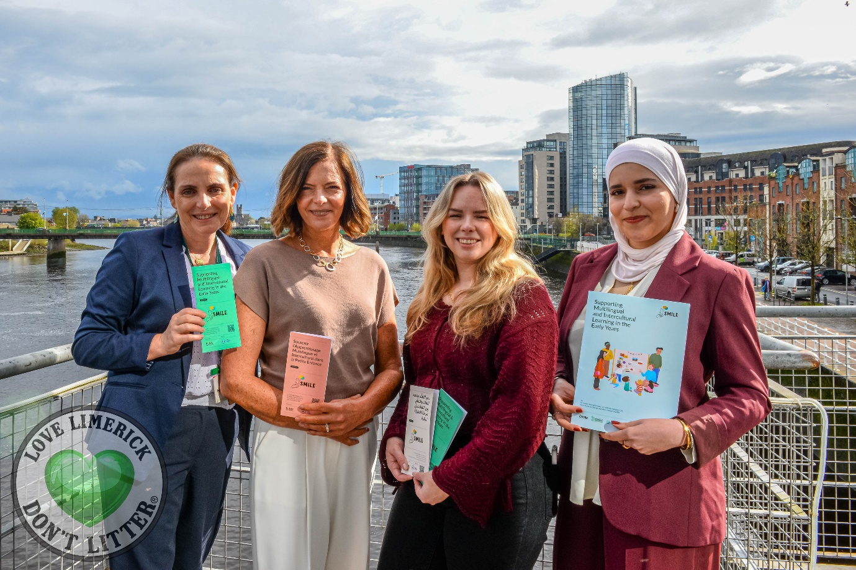
Summary of Good Practice
Through my work as a migrant guidance counsellor, I regularly encounter parents struggling with questions around multilingualism, identity, belonging, and language development. Many families receive conflicting advice about whether speaking their home language will negatively affect their child’s English acquisition, often leaving parents feeling uncertain and unsupported.

The SMILE Project (Supporting Multilingual and Intercultural Learning in the Early Years) was developed to support the growing linguistic and cultural diversity within Early Years settings in Limerick and Clare through practical, accessible and culturally responsive resources and supports.

The project aimed to support multilingual children, families, and educators by providing research-informed resources that promote inclusion, belonging, positive language development, and greater understanding of multilingualism.
SMILE was developed collaboratively with migrant parents, Early Years educators, community organisations, and academic partners to ensure that all resources reflected both professional expertise and lived experience. The project also sought to challenge common myths surrounding multilingualism and promote the understanding that maintaining a child’s home language supports emotional wellbeing, identity development, confidence, and overall educational outcomes.
Resources developed through the project included:
- Multilingual parent guidelines and information leaflets on language development and bilingualism, translated into multiple languages
- Resource posters and practical supports for Early Years educators
- Policy briefs and research resources for researchers and stakeholders
- Community engagement sessions and workshops for parents and professionals
The project focused on creating inclusive Early Years environments where multilingual children feel their languages, identities, and cultures are recognised and valued.
Stakeholders
- Doras
- University of Limerick
- Limerick and Clare Education and Training Board
- Limerick City Partnership
- Migrant parents and families
- Early Years educators and childcare providers
- Speech and language specialists
- Community workers and intercultural support organisations

Innovation / Key Features
- Co-designed with migrant parents and educators using a participatory approach
- Combined lived experience with academic research and professional expertise
- Focused on practical, easy-to-use resources for everyday settings
- Promoted multilingualism as a strength and asset rather than a barrier
- Addressed emotional wellbeing, identity, belonging, and inclusion alongside language development
- Delivered multilingual resources accessible to diverse communities
- Built strong collaboration between community, education, and academic sectors

Resources Required
- Funding support through the Adult Literacy for Life (ALL) Strategy funded by SOLAS
- Staff time for project coordination and stakeholder engagement
- Collaboration with speech and language experts and researchers
- Translation and design services for multilingual materials
- Community consultation workshops and focus groups
- Partnership support from local organisations and educators

Key Outcomes and Impact
- Increased awareness among parents and educators about the benefits of multilingualism
- Improved confidence among parents in maintaining home languages
- Greater understanding among educators of inclusive multilingual practices
- Strengthened collaboration between migrant communities and Early Years services
- Development of accessible multilingual resources for ongoing use
- Reduced stigma and misconceptions surrounding bilingualism and language development
- Enhanced focus on children’s identity, belonging, and emotional wellbeing in Early Years settings

Limitations / Challenges
- Persistent myths and misconceptions around multilingualism
- Limited time and capacity within Early Years settings
- Need for continued funding and long-term sustainability
- Challenges in reaching all linguistic communities equally
- Requirement for ongoing educator training and awareness-building
- Limited availability of multilingual resources across some services

Key Lessons Learnt
- Parents’ lived experiences are essential in shaping meaningful supports
- Early intervention and support in the Early Years is critical
- Language is closely connected to identity, culture, wellbeing, and belonging
- Practical, accessible resources are more effective than overly academic materials
- Cross-sector collaboration strengthens impact and sustainability
- Educators benefit from reassurance and practical guidance rather than theory alone
- Inclusion is most effective when children and families feel their full identities are recognised and valued

Recognition and Future Development
- Following the success of the SMILE Project, the team developed SMILE+, an expanded initiative aimed at strengthening inclusive supports for multilingual children and families. The project received first prize at the University of Limerick Citizens’ Assembly, recognising its innovation, community impact, and commitment to inclusion and belonging.
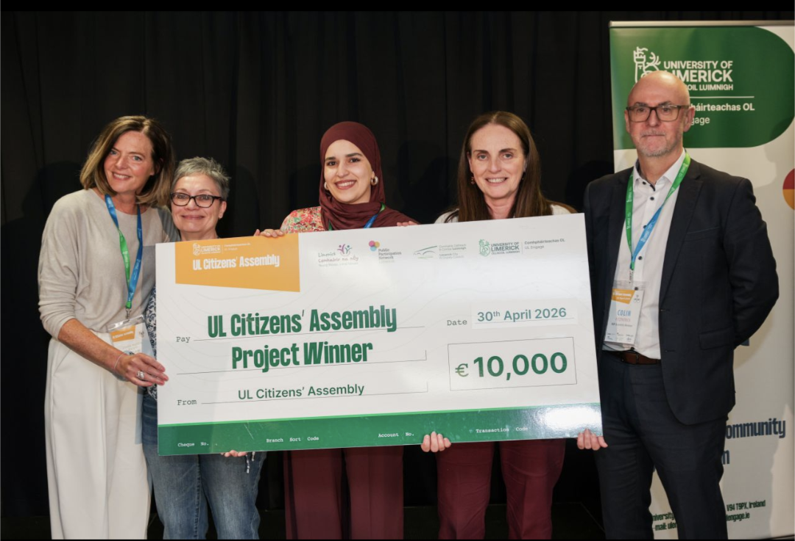

Further information:
SMILE Project finds supporting multilingual children to develop their home language nurtures identity and belonging https://www.ilovelimerick.ie/smile-project-limerick-launch/
Supporting multilingual children to develop their home language nurtures their identity, confidence and belonging – new research | Doras
Resources: https://doras.org/smileproject

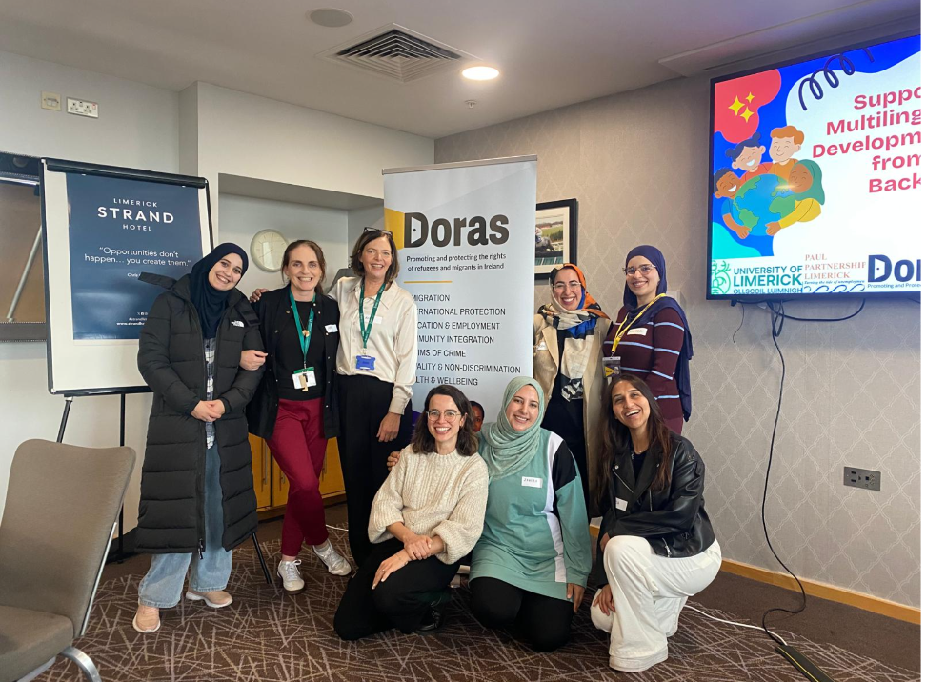
Workshops with parents



