International Literacy Day 2026
Celebrating literacy across Ireland
What’s on?
To mark International Literacy Day (8 September), we're sharing some events and activities hosted by organisations and partners across Ireland throughout September and October.
October is Health Literacy month, so the guide includes health literacy events and activities.
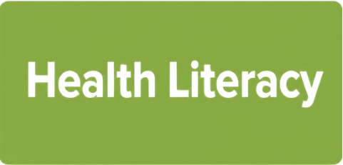
We use this green box to show which events are about Health Literacy.

All events are free and open to the public.

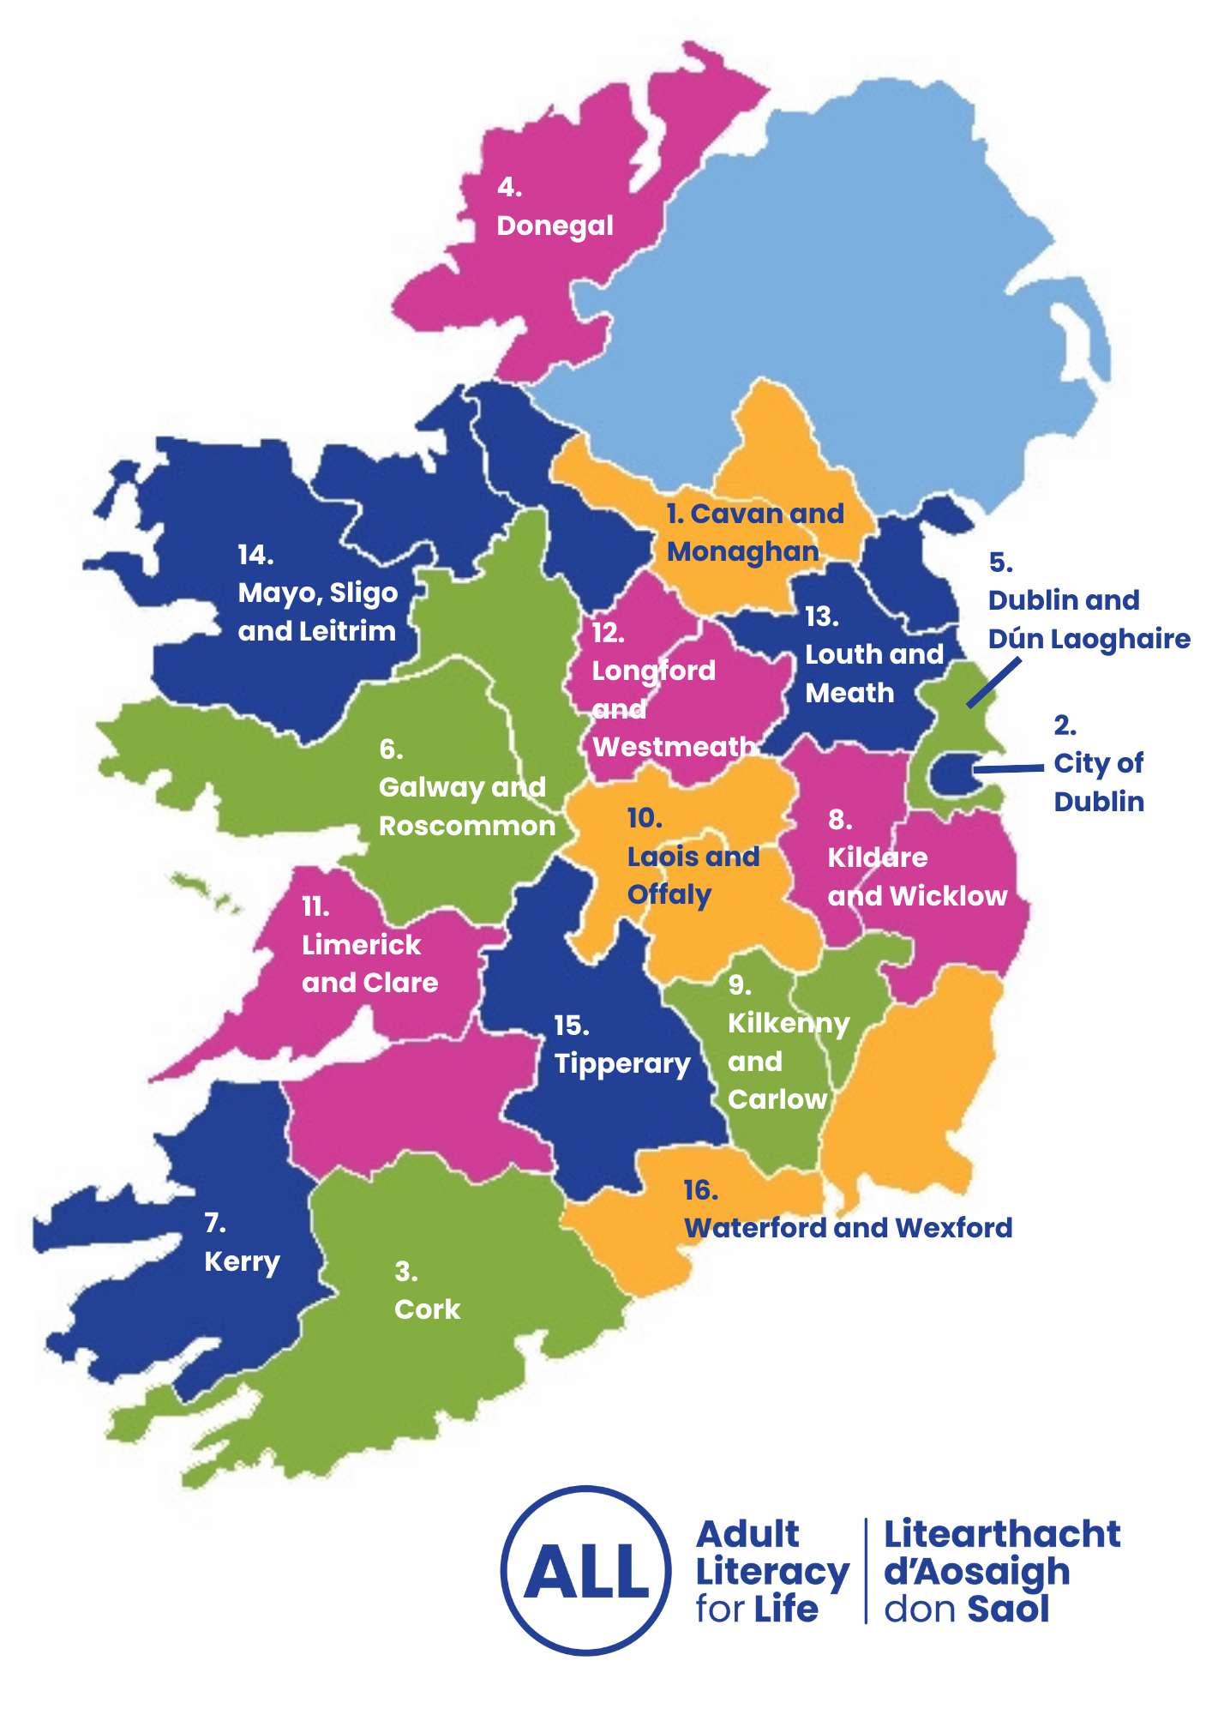

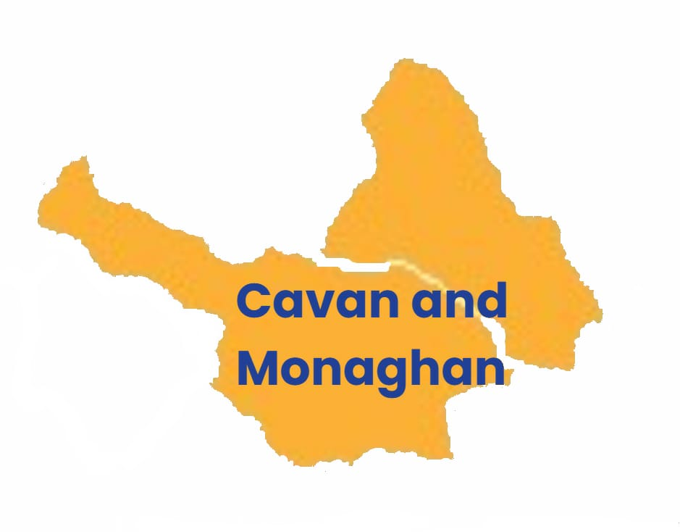

1. Cavan Monaghan
Digital literacy (Webinar)
CMETB tutors' presentation on introductory digital literacy projects.

Where: Online

When: Thursday 24 September, 1pm - 2pm

Making literacy and numeracy part of everyday teaching across FET (Webinar)
Professional learning and development session delivered by Claire O'Boyle and Ceinwen Fergus.

Where: Online

When: Tuesday 1 September, 2pm - 4pm

Literacy, numeracy and plain English in practice (Webinar)
How to include literacy and numeracy in Further Education and Training, including using plain language to deliver a clear message.

Where: Online

When: Date to be confirmed, 2pm – 3.30pm

Your health is your wealth (Talk)
Free event for the public that includes presentations on health, financial and energy literacy. Will feature stands from coalition members and light refreshments.

Where and when:

- Cavan Town Hall Theatre, Thursday 10 October from 11am to 1pm
- Monaghan Peace Campus, Thursday 15 October from 11am to 1pm

Contact
Ceinwen Fergus
Regional Literacy Coordinator
Email: ceinwenfergus@cmetb.ie

Contact Ceinwen for more information or to register for an event.

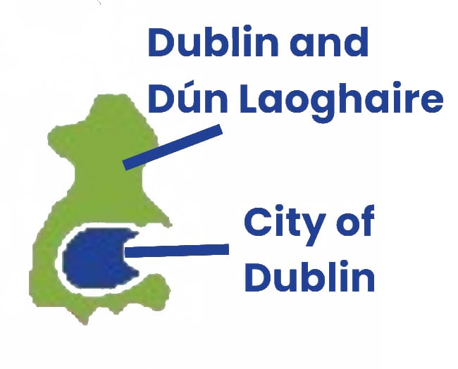
2. City of Dublin
Andrew Connolly is your Regional Literacy Coordinator for the City of Dublin.

You can contact Andrew on andrew.connolly@aes.cdetb.ie to find out more about what is happening in your area.

5. Dublin and Dún Laoghaire
Health literacy (Webinar)
Doreen Carpenter and Kathleen Joyce will present on Traveller mental health.

Where and when:
Online on Wednesday 10 September from 1pm- 2pm.

Contact Helena Browner, Regional Literacy Coordinator, for the Teams link at helenabrowner@ddletbaes.ie

Digital literacy (Webinar)
Mary Mitchell will present on digital literacy.

Where and when:
Online on Thursday 24 September from 1pm-2pm.

Contact Helena Browner, Regional Literacy Coordinator, for the Teams link at helenabrowner@ddletbaes.ie

Literacy hub at the library (Hub)
Drop in literacy hub at Blanchardstown Library

Where: Blanchardstown Library, The Civic Centre, Blanchardstown Centre, Dublin 15

When:
Every Wednesday, 10am-12pm

9 September
16 September
23 September
30 September

Booking:
- Email: dlrlexiconlib@dlrcoco.ie
- Phone: 01 2047219

Digital literacy (Workshop)
Six-week digital literacy course for learning how to use your smart phone.

Where: LexIcon Library, 1 Haddington Terrace, Dún Laoghaire, Co Dublin

When:
Every Wednesday 10am-12pm

4 November
11 November
18 November
25 November
2 December
9 December

Booking:
- Email: dlrlexiconlib@dlrcoco.ie
- Phone: 01 2047219

Digital literacy at the library (Workshop)
Six-week digital literacy course for learning how to use your smart phone.

Where: LexIcon Library, 1 Haddington Terrace, Dún Laoghaire, Co Dublin

When:
Every Wednesday, 10am-12pm

4 November
11 November
18 November
25 November
2 December
9 December

Booking:
- Email: dlrlexiconlib@dlrcoco.ie
- Phone: 01 2047219

Guidance and literacy hubs (Hub)
Drop-in guidance and literacy hub

Where and when:
- Priorsgate Adult Education Centre, Tallaght, Dublin 24
Tuesday 8 September 10am -12pm
- Clondalkin Adult Education Centre, Clondalkin
Wednesday 9 September, 10am -12pm
- Lucan Adult Education Centre, Lucan
Thursday 10 September, 10am - 12pm

Booking:
- Email: helencleary@ddlebaes.ie for more information

Health literacy (Webinar)
Online health literacy information event to coincide with World Patient Safety Day.

Where and when:
Online on Thursday 17 September, 10am – 11am

Booking:
- Email: helencleary@ddlebaes.ie

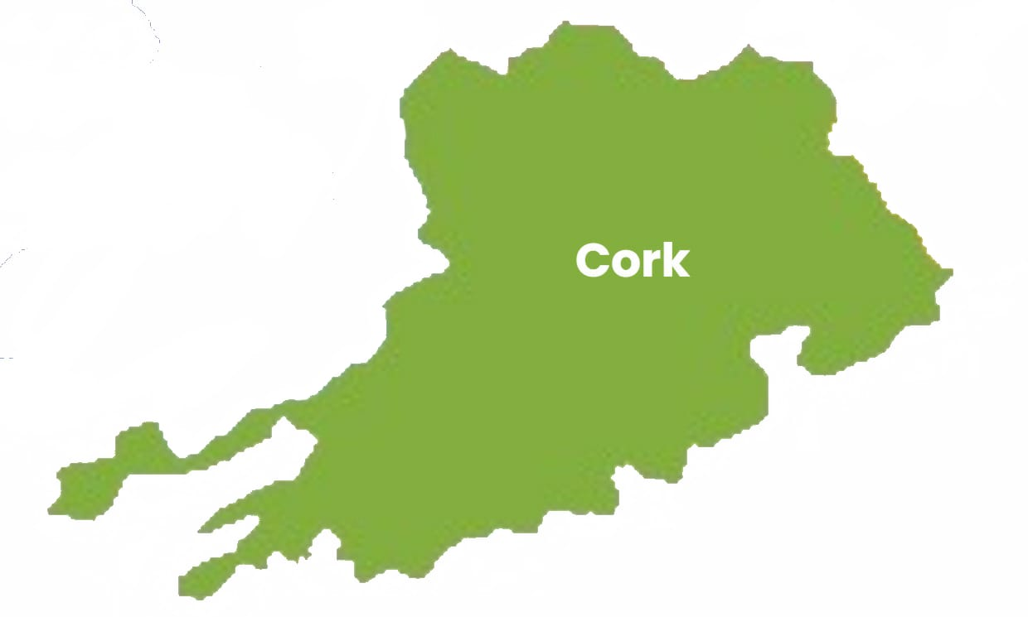
3. Cork
Healthy bones, better balance (Presentation)
Staying active and maintaining strength, balance and mobility are key to staying strong and steady on your feet. Norma Mulcahy, Neuromuscular Therapist, will provide you with information on the benefits of physical activity for mobility, bone health and brain health, as well as recommended activities for staying strong and steady, and simple ways to reduce fall risks at home.

Where:
Kanturk Library, Main Street, Kanturk, Co. Cork, P51 K886

When:
Friday 9 October, 11am

Medicinal herbs (talk)
Sonya McGee, medicinal herbalist, will discuss the gathering and traditional uses of herbal teas, their properties and medicinal values.

Where:
Bantry Library, Bridge Street, Town Lots, Bantry, Co. Cork, P75 K402

When:
Friday 25 September, 11am- 11:45am

Getting winter-ready: nourish, energise, and feel your best (talk)
A talk by nutritionist Garima Sieghardt.

Where:
Mallow Library, Thomas Davis Street, Mallow, County Cork, P51 DK50

When:
Friday 25 September, 2pm

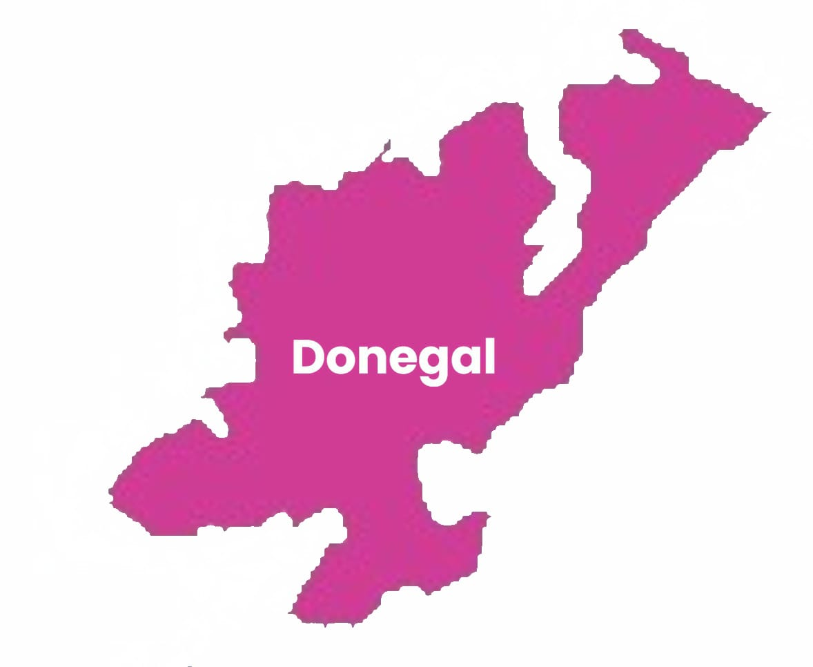
4. Donegal

Donegal voices: how literacy changes lives (Online)
A five-part podcast series highlighting the experiences of adults engaging with literacy, numeracy and digital skills services in Donegal, alongside the perspective of a volunteer tutor.

The series will share authentic learner stories that demonstrate the positive impact of adult learning on confidence, participation, wellbeing and everyday life.

The podcasts will help raise awareness of literacy services, challenge stigma, and encourage adults to explore learning opportunities available in their communities.

Where and when:
Episodes will be released weekly from the 8 September through Acast and distributed across major podcast platforms.

Health literacy talk
This health literacy session will help women build the skills and confidence to find, understand, evaluate and use health information when interacting with healthcare providers.

Participants will learn how to prepare for appointments, communicate effectively, ask questions, understand medical terminology, and make informed decisions.

Where: Community venue, Stranolar, County Donegal

When: Monday 7 September, 7.45pm

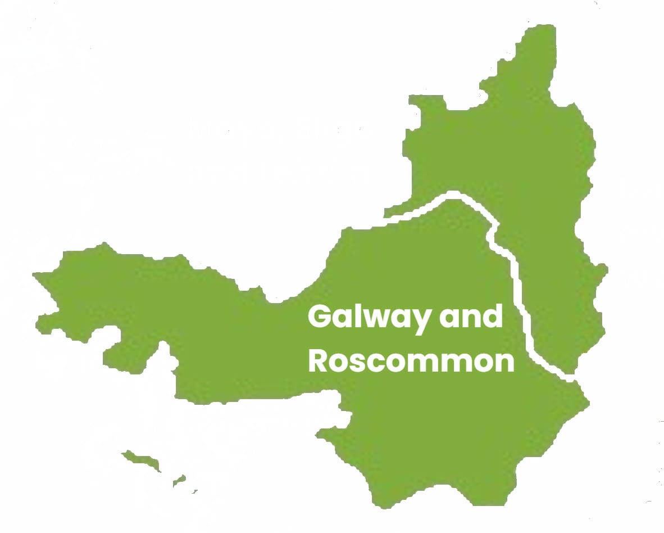
6. Galway and Roscommon

Please contact allinnovation@solas.ie for more information on literacy activities and events in Galway and Roscommon.

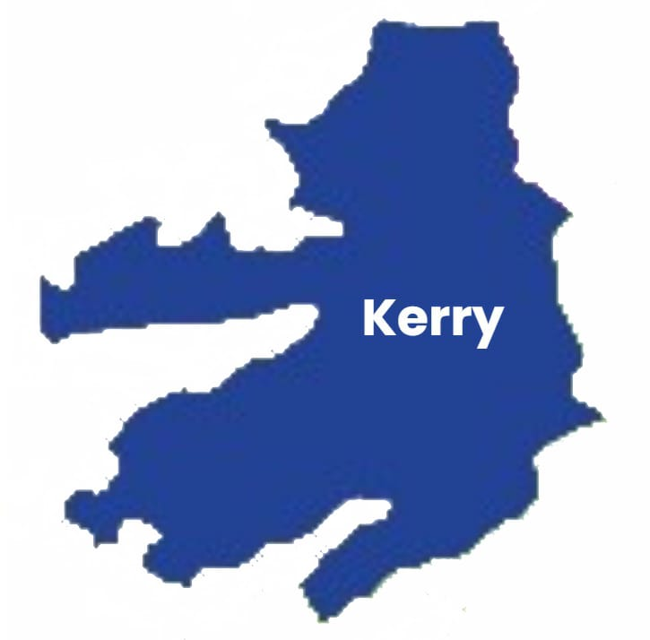
7. Kerry

Paula Tiller is your Regional Literacy Coordinator for Kerry.

You can contact Paula on paula.tiller@kerryetb.ie to find out more about what is happening in your area.

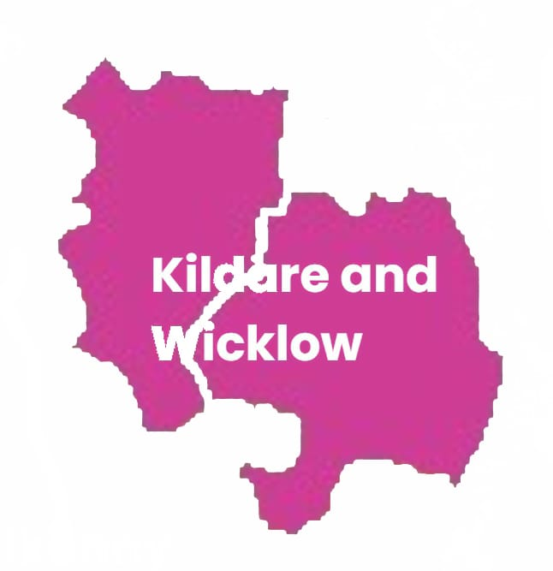
8. Kildare and Wicklow

Literacy in real life - stories and voices across communities (Webinar)

A series of free online lunchtime talks to celebrate International Literacy Day 2026. For more information, please click here https://kwetb.ie/international-literacy-day-2026/

Where and when:
Online every Thursday in September and 1 October, 1pm – 2pm

Health literacy and digital learning (Course)

A pilot course in safe internet and digital learning with long-term prisoners in Shelton Abbey.

Where and when:
Shelton Abbey Prison, Arklow, County Wicklow, Y14 T638
September-October 2026

For more information:

Email: IrynaAvalishvili@kwetb.ie
Phone number: 087 188 4355

Irish heart mobile unit health checks (Hub)

The Mobile Health Unit Service is a free service for community, based on a criterion with a focus on underserved communities. The service offers heart health information and free blood pressure and pulse checks.

Where and when:
Athy Further Education and Training College (FETC) Carlow Road, Athy, County Kildare, R14 D272
Wednesday 4 November

For more information:

Email: IrynaAvalishvili@kwetb.ie
Phone number: 0871884355

Managing and keeping your money safe (Workshop)
Financial literacy event.

Where and when:
Keadeen Hotel, Newbridge, County Kildare, W12 T925 on the 13 October, 10am-12am

For more information:

Email: newbridge@aib.ie
Phone: 087 095 3279

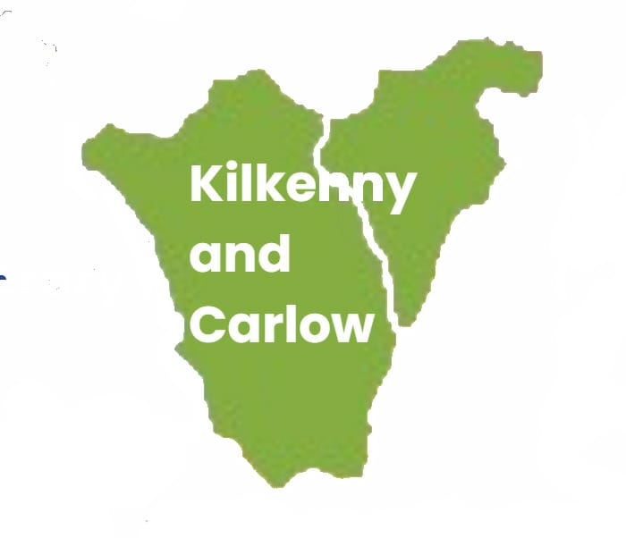
9. Kilkenny and Carlow
- Kilkenny and Carlow
Health literacy with Irish Heart Ireland (Talk)
The Mobile Health Unit Service is a free service for community, based on a criterion with a focus on underserved communities. The service offers heart health information and free blood pressure and pulse checks.

Where: Carlow Adult Learning Service, Tullow Road, Carlow

When: 13 October from 10am-3pm

Health literacy in the library (Stand)
Health literacy stand in local libraries in Carlow and Kilkenny

Where and when:

Bagenalstown library, Bagenalstown, County Carlow
10 September from 10am-1pm

For more information:

Email: deirdre.geoghegan@kcetb.ie
Phone: 087 7675547

Health literacy at your library (Stand)
Health literacy stand in the local library promoting health literacies and other supports.

Where and when:
Ferrybank Library, Belmont Road, Ferrybank, Co. Kilkenny
Wednesday 23 September from 10am-1pm

For more information:

Email: deirdre.geoghegan@kcetb.ie
Phone: 087 7675547

Tea /coffee cake and stories (Talk)
Come along for tea or coffee and some cake. Bring a book to swap, if you would like to, and share your stories and experiences.

Where:
Leighlinbridge parish centre, Church street, County Carlow

When:
Tuesday 8 September, 11am- 1pm

For more information:

Email: deirdre.geoghegan@kcetb.ie
Phone: 087 7675547

Digital cafe with tea, coffee and cake (Hub)
Bring your phone and over tea, coffee, cake and a chat. Learn about how to use your phone.

Where:
Droichead Family Resource Centre, West Street, Callan, Co Kilkenny

When:
Tuesday 8 September, 11am- 1pm

For more information:

Email: deirdre.geoghegan@kcetb.ie
Phone: 087 7675547

Literacy awareness training (Workshop)
Literacy awareness training for AIB staff.

Where:
Langtons Hotel, 67-69 John Street Lower, Gardens, Kilkenny, R95 XN44

When:
Wednesday 16 September, 12am-1pm

For more information:

Email: deirdre.geoghegan@kcetb.ie
Phone: 087 7675547

Literacy awareness training (Workshop)
Literacy awareness training for Carlow county council training.

Where:
Carlow town library, Tullow street, Carlow town, R93 K126

When:
Wednesday 12 and Friday 14 August, 10am-11:30am
Wednesday 26 and Friday 28 August, 10am-11:30am

For more information:

Email: deirdre.geoghegan@kcetb.ie
Phone: 087 7675547

Open day (Hub)
Open day for the literacy service.

Where: Carlow adult learning centre, Tullow road, Carlow, County Carlow, R93 R2P0

When: Friday 11 September, 10am-3pm

For more information:

Name: Tara Kelly
Phone: 087 7675547

Literacy awareness training (Workshop)
Literacy awareness training for integration workers.

Where:
JETS (Jobs, Education, Training and Support) 61–63 Burrin street, Carlow, R93 H2V6

When:
Monday 7 September, 10:30am-11:30am

For more information:

Email: deirdre.geoghegan@kcetb.ie
Phone: 087 767554

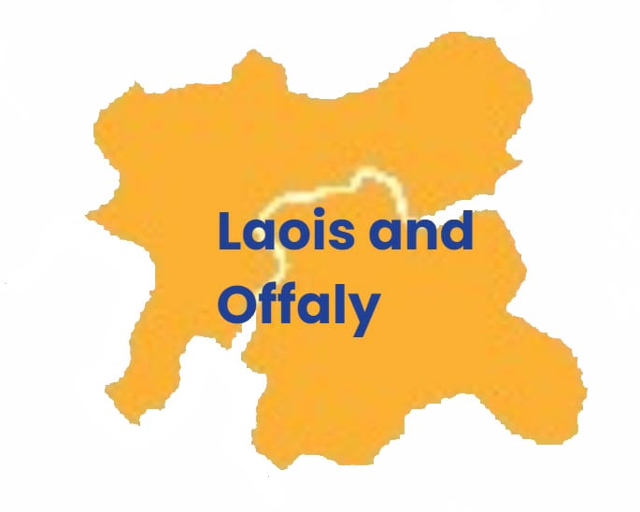
10. Laois and Offaly
Ask the experts (Hub)
Family health questions answered for parents and caregivers. Panel discussion with health experts, with information stands from Health Service Executive (HSE), Age Friendly, Money Advice and Budgeting Service (MABS), Citizens Information, An Garda Siochana, and health screenings from the Irish Heart Foundation.

Where and when:
Portarlington community centre, Portarlington, County Laois
Friday 16 October, 10am – 12:30am

Charleville community centre, Church St., Tullamore, Co. Offaly, R35H660
Monday 19 October, 10am – 12:30am

Open to the public, all welcome, registration link to follow.

Your money, your questions (Hub)
Hear from experts and connect with local supports. All welcome.

Where:
Midlands Park Hotel, Jessop Street, Maryborough, Portlaoise, Co Laois, R32KV20

When:
Tuesday 20 October, 10am - 12.30pm

Open to the public, all welcome, registration link to follow.

Launch of Laois Offaly literacy friendly template (Event)
Launch of Laois Offaly literacy friendly template and pilot to celebrate International Literacy Day.

Where:
Portlaoise Library, 23 Lower Main Street, Portlaoise, County Laois, R32 N7EP

When:
Wednesday 9 September, 12pm-1pm

For more information:

Email: rlawlor@loetb.ie
Phone: 085 8442576

Literacy awareness training (Workshop)
Literacy awareness training for literacy champions in Laois and Offaly.

Where:
Midlands Skills Centre, Unit 25 / 26E Axis Business Park, Tullamore, Co. Offaly, R35 TF80

When:
Monday 21 September, 09.30am - 2pm

Open to participants of Laois and Offaly Literacy Champions Programme. For more information, email rlawlor@loetb.ie

Plain language training (Workshop)
Sean Driver from the National Adult Literacy Agency (NALA) will deliver plain language training for literacy champions in Laois and Offaly.

Where:
Online

When:
Thursday 1 October, 09.30am - 12.30pm

Open to participants of Laois and Offaly Literacy Champions Programme. For more information, email rlawlor@loetb.ie

Access and inclusion through literacy (Workshop)
Information session for Literacy Champions in Laois and Offaly.

Where:
Midlands Skills Centre, Unit 25 / 26E Axis Business Park, Tullamore, Co. Offaly, R35 TF80

When:
Tuesday 6 October, 09.30am- 2pm

Open to participants of Laois and Offaly Literacy Champions Programme. For more information, email rlawlor@loetb.ie

Universal design training (Workshop)
Training in universal design for literacy champions in Laois and Offaly, delivered by Lorraine Gallagher from the Association for Higher Education Access and Disability (AHEAD).

Where:
Midlands Skills Centre, Unit 25 / 26E Axis Business Park, Tullamore, Co. Offaly, R35 TF80

When:
Wednesday 14 October, 10am - 2pm

Open to participants of Laois and Offaly Literacy Champions Programme. For more information, email rlawlor@loetb.ie

Disability awareness training (Workshop)
Disability awareness training for literacy champions in Laois and Offaly, with speakers from Vision Ireland and Chime.

Where:
Midlands Skills Centre, Unit 25 / 26E Axis Business Park, Tullamore, Co. Offaly, R35 TF80

When:
Friday 23 October, 9.30am - 2pm

Open to participants of Laois and Offaly Literacy Champions Programme. For more information, email rlawlor@loetb.ie

Learning through the arts (Course)
Express yourself, connect with others, and develop new skills through a blend of music, maths, and drama in our new course programme.

Where:
Laois Offaly Education and Training Board (LOETB) Learning Hub, Mountmellick Road, Portlaoise, R32 ED21

When:
Week starting on the 21 September

Contact us now on 057 866 1338 or learninghub@loetb.ie to register your interest

Learning through film (Course)
Improve your computer skills, build confidence in literacy, and strengthen your everyday maths with our new course programme.

Where:
LOETB Learning Hub, Mountmellick Road, Portlaoise, R32 ED21

When:
Week starting on the 21 September

Contact us now on 057 866 1338 or learninghub@loetb.ie to register your interest.

Green skills for everyday life (Course)
Discover how active lifestyle choices, nutrition, and climate awareness can help you create a better future for yourself and your community in our new course programme.

Where:
LOETB Learning Hub, Mountmellick Road, Portlaoise, R32 ED21

When:
Week starting on the 21 September

Contact us now on 057 866 1338 or learninghub@loetb.ie to register your interest.

Skills for work - hospitality and customer service (Course)
Get job ready and gain practical experience in Barista, Retail Skills and Communications through IT, to help you succeed in today's workplace.

Where:
LOETB Learning Hub, Mountmellick Road, Portlaoise, R32 ED21

When:
Week starting on the 21 September

Contact us now on 057 866 1338 or learninghub@loetb.ie to register your interest.

Trade start (Course)
Learn trade basics in Finances, Woodwork, and Painting and Decorating all in one place with our new course programme.

Where:
LOETB Learning Hub, Mountmellick Road, Portlaoise, R32 ED21

When:
Week starting on the 21 September

Contact us now on 057 866 1338 or learninghub@loetb.ie to register your interest.

Student space launch
Training and commencement of the student council in the adult learning hub in the adult literacy service.

Where:
LOETB Learning Hub, Mountmellick Road, Portlaoise, R32 ED21

When:
Voting and training date for early October.

Contact us now on 057 866 1338 or learninghub@loetb.ie for more information

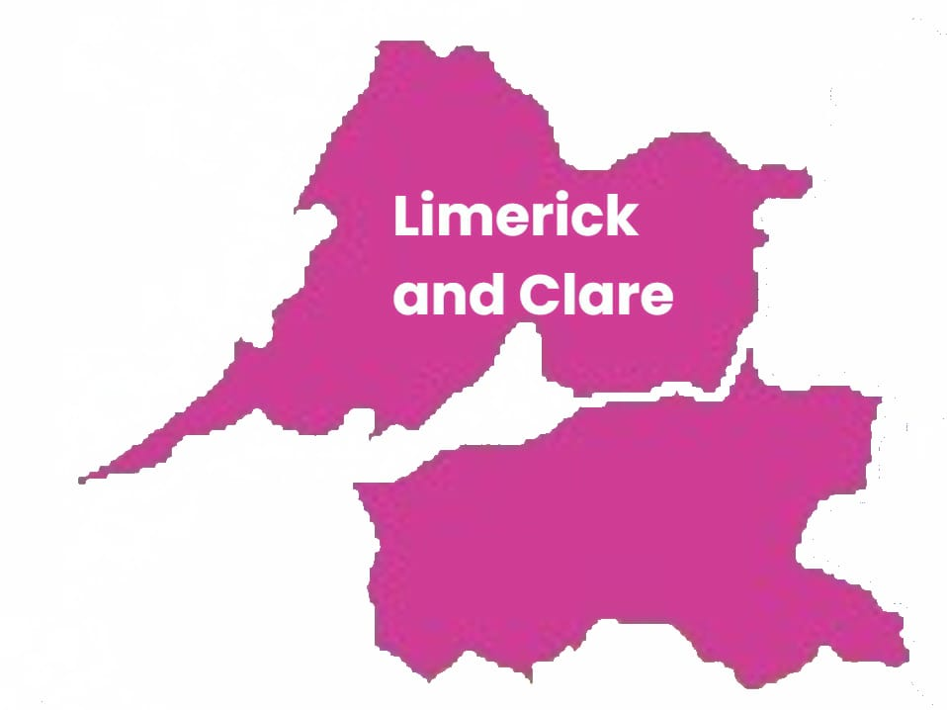
11. Limerick and Clare
Taking charge of your health (Workshop)
Come along to find out more about understanding health information, asking questions, making informed choices and taking charge of your health. Tea, coffee and scones will be served on arrival.
The workshop will be followed by a light lunch. Everyone welcome!

Where:
Hospital Family Resource Centre, Knockainey Road, Hospital, Co. Limerick, V35 RP26

When:
Tuesday 8 September, 10am – 12pm

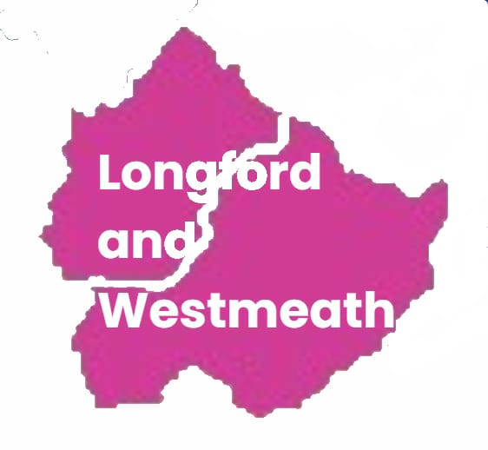
12. Longford and Westmeath
Literacy for people, the planet and prosperity- 60th International Literacy Day celebration in Athlone library (Event)
Health and wellbeing for people and the planet in Athlone Library.

Where and when:
Athlone Library, Athlone Civic Centre on 8th September, 11am – 1pm.

Booking:
For more information or to book a place, contact Anne Maria Egan on 085 857 0991 or email aegan@lwetb.ie.

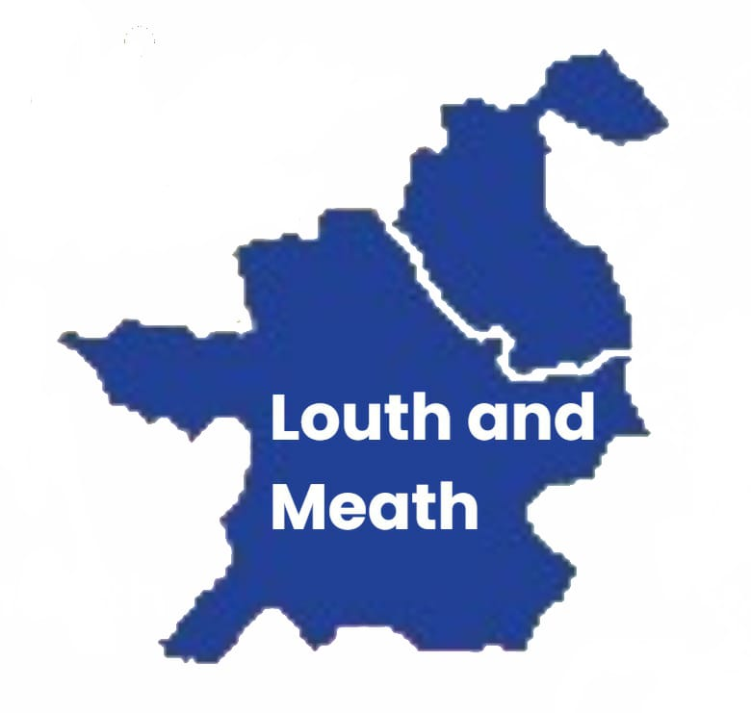
13. Louth and Meath
Becoming work ready (Workshop)
Skills for life in the libraries in collaboration with LMETB guidance department and Adult Literacy for Life will deliver a becoming work ready roadshow across 15 libraries in Meath from September to November.

The sessions are 1 hour and will focus on

- C.V prep,
- interview techniques,
- adult learning and training options,
- finding the right course, and
- apprenticeships explained, among other topics.

Where and when:

Nobber library, Main Street Nobber Co. Meath A82 YW99
10 September, 10.30am to 11.45am

Slane library, Castle Hill Slane Co. Meath C15 XWF5
18 September, 10.30am to 11.45am

Trim library, High Street, Trim, Co. Meath, C15 P668
24 September, 6.15pm to 7.30pm

Duleek library, Main Street, Duleek, Co. Meath A92 CR33
1 October, 10.30am to 11.45am

Dunboyne library, Castle View Dunboyne Co. Meath A86 H393
5 October, 10.30am to 11.45am

Oldcastle library, Millbrook Road, Oldcastle A82 N125
16 October, 10.30am to 11.45am

Ballivor library, Ballivor Co. Meath C15 HT27
21 October, 10.30am to 11.45am

Bettystown library, East Meath Civic Centre Seaview Terrace Bettystown Co. Meath A92 AEC6
27 October, 6.15pm to 7.30pm

Dunshaughlin library, Main Street Dunshaughlin Co. Meath A85 KW81
6 November, 10.30am to 11.45pm

Kells library, Maudlin Street Kells Co Meath A82 YN52
11 November, 10.30am to 11.45am

Ráth Cairn library, Ráth Cairn, Baile átha Buí, Co. Na Mí C15 A9X3
18 November, 10.30am to 11.45am

Athboy library, Main St, Athboy, Co. Meath C15 TY80
27 November, 10.30am to 11.45am

Navan library, Railway Street Navan Co. Meath C15 RW31
1 December, 6.15pm to 7.30pm

Family literacy workshop (Workshop)
A workshop for community groups and organisations who would like to learn about family literacy and how they can introduce it into their centres.

Where: City North Hotel, Gormanston, K32W562, County Meath.

When: Monday 12 October, 9.30am to 2pm

For queries and how to register please contact: Niamh McShane, nmcshane@lmetb.ie or call 086-2011988

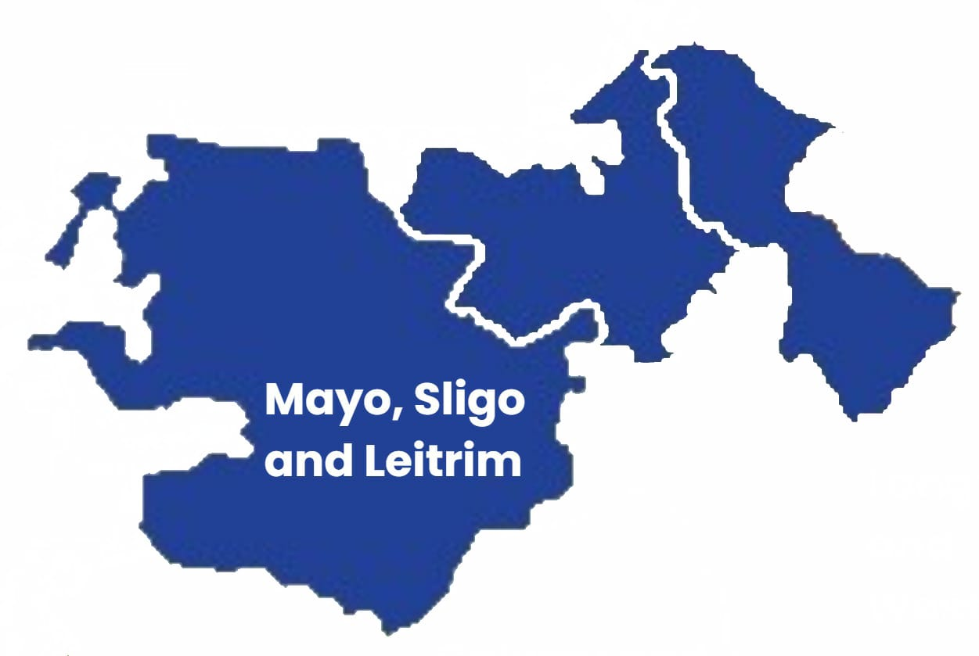
14. Mayo, Sligo and Leitrim

Yeats for All (Book launch)

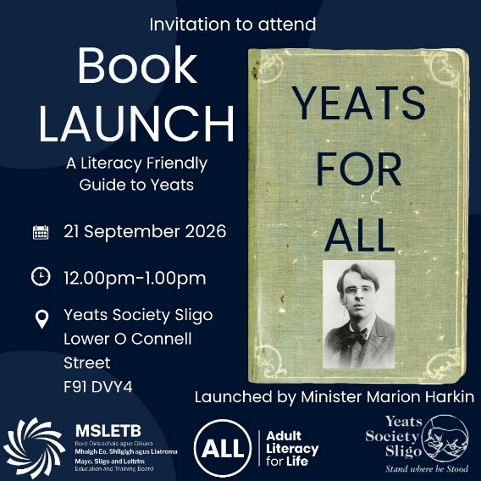

Join us for the launch of a groundbreaking new publication that makes the life, poetry, and legacy of W.B. Yeats more accessible than ever before.

This culturally accessible and literacy-friendly Plain English Guide to W.B. Yeats is the first of its kind, opening the door for readers of all ages, abilities, and backgrounds to engage with one of Ireland's greatest literary figures. Designed to break down barriers to understanding, the guide presents Yeats' poetry, themes, and connection to Sligo in clear, straightforward language while preserving the richness of his work and cultural significance.

Whether you are discovering Yeats for the first time, returning to his work after many years, or seeking an inclusive educational resource, this innovative guide offers a welcoming and engaging introduction to the renowned Sligo poet.

The launch will be officiated by Minister Marian Harkin, who will celebrate this important step towards making Irish literary heritage more inclusive, accessible and available to all.

Come along for an inspiring evening that honours the legacy of W.B. Yeats while championing the power of literacy, accessibility and lifelong learning.

Where: Yeats society Sligo, Lower O Connell, F91 DVY4

When: Monday 21 September, 12pm to 1pm

The Women’s health edit (Events)
Join us for The Women's Health Edit, exciting and empowering events designed specifically for women aged 30+ who want honest, expert-led conversations about their health, hormones, and overall wellbeing.

The Women's Health Edit is a celebration of women supporting women. Alongside expert health advice, you'll enjoy inspiring stories from successful female founders, practical wellness insights, networking opportunities, and plenty of surprises.

Whether you're navigating hormonal changes, looking to take control of your wellbeing, or simply want an evening of inspiration and connection, these events are for you.

Expect:

✓ expert advice on menopause, perimenopause and hormone health,
✓ honest, no-holds-barred discussions about women's health,
✓ inspiring conversations with successful female founders,
✓ beauty, wellness and self-care insights,
✓ Q&A opportunities with industry experts,
✓ exclusive giveaways, treats and surprises, and
✓ a supportive and empowering atmosphere.

Where and when:

Yeats society Sligo, Lower O Connell, F91 DVY4
Friday 16th October, doors open from 7pm

Sligo City Hall, Quay Street, Rathedmond, Sligo, F91 PP44
Friday 16th October, 12.30pm-13.30pm

GET LIT: hidden in plain sight (Podcast)
To mark International Literacy Day, join GET LIT for an important and honest conversation about adult literacy in Ireland. Despite common misconceptions, unmet literacy needs affect many adults across our communities, workplaces and public services.

In this special episode, three Regional Literacy Coordinators from the Adult Literacy for Life Strategy come together to discuss why literacy is everyone's business, what it means to create literacy-friendly organisations, and how a literacy-friendly society can empower people to fully participate in everyday life.

From navigating healthcare and financial services to supporting parents, employees and community members, literacy impacts every aspect of modern living. Hear expert insights, real-world examples and practical ways we can all help reduce stigma and improve accessibility.

A candid, thought-provoking conversation that shines a light on an issue often hidden in plain sight and explores how greater awareness can create a more inclusive Ireland for all.

Check out more episodes here MSLETB Get Lit! | Podcast on Spotify

When: released on Friday 4 September on Spotify

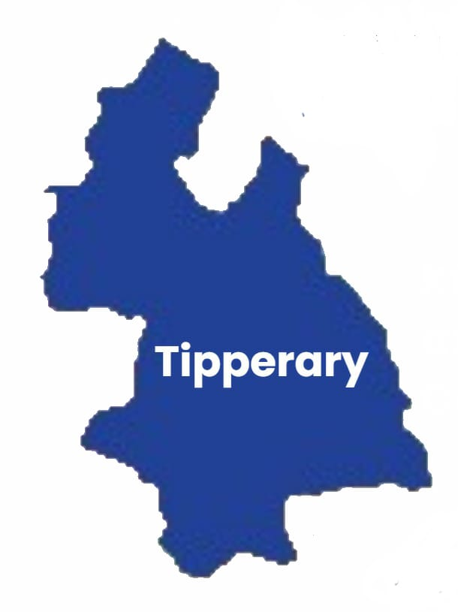
15. Tipperary

eLearning courses launch (Online)
ALL eLearning courses will be launched on TETB Moodle site.

Where and when: Tuesday 8 September, 9am

Introduction to plain language (Workshop)
A 1.5 hour introductory course to Plain Language.

Where and when:

Tipperary FET College, Tipperary Education and Training Board (ETB), Unit 1, Tyone, Nenagh, Co. Tipperary, E45 R896
Wednesday 9 September, 11am - 12.30pm

Online (https://teams.microsoft.com/meet/326969359072927?p=oEOSZ8WoyYJSPMuVDJ)
Wednesday 30 September, 11am - 12.30pm

Talbot Hotel Clonmel, Cahir Road, Clonmel, Co. Tipperary, Ireland
Wednesday 07 October, 11am - 12.30pm

Universal design learning and adult literacy for life (Training)
Full day course on literacy-friendly approaches to support universal design learning.

Where and when:
Archerstown Training Centre, Archerstown Business Park, Thurles, Co. Tipperary, E41 YH58
Friday 11 September, 9.30am-4pm

Financial literacy (Workshop)
Managing and keeping your money safe

Where and when:
Talbot Hotel Clonmel, Cahir Road, Clonmel, Co. Tipperary
Thursday 24 September, 10.30am - 12pm

Literacy conference for part-time tutors (Conference)
Input session for tutors on universal design learning and 'Learning to Learn' for part-time tutors.

Where and when:
Technological University of the Shannon- Thurles campus, Thurles, Co. Tipperary
Monday 31 August, 11.30am - 12.30pm

Let's talk about health (Workshop)
The HSE librarian will discuss common health challenges in a workshop style event with space for group and personal questions afterwards.

Where and when:
Carrick-on-Suir Library, Fair Green, Carrick-on-Suir, Co. Tipperary, E32 X860
Monday 31 August, 11.30am - 12.30pm

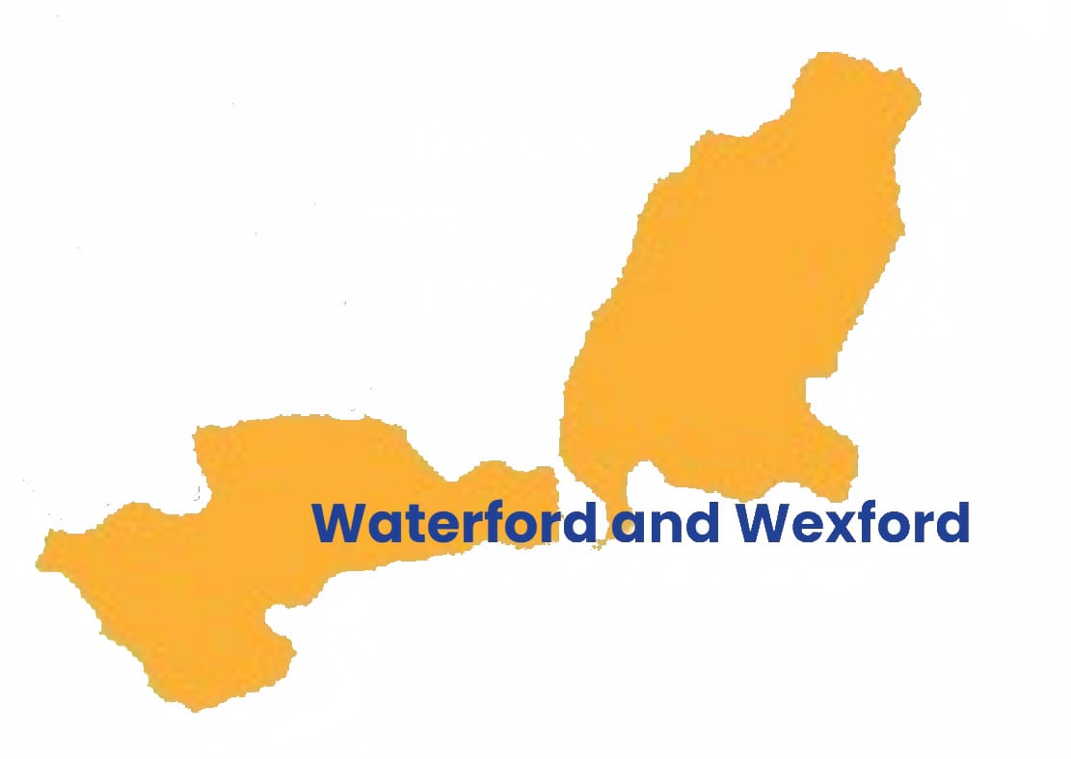

16. Waterford and Wexford
Managing and keeping your money safe (Event)
A free community event to support financial literacy skills among the public.

Where: The Tower Hotel, The Mall, Waterford

When: Thursday 17 September, 10am-11am

Booking:
Call 087 271 5845 or register on the day at the event

Literacy awareness training (Workshop)
Literacy awareness training workshop delivered by Edel Finan and Deirdre Geoghegan to AIB branch managers in the South-East. This is a private event.

Where: Langton's Hotel, 67-69 John Street Lower, Gardens, Kilkenny, R95 XN44

When: Wednesday 16 September

Plain language training to Wexford local development (Workshop)
Facilitating an in person plain language workshop to Wexford Local Development to mark International Literacy Day.

Where: Old Council Chamber, Wexford Local Development, Spawell Road, Wexford

When: Monday 21 September, 10:30am -1pm

Waterford and Wexford regional adult literacy coalition meets Donegal regional adult literacy coalition (Event)
Waterford and Wexford Regional Adult Literacy Coalition invited Donegal Regional Adult Literacy Coalition to join our meeting and share experiences of delivering the ALL strategy and developing regional adult literacy action plans.

Where: WWETB Wexford College of Further Education, Whitemill Industrial Estate, Wexford, Y35 XR22

When: Wednesday 16 September, 10am - 1pm

Literacy display for organisations (Event)
Literacy display for public facing reception areas and staff working with the public. This is an A5 4-tiered literacy display developed to signpost to WWETB, Adult Literacy for Life, and to eLearning digital literacy videos. The display also includes an A5 reading tips handout for the public.

Where and when: Online, 1 September 9am

Launch of community and inclusion interactive literacy calendar (Launch)
This free interactive calendar brings together a wide range of resources that support inclusion, participation and lifelong learning. Throughout the month you can click on a different calendar entry each day to discover new information, practical tools, inspiring stories, videos, courses and learning resources.

Where and when: Online, 1 September 9:00am

Community and inclusion interactive literacy calendar

Literacy awareness training (Workshop)
Literacy awareness training workshop will be delivered by Edel Finan to Waterford Probation Officers. This is a private event.

Where and when: Waterford City, Wednesday 23 September, 10am – 1pm

Healthy living for everyday life manual launch (Event)
This manual will provide information and guidance for other organisations across the country to plan and deliver a similar programme. The launch will be used to mark ILD and Health Literacy Month in October.

Where and when:
Wexford Primary Care Centre, Grogan's Road, Townparks, Wexford Town, Wexford, Y35 DA39
1 October

Radio interview with Waterford local radio (WLR)
Radio interview with Edel Finan, Regional Literacy Coordinator, and Maurice Sammon, Literacy Ambassador on Waterford Local Radio.

When: Tuesday 8 September, 11am-12pm

Teaching resources and materials review through a literacy and plain English lens (Workshop)
Workshop with Wexford Local Development educators, facilitated by Edel Finan (RLC), to review materials used through a literacy and plain English lens.

Where: Wexford Local Development Enniscorthy, 5 Slaney Pl, Templeshannon, Enniscorthy, Co. Wexford, Y21 FE81

When: Wednesday 30 September, 2pm - 4:30pm

Age friendly AI (Workshop)
This free, friendly and interactive AI workshop is designed to help participants build confidence in using AI technologies safely and effectively.

Where: Wexford Town Library, Mallin Street, Wexford, Co. Wexford, Y35 AY20

When: Monday 14th September, 2pm-3:30pm

Launch of ALL literacy awareness courses on Wexford local development academy (Launch)
Wexford Local Development (WLD) will launch the Adult Literacy for Life eLearning courses on WLD Staff Academy staff training website.

Where: Wexford Town Library, Mallin Street, Wexford, Co. Wexford, Y35 AY20

When: Tuesday 22 September

