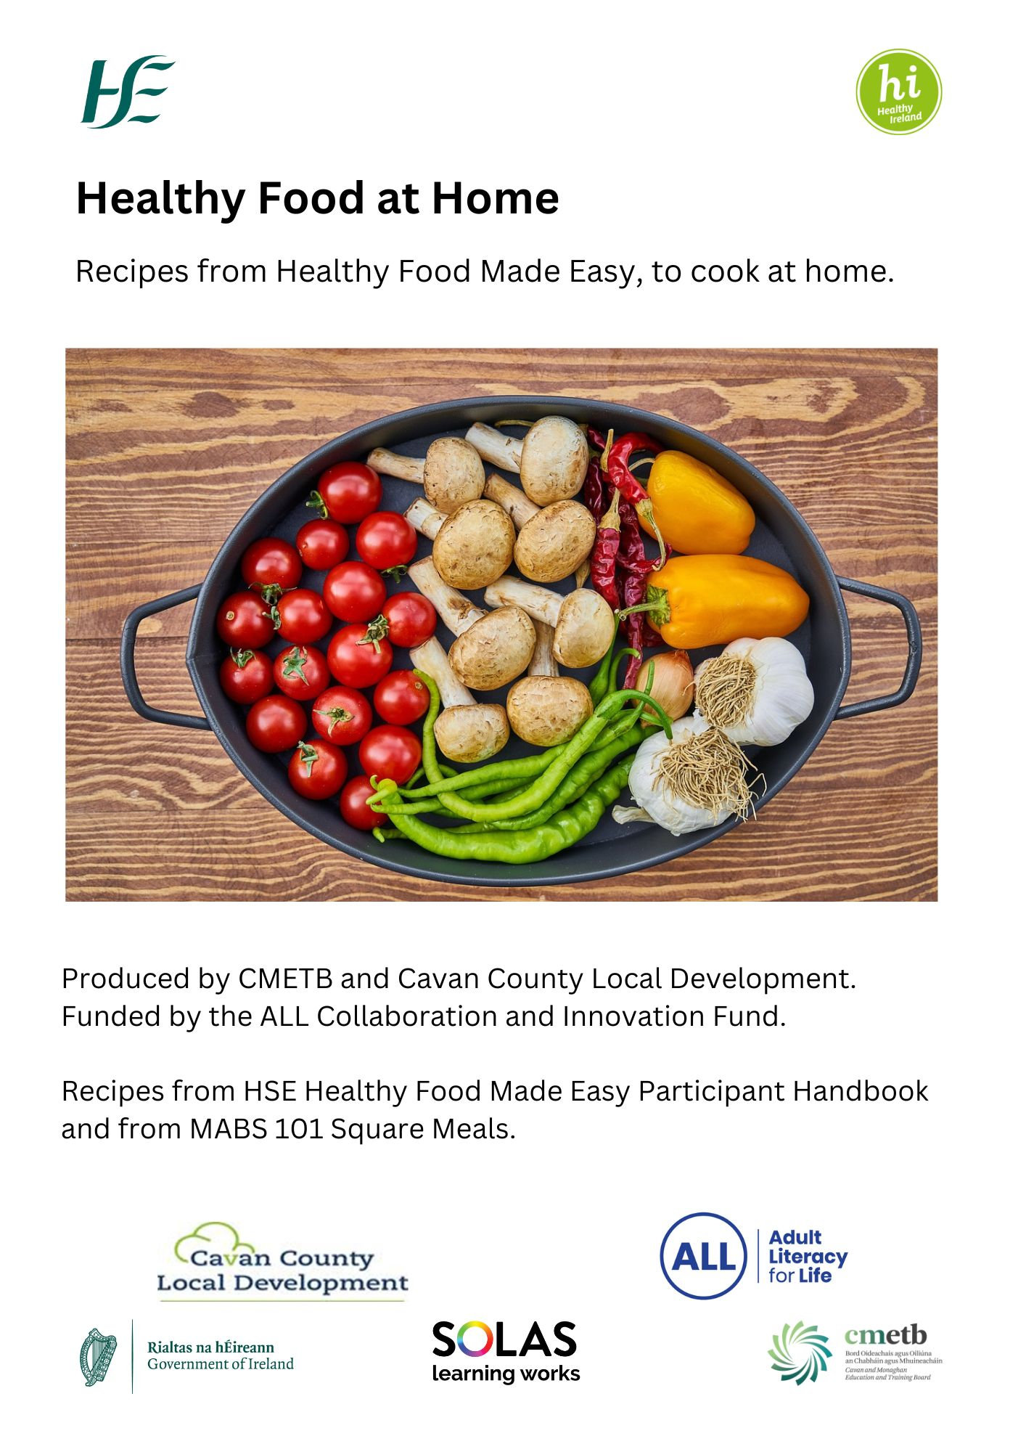
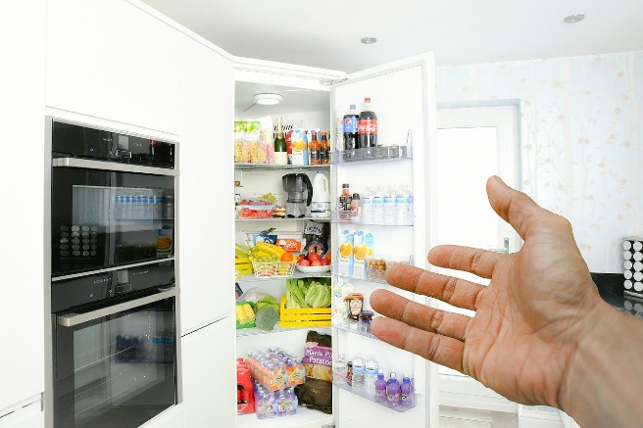

Food Safety Tips

Storing food
- Store refrigerated and frozen foods as soon as possible after buying.
- Take care not to overload your fridge or freezer.
- Store raw meat in sealed packaging or containers on the bottom shelf of your fridge
- If you have cooked food and do not serve it straight away, put it on a clean plate, cover it, and put it in the fridge within 2 hours.
- Eat leftovers within 3 days.

Freezing
- Cool food before putting it in the freezer.
- Keep the freezer door properly closed.
- Do not freeze food that is past its “use by” date, as it may not be safe to use.
- Your freezer should be at -18 Celsius.

Defrosting
- Always follow manufacturer’s instructions: do not defrost food if the instructions say to cook from frozen.
- Defrost food in the fridge. You will need to allow extra time for this. Roughly 24 hours for 2 kilos.
- Make sure food has thawed before cooking.
- Cook or eact defrosted food within 24 hours.
- Don’t re-freeze thawed food.

General kitchen hygiene
- Regularly clean worktops, chopping boards and any surface you have prepared food on.
- Wash the worktop with hot soapy water before you start.
- Wash it again after it has been in contact with raw meat, raw eggs or soil from vegetables.
- Wash dishcloths every 2 days.

Hand washing
- Wash your hands before and after handling raw meat, fish or vegetables.
- After coughing, sneezing, or using a handkerchief.
- After handling a baby’s nappy
- After handling pets

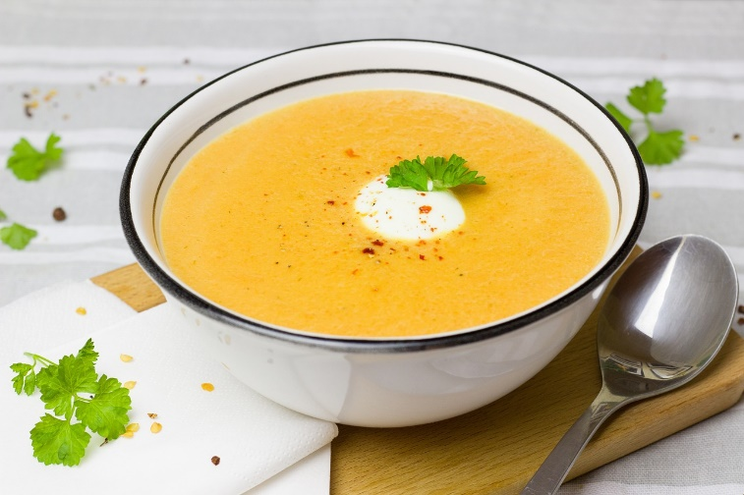
Farmhouse vegetable soup
  - Serve with wholegrain or oat bread
Serves: 6 adults
Preparation time: 15 minutes
Cooking time: 30-35 minutes

You will need:
- Vegetable peeler
- Sharp knife for chopping
- Large saucepan
- Wooden spoon
- Blender

Ingredients
- 2 small onions  - 2 large carrots  - 1 large parsnip  - 2 medium potatoes | - Half a cauliflower  - 1 medium stem of broccoli  - 1 clove of garlic
- 1250ml (2 pints) of vegetable stock, made from 1 stock cube dissolved in 1150ml (2 pints) of boiling water, a few mixed herbs, and black pepper

Method
- Wash, peel and chop the vegetables. Finely chop or crush the garlic, cut the cauliflower and broccoli into florets, and roughly chop the remaining vegetables into chunks.
- Place the onions and garlic in the saucepan with a little water and cook gently for 5 minutes or until soft.
- Add the carrots, parsnip and potatoes and cook gently for another 5 minutes.
- Add the stock and bring to the boil.
- Stir in the cauliflower and broccoli.
- Simmer for 10-15 minutes or until the potatoes are soft.
- Once cooked, liquidise the mixture using a blender.
- Return the blended soup to the saucepan and reheat without boiling.
- Season with mixed herbs and black pepper.

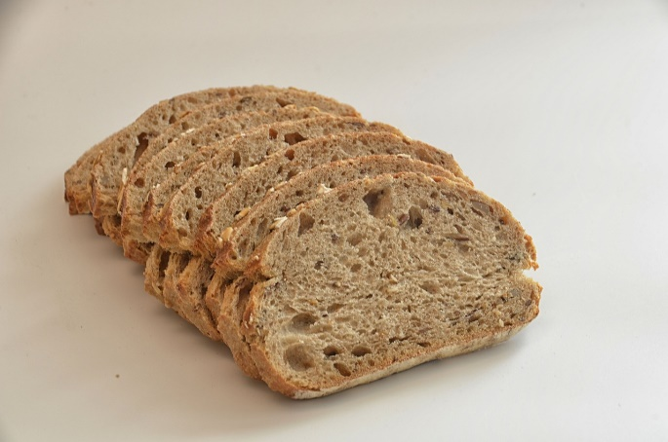
Simple Oat Bread
  - Serve with fresh fruit
Serves: 8 adults
Preparation time: 10 minutes
Cooking time: 1 hour

You will need:
- Mixing bowl
- Wooden spoon
- Loaf tin
- Whisk

Ingredients
- 500ml of natural yoghurt
- 1 beaten egg
- 350g of porridge oats
- 2tsp of bread soda (sometimes called sodium bicarbonate)
- You can add a few dessertspoons of seeds like sunflower, poppy, pumpkin or sesame seeds to the bread mix.
- You can add dried fruit like raisins, cranberries or chopped apricots for a sweeter tasting bread.

Method
- Preheat the oven to 180C / 350F / Gas Mark 4.
- Place the yoghurt and egg in a bowl and mix well.
- Add the oats and bread soda to the yoghurt mixture and stir well. The mixture should be wet but not a liquid.
- Place the mixture in a greased or parchment-lined loaf tin and bake for 60 minutes.

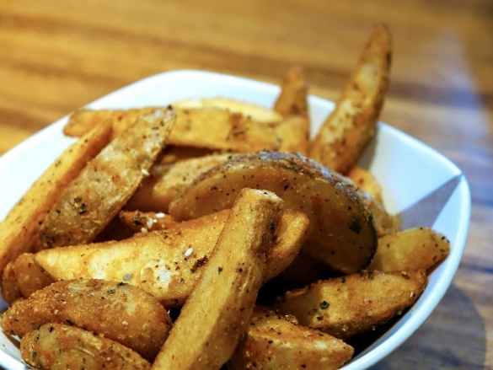
Potato wedges

Serves: 4 adults
Preparation time: 10 minutes
Cooking time: 35-45 minutes

You will need:
- Baking tray
- Sharp knife for chopping
- Bowl
- Spoon for stirring

Ingredients
- 4 large potatoes
- 3 dessertspoons vegetable oil
- Paprika or chilli or garlic and herbs (optional)

Method
- Pre-heat the oven and baking tray to 210C or 400F or Gas Mark 6. If making with burgers cook both at 180C or 350F or Gas Mark 4 (cooking may take 5 or 10 minutes longer).
- Wash and cut the potatoes into wedges.
- Put the chopped potatoes in the bowl.
- Add the oil to the bowl. Add the paprika or herbs if using those.
- Stir until the potatoes are coated in oil.
- Cook the potatoes on the baking tray for 35-45 minutes or until soft and golden brown.

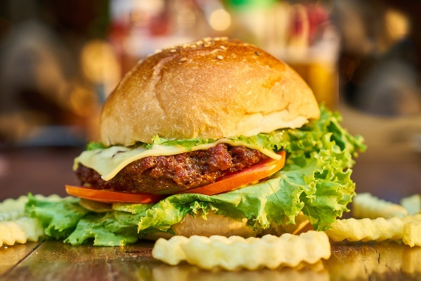
Quick burgers
Serves: 8 small burgers
Preparation time: 10-15 minutes
Cooking time: 15-20 minutes

Ingredients
- 450g (1 lb) minced beef
- 110g (4oz) breadcrumbs- from 4 slices of bread
- pinch mixed herbs
- 1 small onion
- 1 small beaten egg
- pepper
- burger bun or mashed potato or potato wedges
- a little flour

Variations
To give the burgers extra flavour, try adding the following ingredients to the mince meat mixture:
1 tsp mustard or 2 tsp Worcestershire sauce or Mixed herbs or a few drops of Tabasco sauce

What to do
- Peel and finely chop the onion.
- Beat the egg.
- Mix the minced beef, breadcrumbs, mixed herbs, onion and pepper together in a bowl.
- Bind with a little beaten egg.
- Shape mixture into flat round shapes and pat with a little flour.
- Grill or bake gently on both sides at low heat until cooked through. (if serving with potato wedges, cook at 180°C or 350°F or gas mark 4).
- Serve in a burger bun or with mashed potatoes or potato wedges.

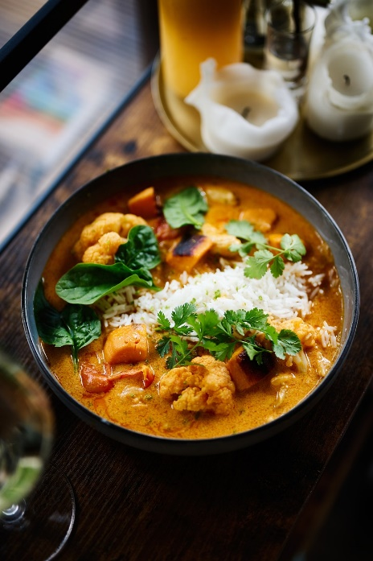
Chicken curry

Serves: 4 adults
Preparation time: 30 minutes
Cooking time: 30 minutes

You will need:
- Sharp knife for chopping
- Small grater
- Large saucepan
- Wooden spoon

Ingredients
- 4-6 chicken thighs without skin or 4 chicken breasts  - 2 tins chopped tomatoes  - 1 clove garlic  - 1 large onion  - 1 red pepper  - 4 tsp curry paste (adjust to taste) | - 1-2 tbsp olive oil  - A handful of raisins  - 2 tbsp mango chutney  - Wholegrain rice  - Optional extra: natural yoghurt  - Toasted almond flakes

Method
- Peel and chop the onion. Peel and grate or chop the garlic. Wash and chop the pepper.
- Chop the chicken into chunks if using chicken breasts.
- Heat 1 tbsp of oil in pan and fry the onion and garlic.
- Add the red pepper. Add the chicken and brown well.
- Add the curry powder and mix it through.
- Add 2 tins of chopped tomatoes and bring to the boil.
- Add the raisins and mango chutney and simmer for 30 minutes or until the chicken is cooked.
- Serve with the cooked rice. Add a dollop of natural yoghurt and toasted almond flakes if you want.

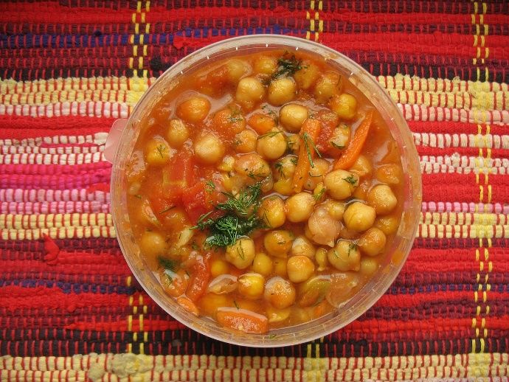
Chickpea curry
Serves: 4 adults
Preparation time: 10 minutes
Cooking time: 30 minutes

You will need:
- Vegetable peeler
- Sharp knife for chopping
- Large saucepan
- Wooden spoon

Ingredients
- 30ml or 2 tbsp vegetable oil  - 1 medium onion  - 1 large parsnip  - 2 cloves of garlic  - 3 tbsp curry powder mild or hot  - 4 carrots or 1 small cauliflower  - 225g (8oz) mushrooms  - 1 tin of whole tomatoes or 4 fresh ripe tomatoes | - 1 tbsp tomato puree  - 1 vegetable stock cube dissolved in 500ml water  - 225g (8oz) tin chick peas drained and rinsed  - Pepper  - Whole grain rice or jacket potato

Method
- Cook the rice as instructed on the packet or wash the potato, prick with a fork and bake in an oven at 220C or 425F or Gas Mark 7 for about 1½ hours until cooked through.
- Peel and chop the onion. Peel and chop or crush the garlic. Wash peel and chop the carrots. Wash and break the cauliflower into florets. Wash and quarter the mushrooms.
- Heat the oil in a large pan and gently fry the onion for 2 minutes. Add the garlic and curry powder, stir and leave to cook gently for 2 minutes.
- Add the carrots, mushrooms and cauliflower (if using) and gently fry for a few minutes.
- Add the tomato puree, tinned tomatoes and stock, then bring to the boil.
- Leave to simmer gently for 20 minutes, then stir in the chickpeas. Cook until heated through.
- Add salt and pepper to your taste, and serve with the rice or jacket potato.

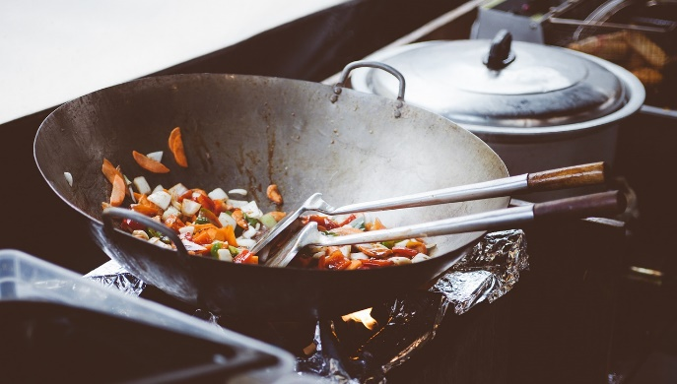
Stir fry chicken
Serves: 4
Preparation time: 30 minutes
Cooking time: 20 minute

Ingredients
- 3 chicken breast fillets  - 1 dessertspoon soy sauce or dessertspoon water or sherry  - 1/4 tsp ground ginger or 1 tsp freshly grated ginger  - 2 tsp cornflower  - 2 dessertspoons pure vegetable oil  - 2 cloves garlic | - 3 scallions  - 1 small green pepper  - 110g (4oz) mushrooms  - small head of broccoli  - 6 tbsp water  - optional extra: small tin of sweetcorn  - wholegrain rice

What to do
- Cook wholegrain rice as instructed on the packet.
- Peel and finely chop, grate or crush the garlic.
- Place the soy sauce, sherry or water, ginger, garlic and cornflour in a bowl and mix together.
- Cut the chicken into bite-sized portions or pieces.
- Stir in the chicken pieces and coat everly in the mixture. Leave to stand for 10 minutes.
- Wash, peel and chop the scallions. Wash, de-seed and chop the pepper. Wash and slice the mushrooms. Wash the broccoli and break into florets. Open the tinned sweetcorn, drain and rinse (if using).
- Heat 1 dessertspoon of oil in a larger pan or wok until hot, then stir fry the chicken until it is cooked through. Transfer the chicken to a plate.
- Heat the remaining oil until hot and add the scallions, pepper, mushrooms. broccoli and stir fry for 1 minute.
- Add 6 dessertspoons water and cook for 3-5 minutes.
- Return the chicken to the pan, stir in the sweetcorn and heat through on medium heat for 1 minute. Serve with the cooked wholegrain rice.
Food Waste Tip: Ginger freezes well. Cut it into thumb-sized pieces and freeze. Run under warm water to defrost, and rub the skin off. Then chop or grate to use.

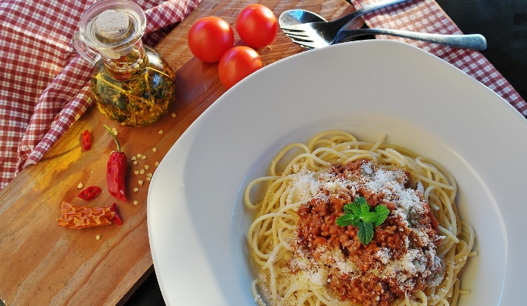
Bolognaise sauce

Serves: 5
Preparation time: 30 minutes
Cooking time: 45 minutes

Ingredients

1 medium onion  2 large carrots  1 clove garlic (optional)  450g (1 lb) lean minced beef  1 tin chopped tomatoes | ½ tsp sugar  2 dessertspoons tomato puree  2 tsp dried mixed herbs  pepper  wholegrain spaghetti

What to do
- Peel and chop or grate the onion and garlic. Peel, wash and chop, dice or grate the carrots.
- Brown the mince over a high heat (you don't need to add any oil). Drain off any fat into a bowl.
- Add the onions, carrots and garlic and cook for about 5 minutes over a low heat.
- Add the tomato puree, mixed herbs, tinned tomatoes and sugar. Stir.
- Add pepper.
- Cover and leave to cook over a low heat for 45 minutes (or longer if you can).
- Serve with spaghetti.

Variations
Other good flavouring options include crushed garlic or fresh chopped thyme.

TIP
Some tinned tomatoes have mixed herbs added which can add to the flavour of the dish.

FOOD WASTE TIP
You can use any leftover Bolognaise sauce to fill tortilla wraps or as a topping for baked potatoes.

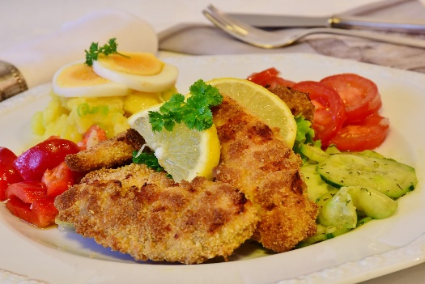
Chicken goujons
  - Serves: 4 adults
Preparation time: 10 minutes
Cooking time: 15 minutes

Ingredients
- 4 chicken breasts, skin removed
- 25g (1oz) flour
- 50g (2oz) fresh breadcrumbs
- 50g (2oz) porridge oats
- 2 eggs
- 2 dessertspoons of pure vegetable oil

What to do
- These chicken fingers can be baked or fried. Pre-heat the oven to 180°C or 350°F or gas mark 4 if baking your chicken fingers.
- Cut the chicken into strips.
- Beat the eggs in a bowl.
- Mix the breadcrumbs and porridge oats together and then scatter on a plate.
- Place the flour on a plate.
- Roll the chicken strips in the flour.
- Dip the chicken into the beaten egg.
- Roll the chicken strips in the breadcrumb mixture until they are fully coated
- Cook in the oven for 15-20 minutes until cooked through. Alternatively, to fry, heat the vegetable oil in a frying pan.
- Cook the chicken on each side for about 1-2 minutes to seal all sides. Reduce the heat and cook slowly for another 15-20 minutes turning every now and then until the strips are cooked through. Serve with mashed potatoes and vegetables.

Variations
Use fish instead of chicken to make your own homemade fish fingers.

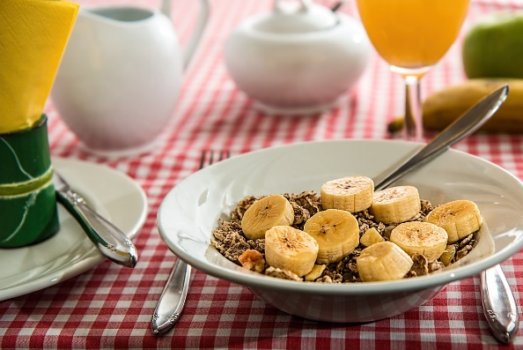
Breakfast ideas

A good breakfast helps give you energy until lunch or break-time and it will help your concentration. Here are a few quick breakfast ideas:

1 Minute Breakfasts
- Wholegrain or high fibre cereal, low fat milk and a glass of orange juice
- Microwavable porridge oats - add cinnamon, dried or fresh fruit or yoghurt for extra flavour
- Yoghurt and a banana
- Wholegrain toast and mandarin orange
- Wholegrain toast with a banana
- Bagel with jam and a glass of low fat milk. Handful of berries Bagel with low fat cream cheese.
- Apple slices English muffin with marmalade and a low fat yoghurt. Grapes
- Fresh fruit or unsweetened fruit juice
- Yoghurt and a piece of fruit
- A portion of fruit, a cereal bar and a glass of low fat milk (try to choose a cereal bar with a lower sugar content).

5 Minute Breakfasts
- Poached eggs on toast with sliced tomato
- Baked beans on toast
- Scrambled eggs on toast with a small glass of orange juice
- An omelette
- A homemade fruit smoothie
- Fresh fruit salad and yoghurt

Food waste tip
Some fruits like apples, bananas and nectarines speed up the ripening of other fruits. Keep these fruits separate or somewhere with good ventilation to slow down ripening.

