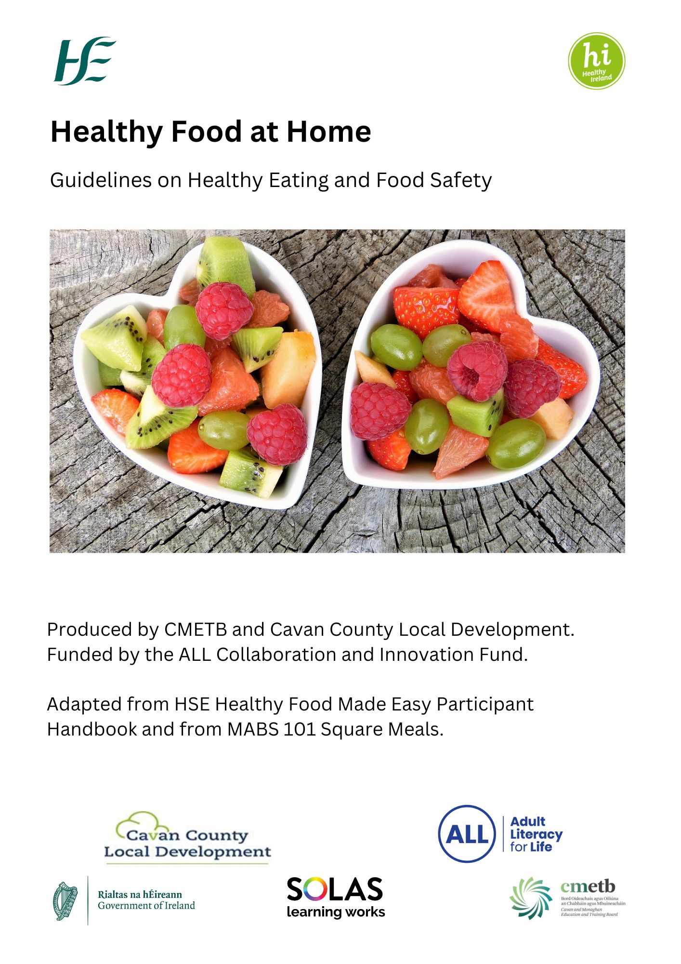
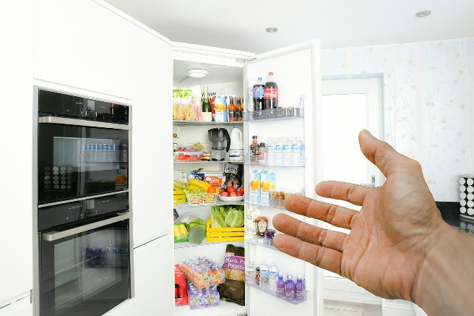

Food Safety Tips

Storing food
- Store refrigerated and frozen foods as soon as possible after buying.
- Take care not to overload your fridge or freezer.
- Store raw meat in sealed packaging or containers on the bottom shelf of your fridge
- If you have cooked food and do not serve it straight away, put it on a clean plate, cover it, and put it in the fridge within 2 hours.
- Eat leftovers within 3 days.

Freezing
- Cool food before putting it in the freezer.
- Keep the freezer door properly closed.
- Do not freeze food that is past its “use by” date, as it may not be safe to use.
- Your freezer should be at -18 Celsius.

Defrosting
- Always follow manufacturer’s instructions: do not defrost food if the instructions say to cook from frozen.
- Defrost food in the fridge. You will need to allow extra time for this. Roughly 24 hours for 2 kilos.
- Make sure food has thawed before cooking.
- Cook or eact defrosted food within 24 hours.
- Don’t re-freeze thawed food.

General kitchen hygiene
- Regularly clean worktops, chopping boards and any surface you have prepared food on.
- Wash the worktop with hot soapy water before you start.
- Wash it again after it has been in contact with raw meat, raw eggs or soil from vegetables.
- Wash dishcloths every 2 days.

Hand washing
- Wash your hands before and after handling raw meat, fish or vegetables.
- After coughing, sneezing, or using a handkerchief.
- After handling a baby’s nappy
- After handling pets

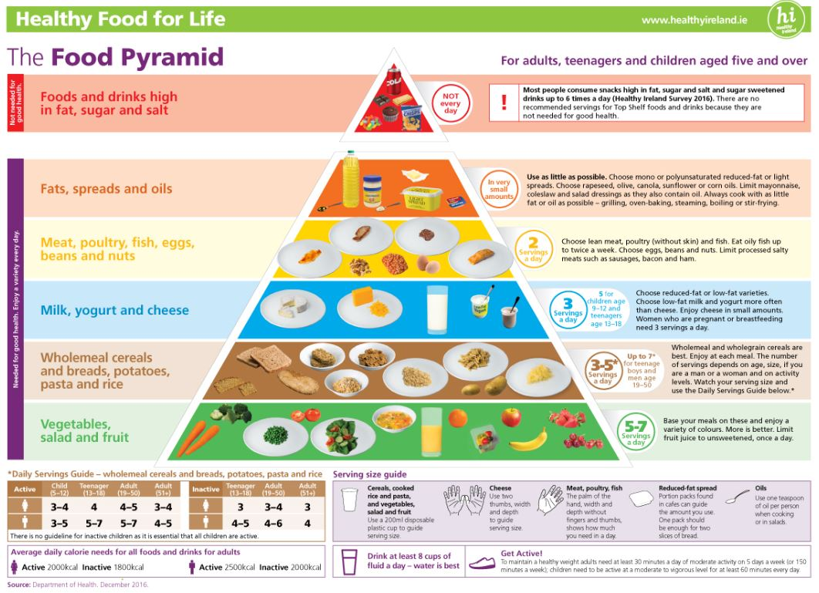

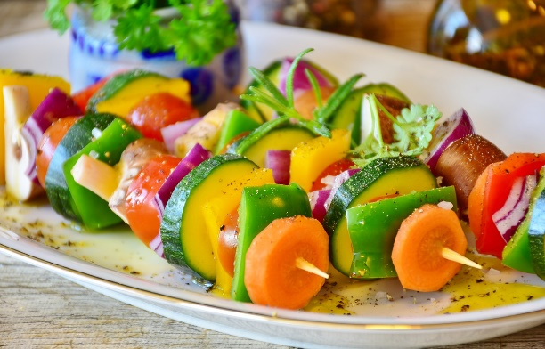
How to eat well
Eat a wide range of food to give you energy and keep you healthy.

Benefits of eating healthily
Eating well helps you feel your best and can help you avoid some diseases.
Good eating habits can help you to have:
- a healthier body weight
- less risk of type 2 diabetes, heart disease and cancer
- a healthy cholesterol level
- feel better
Good eating habits can also help you to live well with health conditions, such as:
- obesity
- type 2 diabetes
- long COVID
- heart disease

Diet, nutrition and your body
Foods are made up of nutrients. Protein, carbohydrate, fat, vitamins and minerals are types of nutrients.
Your body needs the right mix of nutrients to be healthy and well. This is what it means to eat a balanced diet.
Different foods contain different nutrients. Choosing a mix of foods every day will help you get to get all the nutrients you need.
Foods that contain the same types of nutrients are grouped together in the food pyramid as:
- vegetables, salads and fruit
- wholemeal cereals and bread, potatoes, pasta and rice
- milk, yogurt and cheese
- lean meat, poultry, fish, eggs, beans and nuts
- fats, spreads and oils
If you do not get enough nutrients in your diet, you may be at risk of malnutrition.

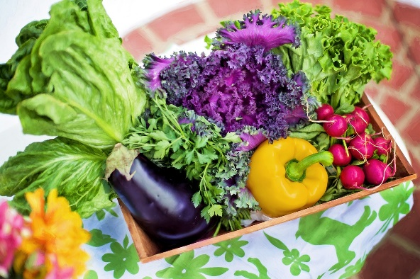
Vitamins and minerals
Vitamins and minerals are nutrients your body needs in small amounts to work properly.
Most people should get the nutrients they need by having a varied diet. Some people may need to take extra supplements.

More about minerals and vitamins

Healthy eating habits
How you plan and prepare your food and drinks can make a difference to your health.
Plan your eating habits using these tips:
- Eat regular meals and snacks.
- Plan your meals in advance - this helps you eat a variety of foods and to save money.
- Prepare your meals using fresh ingredients and choose foods like fruits, salads and vegetables for snacks.
- Use healthier cooking methods like grilling and steaming instead of frying or roasting .
- Use the food pyramid as a guide for serving sizes.
- Eat at a table
- Avoid eating in front of TV or computer screens.
- Ask your GP if the "Healthy Food Made Easy" course is available near you.
- Use leftovers in meals or snacks the next day.
- Make healthy choices
Use the food pyramid as a guide for the types and amounts of food you need each day.
The number of servings you need depends on:
- your age
- your size
- if you are a man or a woman
- your activity levels
The nutrition advice for babies and children aged 0 to 4 years is different to that for older children and adults.

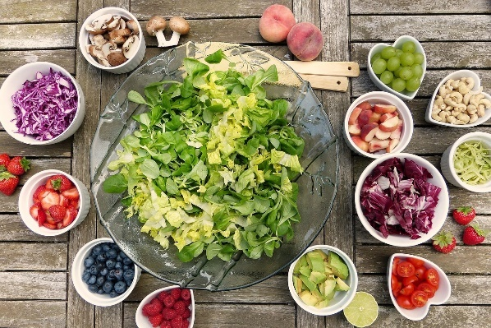
Vegetables, salads, fruits
Base your meals on plenty of vegetables, salads and fruits. They provide many important vitamins, minerals and fibre.
Fill half your plate with vegetables, salads or fruit at every meal. Choose a variety of colours.
Choose 5 to 7 servings a day.

Serving size
One serving size is:
- 1 apple, orange, pear or banana
- 2 plums, kiwis or mandarin oranges
- half a cup of cooked vegetables - fresh or frozen
- 1 bowl of salad – lettuce, tomato, cucumber
- 1 bowl of homemade vegetable soup
Add fresh or frozen vegetables to stir-fries, stews and curries.
Limit fruit juice to once a day with a meal and always choose unsweetened.

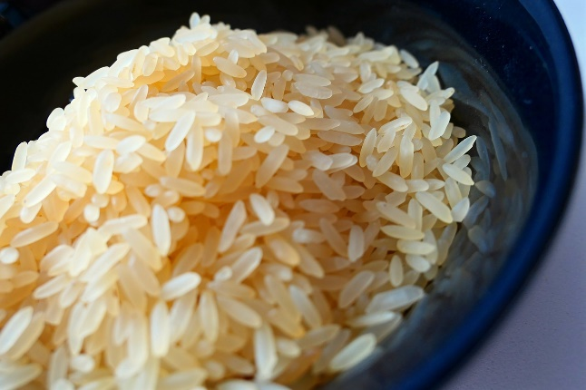
Wholemeal cereals and breads, potatoes, pasta and rice
Choose wholemeal and wholegrain breads, cereals, pasta and brown rice.
Wholegrain and wholemeal choices contain vitamins and fibre to help keep your digestive system healthy.

Serving size
One serving size is:
- 2 thin slices of wholemeal bread
- 1.5 slices of wholemeal soda bread
- 1 pitta
- 1 cup of cooked rice, pasta, noodles or couscous
- 2 medium or 4 small potatoes
- 1 cup of yam or plantain

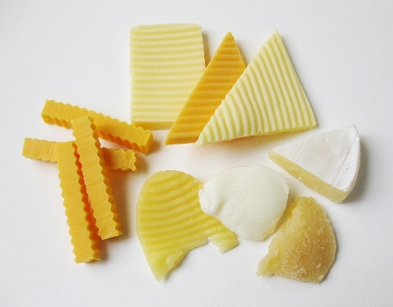
Milk, yogurt and cheese
Choose low-fat milk, yogurt or cheese. Low-fat options have the same amount of calcium as full fat, which is important for healthy bones and teeth.
Choose milk and yogurt more often than cheese.

Serving size
One serving size is:
- 1 glass (200ml) milk
- 1 carton (125g) yogurt
- 1 bottle (200ml) yogurt drink
- 2 thumbs (25g) of hard or semi-hard cheese, such as cheddar or edam
- 2 thumbs (25g) soft cheese, such as brie or camembert
Using milk in cereal can be a good way to reach 5 servings a day for children.
Some yogurts and yogurt drinks can have added sugar. Check the label.
If you choose alternatives such as soya milk and yogurts, choose ones with calcium.

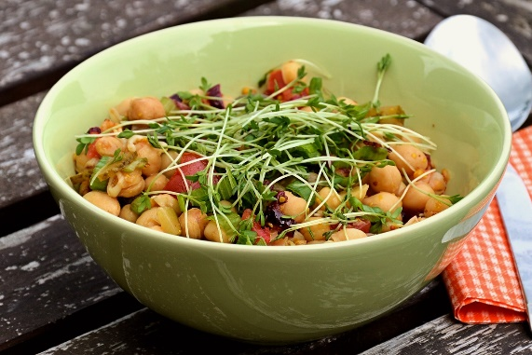
Meat, poultry, fish, eggs, beans and nuts
Include a variety of beans, fish, poultry, eggs, or nuts in 2 meals per day. Choose fish up to twice a week. These foods provide an important source of protein.
Limit how often you eat processed meats such as sausages.
Use low-fat cooking methods such as grilling, baking, steaming or boiling.

Serving size
One serving size is:
- 50g to 75g of cooked lean beef, lamb, pork, or poultry (half the size of the palm of your hand)
- 100g of cooked fish, soya or tofu
- three quarters of a cup of beans or lentils
- 2 eggs
- 40g of unsalted nuts or seeds

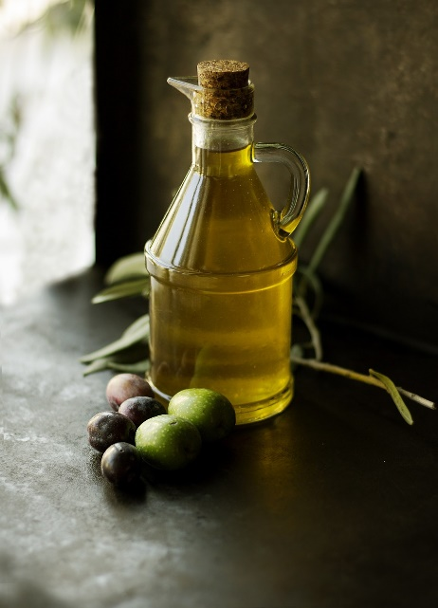
Fats, spreads and oils
A small amount of fat is an essential part of a healthy, balanced diet. Fat is a source of essential fatty acids, which the body cannot make itself.
The main types of fat found in food are:
- saturated fats
- unsaturated fats
Most fats and oils contain saturated and unsaturated fats in different amounts.
Try to cut down on foods and drinks that are high in saturated fats and replace some of them with unsaturated fats.

Serving size
One serving is:
- 1 portion pack of reduced-fat or light spread for 2 slices of bread
- 1 teaspoon per person of rapeseed, olive, canola, sunflower or corn oil used in cooking.

Food and drinks high in fat, sugar and salt
Limit foods and drinks that are high in fat, sugar and salt. Eat them occasionally, but not every day.
Choose smaller amounts or fun-size servings. Limit chips and takeaway food as much as possible. Most of these are very high in fat, salt and calories.
Choose healthy snacks such as fruit and vegetables. Drink water instead of sugary drinks.

