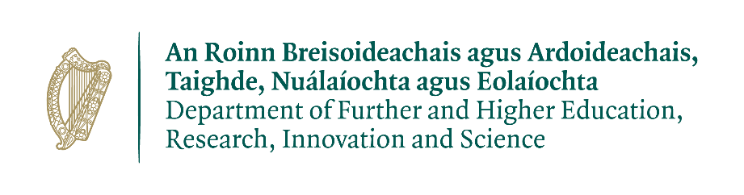

Research Ireland Public Service Fellowship 2026

Name of Governmental Department or Agency
Department of Further and Higher Education Research, Innovation and Science

Title of the Project
A Deeper Analysis of Ireland’s PIAAC Results Using CSO data

Description of the Project
This executive summary outlines two complementary research proposals under the PSF 2026 Fellowship, aimed at addressing adult literacy challenges in Ireland through both pedagogical innovation and data-driven analysis. This proposal leverages Ireland’s PIAAC data to identify and profile adults with the greatest literacy challenges. It combines quantitative and qualitative methods to uncover barriers to engagement and assess the role of AI and digital tools in enabling access.

The second proposal focuses on literacy pedagogy, exploring how teaching practices, curriculum design, and technology can better support adults—particularly those in employment—with unmet literacy needs. It seeks to understand learner motivations and develop flexible, integrated provision models. Together, these projects aim to bridge the gap between literacy and skills development, informing policy and practice that supports inclusive workforce participation and lifelong learning.

Given the overlaps, there is strong potential to:
- Coordinate data collection and share insights across both strands.
- Develop joint outputs such as a unified policy framework or cross-cutting recommendations.
- Ensure complementarity: the pedagogy project can apply insights from the data analysis to refine instructional models, while the data project can use pedagogical findings to interpret learner outcomes.

The OECD’s Programme for the International Assessment of Adult Competencies (PIAAC), Cycle 2 results show that while Ireland performs above the OECD average in literacy, 21% of adults still score at Level 1 or below. This indicates persistent unmet literacy needs, despite significant investment and strategic efforts under the Adult Literacy for Life (ALL) Strategy. Ireland’s performance in the OECD’s Programme for the International Assessment of Adult Competencies (PIAAC) remains average despite increased budget allocations and policy efforts. Particularly concerning are:

- Persistently low numeracy scores
- Poor performance among older adults
- Underrepresentation of vulnerable groups (e.g. Travellers, people with undiagnosed learning difficulties, rural populations, and those in temporary accommodation)

The CSO’s public use file contains over 3,000 variables, offering a rich opportunity for deeper analysis. However, limitations in coverage (e.g. exclusion of those over 65 and underrepresentation of rural and marginalised communities) suggest that the true extent of literacy challenges may be underestimated.

Project Scope
Background
Adult Literacy for Life Strategy
Launched in 2021, the vision of the 10-year Adult Literacy for Life (ALL) Strategy is to ensure that everyone has the literacy, numeracy, and digital literacy to fully participate in society and realise their potential. The Strategy is a cross-government, cross-economy and cross-society approach aimed at addressing adult literacy challenges, enhancing skills, and supporting lifelong learning. It is part of Ireland's broader efforts to ensure that all adults have the necessary literacy, numeracy, and digital skills to thrive in modern society and the workforce.

The targets set in the Strategy are to decrease the share of adults with unmet literacy needs from 18% to 7%; the share of those with unmet numeracy needs from 25% to 12% and to decrease the share of those without basic digital skills (as measured by the European Commission’s Digital Society and Economy Index (DESI) 2019 from 47% to 20%.

Objectives

- To conduct a detailed statistical analysis of the Irish PIAAC dataset using CSO microdata.
- To identify specific cohorts with disproportionately low literacy and numeracy outcomes.
- To assess the impact of socio-demographic factors (age, region, ethnicity, housing status, education history) on literacy outcomes.
- To develop evidence-based recommendations for targeted literacy interventions.
- To identify and profile adults with the most acute unmet literacy needs, including those in employment, using advanced statistical techniques
- To explore the socio-demographic and employment-related characteristics of low-literacy adults, including age, region, work status, and education history.
- To investigate barriers and levers to engagement in literacy improvement, including time constraints, stigma, motivation, and access to provision.
- To assess the potential role of technology—including AI-powered tools—in reducing barriers and supporting personalised learning pathways.
- To inform a more integrated approach to literacy and skills development, aligning adult literacy with broader workforce and lifelong learning strategies.

Methodology
This project will adopt a mixed methods approach, combining:
- Quantitative analysis of CSO’s PIAAC microdata to identify predictors and patterns of low literacy and numeracy across different cohorts, including employed adults.
- Cluster analysis to isolate high-need groups based on literacy scores, employment status, and socio-demographic factors.
- Qualitative research (e.g. interviews or focus groups) to explore aspirations, motivations, and perceived barriers among adults with unmet literacy needs.
- Technology review to assess the feasibility and impact of digital and AI-enabled literacy supports.
- Policy synthesis to connect literacy challenges with broader skills and employment strategies.

Skills/Expertise Required
Quantitative and Statistical Analysis
- Proficiency in statistical software
- Experience with large-scale survey datasets and microdata
- Knowledge of regression, clustering, and multivariate analysis techniques

Data Management and Cleaning
- Expertise in handling complex datasets with thousands of variables
- Familiarity with CSO data structures and OECD PIAAC formats

Policy Analysis and Evaluation
- Understanding of adult learning and education policy in Ireland and comparator countries
- Ability to translate data insights into actionable policy recommendations

Expected Outputs of Project
- A comprehensive report detailing literacy challenges in Ireland.
- Identification of high-need cohorts for targeted intervention.
- Policy recommendations for DFHERIS and SOLAS.
- A framework for improving future data collection and analysis.

Working Arrangements
Location: Dublin

The placement would be in the DFHERIS offices in Dublin. This project will be managed by DFHERIS. The researcher will be expected to attend in-person team meetings one to two days per week, with occasional travel required to stakeholder engagements and public consultations around the country. Office attendance can be scheduled in advance and flexibility will be provided where appropriate.

Project Duration and Expected Commitment
12 months full-time.

Project Lead
Maria O’Brien, Principal Officer, FET Unit, DFHERIS.

