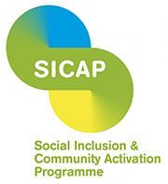
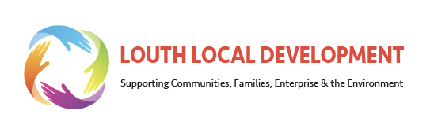
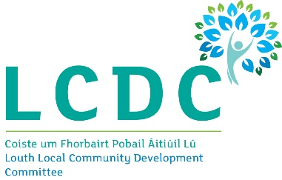

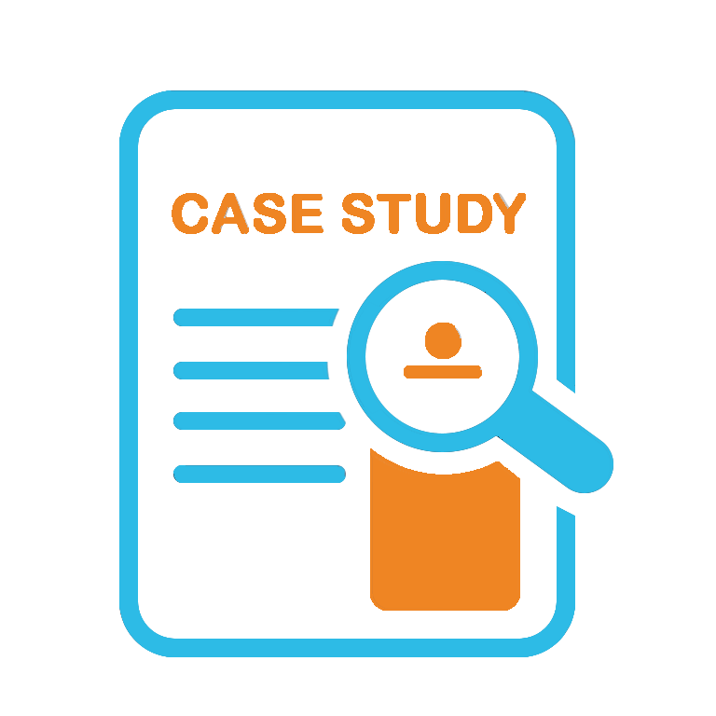
Louth Local Development
SICAP Video Case Study 2025
Lot Area 10-1

L Title: SMART Cafés – Smarter Living for Older People
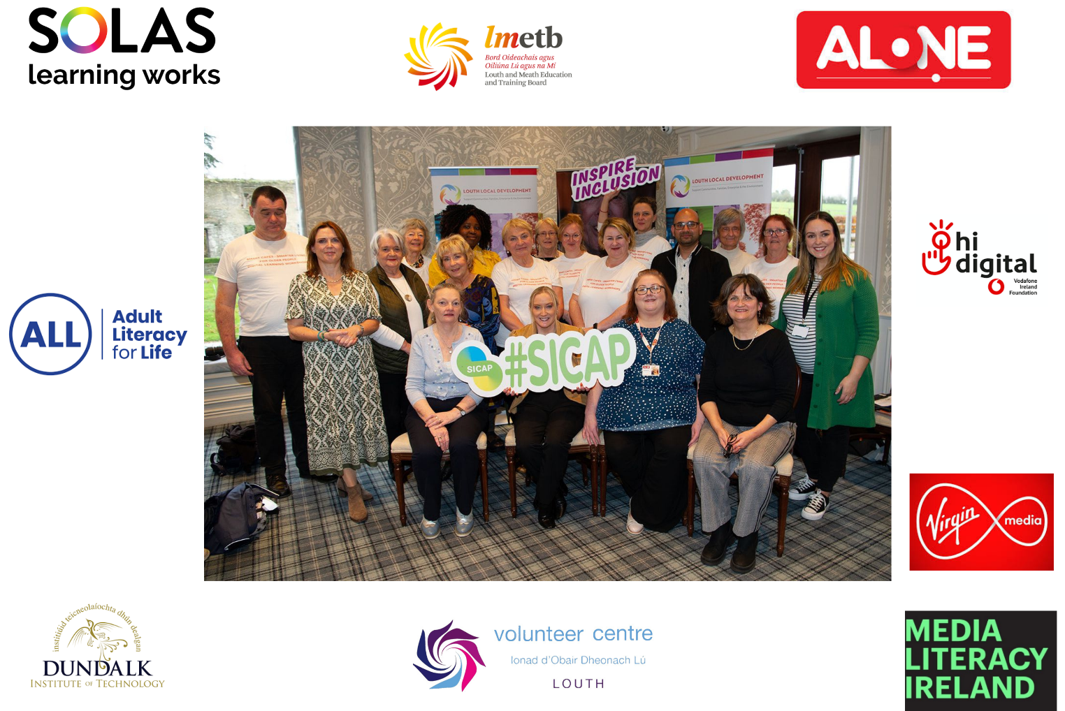
Focus: Older People (aged 65+ Years) in Isolation

Goal 1 – SICAP Case Study 2025

Rationale – Demonstrates SICAP Thematic Area 1 – Older People (aged 65+ Years) in Isolation
For the 2025 Case Study, we wanted to highlight a countywide award-winning and impactful Goal 1 Community Development project demonstrating the core work of SICAP in County Louth that focuses on providing grassroots-level collaborative supports in addressing the digital divide faced by older people whilst also combatting social isolation by fostering local community connections to enhance overall wellbeing.


The SMART Cafés Smarter Living for Older People project was established in 2024 to prevent older persons from being at a disadvantage by familiarising them with the use of modern digital technology, both to enhance their technology skills in a digital age and to combat social isolation to enhance wellbeing.

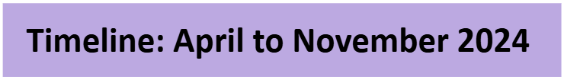
In April 2024 the SICAP Social Inclusion Manager identified a possible leverage funding opportunity under the Louth and Meath Education and Training Board (LMETB), Solas in the Adult Literacy for Life’s (ALL) Strategy Collaboration & Innovation Fund to develop a drop-in cafe concept for older people across County Louth. The SICAP Community Development Officer for Dundalk and Mid-Louth supported the application that encouraged a collaborative partner, and ALONE agreed to participate with us in the project. We were successful in the application and were awarded €7,462.00 in June 2024.
Across the summer period the Social Inclusion Manager brought together a SICAP planning team to deliver the project in the autumn, and the Community Development Officer for Dundalk and Mid Louth then co-ordinated the project with the team and collaborative partners.
An innovative aspect of the project included recruiting volunteers of a similar age that had interest and skills in digital technology, and we began to recruit the 20 volunteer Digital Champions across the summer period. We are blessed to have an excellent collaborative working relationship with Louth Volunteer Centre, and they supported us to recruit a number of grassroots volunteers for the project to enhance the peer-to-peer learning element of the project.
In September we commenced a recruitment campaign to host the SMART cafes in Dundalk, Ardee and Drogheda. We advertised using the traditional methods, including liaising with our Older Person Local Community Groups and Networks, newspaper advertisements, local radio and social media platforms.
In October the collaborative project hosted learners over the age of 65 years to attend classes in a drop-in café-style environment in Dundalk, Ardee and Drogheda twice a week. Almost 50 participants attended the beginners’ classes, with a further 64 attending the advanced sessions.
In total there were an outstanding 20 volunteer grassroots Digital Champions recruited for the project that were trained under the Hi Digital training that ALONE contributed to the project and voluntarily donated their time to help train the learners along with the 2 class tutors.

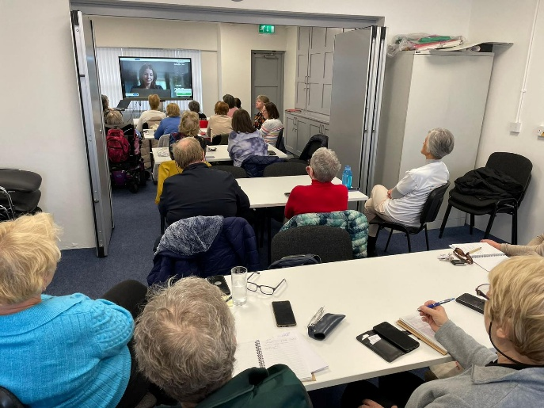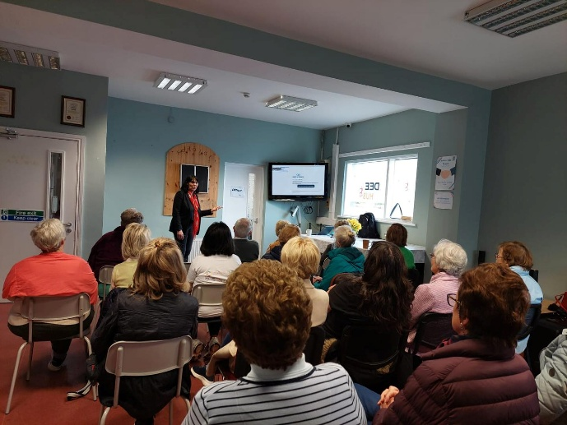
SMART cafes in Dundalk – October 2024 SMART cafes in Ardee – October 2024
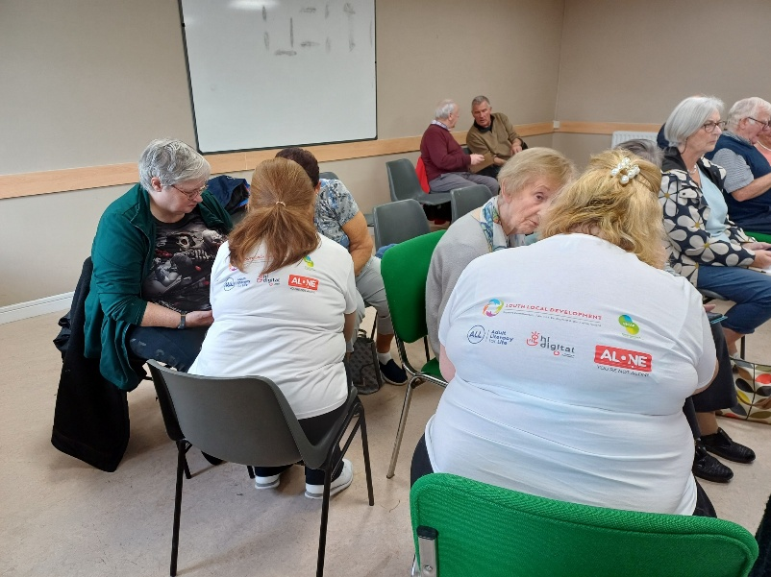
SMART cafes in Drogheda – October 2024
In November the learners, volunteer Digital Champions, representatives from the SICAP programme and ALONE came together to attend a heartwarming Celebration of Success Prize Giving Ceremony in the Monasterboice Inn.
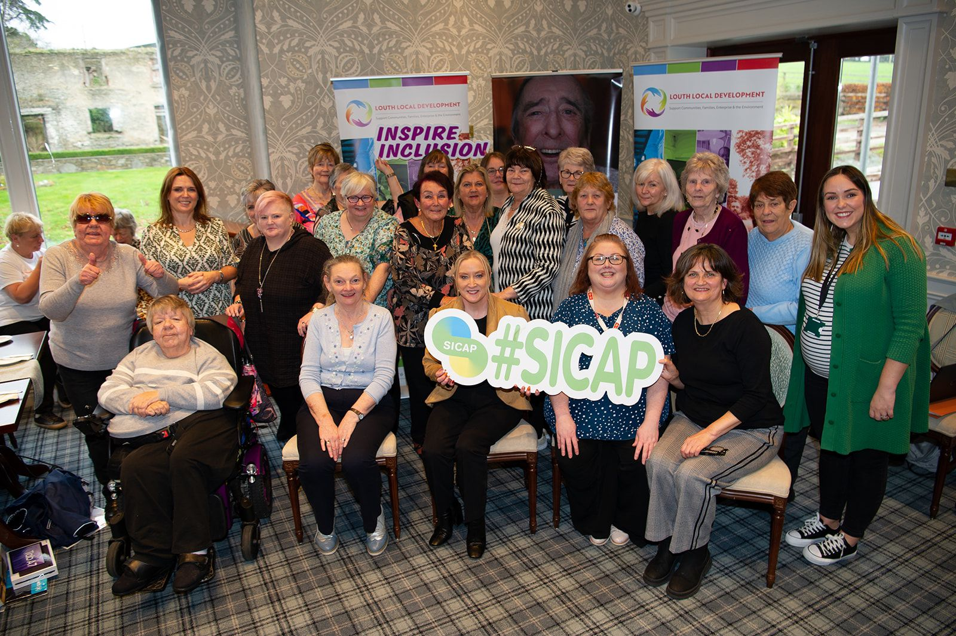
Celebration of Success Prize Giving Ceremony 7th November 2024
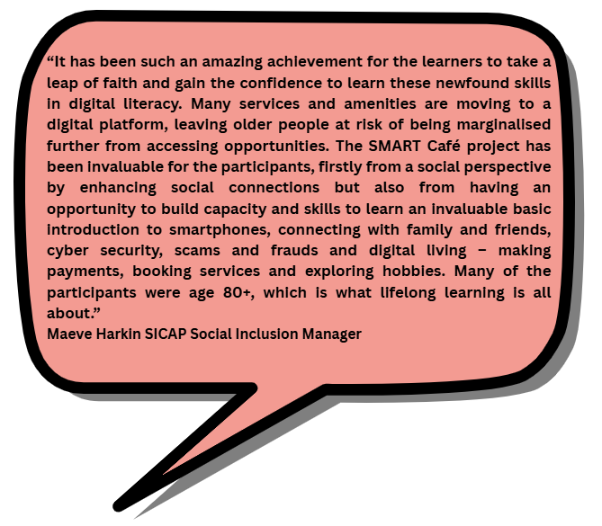
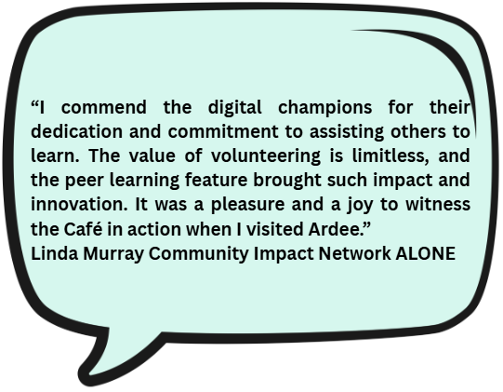
In November the LMETB’s Adult Literacy for Life (ALL) Coordinator requested SICAP to participate in a showcase video for Solas Adult Literacy for Life (ALL) to highlight the impacts of what their value-adding funding can achieve within local communities. The video that was filmed in a SMART cafe in Ardee provided a real-life example of the lived experience and the significance and worth of the project in relation to lifelong learning, innovation, collaboration, potential for replication and shared learning nationally. The video also promoted adult media literacy in action and is considered an exemplar of good practice, highlighting our professional achievement in delivering a broad range of community development approaches.

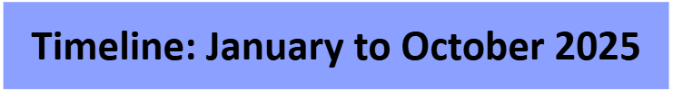
The Solas Adult Literacy for Life (ALL) Co-ordinator promoted the 2025 ALL funding by showcasing our SMART cafes video at their informative funding webinar workshops, and SICAP was highly commended by all stakeholders as an example of good practice. (Please see video link of Case Study)
Across March and April, we piloted a further collaborative actual drop-in cafe for older people in our Community Office in Dundalk. This project facilitated older persons attending the SMART cafe on an ad hoc basis. We also harnessed an innovative intergenerational feature with fourth-year social science students from our new collaborative partners in 2025, the Dundalk Institute of Technology (DkIT). This concept project had a person-centered approach for the delivery and encouraged community connections, peer-to-peer support and capacity-building skills to bridge the gap in the digital divide and address the social exclusion that older people continue to face in an ever-evolving digital landscape.

The DkIT students were natural and proficient in the use of SMART devices and were there to help the older person on a person-centred one-to-one level with any assistance they required in learning how to use and master their digital device.

This follow-on initiative was a collaboration with DKiT and ALONE, and hopefully if additional funding becomes available, we could consider further and consistent delivery across all provincial towns and rural communities in County Louth.
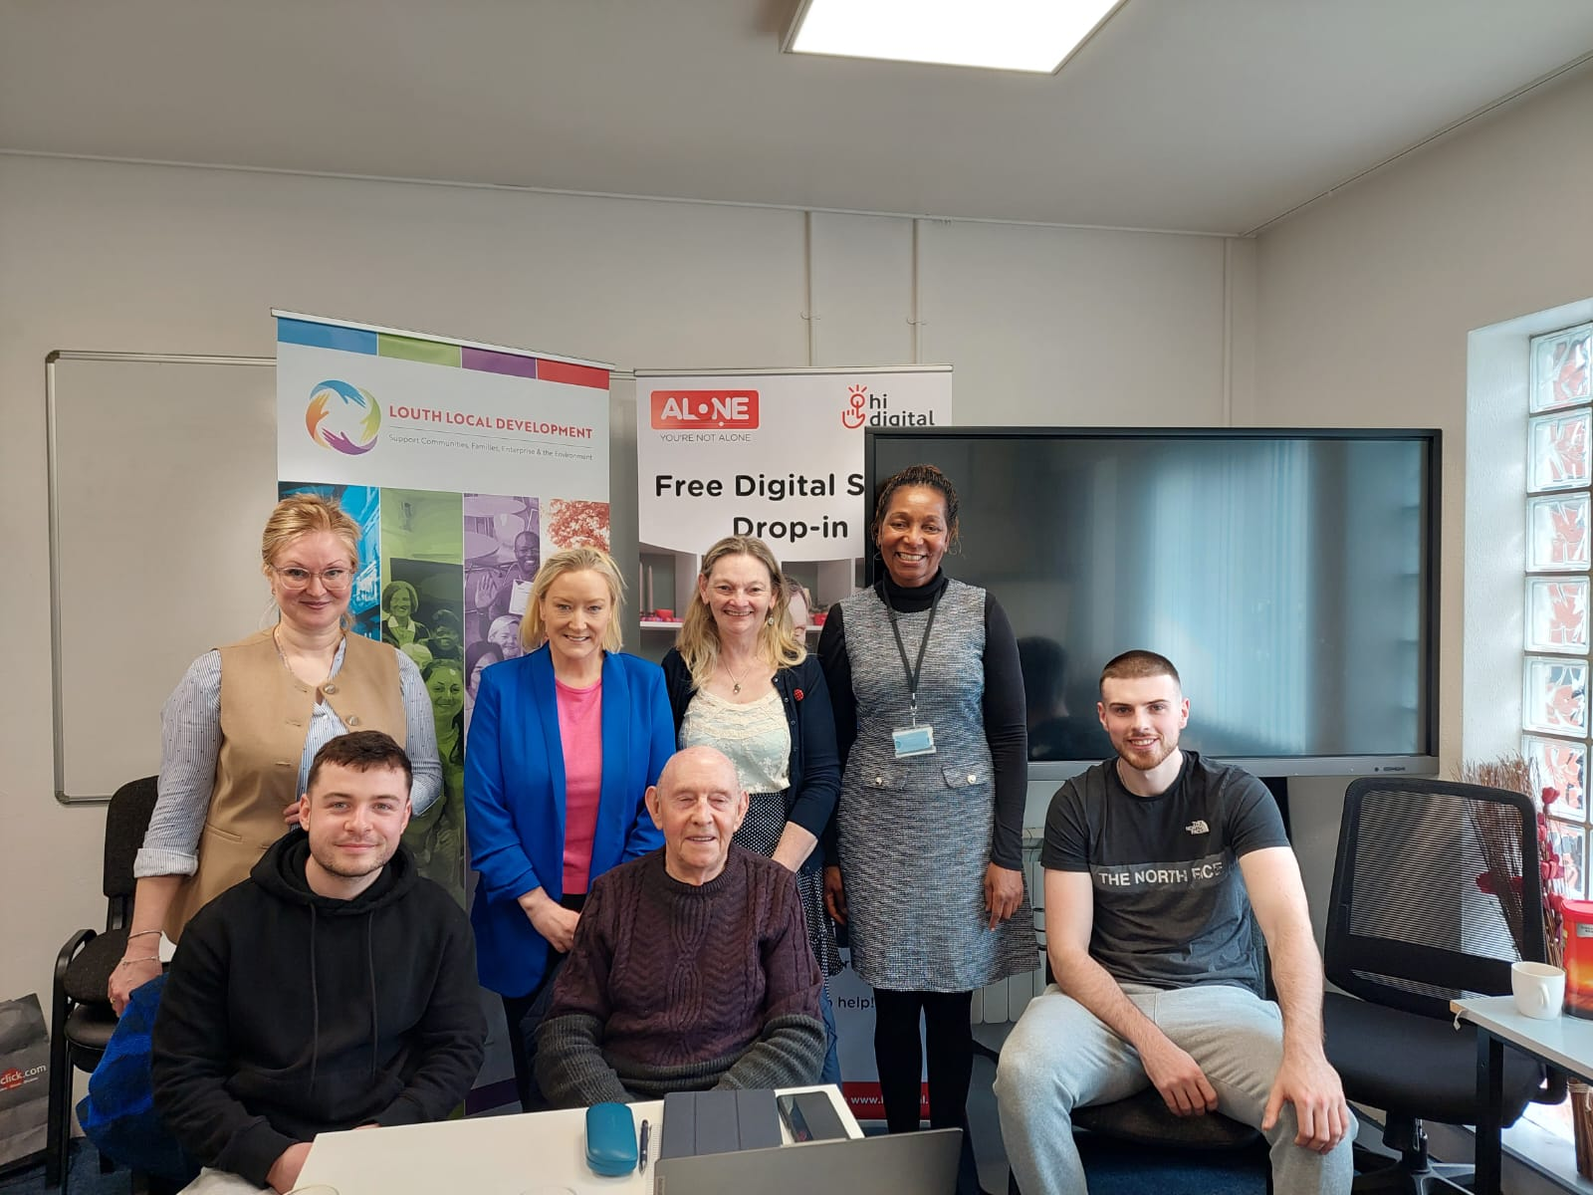
An intergenerational Digital drop-in cafe for older people – Community Office Dundalk April 2025


In July, SICAP submitted the Smart Cafes concept project idea to Media Literacy Ireland, and on Friday, 5th September, we were advised that our entry had been shortlisted in the Best Media Literacy Initiative for Older People category.

The Media Literacy Ireland awards event was held on Monday, 6th October, in the Virgin Media Studios Dublin. The competition was strong, and we are delighted to announce that we won a Highly Commended National Award for the Best Media Literacy Initiative for Older People with the SICAP Social Inclusion Manager and SICAP Development Officers who facilitated the cafes across County Louth in attendance.

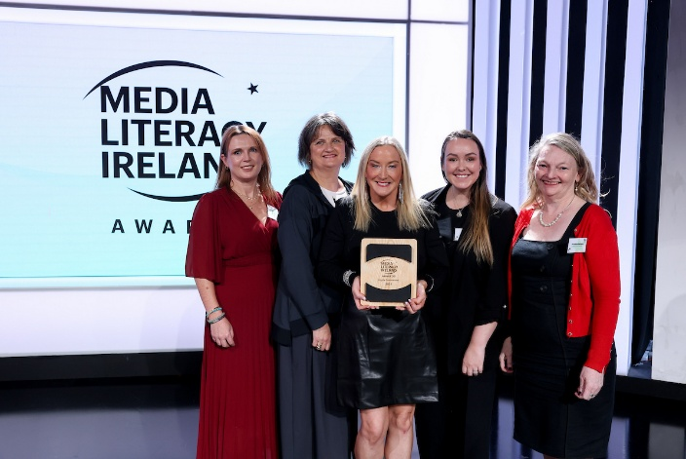


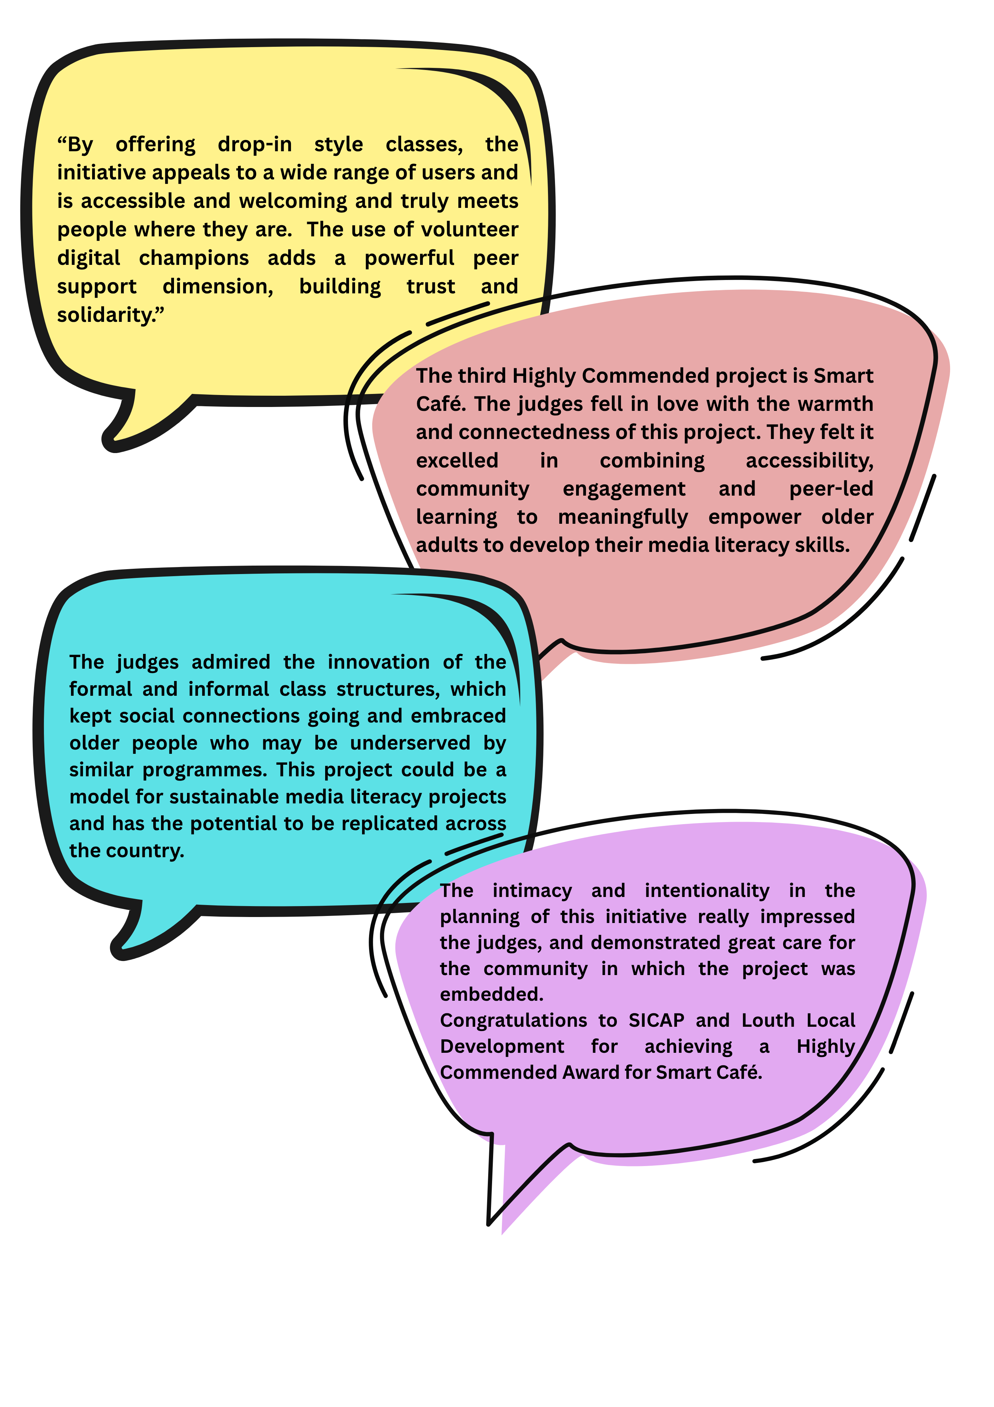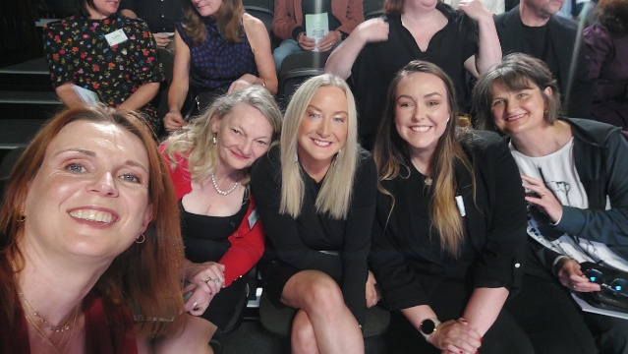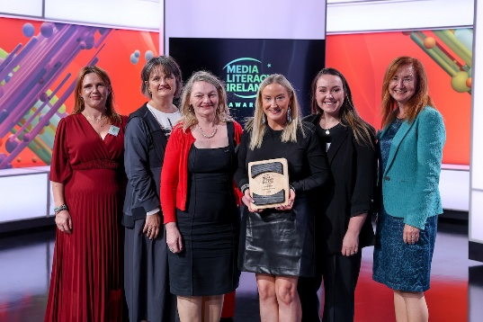
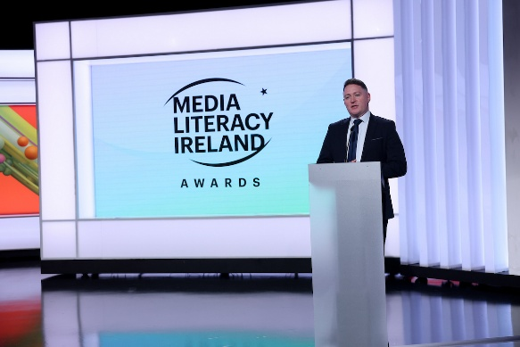 Media Literacy Ireland Awards October 2025
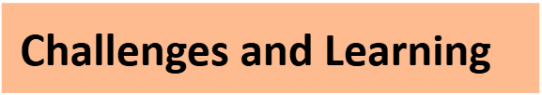
This project was identified as a needs-based issue following the transition into the new SICAP contract 2024–2028 in that we were unable to deliver similar-style SMART Start digital learning courses under Goal 2 funding. These types of supports and concept ideas are now formed under Goal 1: Thematic Focus Area: Older People (aged 65+ years) in Isolation. Due to limited funding within Goal 1, the SICAP Social Inclusion Manager identified this leverage funding through Solas Adult Literacy for Life (ALL) and not only has it been an award-winning project, but it has also achieved the aims of the Thematic Focus Area 1 that is underpinned by the principles of community development. This highlights the need for additional resources to continue to deliver these vital project ideas under the thematic focus areas on an ongoing basis using a collaborative approach with interagency stakeholders.

The learning from this is to recognise that older people are at a definite vulnerable risk of social exclusion in both navigating a digital landscape and the profound effects of social isolation and increased loneliness and how it impacts overall holistic wellbeing.

SICAP would like to give thanks to the Board and Chief Executive of Louth Local Development, the staff team who stepped up to support the delivery of this leverage-funded project and its achievements, in particular the Community Development Officer in Dundalk and Mid-Louth, the Louth Local Community Development Committee and Louth County Council for their continued support, all the collaborative stakeholders that were involved and most of all to our volunteer Digital Champions and older people who took the brave step into a digital world.

‘This project was supported by the Collaboration and Innovation Fund as part of the Adult Literacy for Life strategy. Adult Literacy is co-funded by the Government of Ireland and the European Union.’

SICAP acknowledges thanks to Niamh Mc Shane, the LMETB Regional Literacy Coordinator, for the help and support in accessing the leverage funding and for supporting us throughout the delivery of the programme and application to the Media Literacy Ireland Awards.


The video we are presenting is a detailed sample that aligns to the Thematic Focus Area 1: Older People (aged 65+ Years in Isolation.

We intend to promote this video on our Louth Local Development Social Media Platforms and Website for a wider reaching audience.

We hope you enjoy the video, link below.
https://youtu.be/JZeZhDWo3mE

