Sample Assessment
- You want to change energy supplier for your home, but you want to get the best value for money
Using Sample Bill A

Discuss with Student what is meant by:
- Smart meter
- Day rate
- Night rate

- Ask students what they need to know about their personal energy usage before choosing what energy supplier to go with.
Step 1 Identify the energy units used and the charge per unit
- How much electricity are you using monthly
- What is your current rate per unit
With this information you can work out your total energy cost (before standing charges, levies, VAT)

Step 2 What are your current standing Charges and Levies
- PSO levy
- Standing charges
Subtotal before VAT
- Vat @ 9%

Step 3 Calculate effective average unit cost

$\frac{Total Cost}{Units Used }$ = average unit cost

Sample Bill A
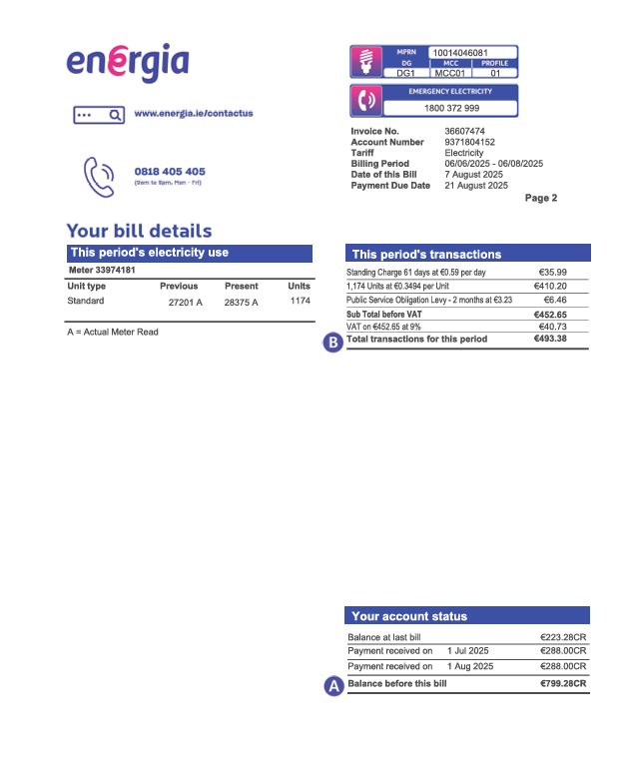

Using the Energy units used in Sample Bill A
Assess whether it would be a cheaper or more expensive to move from provider in Simple Bill A to Sample Bill B?
- Fill in units used as per Energia Bill in box A
- Calculate the total cost of units B
- Put in the number of standing charge days (61) C and calculate the total Standing Charge D
- Subtotal charges excluding VAT E
- Allow for VAT on Subtotalled Charges @9% F
- Add the VAT to find total charges for this period G
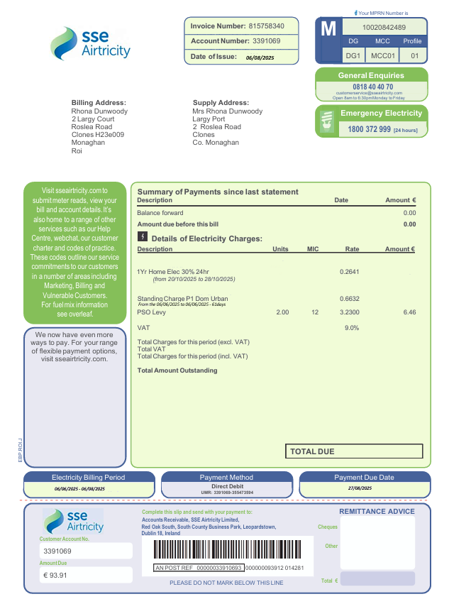
- Compare the Tariffs between SSE Airtricity and Energia and calculate potential saving if any?
Sample Bill B
€

€

€

€ 6.46

€
G
F
E
D
C
B
A
€

1234567
John Doe,
23 Main Street,
Monaghan,
Co. Monaghan
John Doe,
23 Main Street,
Monaghan,
Co. Monaghan.

