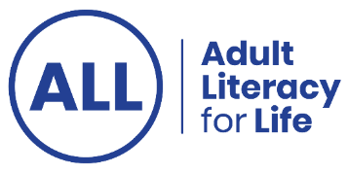
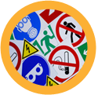
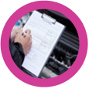
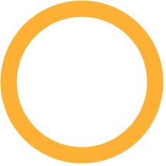

Let's talk about health literacy
The resource shows different ways that members of the public, health practitioners and educators can learn about health literacy and best practice.
You can click on a new item each day to access information, resources and tips about health literacy. All items are free to view or to use.

Ctrl + click on the heading beside each number to view the resource.
- Introduction: What is health literacy
A podcast conversation explains all about health literacy
- Health literacy research factsheet
A factsheet from research commissioned by Adult Literacy for Life in 2023
- A to Z on health conditions
Information from the HSE, organised from A to Z on health conditions.

- My medicines list
You can use this to create a list of all the medicines and supplements you take.

- Health Literacy in Pharmacy Practice
A webinar about health literacy in pharmacy practice and how to build understanding and confidence in pharmacy consultation.

- Health literacy in General Practice
A video where Dr Austin speaks about how to communicate in General Practice, so patients understand.

- Know your health numbers
The numeracy highlighted in many areas of health.

- HSE plain language guidelines
A guide for health practitioners on how to communicate clearly with people.

- My health, my voice
Useful questions to ask when using health and social care services.

- Health and well-being
A reading and writing health workbook for adults.

- The Parenting Platform: Raising healthy children
A YouTube channel with lots of videos, webinars and podcasts supporting parents on parenting related issues.

- Ask me 3
A video sharing the three important questions we should ask to understand your condition and take care of yourself.

- Preparing for your health appointment - HSE
Useful tips from the HSE on what to do before an appointment, what to bring on the day and lots more.

- Food for thought - easy read guide to healthy eating
A self help guide to help you be healthier.

- Well Now
A tutor guide to deliver health literacy.

- Health information from Citizens Information
Useful information on health system, medical cards, health services and lots more.

- Talking health and wellbeing - HSE podcast
A HSE podcast with over 130 episodes talking about health and wellbeing.

- Getting health information and support between appointments
A video where Tony talks about where to get information and support between medical appointments.

- Balancing Stress is the HSE's free programme
A free six part programme to help you manage stress, worry, low mood and relationship difficulties. You can do the programme any time and at your own pace.

- Let’s talk about health literacy for everyone
An online eLearning course about health literacy.

- Health promotion publications - HSE
A wide range of health resources you can order or download from the HSE.

- Let’s talk about a literacy friendly approach for practitioners
An online eLearning course about how practitioners can apply best practice in health literacy.

- Getting the most from your health appointment
A video where Karen shares her experience and advice about how she gets the most from health appointments.

- Improve the hospital experience for adults
A printable leaflet on how healthcare professionals can improve the hospital experience for adults with a disability.

- Let’s talk about plain language
An online eLearning course about plain language.

- Health information calendar - HSE
A calendar with hyperlinks to websites providing information on the 2026 campaign theme and related support resources.

- Stages of Changes
A video explaining the stages of change.

- TED Talk: AI, medical jargon and the healthcare maze
Karen Komondo delivering a TED Talk about how we all struggle to understand health information – sharing her personal experiences.

- A conversation with your health practitioners
A video demonstrating how to communicate clearly during a health appointment.

- Unclear terminology and teach back
Two videos talking about terminology and teach back in a healthcare setting.

- Health literacy for healthy living
Irish Heart website with lots of helpful tips and resources to support you with healthy habits.

