International Literacy Day 2025

**What’s on?**

All events are free and open to the public.

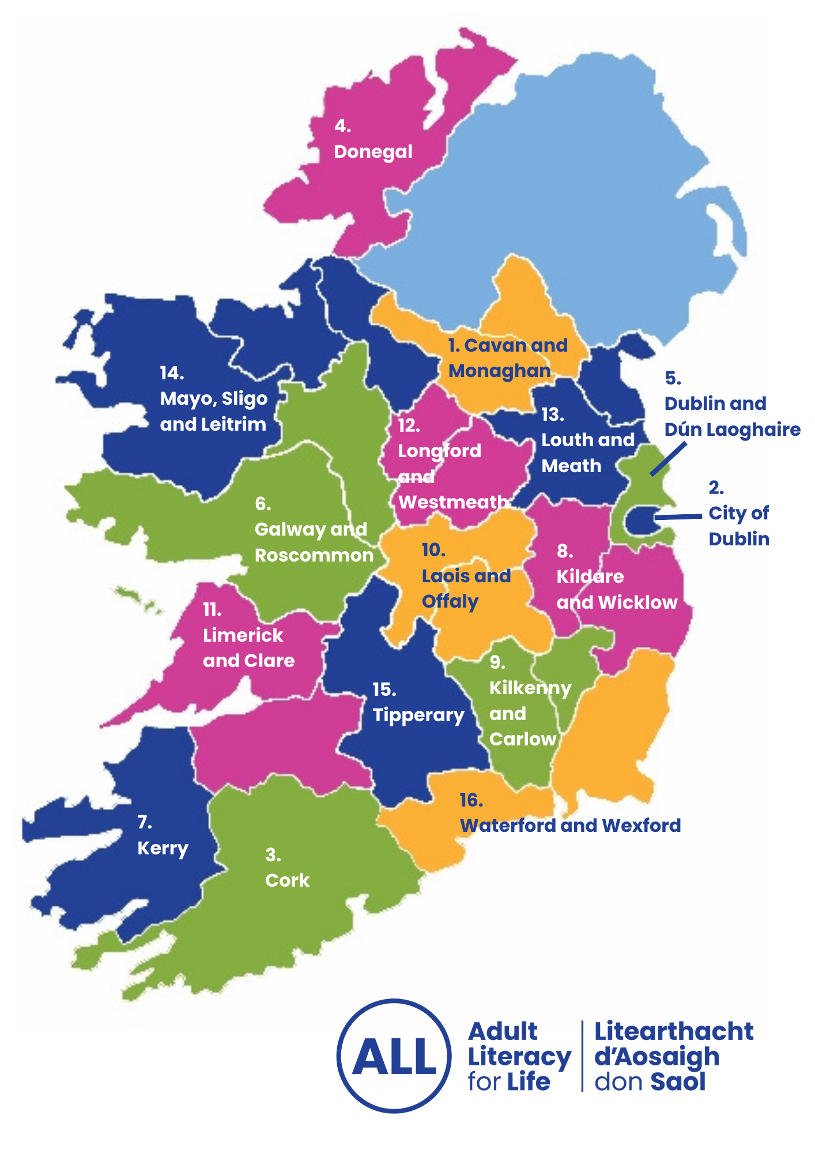

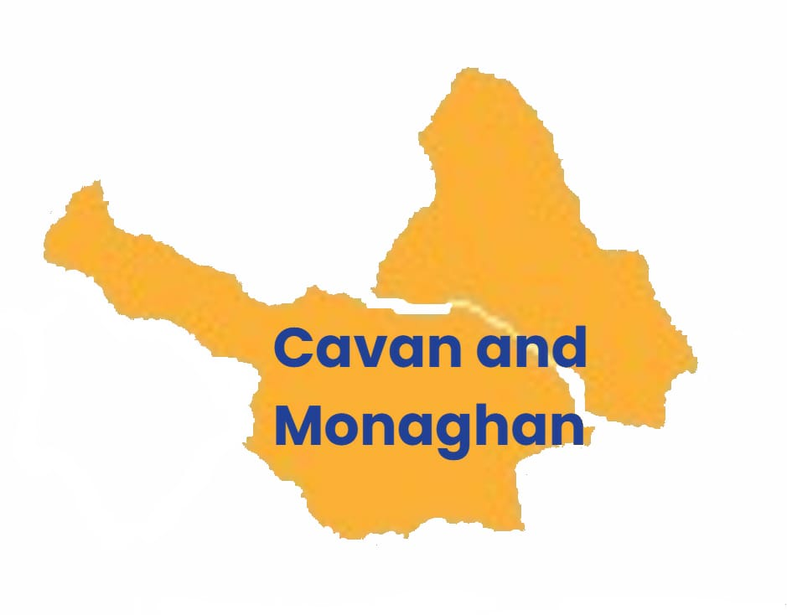

**1. Cavan Monaghan**

1. **Cavan and Monaghan**

**CMETB - The journey (Podcast)**

How common are unmet literacy needs in adults in Ireland? What happens if you approach your local ETB for support? How can learning change your life? What are libraries doing to support literacy learning?

We chat with Sinead Cahill and Michael Duffy about what it's like to return to learning. We also meet Laura Carey from Cavan Libraries, and Karen McCague from Monaghan Libraries, to find out how they support adults with unmet literacy needs.

**Where:** Spotify <https://open.spotify.com/show/0sqBjCMBoizGEBzGtwgykH?si=4bfb117f687c4347>

**When:** Anytime from 5 September

**AI in our daily lives: present and future by Dr Dympna O'Sullivan (Talk)**

“AI in our daily lives: present and future”, will explore how AI impacts everyday life and will address common misconceptions about AI.

Topics to be covered:

* How AI technologies actually work.
* Ethical considerations and societal impacts.
* Ireland’s role in shaping global AI innovation.
* Practical advice for navigating an AI-driven future.

**Where:** Carrickmacross Library, Riverside Road, Carrickmacross, Co. Monaghan, A81 HY83.

**When:** Monday 8 September, 18:30-19:30

**Tales that teach: Navigating the online and offline world (Storytime)**

This storytime event encourages children and adults to think before they act—online and offline.

We look at:

* Stories like Troll by Frances Stickley and #Goldilocks: A Hashtag Cautionary Tale by Jeanne Willis
* The “Stop, Think, Check” approach to media literacy.

There will be a display of fiction and non-fiction books and posters. These will help you talk to your child about online safety, checking where things come from, and spotting threats.

We will also provide resources to help you and your child become more thoughtful, informed, and secure online.

**Where:** Johnston Central Library, Farnham Centre, Farnham Street, Cavan

**When:** Monday 8 September, 10:30-11:00 and11:30-12:00

**Byte and brew – social smartphone classes (Class)**

Byte and Brew classes are social smartphone classes. You can decide what you want to learn. You can learn from one another as well as from the tutor.

**Where and when:**

* Cavan town
* Monaghan town
* Bailieborough
* Virginia
* Carrickmacross
* Castleblayney
* Latton

**When:** From Tuesday 2 September onwards.

**Booking:**

For more information or to book a place, contact your local library or Ceinwen on 047 71914 or [ceinwenfergus@cmetb.ie](mailto:ceinwenfergus@cmetb.ie)

**TechKnow 121 digital skills (Help hub)**

If you would like some help with technology and finding your way around the online world, then drop into your local library today. Our helper will provide 1 hour of one to one support on your technical or digital questions.

**Where and when:**

**Monaghan Town Library**, Library Building, Dawson Street, Monaghan Town, Co. Monaghan, H18 FW50

Every Monday, 10am – 1pm – runs from 8 September to 21 November

**Clones Library**, 98 Ave, Crossmoyle, Clones, Co. Monaghan

Every Monday, 2pm – 5pm – runs from 8 September to 21 November

**Carrickmacross**, 16 Drummond Ross, Drummond Otra, Co. Monaghan

Every Tuesday, 10am – 1pm – runs from 8 September to 21 November

**Castleblayney**, [Gatelodge, 2 Market Square, Onomy, Castleblayney, Co. Monaghan, A75 V383](https://www.google.com/maps/place//data=!4m2!3m1!1s0x4860bb008ee46137:0x9aa568af8411f188?sa=X&ved=1t:8290&ictx=111)

Every Thursday, 10am – 1pm – runs from 8 September to 21 November

**Organisers**: Cavan Library Service in collaboration with the Regional Literacy Coordinator

Contact details: [library@cavancoco.ie](mailto:library@cavancoco.ie)

**Online know-how: Be informed, be secure (Workshop)**

We will look at the “Stop, Think, Check” approach. This helps us check information that we see and hear. You will learn how to

* spot trustworthy sources
* identify fake headlines
* understand where information comes from
* why it’s being shared.

We’ll also explain key terms like phishing and cookies.

Ceinwen Fergus, Regional Literacy Coordinator for Carlow and Monaghan, is facilitating this session.

**When:** Thursday 11 September, 11:00

**Where:** Johnston Central Library Cavan, Farnham Centre, Farnham Street, Cavan H12 A3T1

**Booking:**

For more information or to book a place, contact Cavan Library Service on 049 4378500 or [library@cavancoco.ie](mailto:library@cavancoco.ie)

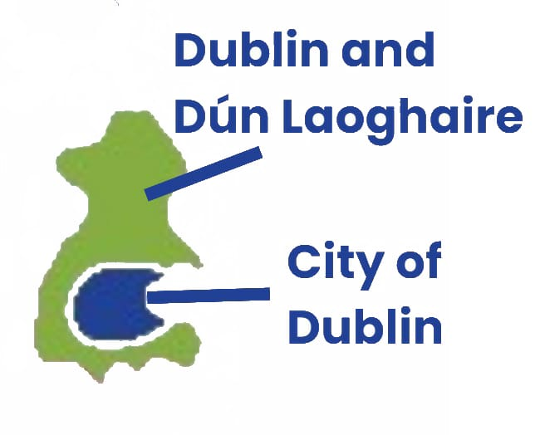

1. **City of Dublin**

**Creating a website using free services (Talk)**

This free talk is for the general public. It will give you some information on creating a website using free services:

* Introduction to website builders (Weebly, Wix, WordPress)
* Setting up a free website
* Customising templates and adding content
* Understanding basic search engine optimisation (SEO) and website maintenance

**Where:**

* **Central Library**, Ilac Centre, Henry St, North City, Dublin, D01 E9V3
* **Donaghmede Library**, Donaghmede Shopping Centre, Grange Rd, Donaghmede, Dublin 13, D13 XW28
* **Inchicore Library at Richmond Barracks**, Richmond Barracks, St Michael's Estate, Inchicore, Dublin 8, D08 YY05

**When:** Thursday 4 September, 18:00-19:45

**5. Dublin and Dún Laoghaire**

**Age friendly financial workshops (Class)**

Gain confidence, make new friends while you learn about:

* Budgeting basics
* Loans and credit scores
* Digital and online banking
* Avoiding frauds and scams
* Savings, investments and retirement planning

**Where:**

LexIcon Library, Haigh Terrace, Moran Park, Dún Laoghaire, County Dublin A96 H283

**When:**

* Every Wednesday, 10am - 2:30pm
* From 17 September to 10 December (no class on Wednesday 29 October)

**Booking:**

Contact Bernie at [dlrlexiconlib@dlrcoco.ie](mailto:dlrlexiconlib@dlrcoco.ie) or phone (01) 204 7219.

**Digital discovery @ the Hub (Help hub)**

We'll show you how to use your email, smartphone, apps and more. We can also help you with online banking, managing your money. We've got friendly experts from local banks, Money Advice & Budgeting Service (MABS), An Post and more.

**Where:**

Blanchardstown Library, The Civic Centre, Blanchardstown Centre, Co. Dublin, D15 RY73

**When:**

* Every Tuesday and Thursday, 10am - 12:30pm
* From 19 August September to 1 October

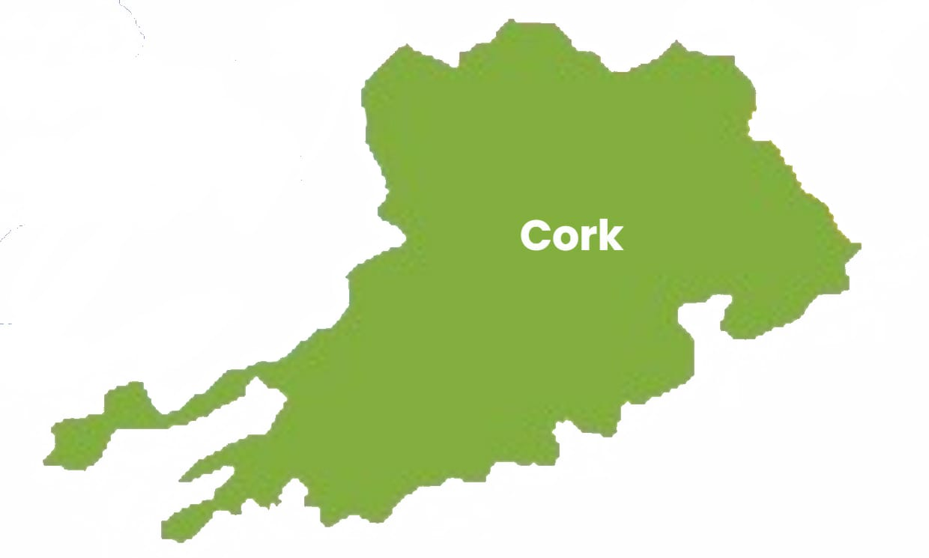

**3. Cork**

**Become media smart: Fake news, real consequences (Talk)**

This talk looks at social media and how we use information. It also looks at how extreme content is spread and gives useful tips on how to protect family and friends from false information.

Topics include:

* fact checking
* questioning the information you read
* looking out for content that has been altered or created by AI
* identifying fake accounts

Free Event, no need to book

**Where and when:**

**Fermoy Library**, Connolly Street, Fermoy, Co. Cork, P61 C663

Saturday 30 August, 11am – 12 noon

**Cobh Library**, Arch Building, Casement Square, Cobh, Co. Cork, P24 RX89

Saturday 30 August, 2pm – 3pm

**Mallow Library**, Thomas Davis St. Mallow, Co. Cork, P51 DK50

Saturday 6 September, 10am – 11am

**Midleton Library**, Main Street, Midleton, Co. Cork, P25 W085

Saturday 6 September, 2pm – 3pm

**Bandon Library**, The Old Market Market Street, Bandon, Co. Cork, P72 WD58

Saturday 13 September, 10am – 11am

**Carrigaline Library**, Strand Road, Carrigaline, Co. Cork, P43 HA25

Saturday 13 September, 2pm – 3pm

**Digital drop-in clinic for older adults (Help hub)**

Looking to boost your digital skills or get help with forms or online services? The digital drop-in clinic is here to support you.

Find us in your local library, free confidential assistance with filling forms, digital and smartphone support.

**Where:**

Cork City Library, 57-61 Grand Parade, Cork, T12 NT99

**When:**

* Every Friday, 10am - 1pm
* From 19 September onwards

**Everyday AI: Using AI in your day-to-day life (Talk)**

Join Graphic Designer Cian Walsh to see ideas brought to life with some powerful new AI tools. This exciting session will help to make AI less of a mystery and will show you how to use AI to become more creative. Whether you are new to AI or curious about all it can do, you’ll leave with clear tips to make AI work for you.

**Where and when:**

**Skibbereen Library**, North Street, Skibbereen, Co Cork, P81 PW10

Tuesday 7 October, 3:30pm-5pm

**Clonakilty Library**, Kent Street, Clonakilty, Co. Cork, P85 XD95

Tuesday 7 October, 7pm-8:30pm

**Kanturk Library**, Percival St, Kanturk, Co. Cork, P51 K886

Wednesday 8 October, 11am – 12:30pm

**Macroom Library**, The Briery Gap Cultural Centre, Main Street, Macroom, Co. Cork, P12 KR25

Wednesday 8 October, 3pm – 4:30pm

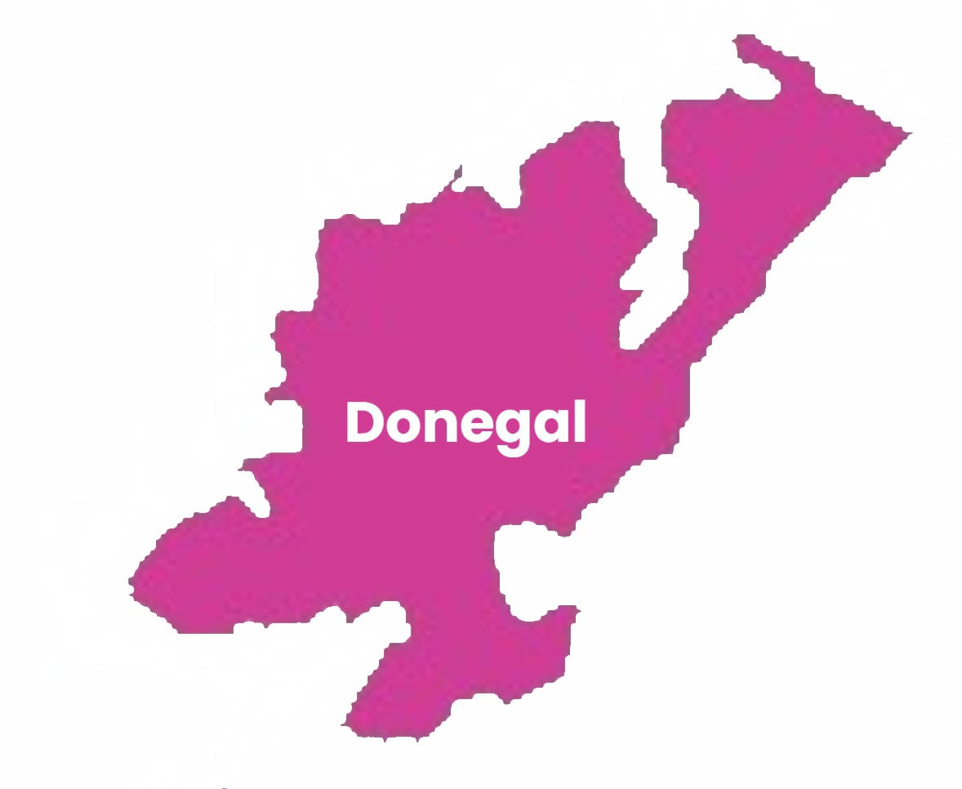

**4. Donegal**

**Security, scams and smartphones (Class)**

A free event to help you navigate the online world. From online safety to fact checking, there will be a wealth of information to help keep you safe online.

**Where and when:**

**Central Library Letterkenny**, St Oliver Plunkett Rd, Letterkenny, Co. Donegal

Monday 8 September, 2pm – 3pm

**Gaoth Dobhair Library**, Aishlinn Gaoth Dobhair, Páirc Ghnó Ghaoth Dobhair, Co. Dún na nGall

Friday 19 September, 11am – 12 noon

**Buncrana Library**, St Mary's Road, Buncrana, Co. Donegal F93 YK68

Tuesday 23 September, 11am – 12 noon

**Twin Towns Community Library - Stranorlar**, The Base Enterprise Centre, Railway Rd, Stranorlar, Co. Donegal, F93 Y5C3

Wednesday 24 September,11am – 12 noon

**Bundoran Library**, Station Road, Bundoran, Co. Donegal, F94 CKX7

Tuesday 30 September,10am – 11am

**Literacy awareness training (Class)**

Staff from Donegal County Council attending bespoke Literacy Awareness Training for specific staff.

**Where:** Public Service Centre, Letterkenny, Co. Donegal

**When:** Monday 8 September, 10am – 12:30pm

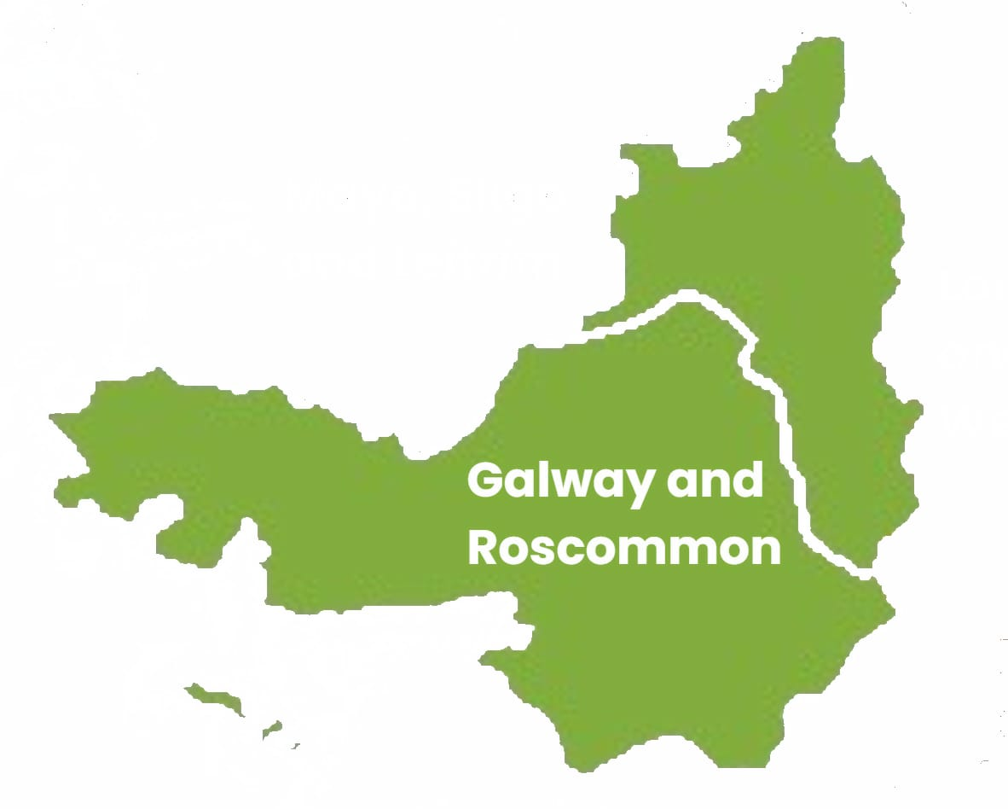

**6. Galway and Roscommon**

Patrick Fox is our new Regional Literacy Coordinator for Galway and Roscommon.

You can contact Patrick on [patrick.fox@gretb.ie](mailto:patrick.fox@gretb.ie) to find out more about what is happening in your area.

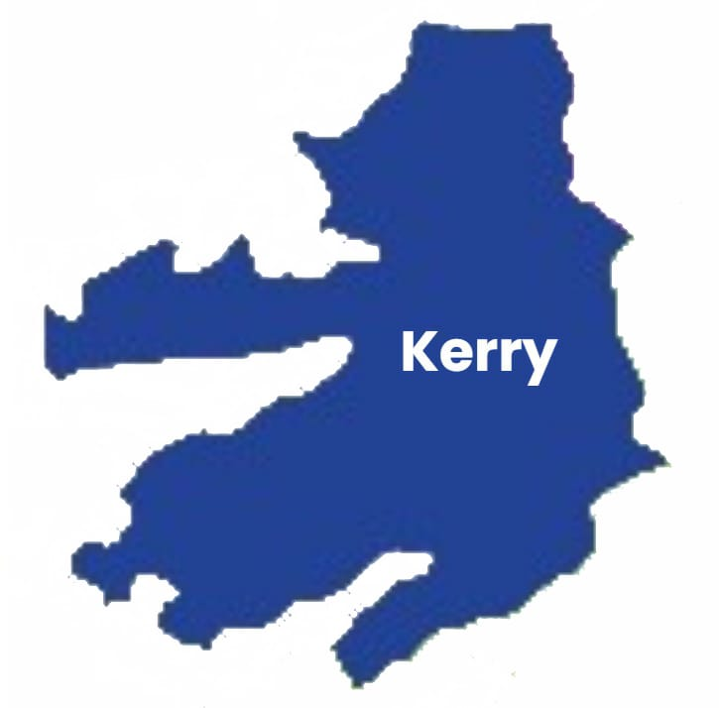

**7. Kerry**

**Stop - Think – Check: Media literacy workshop (Class)**

**Where and when:**

These events take place in libraries – venues to be confirmed

* Friday 12 September, 11am to 12 noon followed by 1-to-1 help
* Friday 19 September, 11am to 12 noon followed by 1-to-1 help
* Friday 26 September, 11am to 12 noon followed by 1-to-1 help

**Info and bookings:**

For more information contact Paula Tiller by phone or WhatsApp on 087 337 2139 or email [rlc@kerryetb.ie](mailto:rlc@kerryetb.ie).

**Empowerment hubs (Help hub)**

One-to-one help and advice available from October 2025.

**Where:**

* Killarney Library,
* Killorglin Library,
* Local Adult Basic Education centres in Killarney and Killorglin

**Booking:**

Call into your **local library.**

Visit the **Adult Basic Education** service at First floor, 37 High Street, Killarney, Co. Kerry, V93 R52W

* **Phone:** 064 6636990
* **Mobile:** 086 796 9625
* **Email:** [elaine.clifford@staff.kerryetb.ie](mailto:elaine.clifford@staff.kerryetb.ie)

**Digital Literacy 1-to-1 (Class)**

Individual 1-to-1 classes help you learn how to have confidence in using your own smartphone, iPad or laptop. Bookings taken from 17 September.

**Where and when:**

Dingle Further Education and Training Centre, Rice House, Goat Street, Dingle, Co. Kerry

**Booking:**

* **Phone:** 066 9152361
* **Email:** dinglefet@kerryetb.ie

**Men’s Shed Digital skills (Class)**

This digital skills class will give you confidence in using your own smartphone, iPad or laptop.

**Where:** O’Connell Centre, Carhan Road, Cahersiveen, Co. Kerry

**When:** 7 October for 8 weeks – times to be confirmed

**Booking:**

For more information or to book a place, contact Deirdre O’Shea at the O’Connell Centre on 0669472414 or email [info@oconnellcentre.ie](mailto:info@oconnellcentre.ie)

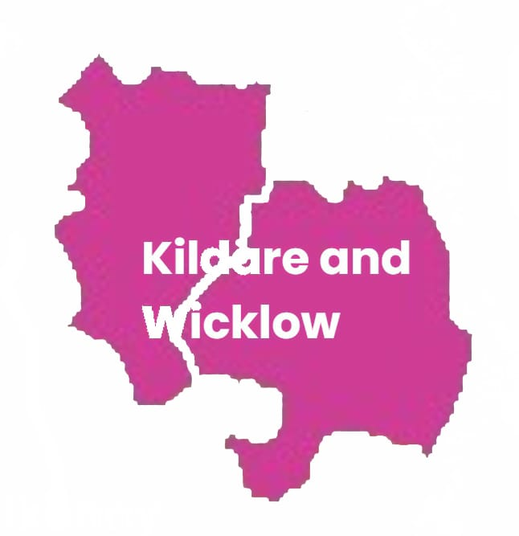

**8. Kildare and Wicklow**

**Stop - Think – Check: Media literacy workshop (Class)**

A free event that will help address your digital literacy needs.

Topics to be discussed:

* What is media literacy?
* Information comes to us daily. What are the benefits and challenges of this?
* Stop-Think-Check
* Fact checking tips
* Phishing emails
* Fake news
* Cookies
* Resources that can help us.

**Where and when:**

**Athy Library**, Convent Lane Athy, Co. Kildare R14 DK33

October, date to be confirmed.

For more information contact Athy Library, ([045)](tel:045) 980 555

**Leixlip Library**, Captain's Hill Leixlip Co Kildare W23 WR96

October, date to be confirmed.

For more information contact Leixlip Library, [(045) 980 844](tel:045980844)

**Wicklow Library**, The Mall, Main Street, Wicklow, County Wicklow A67 X504

October, date to be confirmed.

For more information contact Wicklow Library, (0404) 67025

**Blessington Library**, New Town Centre Blessington Co. Wicklow W91 RW83

October, date to be confirmed.

For more information contact Blessington Library, (045) 891 740

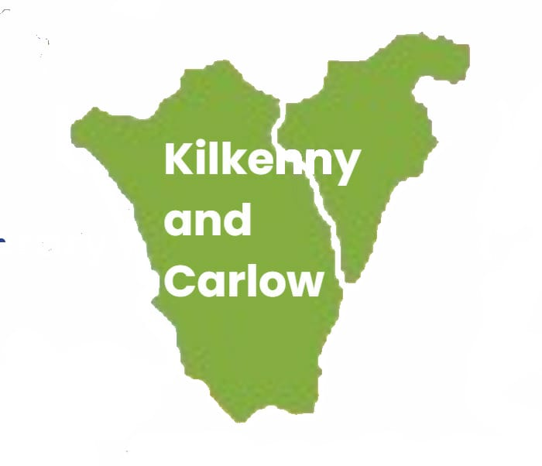

**9. Kilkenny and Carlow**

1. **Kilkenny and Carlow**

**Misinformation in the aftermath of the Carlow shooting (Talk)**

RTE journalist Jack McCarron talks about his work reporting on the Carlow shooting incident on Sunday 1st June and subsequent false claims, misinformation and disinformation online in the immediate aftermath of the incident. The talk will also include a broader discussion on misinformation and media literacy with some practical recommendations for how to be more media-literate and be able to critically evaluate content across various media platforms.

**Where:** Carlow Library, Tullow St, Carlow, R93 K126

**When:** Tuesday 26 August, 7pm – 8pm

**Spotting fake news in everyday life (Talk)**

To mark International Literacy Day, Kilkenny and Carlow Education and Training Board (KCETB) and Carlow Libraries host a thought-provoking media literacy talk with journalist and broadcaster Eimear Ní Bhraonáin of Eimear.ie. Drawing on her extensive experience in newspapers, radio and television, Eimear will explore how we consume news today—and the risks posed by misinformation, disinformation and fake news. Using real-life examples, she will offer practical advice on how to navigate the modern media landscape with confidence and critical thinking.

**Where and when:**

**Carlow Library**, Tullow St, Carlow, R93 K126

Tuesday 9 September, 6:30pm – 7:30pm

**Tullow Library**, Inner Relief Road, Tullow, Co. Carlow, R93 XD93

Thursday 11 September, 11:30am – 12:30pm

**Muinebheag Library**, Main St, Moneybeg, Muine Bheag, Co. Carlow, R21 X529

Thursday 11 September, 2:30pm – 3:30pm

**Borris Library**, The Old Schoolhouse, Lower Main St, Borris, Co. Carlow, R95 HF25

Monday 29 September, 2:30pm – 3:30pm

**Be media smart: Stop, think, check (Class)**

Media, especially digital media, is central to our daily lives and the technology behind it is changing all the time. Knowing how to use, understand and evaluate media is essential if we want to be able to participate fully in society, and make informed decisions based on accurate and reliable information. Martina Chapman, National Coordinator of Media Literacy Ireland, will highlight the important role that media has in our lives and how to manage our relationship with media. A range of topics will be explored such as AI, verifying information and protecting our data, as well as avoiding digital pitfalls like scams and misinformation.

**Where:** Carlow Library, Tullow St, Carlow, R93 K126

**When:** Thursday 20 November, 7pm – 8pm

**Adult Literacy for Life on the radio (Radio)**

A series of five sessions (20 mins) during the month of September on Community Radio Kilkenny City (CRKC).

**Where:** Community Radio Kilkenny City (CRKC) [88.7FM](https://crkc.ie/)

**When:**

* Wednesday 27 August - Session 1: RLC to give an overview of ALL and events for September
* Wednesday 3 September - Session 2: ALO from Kilkenny Adult Literacy Service to chat about local services
* Wednesday 10 September - Session 3: Two members of the the Regional Adult Literacy Coalition to speak about the work of the Coalition
* Wednesday 17 September - Sessions 4 & 5 - Digital Literacy/ESOL and/or Family Literacy learners with a staff member to chat about their experiences

**Your phone is listening: What you should know about digital media in 2025? (Talk)**

Laura Stapelton from Little Spark Media will present an interactive workshop with Q&As looking at:

* Your phone is listening to you – is it really?
* The role of AI in our digital lives
* Being digitally media literate
* Online safety for you and your family

**Where:** Castlecomer Library, Kilkenny Street, Castlecomer, Co Kilkenny R95 AH33

**When:** Tuesday 9 September, 6:30pm – 8pm

**Booking is essential:**

Phone 056 4440561 or email [castlecomer@kilkennylibrary.ie](mailto:castlecomer@kilkennylibrary.ie) to book a place.

**Your phone is listening to you – is it really? (Talk)**

Laura Stapelton from Little Spark Media will present an interactive workshop with Q&As looking at:

* Your phone is listening to you – is it really?
* The role of AI in our digital lives
* Being digitally media literate
* Online safety for you and your family

**Where:** Ferrybank Library, Ferrybank Shopping Centre, Waterford X91 D211

**When:** Wednesday 10 September, 6:30pm – 8pm

**Booking is essential:**

Phone 056 4440561 or email [castlecomer@kilkennylibrary.ie](mailto:castlecomer@kilkennylibrary.ie) to book a place.

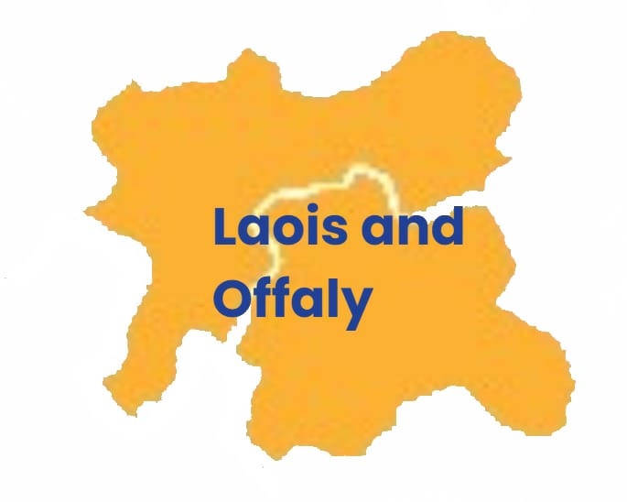

**10. Laois and Offaly**

**Spotting fake news in everyday life (Talk)**

To mark International Literacy Day, LOETB and Laois Library Service invite you to a media literacy talk at Portlaoise Library with journalist and broadcaster Eimear Ní Bhraonáin. With years of experience in newspapers, radio, and TV, Eimear will explain how news is made and how to spot false or misleading information. Using real-life examples, she’ll share simple tips to help you think clearly and confidently about the news you read, hear, and watch.

**Where and when:**

**Portlaoise Library**, 23 Main St, Maryborough, Portlaoise, Co. Laois, R32 N7EP

Tuesday 9 September, 11am – 11:45am

**Portarlington Library**, 2 Main St, Cooltederry, Portarlington, Co. Laois, R32 F9WF

Wednesday 11 September, 11am – 11:45am

**Birr Library**, Wilmer Rd, Townparks, Birr, Co. Offaly

Thursday 25 September, 11am – 11:45am

**Tullamore Library**, Bridge Ln, Tullamore, Co. Offaly

Friday 26 September, 11am – 11:45am

**Digital Hubs and Form Filling Supports (Help Hubs)**

Looking to boost your digital skills or get help with forms or online services? The Digital Help Hubs in Portlaoise and Tullamore Libraries are here to support you.

Find us in your local library, free confidential assistance with filling forms, digital and smartphone support.

**Where and when:**

* Every Monday, Tullamore Library, 10.30-12.30.
* Every Tuesday, Portlaoise Library, 10.00-12.00

Free, Confidential, One to One Service.

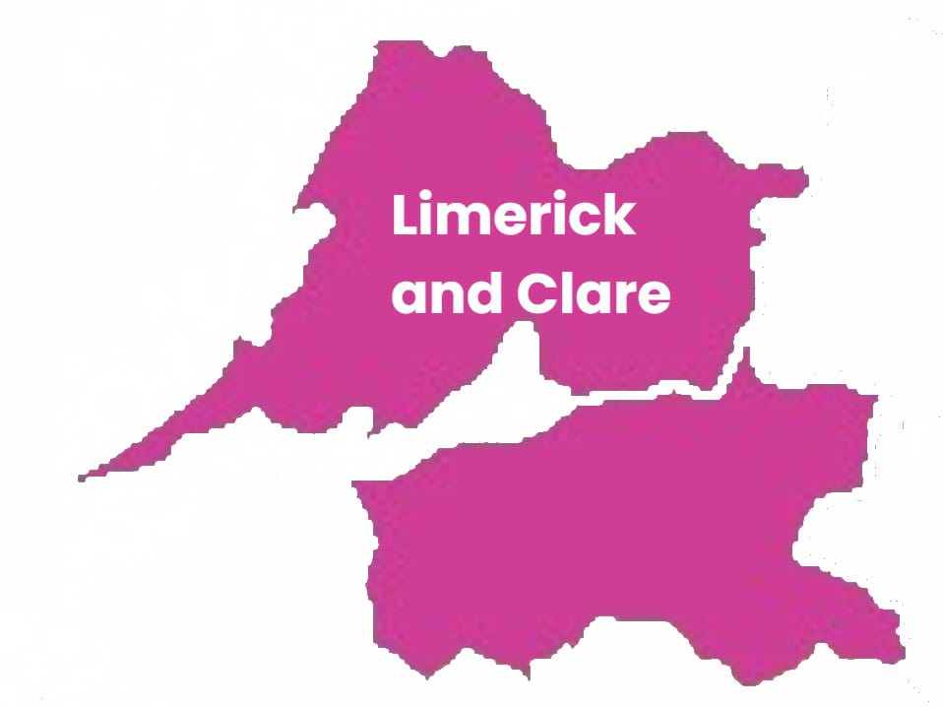

**11. Limerick and Clare**

**Artificial Intelligence workshop (Class)**

Artificial Intelligence session including media literacy for general public.

**Where and when:**

**Kilkee - Sweeney Memorial Public Library**, O'Connell Street, Kilkee, County Clare V15 P960

Tuesday 9 September, 11am – 1pm

**Killaloe Library**, The Lock House Killaloe Co Clare V94 ED83

Tuesday 16 September, 11am – 1pm

**Limerick City Library**, Barrow House, Michael Street, Limerick, V94 RF63

Monday 22 September, 11am – 1pm

**Watchouse Cross Library**, Watch House Cross Shopping Centre, Moyross, Limerick V94 NH51

Tuesday 23 September, 11am – 1pm

**Dooradoyle Library**, Crescent Shopping Centre, Dooradoyle, Limerick V94 AP03

Monday 29 September, 11am – 1pm

**Kilmallock Library**, Áras Mainchín Seoighe, Railway Road, Kilmallock, Co. Limerick V35 HC98

Tuesday 30 September, 11am – 1pm

**Adare Library**, Adare Heritage Centre, Main Street, Adare, Co. Limerick V94 HNH0

Monday 6 October, 11am – 1pm

**Ennistymon Library**, The Square Ennistymon Co. Clare V95 V99D

Tuesday 7 October, 11am – 1pm

**Newcastle West Library**, Gortboy, Newcastle West, Co. Limerick V42 F654

Tuesday 14 October, 11am – 1pm

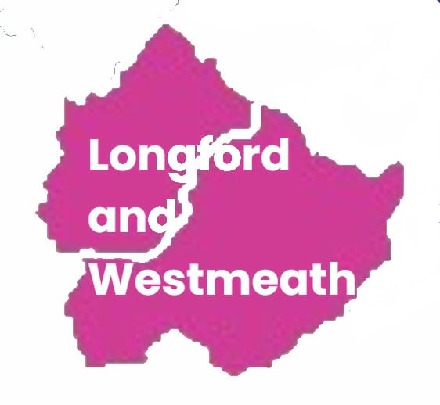

**12. Longford and Westmeath**

**Digital hub in your Library (Help hub)**

You can come to Westmeath and Longford libraries for help with setting up your online accounts and accessing services. A tutor can help you out, no matter what your technical, educational, or language skills. You can bring their own device to build your confidence.

The library can also provide a laptop or other device if you don’t have one of your own. These sessions take place once a week for six-weeks.

**Where and when:**

To be confirmed.

**Booking:**

For more information or to book a place, contact Annemaria Egan on 085 857 0991 or email [aegan@lwetb.ie](mailto:aegan@lwetb.ie).

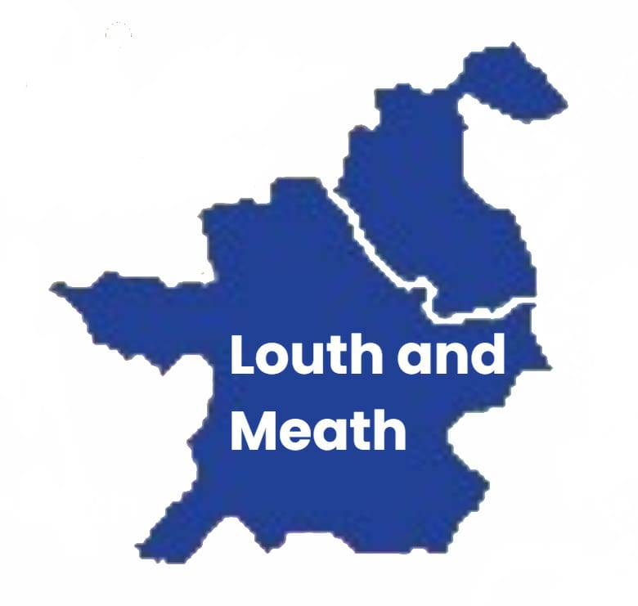

**13. Louth and Meath**

**The Glass Room misinformation exhibition (Exhibit)**

This exhibition will allow teenagers and adults to explore how social media has changed the way we read information. Find out about new types of influencers, the tactics they use, and how users and consumers can identify misinformation.

**When and where:**

**Ashbourne Library,** 1/2 Killegland Square Upper, Ashbourne, County Meath, A84 NY73

**When:** Tuesday 9 September- Tuesday 23 September, see library opening hours

**Be media smart - Questions matter! (Talk)**

Can you believe everything you read? Should you click on that link?

Asking yourself these questions will guide you through what you see online and on social media.

Questions matter is a media literacy talk with questions and answer session at the end.

Free and open to the public.

**When and where:**

**Ardee Library**, Market Street, Townspark, Ardee, Louth A92 XH22

Thursday 23 October

**Drogheda library,** Stockwell Lane, Moneymore, Drogheda, Louth A92 PY20

Friday 24 October

**Dundalk library,** Roden Place, Dundalk, A91PY17

Wednesday 29 October

**Dunleer library,** Main Street, Dunleer, Louth, A92DRV0

Thursday 30 October

**Meath Libraries – locations and times to be confirmed**

**Booking:**

**Times to be confirmed.** For more information or to book a place, please contact Niamh McShane on 0862011988 or [nmcshane@lmetb.ie](mailto:nmcshane@lmetb.ie)

**Digital Hubs at your local library (Help hub)**

Digital hubs will be available in partnership with you local libraries and Louth Meath Education and Training Board. Hubs will be available from the last week in September. Please bring your device where we will support you with any questions you have. Sessions are free and confidential.

Open to the public throughout County Louth and County Meath.

**When and where:**

**County Louth**

From Monday 6 October - times to be confirmed

* **Ardee Library**, Market Street, Townspark, Ardee, Louth A92 XH22
* **Drogheda library,** Stockwell Lane, Moneymore, Drogheda, Louth A92 PY20
* **Dundalk library,** Roden Place, Dundalk, A91PY17
* **Dunleer library,** Main Street, Dunleer, Louth, A92DRV0

**County Meath**

From Monday 6 October - times to be confirmed

* 10 library locations

For more information, please contact Niamh McShane on 0862011988 or [nmcshane@lmetb.ie](mailto:nmcshane@lmetb.ie)

**What’s on your doorstep (Exhibit)**

Come along to see what opportunities are available in your local community. This event will showcase the fantastic work delivered locally by clubs, organisations and local groups.

LMETB will be there to signpost you to courses and classes in reading, writing, working with numbers, media/digital. Learn more about Adult Literacy for Life and see our digital hubs in action!

This event organised by SICAP (Social Inclusion and Community Activation Programme) through Meath Partnership.

**Where:** Ashbourne Library, 1 -2 Killegland Square Upper, Killegland Street, Ashbourne, Co. Meath, A84 NY73

**When:** Saturday 13 September, 12:00 to 15:00pm

**Meath Cares about Older People (Exhibit)**

Age Friendly Meath and Meath County Council event to showcase what is on offer in Meath. Come along and learn more about Adult Literacy for Life and the media classes on in Louth Meath Education and Training Board also see our digital hubs in action!

**Where:** Athboy Community Centre, Main St, Athboy, Co. Meath, C15P280

**When:** Wednesday 8 October, 11:00am to 14:30pm

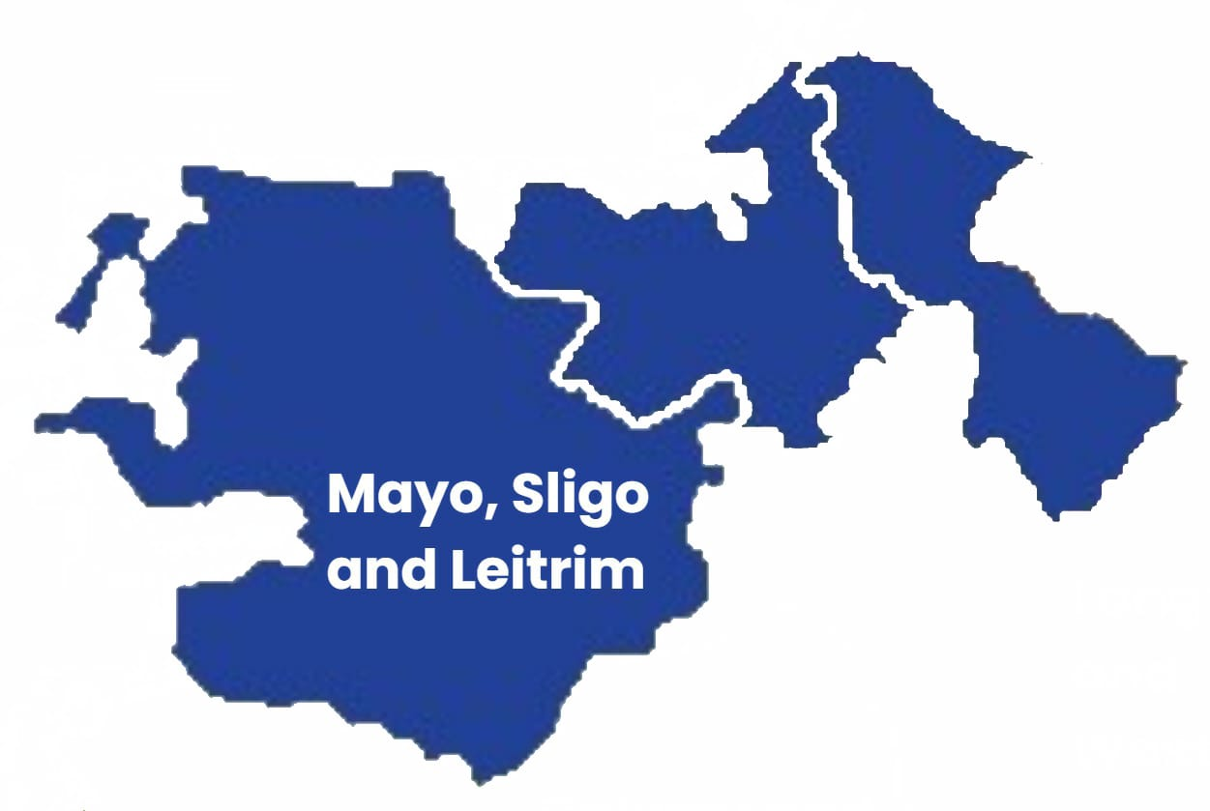

**14. Mayo, Sligo and Leitrim**

Roisín Egan is our new Regional Literacy Coordinator for Mayo, Sligo and Leitrim.

You can contact Roisín on 086 0320520 or [roisinegan@msletb.ie](mailto:roisinegan@msletb.ie) to find out more about what is happening in your area.

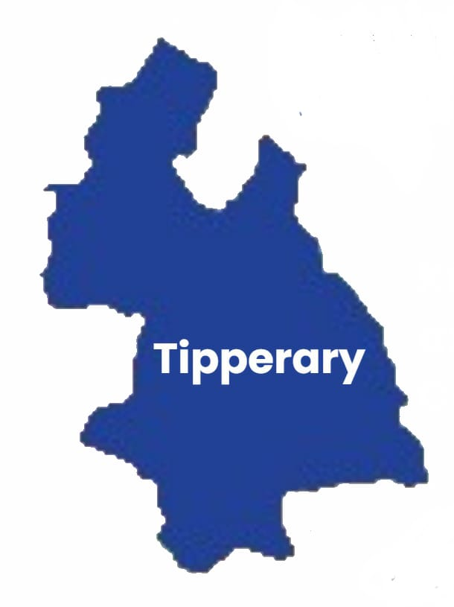

**15. Tipperary**

**National Libraries Open day (Exhibit)**

Learn more about Adult Literacy for Life and our Media savvy workshops with the libraries

**Where:** Nenagh Library, O’Rahilly Street, Nenagh, Co. Tipperary, E45 AK50

**When:** Saturday 27 September, 10:30-12:30

**Fake or fact? A media literacy workshop to help you become media savvy (Workshop)**

This workshop will explore how media can be used to manipulate and influence users. It will give attendees the skills to stop, think, and check media messages. There will be a questions and answers session, and a chance to discover the local library.

**Where and when:**

**Thurles Library,** The Source, Cathedral Street, Thurles, Co. Tipperary, E41 K802

Wednesday 5 November, 10:30-12:00

**Nenagh Library**, O’Rahilly Street, Nenagh, Co. Tipperary. Eircode: E45 AK50

Monday 10 November, 10:30-12:00

**Cashel Library,** Friar Street, Cashel, Co. Tipperary. Eircode: E25 K798

Wednesday 19 November, 10:30-12:00

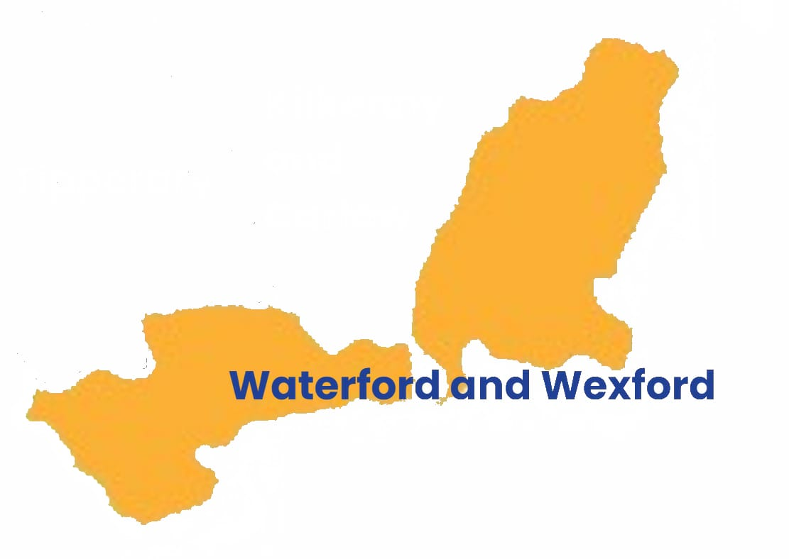

**16. Waterford and Wexford**

**Coffee morning with bite size learning for everyday life (Talk)**

A free event that will help you:

* Find health information you can trust,
* Provide tips on how to manage your money, and
* Find out how to spot fake news and misinformation.

**Where: The Tower Hotel,** Ardmore Suite, The Mall, Waterford, X91 VXEO

**When:** Tuesday 30 September, 9:30-13:00

**Booking is essential:**

Register here: [Coffee morning with bite size learning](https://forms.office.com/e/pXrgwAL9Uu)

Or phone 086 084 5354 or email [edelfinan@wwetb.ie](mailto:edelfinan@wwetb.ie) to book a place.

**See it, hear it? Can we believe it? (Talk)**

A free event that will help address your digital literacy needs.

Topics to be discussed:

* Information you receive online and on your phone every day,
* Phishing,
* Fraud,
* Cookies and lots more.

**Where: New Ross Library,** Barrack lane, New Ross, Co Wexford Y34 NW56

**When:** Wednesday 24 September, 11:00-12:00

**Booking is essential:**

Telephone New Ross Library on 051 421 877 to book your place.

**Literacy Awareness (Workshop)**

**When**: **Wednesday, 10 September 2025 | 10 am – 1 pm**

(Tea/coffee from 9:30 am)

**Where**: The Talbot Hotel, Wexford Town

This is a great opportunity to

* learn more about literacy,
* become more aware of unmet literacy needs and
* learn how to provide a more literacy friendly service.

**Booking is essential:**

Please **telephone** **086 084 5354** to book your place. You must book in advance.