

10 Tips for a Literacy Friendly Workplace


Tip 1: Use plain language
Write policies, safety instructions, and HR forms clearly. Avoid words like ‘utilise’ say ’use’ or ‘start’.


Tip 2: Keep instructions short and clear
Give short, step-by-step instructions so tasks are easy to follow and remember. Example: ‘Turn off machine. Wait five minutes. Restart.’


Tip 3: Use clear headings
Use clear headings like ‘Break Times’ or ‘Health and Safety’ so staff can quickly find information in digital and paper documents.

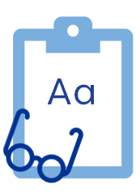
Tip 4: Use easy-to-read fonts
Use clear fonts like Calibri or Verdana and good spacing so text is easy to read on paper and screens.


Tip 5: Provide information in different formats
Share information using print, video, and spoken updates. This helps staff who prefer listening or visual learning.

10 Tips for a Literacy Friendly Workplace

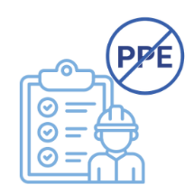
Tip 6: Avoid acronyms
Write out full terms so everyone understands. For example, instead of PPE, use ‘Wear your safety helmet, gloves, boots, and high-visibility clothing in this area’, using bullet points.

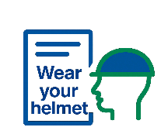
Tip 7: Use active voice in instructions and policies
Say ‘Wear your safety helmet’ instead of ‘Safety helmets must be worn’. This makes instructions and rules easier to follow.


Tip 8: Digital guidance

Show staff how to use emails, apps, portals, and online forms step-by-step.

Tip 9: Check understanding

Ask colleagues to review documents or systems to ensure they are easy to use.

Tip 10: Support Questions
Encourage questions about tasks or technology with respect and without judgement or pressure.
You can contact your local Regional Literacy Coordinator to find out more about how to make your workplace literacy friendly. Your Regional Literacy Coordinator can organise training in Literacy Awareness and Plain Language training.

