The Hable One Starting Guide - Android
This is the Hable One start guide. Use this guide if you are just starting to work with the Hable One. If you want to look up certain functionalities quickly, we advise you to consult the Hable One manual. You can consult the manual here.

This manual will take you step by step through all functionalities of the Hable One. First, it explains how to get started and how to set up the Hable One correctly. Then it explains how to navigate, type, and edit texts on your phone, how to become faster by using different shortcuts and finally how the Hable Menu works. The Getting Started Guide has six chapters that can be downloaded from the website. Here you can find an overview of the different chapters.

- Setting up for the first time
- Operating the phone
- Typing
- Editing text
- Hotkeys
- Working with the Hable Menu

For each of these topics, the guide offers three different levels of difficulty.

- Basic: The minimum number of functions you need to remember to navigate, text or edit text. These functions are relatively easy to remember but already give you the ability to fully use your phone.
- Advanced: These functions allow you to use the phone much faster. We strongly recommend that you practice these functions once you are able to work with all the basic functions. Remembering these functions may take a little more time, but they will save you a lot of time in the future.
- Expert: Are you ready for even more of a challenge? The expert functions are not essential for using your phone. But, if you master these functions, you will become an incredibly fast smartphone user. We recommend that you go through these functions and then decide for yourself if you want to learn them, good luck!

The guide is divided into several chapters. We recommend that you work through a new chapter every day. This way, you will only spend 15 minutes a day on it and within a week you will have worked through almost all the functions.
Have fun with this starter guide!

1. First time set-up

The Hable One is a controller that allows you to navigate and type on your mobile phone. VoiceOver gives you feedback while using the Hable One. This video explains in full what the Hable One is. With the help of this manual, you will be able to use the controller quickly. First, we will explain how to hold, set up and use the Hable One.

What’s in the box:
In the box you will find the following:
- The Hable One controller
- USB C charging cable
- Lanyard strap for your wrist
- Warranty and Safety document

Orientation

Front side
The Hable One controller is about the same size as the iPhone Six, but slightly thicker for a better grip. The Hable One has a matte black finish, and the middle six buttons for Braille input have a white finish for high contrast. Together this gives the controller a futuristic and modern look. On either side of the six Braille input buttons are the function keys, also referred to in the manual as points seven and eight.

Backside
The back of the Hable One is flat and has four rubber feet, one in each corner of the device. Next to the rubber feet is a sticker on the inside. When the Hable One is in use, the back of the device is closest to you, and the front is facing away from you.

Top edge
The on/off switch is located on the top edge of the unit. The on/off switch is located between two tactile markings, one a small circle (off), the other two small triangles (on). For on, you must turn the switch to the right.

Bottom edge
The USB-C charging port is located on the bottom edge of the device. It is used to charge the device and perform software updates.

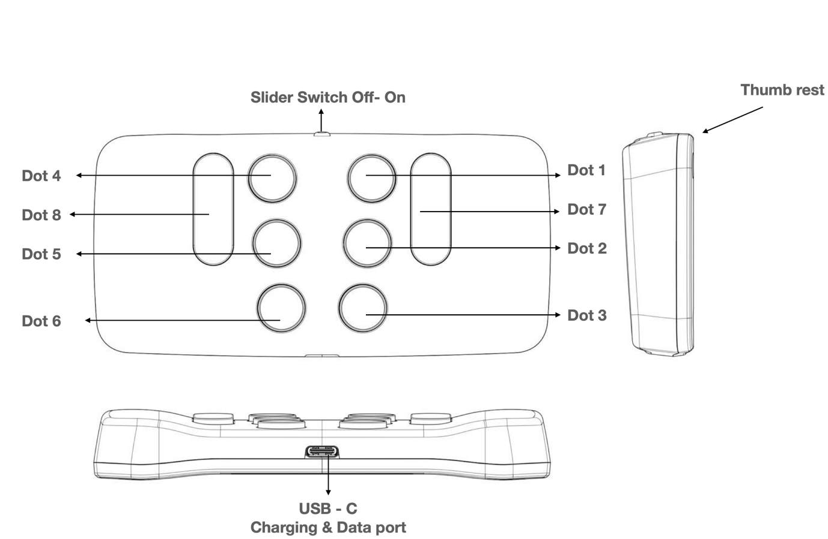
Figure 1: The Hable One side- and top-view

1.3. Holding the Hable One
When using the Hable One, hold the controller in the air with both hands; do not place it on a table or desk. If you prefer to lay it down, you can, but we recommend you turn the buttons around. See the "Hable Menu" section on how to do this. Make sure the power slider is facing the ceiling. The flat back side should point towards you, this way the buttons will automatically point away from you.
Hold the controller with both hands. You do this by wrapping your hands around the short left and right sides of the Hable One. If you do this correctly, your index, middle and ring fingers will automatically fall on the six Braille input buttons. Note that the buttons point away from you, and you press them towards you.

From now on, each button is indicated by numbers. The six small buttons are numbered like a Braille cell. The three buttons on your left hand are numbered as one, two and three, with button one being closest to the power slider and button three being furthest away.
The three buttons on your right hand are numbered four, five and six, with button four being closest to the power slider and button six being furthest away.

Place the left-hand index finger, the middle index finger, and the ring finger on buttons one, two and three.
Place the right-hand index, middle and ring fingers on the four, five and six buttons.
There are two more longer buttons, which are the function buttons. On the left side of your left index finger, you will find button seven. On the right side of your right index finger, you will find button eight.

1.4. First time connecting to the phone
Make sure that VoiceOver is enabled on your phone. To do this go to your phone settings > Accessibility > TalkBack > Turn on TalkBack or use the accessibility shortcut to enable it.

Bluetooth
The Hable One pairs through Bluetooth. Therefore, you will need to enable the Bluetooth connection on your smartphone. You can do this by going to the Bluetooth settings on your phone and activating Bluetooth. You can also use Siri to turn on Bluetooth on your device.

When you hold the device in the correct position, you turn the Hable One on by sliding the slide switch all the way to the right. The Hable One will vibrate twice when it is switched on. This indicates that the device is charged and ready to use.

To pair the Hable One with your smartphone, go to settings on your phone, then Bluetooth, and then look for the name of the controller "Hable One", in the list of Bluetooth devices. Once you have found the device in the list, double click to start pairing. If the controller is not visible, try turning the Hable One off and on again. If the pairing was successful, the Hable One will vibrate to indicate that it is connected.

Correct Modus
The first time your Hable One connects to your phone, it automatically recognises whether it is in iOS or Android mode. If you have previously paired it with an iOS phone, you can change the mode manually. To find out how to do this, go to the "Hable Menu" section in this manual.

Language
The Hable One can be set to several languages. Before we send the Hable One to you, we already set it to the right language for you. If you want to know how to change the language, please check the Hable Menu section of the user manual.

2. Operating the phone

Navigating through the phone is super easy with the Hable One. In this section you will learn how to move through the phone.

2.1. Basic
The basic features allow you to fully navigate your phone. You can go to the next and previous item, select an item, go back and make a shortcut to the home screen. If any of these actions don't work, make sure quick navigation (press and hold button 3) is enabled and that the Hable One is in iOS mode.

Move to next item | Hold 7 and press 8
Move to previous item | Hold 8 and press 7
Select an item | Press 7 and 8
Go back | Hold 1 and 2 (‘b’)
Home screen | Hold 1,2 and 5 (‘h’)

2.2. Advanced
The advanced features let you navigate your phone much faster. Instead of scrolling through one item at a time, you can now jump to the first or last item, scroll pages left, right, up and down, or quickly switch between apps.

Jump to first and last item (this combination cycles between the two functions) | Hold 1,2 and 3
Scroll down | Hold 1,4,5 and 6
Scroll up | Hold 3,4,5 and 6
Scroll left | Hold 2,4 and 6 (arrow to the left)
Scroll right | Hold 1,3 and 5 (arrow to the right)
Long press item | Hold 5 and 8
Recent Apps / app chooser | Hold 2 and 3

2.3. Expert
After learning the expert functions, you will be able to move through the phone very quickly. Some of these functions may be a little tricky to master, but it will be worth it in the end. We strongly recommend that you also read Chapter 5 (Shortcut Keys). Once you have mastered these two aspects of the keyboard, there is no stopping you.

Shortcuts
In Chapter 5, we will focus entirely on the keyboard shortcuts, but since they are also very useful for operating the phone, we will give some of them away here.
Notifications | Hold 1,3,4 and 5 (‘n’)
Status bar | Hold 2,3 and 4 (‘s’)
Volume down (repeatable) | Hold 1,2 and 6
Volume up (repeatable) | Hold 3,4 and 5

3. Typing

Typing is one of the most important functions of the Hable One. Typing works the same as with other Braille input devices. This chapter is a little shorter because typing on the Hable One is easy. Let us begin.

3.1. Basic
Typing letters | Same as Braille - So, when you press button 1, you write the 'a'. Button 1 and 2 gives the 'b', Button 1 and 4 gives the 'c', and so on.
Typing contractions | Same as Braille – You enable or disable contractions by holding 1,2,4 and 5 (‘g’).
Space | Press 8
Backspace | Press 7
Enter (or new line) | Press 4 and 8 or 5 and 8
Numbers | Number sign, followed by the braille numbers like you are used to
Capitals | Capital sign followed by the letter you want to type

4. Text editing

Making text editing easy is one of the most important functions of the Hable One. For text editing, there are a few things to remember. All text editing is built around button 7 for your left hand and buttons 4,5 and 6 for your right hand. In addition, all actions are mirrored, so if you know how to go forward, you automatically know how to go back. For example, you can move to the next character by holding down button 7 and pressing button 4 once. To go back one character, hold down key 4 and press key 7 once. Unfortunately, it is not yet possible to word jump with an external keyboard in TalkBack. As soon as TalkBack is updated, this will be included in a software update for the Hable One.

4.1. Basic
With the basic functions of text editing, you can browse through your written texts, erase, and replace characters or words. You can also start new lines.

Next character | Hold 7 and press 4
Previous character | Hold 4 and press 7
Backspace | Press 7
New line | Press 4 and 8 or 5 and 8 (make sure to only press the 4 and 8 or 5 and 8 shortly)

4.2. Advanced
With the advanced features of text editing, text editing will be much faster. You can select, copy, paste, undo and redo.

Select single character to the right | Hold 7 and press 4 and 5
Select single character to the left | Hold 4 and 5 and press 7

Actions with selected text
Please note that sometimes these actions will cause you to leave the text box and the functions will no longer work. In this case, make sure you focus on the text box and go to the text box by pressing buttons 7 and 8 simultaneously.
Copy | Hold 1 and 4 (‘c’)
Paste | Hold 1,2,3 and 6 (‘v’)
Cut | Hold 1,3,4 and 6 (‘x’)
Undo | Hold 1,3,5 and 6 (‘z’)
Redo | Hold 1,3,4,5 and 6 (‘y’)
Jump to beginning and end of paragraph (this alternates if you press it again) | Hold 1,2 and 3
Select all | Hold 2,3,5 and 6

4.3. Expert
With the expert functions, you can move through texts like a pro and write appealing, accurate texts without mistakes in no time.

Select next line | Hold 7 and press 4,5 and 6
Select previous line | Hold 4,5 and 6 and press 7
Bold text | Hold 1,2 and 8
Cursive text | Hold 2,4 and 8
Underline text | Hold 1,3 and 6

5. Shortcuts

The Hable One uses several shortcut keys to quickly navigate through the phone. Most of these shortcuts are easy to remember. For example, a long press on the letter 'h' takes you to the home screen. As you read through this chapter, we recommend that you use the shortcuts as you read them. Some of these shortcuts you may have learned in previous chapters, but it is helpful to repeat them. Let's get started!

5.1. Basic
These basic functions will significantly improve the speed with which you use the phone. Moreover, they are easy to remember because they are among the most frequently used shortcuts.

Pause reading | Hold 1
Local context menu - also called the TalkBack menu | Hold 2
Go back | Hold 1 and 2 (‘b’)
Home screen | Hold 1,2 and 5 (‘h’)
Notifications | Hold 1,3,4 and 5 (‘n’)
Status bar | Hold 2,3 and 4 (‘s’)

5.2. Advanced
For advanced keyboard shortcuts, we have listed quite a few. The reason is that it will be a huge advantage to include these shortcuts in your repertoire. Nevertheless, most of the functions are intuitive and easy to remember based on the first letter.
Play or pause | Hold 1,2,3 and 4 (‘p’)
Read from next | Hold 1,2,3 and 5 (‘r’)
Read from top | Hold 2,4,5 and 6
Google Now - please note that these functions only work if you have set up Google Now calls in your settings. | Hold 1,4 and 5
Long press item | Hold 5 and 8
Item chooser | Hold 2 and 4 (‘i’)
Volume down (repeatable) | Hold 1,2 and 6
Volume up (repeatable) | Hold 3,4 and 5

Android Shortcuts
TalkBack also features special hot keys to make using the smartphone a lot faster. These work together with first pressing button 3 and then a combination of other buttons to immediately open an app. Below is a list of the different shortcuts.

Please note that all these shortcuts require you to first launch the app category opener by holding 3.

Open Calculator | Hold 1
Open Browser | Hold 1 and 2
Open Calender | Hold 1,2 and 3
Open Contacts | Hold 1 and 4
Open Mail | Hold 1 and 5
Open Maps | Hold 1,3 and 4
Open Music | Hold 1,2,3 and 4
Open texting | Hold 2,3 and 4

5.3. Expert
The expert features are nice to have, but you won't use them regularly. Most of these features are useful when you're working with people who don't use VoiceOver. If you are not a technology enthusiast, we recommend that you read the table so that you know what is possible, but do not memorise it.

Screenshot | Hold 3 and 6
Label element | Hold 1,2,3,4 and 6
Lock screen | Hold 2 and 5
Unlock screen | This can be done with any key. Then navigate with 7 and 8 to the field where you can enter your PIN code, use the number sign and enter it.
Screen curtain (on and off) | Hold 3 and 4
Mute | Hold 1,3,4 and 7 (press again to turn on again)
Mute TalkBack | Hold 1,3 and 4 (press again to turn on again)
Show keyboard on screen | Hold 1,4 and 6
Switch keyboard | Hold 1,5 and 6

6. Hable Menu
In the Hable Menu you can change the device settings, change the button layout, or check the battery status. Please note that every time you open the Hable menu and perform an action, you automatically leave the Hable menu. So, if you want to perform a new action, you must first press and hold button 1 to 6 again.
Open the Hable Menu | Hold 1,2,3,4,5 and 6
All next function only work once you entered the Hable Menu
Exchanging buttons: Exchanges button 1 with button 3 and button 4 with button 6. | Hold 1,3,4,6 (‘x’)
Set operating system as Android | Hold 1 (you feel 3 vibrations)
Set operating system as iOS | Hold 2 (you feel 2 vibrations)
Remove all Bluetooth bindings | Hold 1,2,3 and 5 (‘r’)
Battery status | Hold 3 and 6  - 3 vibrations: High battery level.  - 2 vibrations: Medium battery level.  - 1 vibration: Low battery level.  - No vibration means that the Hable One is empty and needs to be recharged.

Then it is also possible to adjust the "hold down time". This means that you can set how long you must press keys before it works. For example, how long you must press the 'h' of home before it goes to the home screen. This function has four modes which are indicated by the number of vibrations. 1 vibration is the shortest time and 4 vibrations the longest.

Set the duration of the "holding time" (this may be interesting for the faster Hable One user and may increase your speed) | Hold 2,3 and 4 (‘s’)  4 vibrations means you need to hold the buttons the longest, one vibration means the shortest.

Languages
Remember to open the menu before changing the language.
Put the language to Dutch | Hold 1,4 and 5 (‘d’)
Put the language to Belgium | Hold 1 and 2 (‘b’)
Put the language to English (UEB) | Hold 1 and 5 (‘e’)
Put the language to French | Hold 1,2 and 4 (‘f’)

Congratulations! You have now reached the end of this getting started guide. We now recommend that you use the user manual to look up specific functions.

On behalf of the entire Hable Team, good luck with your Hable One!

