Hable One Manual for iOS

General Description 2
What’s in the box: 2
Orientation 2
Front side 2
Backside 2
Top edge 3
Bottom edge 3
Getting started 3
Step one: Holding the Hable One 3
Step two: First time set-up of the Hable One 4
Step three: VoiceOver gestures using the Hable One 5
Step four: typing with the Hable One 5
Now that you can navigate the Hable One, you can start practicing your typing. First, navigate to your note-taking app and open it. This is your first test to see how well you can navigate. 5
Once in the editing area, use the following: 5
To type space, press button eight once. 5
For backspace, press key seven. 5
For enter, press keys four and eight or five and eight simultaneously. 5
Use the keys to enter Braille in the same way as you would a Perkins, for example, for numbers, first press the number sign. 5
For capital letters, type the capital character first. 5
Hable One Shortcuts 5
Special Hable Shortcuts 5
Navigation 6
Shortcuts 6
Use the VoiceOver rotor 8
Hable Menu 10
Product Specifications 11
Safety & Compliance 11
Regulatory Compliance Statements 12

General Description
Welcome to the Hable One user manual! The Hable One is a controller that allows you to navigate and type on your mobile phone. Via VoiceOver you get feedback while using the Hable One. With the help of this manual, you will be able to use the controller quickly. First, we will explain how to hold, set up and use the Hable One.

We recommend that you also read the Hable One's ‘getting started guide’. It explains step by step how the Hable One works. Once you have gone through all the steps in this getting started guide, you will be able to use all functionalities of the Hable One. You can then use this manual to look up specific functions.

What’s in the box:
In the box you will find the following:
- The Hable One controller
- USB C charging cable
- Lanyard strap for your wrist
- Warranty and Safety document

Orientation

Front side
The Hable One controller is about the same size as the iPhone Six, but slightly thicker for a better grip. The Hable One has a matte black finish, and the middle six buttons for Braille input have a white finish for high contrast. Together this gives the controller a futuristic and modern look. On either side of the six Braille input buttons are the function keys, also referred to in the manual as points seven and eight.

Backside
The back of the Hable One is flat and has four rubber feet, one in each corner of the device. Next to the rubber feet is a sticker on the inside. When the Hable One is in use, the back of the device is closest to you, and the front is facing away from you.

Top edge
The on/off switch is located on the top edge of the unit. The on/off switch is located between two tactile markings, one a small circle (off), the other two small triangles (on). For on, you must turn the switch to the right.

Bottom edge
The USB-C charging port is located on the bottom edge of the device. It is used to charge the device and perform software updates.
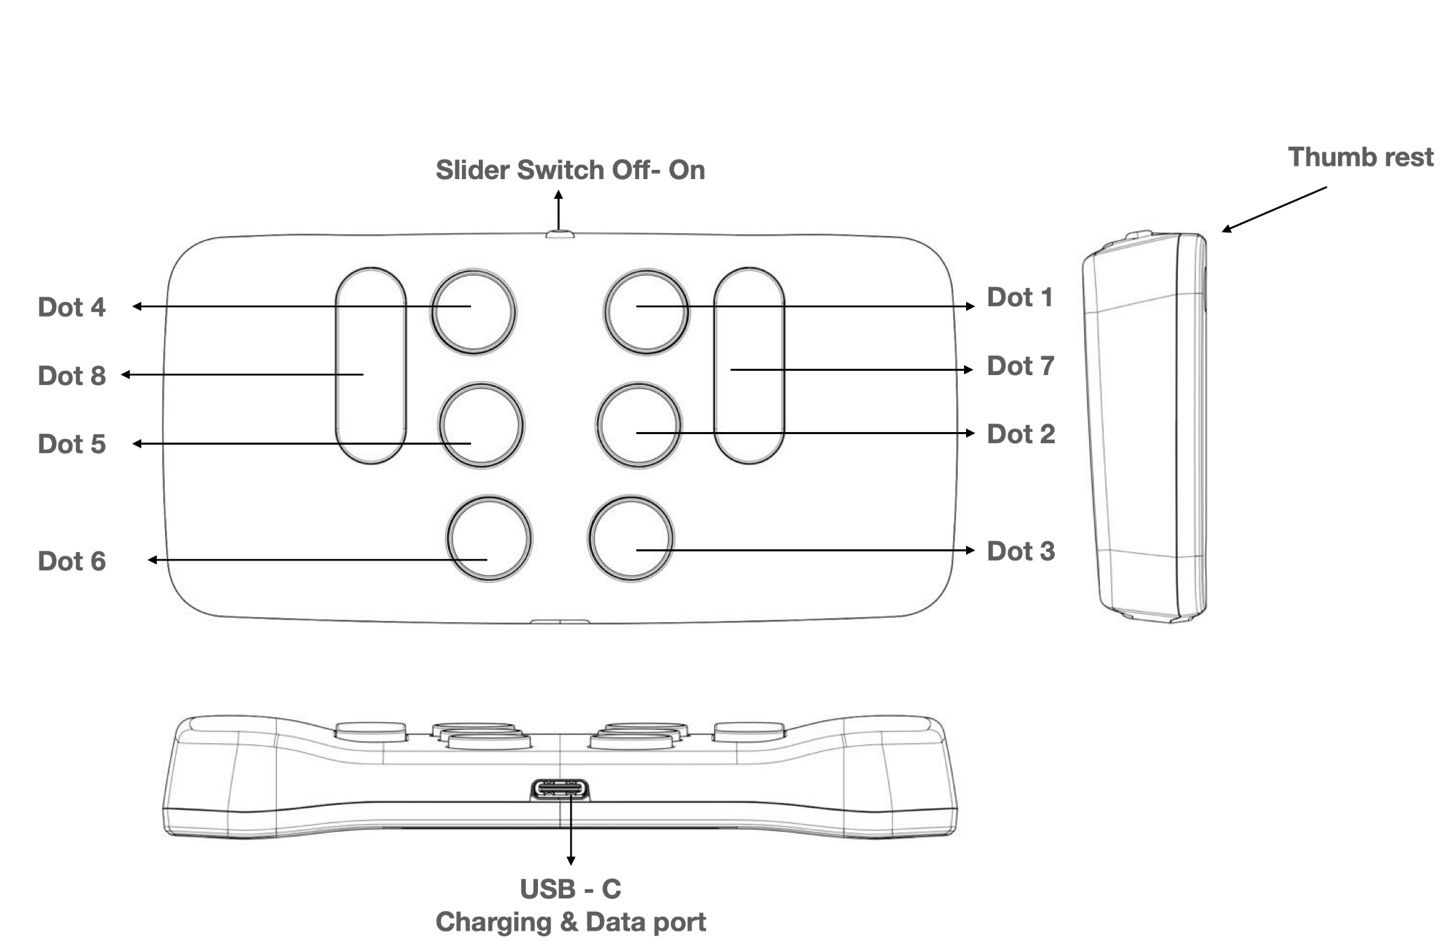
Figure 1: The Hable One side- and top-view

Getting started
In 4 steps, the basics of how to work with the Hable One are explained. There are also several videos that offer this explanation. These videos can be found here. Furthermore, it is recommended that you also read the Hable One's start guide. If you do not have this guide, it can be downloaded from the website, click here.

Step one: Holding the Hable One
When using the Hable One, hold the controller in the air with both hands; do not place it on a table or desk. If you prefer to lay it down, you can, but we recommend you turn the buttons around. See the "Hable Menu" section on how to do this. Make sure the power slider is facing the ceiling. The flat back side should point towards you, this way the buttons will automatically point away from you.
Hold the controller with both hands. You do this by wrapping your hands around the short left and right sides of the Hable One. If you do this correctly, your index, middle and ring fingers will automatically fall on the six Braille input buttons. Note that the buttons point away from you, and you press them towards you.

From now on, each button is indicated by numbers. The six small buttons are numbered like a Braille cell. The three buttons on your left hand are numbered as one, two and three, with button one being closest to the power slider and button three being furthest away.
The three buttons on your right hand are numbered four, five and six, with button four being closest to the power slider and button six being furthest away.

Place the left-hand index finger, the middle index finger, and the ring finger on buttons one, two and three.
Place the right-hand index, middle and ring fingers on the four, five and six buttons.
There are two more longer buttons, which are the function buttons. On the left side of your left index finger, you will find button seven. On the right side of your right index finger, you will find button eight.

Step two: First time set-up of the Hable One
Make sure that VoiceOver is enabled on your phone. To do this go to your phone settings > Accessibility > VoiceOver > Turn on VoiceOver or use the accessibility shortcut to enable it.

Bluetooth
The Hable One pairs through Bluetooth. Therefore, you will need to enable the Bluetooth connection on your smartphone. You can do this by going to the Bluetooth settings on your phone and activating Bluetooth. You can also use Siri to turn on Bluetooth on your device.

When you hold the device in the correct position, you turn the Hable One on by sliding the slide switch all the way to the right. The Hable One will vibrate twice when it is switched on. This indicates that the device is charged and ready to use.

To pair the Hable One with your smartphone, go to settings on your phone, then Bluetooth, and then look for the name of the controller "Hable One", in the list of Bluetooth devices. Once you have found the device in the list, double click to start pairing. If the controller is not visible, try turning the Hable One off and on again. If the pairing was successful, the Hable One will vibrate to indicate that it is connected.

Correct Modus
The first time your Hable One connects to your phone, it automatically recognises whether it is in iOS or Android mode. If you have previously paired it with an Android phone, you can change the mode manually. To find out how to do this, go to the "Hable Menu" section in this manual.

Please note that quick navigation must be enabled to use the Hable One. This is because VoiceOver automatically disables Quick Navigation when you're editing text, so certain functions have different properties. To enable Quick Navigation, press and hold button three for more than one second. You'll feel a vibration when the action is completed.

Step three: VoiceOver gestures using the Hable One
Before we start learning gestures, it is good to know the following: when more than one key is used to execute a command, they must be pressed simultaneously. If the command requires a long press (hold), this means holding the keys down for more than a second until you feel a vibration.

To go to the next item, press and hold button seven and quickly tap button eight once. A further quick press on button eight will take you to the next item. To go to the previous item, press and hold button eight and quickly press button seven once. Again, you can keep tapping button seven to go back through the previous items.
To activate an item, press keys seven and eight simultaneously. You can do this, for example, to open an app.

To go to the home screen, long press the Braille letter H for Home. These are the keys one, two and five.

To go back one level, long press the Braille letter B for Back. These are the buttons one and two at the same time.
If this doesn't work, try holding down button three to make sure quick navigation is enabled.

Congratulations, you can now navigate through your phone with the Hable One. There are also many more advanced shortcuts that allow you to navigate through your phone even faster with the Hable.

Step four: typing with the Hable One

Now that you can navigate the Hable One, you can start practicing your typing. First, navigate to your note-taking app and open it. This is your first test to see how well you can navigate.

Once in the editing area, use the following:

To type space, press button eight once.

For backspace, press key seven.

For enter, press keys four and eight or five and eight simultaneously.

Use the keys to enter Braille in the same way as you would a Perkins, for example, for numbers, first press the number sign.

For capital letters, type the capital character first.

Hable One Shortcuts
In this section you will find some useful shortcuts for Hable One. These have been split up into subsections to make searching easier.

Special Hable Shortcuts

Pause reading | Hold 1
Two finger double tap (or magic touch) - This function can be used for various things including: Picking up the phone, hanging up the phone, pausing or playing music and pausing and playing videos. | Hold 2
Quick navigation on- and off | Hold 3

Navigation

Move to next item | Hold 7 and press 8
Move to previous item | Hold 8 and press 7
Select an item | Press 7 and 8
Go back | Hold 1 and 2 (‘b’)
Home screen | Hold 1,2 and 5 (‘h’)
Jump to first and last item (this combination cycles between the two functions) | Hold 1,2 and 3
Scroll down | Hold 1,4,5 and 6
Scroll up | Hold 3,4,5 and 6
Scroll left | Hold 2,4 and 6 (arrow to the left)
Scroll right | Hold 1,3 and 5 (arrow to the right)
VoiceOver Help | Hold 1 and 3

Shortcuts

Home screen | Hold 1,2 and 5 (‘h’)
Go Back | Hold 1 and 2 (‘b’)
Turn Contractions on/off (for typing) | Hold 1,2,4 and 5 (‘g’)
Notifications | Hold 1,3,4 and 5 (‘n’)
Play or pause | Hold 1,2,3 and 4 (‘p’)
Item chooser | Hold 2 and 4 (‘i’)
Read from next | Hold 1,2,3 and 5 (‘r’)
Read from top | Hold 2,4,5 and 6
Siri - please note that these functions only work if you have Siri enabled in your settings. | Hold 1,4 and 5
Control centre | Hold 2,4 and 5
Status bar | Hold 2,3 and 4 (‘s’)
iOS spotlight | Hold 1 and 6
Label element | Hold 1,2,3,4 and 6
Long press item | Hold 5 and 8
Recent Apps / app chooser | Hold 2 and 3
Screenshot | Hold 3 and 6
Accessibility hotkey - NOTE: This only works for iPhones with a home button. This function must be set in Accessibility, Enable Button. Use it, for example, to disable VoiceOver. | Hold 1,2,5 and 8

Keyboard and screen
Please note that this only works within a word processor or text box.

Show OS-keyboard on screen | Hold 1,4 and 6
Switch keyboard | Hold 1,5 and 6
Screen curtain (on and off) | Hold 3 and 4
Lock screen | Hold 2 and 5
Unlock screen | This can be done with any key. Then navigate with 7 and 8 to the field where you can enter your PIN code, use the number sign and enter it.
Search on the screen | Hold 1,2 and 4 (‘f’)  Then type what you are looking for and press 'enter' (buttons 4 and 8). If you want to go out of search hold the 'b' (buttons 1 and 2).
Find next item on screen - use this together with the find on screen function (the previous function) | Hold 2 and 6. This can be repeated to move to the next item on the screen each time.
Search previous item on screen - use this together with the search on screen function. | Hold 3 and 5. You can repeat this to go to the previous item on the screen each time.

Sound
Mute | Hold 1,3,4 and 7 (press again to turn on again)
Mute VoiceOver | Hold 1,3 and 4 (press again to turn on again)
Volume down (repeatable) | Hold 1,2 and 6
Volume up (repeatable) | Hold 3,4 and 5

Tabs

Close tab | Hold 2,3 and 5
Forward tab (in browser) | Hold 2,3,4 and 5
Backward tab (in browser) | Hold 1,2,5 and 6

Use the VoiceOver rotor

Go to the next item using the rotor setting | Hold 7 and press 6
Go to previous item using rotor setting | Hold 6 and press 7
Select previous rotor setting | Hold 7 and press 5 and 6
Select next rotor setting | Hold 5, 6 and press 7

Editing text - navigating in a word processor or text box
The following key combinations only work if the fast navigation mode is switched off, to leave the document this must be switched on again. You can turn quick navigation on or off with button 3.

Next character | Hold 7 and press 4
Previous character | Hold 4 and press 7
Go to next word | Hold 7 and press 5
Go to previous word | Hold 5 and press 7
Go to next line (using rotor) | Hold 7 and press 6
Go to previous line (using rotor) | Hold 6 and press 7
Select single character to the right | Hold 7 and press 4 and 5
Select single character to the left | Hold 4 and 5 and press 7
Select word to the right | Hold 7 and press 4 and 6
Select word to the left | Hold 4 and 6 and press 7
Select next line | Hold 7 and press 4,5 and 6
Select previous line | Hold 4,5 and 6 and press 7
Jump to beginning and end of paragraph (this alternates if you press it again) | Hold 1,2 and 3
Jump to beginning of line and jump to end of line (alternates) | Hold 3 and 7
Select all | Hold 2,3,5 and 6

Function with selected text
Please note that sometimes these actions will cause you to leave the text box and the functions will no longer work. In this case, make sure you focus on the text box and go to the text box by pressing buttons 7 and 8 simultaneously.

Copy | Hold 1 and 4 (‘c’)
Paste | Hold 1,2,3 and 6 (‘v’)
Cut | Hold 1,3,4 and 6 (‘x’)
Bold text | Hold 1,2 and 8
Cursive text | Hold 2,4 and 8
Underline text | Hold 1,3 and 6
Undo | Hold 1,3,5 and 6 (‘z’)
Redo | Hold 1,3,4,5 and 6 (‘y’)
Copy spoken text | Hold 1,4 and 8
Make new | Hold 1,3,4,5 and 8
Print | Hold 1,2,3,4 and 8

Hable Menu
The Hable One also has its own menu. This can be used to change the operating system, to change the language or to adjust the time it takes for a long press to be registered. When you open the Hable Menu and perform an action, the menu closes automatically.

Open the Hable Menu | Hold 1,2,3,4,5 and 6
All next function only work once you entered the Hable Menu
Exchanging buttons: Exchanges button 1 with button 3 and button 4 with button 6. | Hold 1,3,4,6 (‘x’)
Set operating system as Android | Hold 1 (you feel 3 vibrations)
Set operating system as iOS | Hold 2 (you feel 2 vibrations)
Remove all Bluetooth bindings | Hold 1,2,3 and 5 (‘r’)
Set the duration of the "holding time" (this may be interesting for the faster Hable One user and may increase your speed) | Hold 2,3 and 4 (‘s’)  4 vibrations means you need to hold the buttons the longest, one vibration means the shortest.
Put the language to Dutch | Hold 1,4 and 5 (‘d’)
Put the language to Belgium | Hold 1 and 2 (‘b’)
Put the language to English (UEB) | Hold 1 and 5 (‘e’)
Put the language to French | Hold 1,2 and 4 (‘f’)
Put the language to German | Hold 1,2,4 and 5 (‘g’)
Battery status | Hold 3 and 6  - 3 vibrations: High battery level.  - 2 vibrations: Medium battery level.  - 1 vibration: Low battery level.  No vibration means that the Hable One is empty and needs to be recharged.

Product Specifications

Weight | 100 grams
Dimensions (L.B.H) | 120 × 65 × 32 mm
OS Support | iOS (iPhone & iPad): Voiceover  Android: TalkBack  Mac OS: Writing support  Windows: Writing support
Braille Input Keys | six-dot braille input
Languages Supported | UEB (contracted; uncontracted), Dutch, German, French
Interfaces & Ports | one Micro USB-C, Firmware upgrades and battery storage, Bluetooth V5, Slider Switch
Battery | Non-replaceable, Lithium-ion battery
Battery Life | 14 days of typical use
Charging Method | PC charger: Charge over USB Port – 5V, 500 mA Max Wall charger: Charge over USB Port – 5V, 1000 mA Max;
Environmental Conditions | Operational  Temperature: five °C to 45 °C  Humidity: 10% - 70% relative humidity Storage  Temperature: -15 °C to 70 °C Humidity: 5% - 90% relative humidity

Safety & Compliance
Thank you for purchasing the Hable One™ product (the Product). With this document we aim to inform you about the safety, compliance, and warranty aspects of the Product.

Important Safety Instructions
General warnings
Read, keep, and follow these instructions.
Heed all warnings.
Do not use the Product near water. This can result in a risk of fire or electric shock.
Substances in the Product and its battery may harm the environment or cause injury if handled and disposed of improperly.
Clean only with a dry cloth. Do not use abrasive cleaners.
Do not block any ventilation openings.
Do not use or dispose of the Product at any heat sources, such as radiators, stoves and other apparatus that produce heat. Turn off the product when it feels warm or hot.
Only use attachments/accessories specified by Hable or sold with the Product (such as a USB-C cable).
Refer all servicing to qualified service personnel. Do not open the Product yourself. Servicing is required when the Product has been damaged in any way, e.g. when the charging port is defective or when liquid is spilled over the Product.
The Product may not be used by persons under the age of 8.
Long periods of repetitive motion using the Product may be associated with nerve, tendon or muscle injury in your hands, wrists, arms, shoulders, neck or back. See a qualified health professional for pain, numbness, weakness, swelling, burning, cramping, stiffness or any other medical discomfort that may occur when using the Product.

Specific battery warning
Do not attempt to replace the battery or open the enclosure or disassemble the Product yourself. Doing so will void the warranty and can result in a safety hazard. If the Product is no longer charging, please contact Hable Customer Support for repair or replacement information.

Disposal and Recycling information
Due to the battery incorporated in the Product, the Product may not be disposed with ordinary household waste.

Regulatory Compliance Statements

Hable is authorized to apply the UKCA Mark on the Product. The following Directives and Standards have been applied:

2011/65/EU
2012/19/EU
2006/66/EC
1907/2006
2014/53/EU

Warranty
The Limited Warranty Policy (LWP) for Hable One Products applies to the delivery of the Product. Provided that for customers (any natural person acting for purposes which are outside his trade, business or profession) under UK law the Warranty Period (as defined in the LWP) is six years in England, Wales and Northern Ireland and five years in Scotland. The customer may choose which Warranty Services (as defined in the LWP) are desirable. During the repair or replacement of the Product, the Warranty Period shall be suspended.

