Hospitality Factsheet
Guide Dogs and Assistance Dogs in Hotels, Guesthouses, B&Bs, Air B&Bs and Hostels

Irish Guide Dogs for the Blind has developed this factsheet to provide information on facilitating Guide Dog and Assistance Dog owners in serviced and non-serviced accommodation, including hotels, guesthouses, B&Bs, AirBnBs, hostels, holiday homes, mobile home parks and camp sites.

- Access to Public Places and to Food Business Premises
Guide Dogs and Assistance Dogs are permitted on to all public places, including indoor and outdoor food premises such as restaurants, breakfast rooms, bars, bistros and shops. The Environmental Health Officers Association exempts Guide Dogs and Assistance Dogs from the Food Hygiene Regulations due to the high standards of training, grooming and veterinary care given to them. They are highly trained, reliable sociable, hygienic working animals and they do not disrupt the everyday running of businesses.
For further information contact the Food Safety Authority of Ireland Advice Line by phone: 0818 33 66 77, by email Info@Fsai.ie or visit their website at: https://www.fsai.ie/faq/animals_in_food_premises.html. You can also make contact with the FSAI via their online complaint form which can be accessed at: https://www.fsai.ie/makeitbetter/

- The Law and People with Disabilities
Under the Equal Status Acts 2000 to 2018 and Section 19 (2) of the Intoxicating Liquor Act 2003, accommodation providers and hospitality proprietors, such as hotels, B&Bs, AirBnBs, guesthouses, hostels and campsites, are prohibited from discriminating against people with disabilities. Hospitality proprietors must make reasonable changes to how their services are provided, where without these changes it would be impossible or unduly difficult for people with disabilities to avail of those services. This is known as Reasonable Accommodation. Hospitality proprietors provide reasonable accommodation when they facilitate Guide Dogs and Assistance Dogs on their premises when it’s assisting its owner.
Other examples of Reasonable Accommodation:
- Ensure all new and existing staff are informed on the Equal Status Acts rights of blind or vision impaired people and families of children with autism.
- Provide a water bowl. The owner will provide bedding and food for the Guide Dog or Assistance Dog.
- Provide a suitable dog relief area. Further information can be provided by Irish Guide Dogs for the Blind.
- Consider ways of making your information and premises accessible. You will find further advice in this factsheet.
For further information on the rights of people with disabilities, contact the Irish Human Rights and Equality Commission by phone: 01 8589 601, by email Info@IHerc.ie or visit their website: https://www.ihrec.ie/.

- Guide Dogs & Assistance Dogs: How do you recognise them?
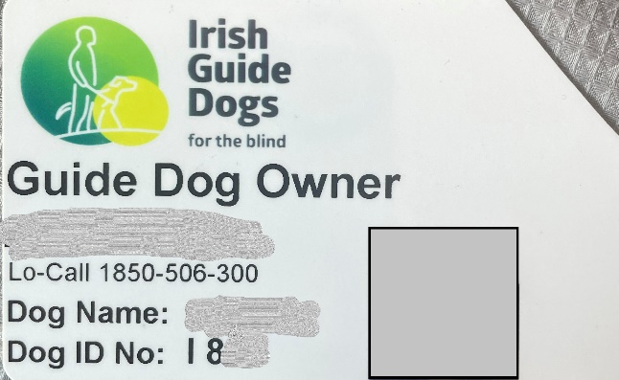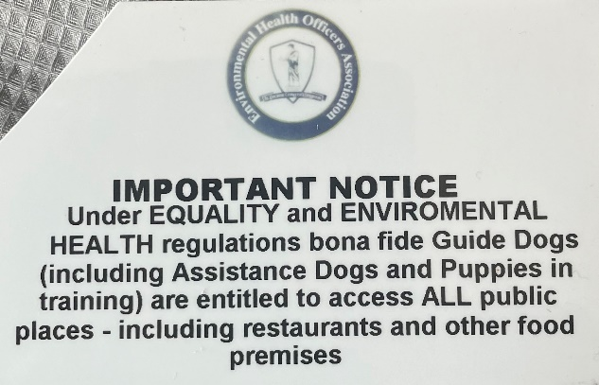Guide Dog owners and Assistance Dog owners carry an official IGDB photo identification card.

Irish Guide Dogs for the Blind is accredited by both the International Guide Dog Federation and Assistance Dogs International. Guide Dogs and Assistance Dogs have a yellow sign on their lead and wear a medallion embossed with the Irish Guide Dogs for the Blind logo on their collar.

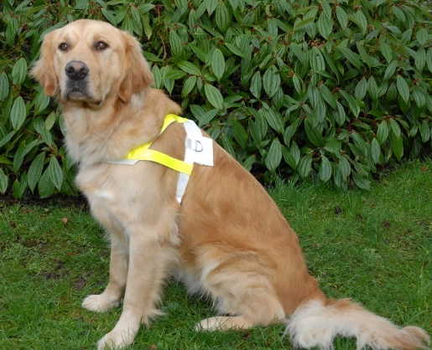
A Guide Dog is a mobility aid for people who are blind or have impaired vision. The Guide Dog steers their owner around obstacles. It helps their owner to locate street crossings and doorways to buildings. Guide Dog warn their owner when hazards and changes in ground level are approaching. They wear a harness with reflective markings when working.

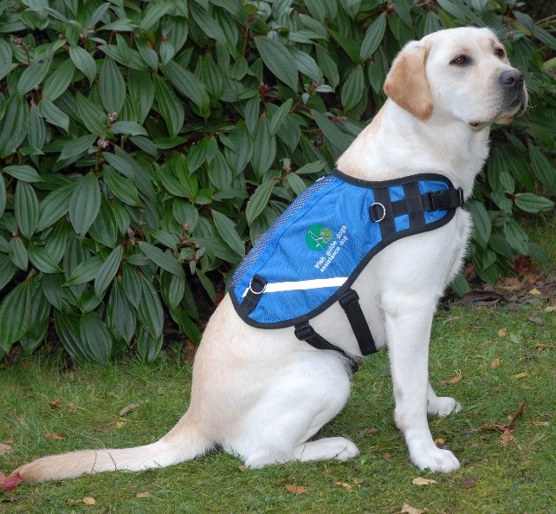
An Assistance Dog is trained to facilitate the needs of children with autism. The Assistance Dog acts as an essential safety aid, anchoring the child with their family and promoting road safety awareness. The Assistance Dog is a constant companion to the child, promoting calmness on family outings. The parent holds the dog’s lead, and the child holds a lead or uses a waistband. Assistance Dogs wear blue jackets which bear the Irish Guide Dogs for the Blind logo.

- The Training
Guide Dogs and Assistance Dogs undergo a comprehensive training programme in order to become a qualified mobility and safety aid. From an early age, they are socialised by a volunteer Puppy Raiser and learn to be obedient in public places. They then undergo a training programme with an instructor before being matched with their potential owner. Both the potential owner and the Guide Dog or Assistance Dog, undergo a training class to become a confident mobile unit. A key feature of the training is that the Guide Dog or Assistance Dog lies quietly beside their owner’s feet, when they are dining in a restaurant or coffee shop.
What to consider for blind and vision impaired people
- Introduce yourself and ask if they need any assistance.
- Knowing how to guide a blind or vision impaired person is very helpful. We can provide further information if you wish.
- Have tactile overlay cards for credit card reading machines.
- Good lighting is helpful as shadows can be disorientating.
- Good clear signage and markings on glass doors is helpful.
- Consider your website. Is it easy to navigate and is accessible to voice over or screen reading technology? Do you have Alt Text descriptions or captions on any images used on your website?
- Consider providing menus and other information in braille, large print, electronic or audio formats.
- Ensure customers are informed on the fire safety procedure.
- Keep circulation routes free of obstructions and trip hazards.

About Irish Guide Dogs for the Blind
Irish Guide Dogs for the Blind is a national charity dedicated to helping people living with sight loss or autism improve their mobility and independence. For over 40 years we have provided life-changing services and support to people across Ireland with sight loss.
- All services are offered free of charge.
- It costs over €5 million to run the organisation annually.
- It costs €53,000 to breed, train and care for a Guide Dog during its working life.
- 85% of funding comes from fundraising, the generosity of the general public, our corporate partnerships and those who leave us a gift in their will.

Further information
If you require further information on any of the above, please do not hesitate to get in touch with our Advocacy & Policy Officer, Léan Kennedy.

Irish Guide Dogs for the Blind
National Headquarters and Training Centre
Model Farm Road
Cork
Phone: 021 487 8300
Email: LKennedy@GuideDogs.ie
Website: www.GuideDogs.ie

