International Travel Factsheet
Guide Dogs and Assistance Dogs on air and sea passenger carriers
Irish Guide Dogs for the Blind has developed this factsheet to provide information on facilitating Guide Dog and Assistance Dog owners on air and sea passenger carriers, such as airplanes and ferries.

- Access to Public Places and Food Businesses
Guide Dogs and Assistance Dogs are permitted on to all public places, including food premises, such as restaurants and coffee shops. The Environmental Health Officers Association exempts Guide Dogs and Assistance Dogs from the Food Hygiene Regulations due to the high standards of training, grooming and veterinary care given to them. They are highly trained, reliable sociable, hygienic working animals and they do not disrupt the everyday running of businesses.
For further information contact the Food Safety Authority of Ireland Advice Line by phone: 0818 33 66 77, by email Info@Fsai.ie or visit their website at: https://www.fsai.ie/faq/animals_in_food_premises.html. You can also make contact with the FSAI via their online complaint form which can be accessed at: https://www.fsai.ie/makeitbetter/

- The Law and People with Disabilities
Under the Equal Status Acts 2000-2018 and Section 19 of the Intoxicating Liquor Act 2003, air and maritime transport providers, i.e. airlines and ferry companies, are prohibited from discriminating against people with disabilities. Air and sea passenger carriers must make reasonable changes to how their services are provided, where without these changes it would be impossible or unduly difficult for people with disabilities to avail of those services. This is known as Reasonable Accommodation. Air and ferry transport providers provide reasonable accommodation when they facilitate Guide Dogs and Assistance Dogs on their airplanes and ferries, when the Guide Dog or Assistance Dog is assisting its owner.

Examples of reasonable accommodation for Guide Dog and Assistance Dog owners:
- Ensure all new and existing staff are informed on the Equal Status Acts rights of blind or vision impaired people and families of children with autism.
- Provide a water bowl.
- Ensure accessible systems, e.g. by app, phone, email, text or online, for booking tickets, suitable seating and travel assistance.
- Consider ways of making your information and services accessible. Further advice is provided in this factsheet.
For further information on the rights of people with disabilities, contact the Irish Human Rights and Equality Commission by phone: 01 8589 601, by email: info@iherc.ie or visit their website: https://www.ihrec.ie

EU Sea Travel Rights of people with Disabilities
Travel agents, tour operators and sea passenger carriers are prohibited from refusing a booking from a Guide Dog or Assistance Dog owner. Sea passenger carriers must facilitate Guide Dogs and Assistance Dogs, with their owner, at no extra charge. Sea ferry companies must provide travel assistance to passengers with disabilities when given the minimum 48 hours’ notice before the journey. If advanced notice is not provided the maritime staff must take reasonable measures to provide assistance.

The law applies to sea carriers travelling to and from an EU port. For further information on EU sea travel rights, contact the Maritime Passenger Rights Section at the National Transport Authority by phone: 01 8798300, by email: info@nationaltransport.ie or visit their website: www.nationaltransport.ie

EU Air Travel Rights of People with Disabilities
Under EC Regulation 1107/2006) Air Travel and People with Disabilities, airlines travelling to and from EU airports must carry Guide Dogs and Assistance Dogs with their owner in the passenger cabin. Travel agents, tour operators and airlines should not refuse a booking from a Guide Dog and Assistance Dog owner. When a minimum 48 hours’ notice prior to travel is provided, the air carrier must notify the airport of a Guide Dog and Assistance Dog owner’s request for travel assistance travelling through the airport, embarking and disembarking the airplane.
Further information on EU air travel rights of people with disabilities can be provided by the Commission for Aviation Regulation by phone: 01 6611700, email: info@aviationre.ie, or Visit: www.aviationreg.iee
The National Transport Authority can also provide further information by visiting: www.nationaltransport.ie.

UN CRPD (United Nations Convention on the Rights of Persons with Disabilities)
Under Article 9 of the United Nations Convention on the Rights of Persons with Disabilities, state parties must ensure access on an equal basis with the general population to transport services. The Department of Transport and Communications, the National Transport Authority and the Commission for Aviation Regulation oversees the operation of governmental transport policies and procedures. Appropriate measures must be taken to provide effective and equal access to transport services open to the public. Discrimination against people with disabilities by air carrier and ferry transport operators is prohibited. The Irish Human Rights and Equality Commission is the independent monitoring mechanism on the implementation of the UN CRPD and can be contacted for further information at: https://www.ihrec.ie/.

- Guide Dogs and Assistance Dogs: How do you recognise them?
Guide Dog owners and Assistance Dog owners carry an EU Pet Passport and an official IGDB letter of accreditation. Guide Dog owners and Assistance Dog owners are informed on preparing their Guide Dog or Assistance Dog for travel under the Pet Passport Scheme.
Guide Dog owners and Assistance Dog owners carry an official IGDB photo identification card.
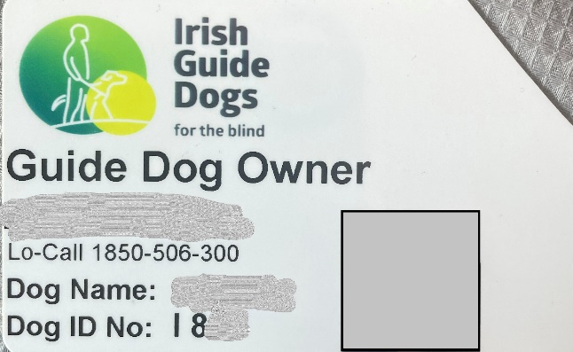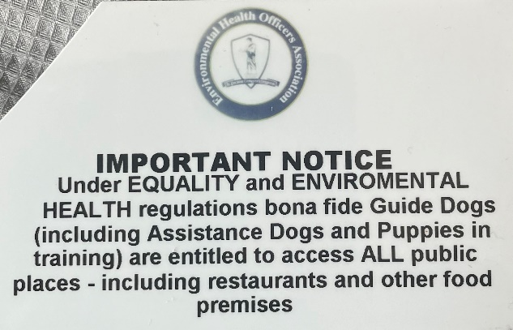
Irish Guide Dogs for the Blind is accredited by both the International Guide Dog Federation and Assistance Dogs International. Guide Dogs and Assistance Dogs have a yellow sign on their lead and wear a medallion embossed with the Irish Guide Dogs for the Blind logo on their collar.

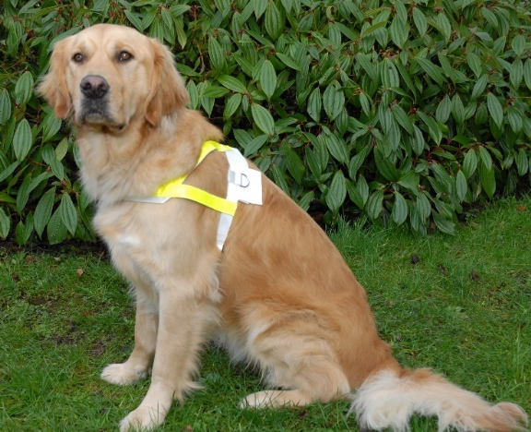
A Guide Dog is a mobility aid for people who are blind or have impaired vision. The Guide Dog steers their owner around obstacles. It helps their owner to locate street crossings and doorways to buildings. Guide Dogs warn their owner when hazards and changes in ground level are approaching. They wear a harness with reflective markings when working.

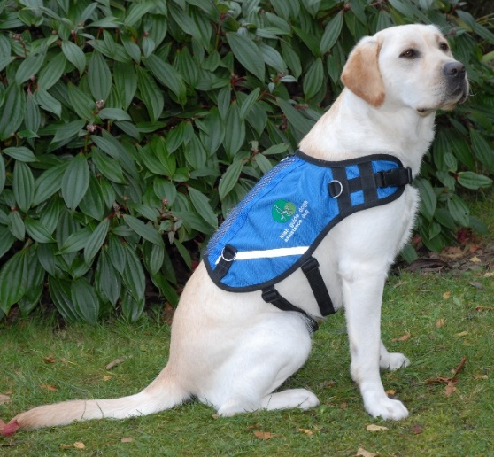
An Assistance Dog is trained to facilitate the needs of children with autism. The Assistance Dog acts as an essential safety aid, anchoring the child with their family and promoting road safety awareness. The Assistance Dog is a constant companion to the child, promoting calmness on family outings. The parent holds the dog’s lead, and the child holds a lead or uses a waistband. Assistance Dogs wear blue jackets which bear the Irish Guide Dogs for the Blind logo.

- The Training
Guide Dogs and Assistance Dogs undergo a comprehensive training programme in order to become a qualified mobility and safety aid. From an early age, they are socialised by a volunteer Puppy Raiser and learn to be obedient in public places. They then undergo a training programme with an instructor before being matched with their potential owner. Both the potential owner and the Guide Dog or Assistance Dog undergo a training class to become a safe, confident mobile unit or team. A key feature of the training is that the Guide Dog or Assistance Dog lies quietly beside their owner’s’ feet, away from the passenger aisle, when the owner is seated on an airplane or on a ferry.

What to consider for blind and vision impaired people
- Introduce yourself and ask if they need any assistance.
- Knowing how to guide a blind or vision impaired person is very helpful. We can provide further information if you wish.
- Air and sea passenger carriers should ensure all staff are aware of the EU travel rights of Guide Dog owners and Assistance Dog owners.
- Air carriers should take appropriate measures to ensure the Guide Dog or Assistance Dog has suitable space to lie down next to the owner’s feet away from the passenger aisle, in the air cabin.
- Ask passengers if they would like to be shown the flight safety evacuation equipment and procedure.
- Consider your website and app. Are they easy to navigate and accessible to voice over or screen reading technology? Do you have Alt Text descriptions or captions on any images used on your website?

About Irish Guide Dogs for the Blind
Irish Guide Dogs for the Blind is a national charity dedicated to helping people living with sight loss or autism improve their mobility and independence. For over 40 years we have provided life-changing services and support to people across Ireland with sight loss.
- All services are offered free of charge.
- It costs over €5 million to run the organisation annually.
- It costs €53,000 to breed, train and care for a Guide Dog during its working life.
- 85% of funding comes from fundraising, the generosity of the general public, our corporate partnerships and those who leave us a gift in their will.

Further information
If you require further information on any of the above, please do not hesitate to get in touch with our Advocacy & Policy Officer, Léan Kennedy.

Irish Guide Dogs for the Blind
National Headquarters and Training Centre
Model Farm Road
Cork
Phone: 021 487 8300
Email: LKennedy@GuideDogs.ie
Website: www.GuideDogs.ie

