Transport Factsheet
Guide Dogs and Assistance Dogs on Trains, Buses and Taxis
Irish Guide Dogs for the Blind has developed this factsheet to provide information on facilitating Guide Dog and Assistance Dog owners on all public, private and commercial rail, bus and taxi services.
- Access to Public Places and Food Businesses
Guide Dogs and Assistance Dogs are permitted on to all public places, including food premises such as train dining carriages, coffee shops, restaurants, bars and shops. The Environmental Health Officers Association exempts Guide Dogs and Assistance Dogs from the Food Hygiene Regulations due to the high standards of training, grooming and veterinary care given to them. They are highly trained, reliable sociable, hygienic working animals and they do not disrupt the everyday running of businesses.
For further information contact the Food Safety Authority of Ireland Advice Line by phone: 0818 33 66 77, by email Info@Fsai.ie or visit their website at: https://www.fsai.ie/faq/animals_in_food_premises.html. You can also make contact with the FSAI via their online complaint form which can be accessed at: https://www.fsai.ie/makeitbetter/

- The Law and People with Disabilities
Under the Equal Status Acts 2000-2018 and Section 19 of the Intoxicating Liquor Act 2003, transport providers i.e., train, bus and taxi businesses, are prohibited from discriminating against people with disabilities. Transport providers must make reasonable changes to how their services are provided, where without these changes it would be impossible or unduly difficult for people with disabilities to avail of those services. This is known as Reasonable Accommodation. Rail, bus and taxi transport providers provide reasonable accommodation when they facilitate Guide Dogs and Assistance Dogs on their vehicles and station premises when the Guide Dog or Assistance Dog is assisting its owner.

Examples of reasonable accommodation for Guide Dog and Assistance Dog owners:
- Ensure all new and existing staff are informed on the Equal Status Acts rights of blind or vision impaired people and families of children with autism.
- Provide a water bowl.
- Provide a ramp for boarding rail and bus vehicles.
- Ensure accessible systems e.g., by app, phone, email, text or online, for booking tickets, suitable seating and travel assistance. Advanced notice should not be a requirement in order for a passenger with a disability to be able to avail of suitable seating and assistance when travelling by rail, bus or taxi.
- Consider ways of making your information and premises accessible. Further advice is provided in this factsheet.

For further information on the rights of people with disabilities, contact the Irish Human Rights and Equality Commission by phone: 01 8589 601, by email: info@iherc.ie or visit their website: https://www.ihrec.ie/.

Taxi Regulations
Along with the equality law, taxi, hackney and small public service vehicles must carry Guide Dogs and Assistance Dogs, with their owner, under the Taxi Regulation Acts 2003-2016. Complaints for refusing to carry a Guide Dog and Assistance Dog are investigated by the National Transport Authority. For further information, email: taxis@nationaltransport.ie or visit their website and complaint form on: www.nationaltransport.ie.

UN CRPD (United Nations Convention on the Rights of Persons with Disabilities)
Under Article 9 of the United Nations Convention on the Rights of Persons with Disabilities, state parties must ensure access on an equal basis with the general population to transport services. The Department of Transport and Communications and the National Transport Authority oversees the operation of governmental transport policies and procedures. Appropriate measures must be taken to provide effective and equal access to transport services open to the public. Discrimination against people with disabilities by public, private and commercial transport operators is prohibited. The Irish Human Rights and Equality Commission is the independent monitoring mechanism on the implementation of the UN CRPD and can be contacted for further information at: https://www.ihrec.ie/.
- Guide Dogs and Assistance Dogs: How do you recognise them?
Guide Dog owners and Assistance Dog owners carry an official IGDB photo identification card.
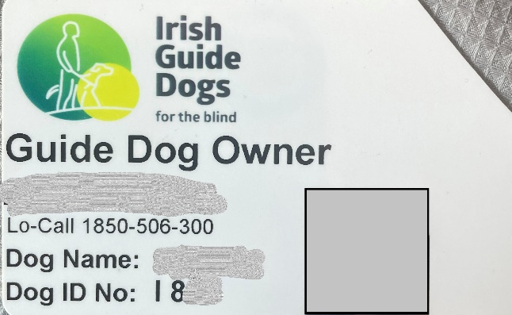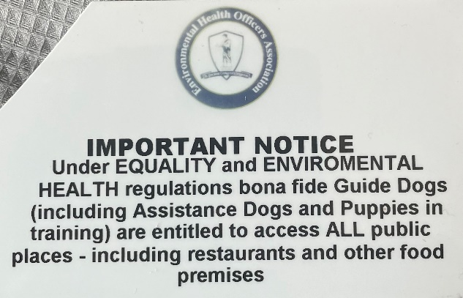
Irish Guide Dogs for the Blind is accredited by both the International Guide Dog Federation and Assistance Dogs International. Guide Dogs and Assistance Dogs have a yellow sign on their lead and wear a medallion embossed with the Irish Guide Dogs for the Blind logo on their collar.

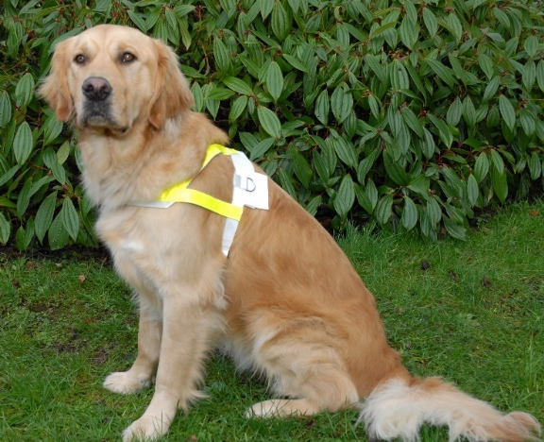
A Guide Dog is a mobility aid for people who are blind or have impaired vision. The Guide Dog steers their owner around obstacles. It helps their owner to locate street crossings and doorways to buildings. Guide Dogs warn their owner when hazards and changes in ground level are approaching. They wear a harness with reflective markings when working.

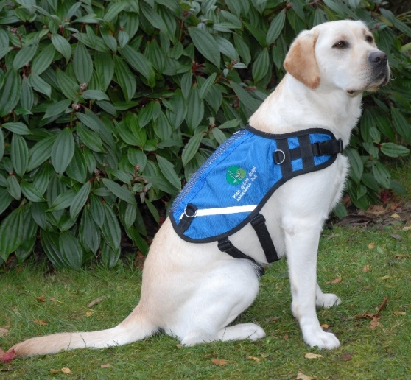
An Assistance Dog is trained to facilitate the needs of children with autism. The Assistance Dog acts as an essential safety aid, anchoring the child with their family and promoting road safety awareness. The Assistance Dog is a constant companion to the child, promoting calmness on family outings. The parent holds the dog’s lead, and the child holds a lead or uses a waistband. Assistance Dogs wear blue jackets which bear the Irish Guide Dogs for the Blind logo.

- The Training
Guide Dogs and Assistance Dogs undergo a comprehensive training programme in order to become a qualified mobility and safety aid. From an early age, they are socialised by a volunteer Puppy Raiser and learn to be obedient in public places. They then undergo a training programme with an instructor before being matched with their potential owner. Both the potential owner and the Guide Dog or Assistance Dog undergo a training class to become a safe, confident mobile unit or team. A key feature of the training is the Guide Dog or Assistance Dog boards trains, buses and taxis with its owner and then lies quietly alongside the owner’s feet whilst the owner is seated on the train, bus or taxi.

What to consider for blind and vision impaired people
- Introduce yourself and ask if they need any assistance.
- Knowing how to guide a blind or vision impaired person is very helpful. We can provide further information if you wish.
- Ensure all train and bus stations are suitably staffed so that people with disabilities can get assistance during operating hours.
- Ensure effective operational audible and visual announcements at all stops.
- Ensure ease of access to accessible bathrooms.
- Provide a suitable dog relief area at rail and bus stations. Further information can be provided by IGDB.
- Ensure indoor stairways are marked with clear colour contrast on the steps and handrails. Guide Dogs walk on the left-hand side of their owner, and as such, blind or vision impaired people will use the handrail on their right-hand side. Handrails should be easily visible with colour contrast and should be on either side of the stairway. External stairs should be clearly marked by corduroy tactile paving 400 millimetres from the first and last step nosing of the stairs. The handrail should be continuous along internal and external stairways, and it should not break at landings, unless it is at the edge of the first and the last step.
- Tactile paving should be used to assist wayfinding to indicate hazards and road crossings at bus and rail stations. Further advice can be provided by IGDB.
- Have tactile overlay cards for credit card reading machines.
- Good lighting is helpful as shadows can be disorientating.
- Good clear signage and markings on glass doors is helpful.
- Consider your website and app. Is it easy to navigate and is accessible to voice over or screen reading technology? Do you have Alt Text descriptions or captions on any images used on your website?
- Taxi and SPSV driver licence numbers must be accessible to blind or vision impaired people and should be given to the passenger upon request.
- Keep circulation routes free of obstructions and trip hazards on trains, buses and at stations.

About Irish Guide Dogs for the Blind
Irish Guide Dogs for the Blind is a national charity dedicated to helping people living with sight loss or autism improve their mobility and independence. For over 40 years we have provided life-changing services and support to people across Ireland with sight loss.
- All services are offered free of charge.
- It costs over €5 million to run the organisation annually.
- It costs €53,000 to breed, train and care for a Guide Dog during its working life.
- 85% of funding comes from fundraising, the generosity of the general public, our corporate partnerships and those who leave us a gift in their will.

Further information
If you require further information on any of the above, please do not hesitate to get in touch with our Advocacy & Policy Officer, Léan Kennedy.

Irish Guide Dogs for the Blind
National Headquarters and Training Centre
Model Farm Road
Cork
Phone: 021 487 8300
Email: LKennedy@GuideDogs.ie
Website: www.GuideDogs.ie

