Educational Establishments Factsheet
Guide Dogs and Assistance Dogs in Schools, Colleges and Universities
Irish Guide Dogs for the Blind has developed this factsheet to provide information on facilitating Guide Dog owners and Assistance Dog owners in educational establishments, such as primary schools, post-primary schools, colleges and universities.

- Access to Public Places and Food Businesses
Guide Dogs and Assistance Dogs are permitted on to all public places, including food premises such as student dining halls, breakfast rooms, canteens and cafeterias. The Environmental Health Officers Association exempts Guide Dogs and Assistance Dogs from the Food Hygiene Regulations due to the high standards of training, grooming and veterinary care given to them. They are highly trained, reliable sociable, hygienic working animals and they do not disrupt the everyday running of schools, college and universities.
For further information contact the Food Safety Authority of Ireland Advice Line by phone: 0818 33 66 77, by email Info@Fsai.ie or visit their website at: https://www.fsai.ie/faq/animals_in_food_premises.html. You can also make contact with the FSAI via their online complaint form which can be accessed at: https://www.fsai.ie/makeitbetter/

- The Law and People with Disabilities
Under the Equal Status Acts 2000 to 2018, educational establishments i.e., primary schools, post-primary schools, colleges and universities are prohibited from discriminating against adults and children with disabilities. Educational establishments must make reasonable changes to how their services are provided, where without these changes it would be impossible or unduly difficult for adults and children with disabilities to avail of those services. This is known as Reasonable Accommodation.

Educational establishments provide reasonable accommodation when they facilitate Guide Dogs and Assistance Dogs on their premises, when the Guide Dog or Assistance Dog is assisting its owner.

Examples of reasonable accommodation for Guide Dog and Assistance Dog owners:
- Ensure students, parents and staff are informed about the Equal Status Acts rights of blind or vision impaired people with a Guide Dog and families of children with an Assistance Dog.
- Speak to parents with an Assistance Dog on how to accommodate their drop off and collection arrangements at school with their child and the Assistance Dog.
- Accommodate the Assistance Dog with the child and the parent at school events such as plays, communions and confirmations and other class events.
- Prioritise seating for students with a Guide Dog where the Guide Dog can lie quietly next to their owner and away from circulation routes.

For further information on the rights of people with disabilities, contact the Irish Human Rights and Equality Commission by phone: 01 8589 601, by email: info@iherc.ie or visit their website: https://www.ihrec.ie/.
Under Article 24 of the United Nations Convention on the Rights of People with Disabilities (UN CRPD), the Department of Education recognises the rights of adults and children to education. It should provide for an inclusive education model at primary school, post-primary school, college and university levels, so that, adults and children with disabilities can experience education on an equal basis to their peers, without discrimination. Reasonable accommodations of the needs of adults and children with disabilities are required. The Irish Human Rights and Equality Commission is the independent monitoring mechanism of the UN CRPD in Ireland.

- Guide Dogs and Assistance Dogs: How do you recognise them?
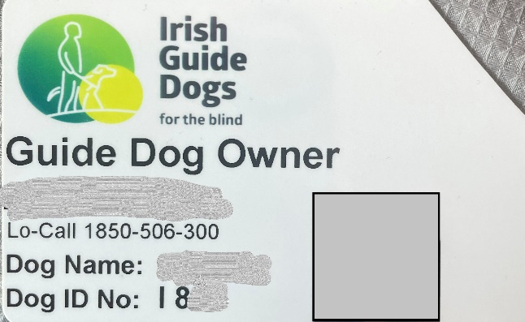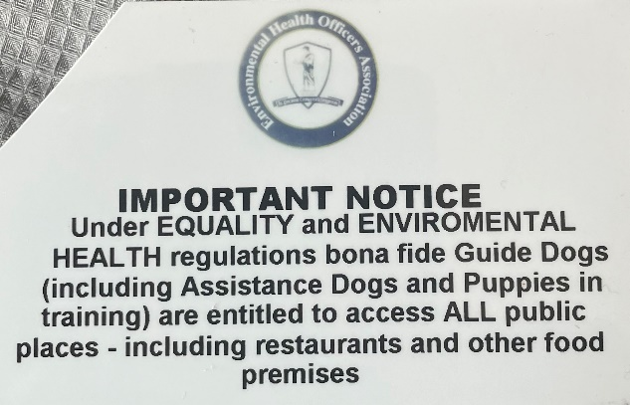Guide Dog owners and Assistance Dog owners carry an official IGDB photo identification card.

Irish Guide Dogs for the Blind is accredited by both the International Guide Dog Federation and Assistance Dogs International. Guide Dogs and Assistance Dogs have a yellow sign on their lead and wear a medallion embossed with the Irish Guide Dogs for the Blind logo on their collar.

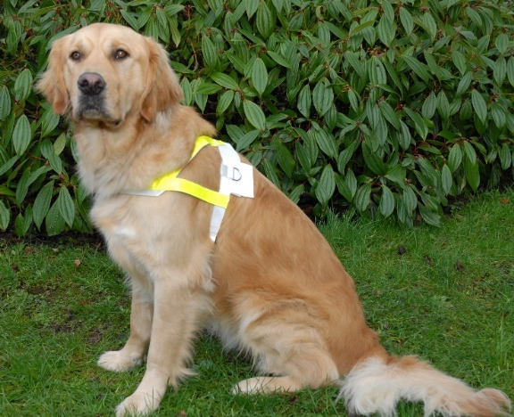
A Guide Dog is a mobility aid for people who are blind or have impaired vision. The Guide Dog steers their owner around obstacles. It helps their owner to locate street crossings and doorways to buildings. Guide Dogs warn their owner when hazards and changes in ground level are approaching. They wear a harness with reflective markings when working.

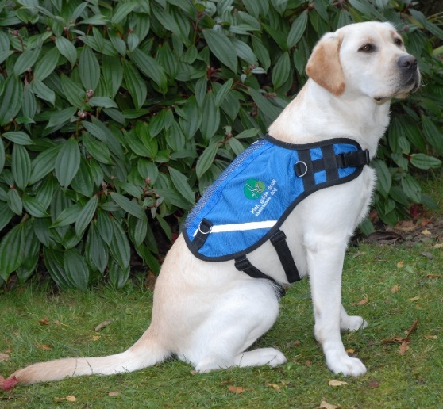
An Assistance Dog is trained to facilitate the needs of children with autism. The Assistance Dog acts as an essential safety aid, anchoring the child with their family and promoting road safety awareness. The Assistance Dog is a constant companion to the child, promoting calmness on family outings. The parent holds the dog’s lead and the child holds a lead or uses a waist-band. Assistance Dogs wear blue jackets which bear the Irish Guide Dogs for the Blind logo.

- The Training
Guide Dogs and Assistance Dogs undergo a comprehensive training programme in order to become a qualified mobility and safety aid. From an early age, they are socialised by a volunteer Puppy Raiser and learn to be obedient in public places. They then undergo a training programme with an instructor before being matched with their potential owner. Both the potential owner and the Guide Dog or Assistance Dog, undergo a training class to become a safe, confident mobile unit or team. A key feature of the training is that the Guide Dog or Assistance Dog lies quietly beside their owner’s feet when they are dining in a school canteen or attending classes or lectures.

What to consider for blind and vision impaired people
- In schools, ensure parents and pupils are informed about not distracting or feeding a working Guide Dog or Assistance Dog. Further information, assisting Guide Dog owners and Assistance Dog owners can be provided by IGDB.
- Ensure circulation routes in school corridors, locker rooms, classrooms and lecture theatres are kept clear of obstructions and trip hazards, such as school bags.
- Ensure indoor stairways are marked with clear colour contrast on the steps and handrails. Guide Dogs walk on the left-hand side of their owner, and as such, blind or vision impaired students will use the handrail on their right-hand side. Handrails should be easily visible with colour contrast and should be on either side of the stairway. External stairs should be clearly marked by corduroy tactile paving 400 millimetres from the first and last step nosing of the stairs. The handrail should be continuous along internal and external stairways, and it should not break at landings, unless it is at the edge of the first and the last step.
- Discuss suitable Guide Dog toileting relief arrangements with the student and parent. Further information can be provided by IGDB.

Educational talks
Irish Guide Dogs for the Blind is happy to facilitate presentations to schools and any educational establishment to understand more about our work and that of Guide and Assistance Dogs.

About Irish Guide Dogs for the Blind
Irish Guide Dogs for the Blind is a national charity dedicated to helping people living with sight loss or autism improve their mobility and independence. For over 40 years we have provided life-changing services and support to people across Ireland with sight loss.
- All services are offered free of charge.
- It costs over €5 million to run the organisation annually.
- It costs €53,000 to breed, train and care for a Guide Dog during its working life.
- 85% of funding comes from fundraising, the generosity of the general public, our corporate partnerships and those who leave us a gift in their will.

Further information
If you require further information on any of the above, please do not hesitate to get in touch with our Advocacy & Policy Officer, Léan Kennedy.

Irish Guide Dogs for the Blind
National Headquarters and Training Centre
Model Farm Road
Cork
Phone: 021 487 8300
Email: LKennedy@GuideDogs.ie
Website: www.GuideDogs.ie

