Micador Large Oil Pastels
1. Product Identifier & Identity for the Chemical
Product name | Micador Oil Pastels - Colourfun
Product codes | Micador Oil Pastels - Colourful
 | OPM612, OPM612L, OPM624, OPM648 , OPM624CS, OPMC24
Recommended use | Art and Craft
Restrictions on use | None known
Date issued | 24th June 2024
Company name | Micador Australia Pty Ltd, Micador International Pty Ltd
ABN | 98 004 509 880, 90 004 624 800
Address | 3 Park Rd, Cheltenham Victoria 3192 Australia
Emergency phone | +61 3 8788 1800 (Monday – Friday from 9am – 5pm)
Phone | +61 3 8788 1800
Email | safety@micador.com.au
Poisons Information Centre
AUSTRALIA | 13 11 26
NEW ZEALAND | 0800 764 766 or 0800 POISON
OTHER | Contact your local country poison centre

2. Hazard Identification
Hazard description: Not applicable
Information concerning particular hazards for human and environment:
The product is not classified as dangerous according to 0SHA Hazard communication standard(29 CFR 1910.1200)
Classification system
The classification is according to the latest edition of the OSHA Hazard Communication Standard(29 CFR 1910.1200) and extended by company and literature data. NOTE: this relates to ingredients in bulk in manufacturing environment, not the finished product.
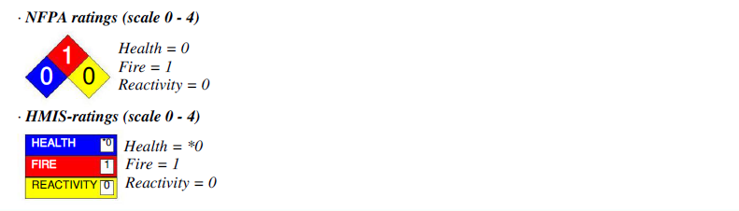

3. Composition/Information on Ingredients
Chemical characterization: No dangerous components
Proprietary, available on request

4. First Aid Measures
After inhalation: Supply fresh air; consult doctor in case of complaints.
After skin contact: Wash with water and soap and rinse thoroughly.
After eye contact: Rinse opened eye for several minutes under running water. Then consult a doctor.
After swallowing: Rinse mouth with water. If symptoms persist consult doctor.

5. Fire Fighting Measures
Suitable extinguishing agents: Use fire fighting measures that suit the environment.
Protective equipment:
- Mouth respiratory protective device.
- Wear fully protective suit.

6. Accidental Release Measures
Personal precautions, protective equipment and emergency procedures:
- Ensure adequate ventilation
- Avoid formation of dust
- Avoid contact with eyes
Environmental precautions:
- Do not allow product to reach sewage system or any water course
- Do not allow to enter sewers/surface or ground water
Methods and material for containment and cleaning up: Pick up mechanically.

7. Handling and Storage
Handling:
Precautions for safe handling:
- Ensure good ventilation/exhaustion at the workplace
- Prevent formation of dust
- Avoid contact with eyes
Information about protection against explosions and fires: Normal measures for preventive fire protection.
Storage:
- Requirements to be met by storerooms and receptacles: Store in a cool location
- Information about storage in one common storage facility: Store away from foodstuffs
- Further information about storage conditions: Store receptacle in a well ventilated area. Keep receptacle tightly sealed.

8. Exposure Controls/Personal Protection
Additional information about design of technical systems: No further data; see item 7.
Components with limit values that require monitoring at the workplace:
471-34-1 calcium carbonate
- PEL (America): 15* 5** mg/m³
*total dust **respirable fraction
- REL (America): 10* 5** mg/m³
*total dust **respirable fraction
- TLV (America): TLV withdrawn
13463-67-7 titanium dioxide
- PEL (America): 15* mg/m³
*total dust
- REL (America): LFC (LOQ 0.2 mg/m³)
- TLV (America): 10 mg/m³
- WEL (Great Britain): 10* 4** mg/m³
*total inhalable **respirable
8002-74-2 Paraffin waxes and Hydrocarbon waxes
- REL (America): 2 mg/m³
- TLV (America): 2 mg/m³
- WEL (Great Britain): Short-term value: 6 mg/m³
Long-term value: 2 mg/m³
Personal protective equipment:
- General protective and hygienic measures: Keep away from foodstuffs, beverages and feed.
- Breathing equipment: Suitable respiratory protective device recommended.
- Protection of hands: Protective gloves
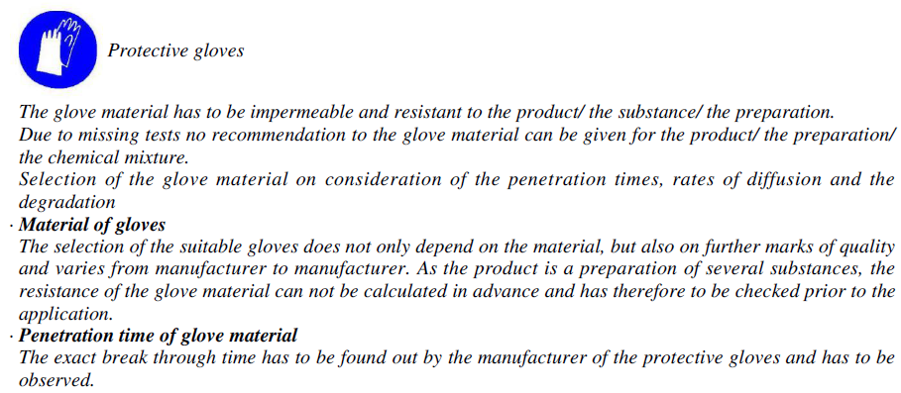

- Eye protection: Safety glasses

9. Physical and Chemical Properties
Form: Solid
Color: -
Odor: Odorless
Change in condition:
- Melting point/Melting range: 65-75°C
- Boiling point/Boiling range: Not available
Flash point: 220°C
Flammability (solid, gaseous): Not available
Auto igniting: Product is not selfigniting
Danger of explosion: Product does not present an explosion hazard
Explosion limits:
- Lower: Not available
- Upper: Not available
Oxidizing properties: Not available
Vapor pressure: Not available
Density: 1.2-1.4 g/ml
Relative density: Not available
Vapour density: Not available
Evaporation rate: Not available
Solubility in / Miscibility with Water: Not available
pH-value: Not available
Viscosity:
- Dynamic: Not available
- Kinematic: Not applicable

10. Stability and Reactivity
Thermal decomposition / conditions to be avoided: No decomposition if used according to specifications.
Dangerous reactions: No dangerous reactions known.
Dangerous products of decomposition: No dangerous decomposition products known.

11. Toxicological Information
Acute toxicity:
LD/LC50 values that are relevant for classification:
471-34-1 calcium carbonate
- Oral LD50: 6450 mg/kg (rat)
13463-67-7 titanium dioxide
- Oral LD50: >20000 mg/kg (rat)
- Dermal LD50: >10000 mg/kg (rabbit)
- Inhalative LC50/4h: >6.82 mg/l (rat)
- Oral LD50: >10800 mg/kg (rat)
Primary irritant effect:
- On the skin: Irritating effect possible
- On the eye: Irritating effect possible
Sensitization: Sensitization possible
Additional toxicological information:
When used and handled according to specifications, the product does not have any harmful effects according to our experience and the information provided to us.

12. Ecological Information
Additional ecological information:
General notes: Water hazard class 1 (Self-assessment): slightly hazardous for water

13. Disposal Considerations
Product:
Recommendation: Smaller quantities can be disposed of with household waste.
Uncleaned packaging:
Recommendation: Disposal must be made according to official regulations.

14. Transport Information
DOT regulations: Not Assigned
- Hazard class: Not Assigned
- Identification number: Not Assigned
- Packing group: Not Assigned
- Hazardous substance: Not Assigned
- Poison inhalation hazard: Not Assigned
- Proper shipping name (technical name): Not Assigned
- Label: -
Land transport ADR/RID (cross-border): Not Assigned
Maritime transport IMDG: Not Regulated
Air transport ICAO-TI and IATA-DGR: Not Assigned
Conclusion: All items are Not Regulated

15. Regulatory Information
Sara:
- Section 355 (extremely hazardous substances): None of the ingredient is listed.
- Section 313 (Specific toxic chemical listings): None of the ingredients is listed.
TSCA (Toxic Substances Control Act): All ingredients are listed.
Proposition 65
- Chemicals known to cause cancer: None of the ingredients is listed.
- Chemicals known to cause reproductive toxicity for females: None of the ingredients is listed.
- Chemicals known to cause reproductive toxicity for males: None of the ingredients is listed.
- Chemicals known to cause developmental toxicity: None of the ingredients is listed.
Carcinogenicity categories
- EPA (Environmental Protection Agency): None of the ingredients is listed.
- IARC (International Agency for Research on Cancer): 13463-67-7 titanium dioxide 2B
- NTP (National Toxicology Program): None of the ingredients is listed.
- TLV (Threshold Limit Value established by ACGIH): 13463-67-7 titanium dioxide A4
- NIOSH-Ca (National Institute for Occupational Safety and Health): 13463-67-7 titanium dioxide
- OSHA-Ca (Occupational Safety & Health Administration): None of the ingredients is listed.
Product related hazard informations:
This material(or substance or mixture) is not considered hazardous by OSHA Hazard Communication Standard(29 CFR 1910.1200).
Safety phrases:
- Keep away from food, drink and animal feeding stuffs.
- When using do not eat or drink.
- Do not empty into drains, dispose of this material and its container at hazardous or special waste collection point.
- In case of accident or if you feel unwell, seek medical advice immediately (show the label where possible).

National regulations:
Water hazard class: Generally not hazardous for water.

16. Other Information
