Happy Learning Partnership

ANTI-BULLYING POLICY

Successful Learners Confident Individuals Responsible Citizens Effective Contributors

Healthy and Active Safe and Nurtured Included and Respected Reaching their Full Potential

"La Houguette Primary School aims to be a school where staff, parents and the community work in partnership to inspire and empower their children to explore, learn and understand the value of hard work and effort in order to challenge themselves to be the best they can be. They focus on exciting, creative teaching and learning and strive to develop happy, motivated children who show consideration, are inclusive, respect and understand others and their environment. Our La Houguette values underpin all that we do. They can help pupils understand right from wrong and they can also help to shape the mindsets and behaviour of future adults."
Introduction
We are committed to providing a caring, friendly and safe environment for all of our pupils so they can learn in a relaxed and secure atmosphere. We teach our pupils that everyone has the right to be themselves and to learn in a happy and safe environment, bullying of any kind is unacceptable at our school. We recognise that pupils may be bullied in any school or setting, and are committed to preventing, raising awareness and consistently responding to any cases of bullying should be a priority to ensure the safety and well-being of our pupils.

La Houguette is a Rights Respecting School and our Rights Respecting Steering group discussed the relevant rights that would not be met if bullying was occuring. We believe the following rights are really important in the fight against bullying and to ensure our children are safe and having their rights met:

Article 2 (non-discrimination) The Convention applies to every child without discrimination, whatever their ethnicity, sex, religion, language, abilities or any other status, whatever they think or say, whatever their family background.
Article 7 (birth registration, name, nationality, care) Every child has the right to be registered at birth, to have a name and nationality, and, as far as possible, to know and be cared for by their parents.
Article 12 (respect for the views of the child) Every child has the right to express their views, feelings and wishes in all matters affecting them, and to have their views considered and taken seriously. This right applies at all times, for example during immigration proceedings, housing decisions or the child’s day-to-day home life.
Article 14 (freedom of thought, belief and religion) Every child has the right to think and believe what they choose and also to practise their religion, as long as they are not stopping other people from enjoying their rights. Governments must respect the rights and responsibilities of parents to guide their child as they grow up.
Article 15 (freedom of association) Every child has the right to meet with other children and to join groups and organisations, as long as this does not stop other people from enjoying their rights.
Article 17 (access to information from the media) Every child has the right to reliable information from a variety of sources, and governments should encourage the media to provide information that children can understand. Governments must help protect children from materials that could harm them.
Article 24 (health and health services) Every child has the right to the best possible health. Governments must provide good quality health care, clean water, nutritious food, and a clean environment and education on health and well-being so that children can stay healthy. Richer countries must help poorer countries achieve this.
Article 28 (right to education) Every child has the right to an education. Primary education must be free and different forms of secondary education must be available to every child. Discipline in schools must respect children’s dignity and their rights. Richer countries must help poorer countries achieve this.
Article 31 (leisure, play and culture) Every child has the right to relax, play and
take part in a wide range of cultural and
artistic activities

Objectives of this Policy
- All our school community should have an understanding of what bullying is.
- All our school community should know what the school policy is on bullying, and follow it when bullying is reported.
- All pupils and parents should know what to do if bullying arises.
- As a school we take bullying seriously. Pupils and parents should be assured that they will be supported when bullying is reported.
- To ensure all of our school community recognise the forms bullying may take.
- To ensure that children know that if they feel they are being bullied they must tell someone.
- To make children aware of the strategies and options available to them if they witnessed or personally experienced an incident which they may feel may be bullying.
- To build upon and demonstrate La Houguette school values:-

- We show respect: we care for ourselves and each other, for property, our community, our environment, our world; we listen to each other respectfully and accept people have other views. We take turns and share.
- We are kind: We include each other, we look to help and care for each other and our environment. We have gentle hands.
- We try to do our best: we don’t give up - we show a Growth Mindset.
- We are honest: to ourselves and each other.
- We are proud of who we are: of what we do, of our families, our teachers, our school, our community, our parish, our island and our world.

What Is Bullying?
The Anti-Bullying Alliance defines bullying as the “repetitive, intentional hurting of one person or group by another person or group, where the relationship involves an imbalance of power. It can happen face to face or online.” There are 3 types of bullying:-
- Verbal bullying which includes name calling or insulting someone about physical characteristics such as their weight or height, or other attributes including race, sexuality, culture, or religion
- Physical bullying which includes hitting or otherwise hurting someone, shoving or intimidating another person, or damaging or stealing their belongings
- Social bullying which includes consistently excluding another person or sharing information or images that will have a harmful effect on the other person

Bullying can be:
- Physically hurting someone (punching, kicking, tripping up, pushing);
- Threatening to physically hurt someone, or people or things precious to them;
- Damaging the things that belong to someone else deliberately;
- Demanding things or favours through frightening someone or through force;
- Stealing or hiding someone’s things;
- Humiliating or embarrassing someone deliberately;
- Put-downs, name-calling, insulting or making fun of a person or a person’s family, culture or religion;
- Sarcasm or mimicking;
- Inappropriate touching or showing material that you know will be offensive;
- Spreading rumours;
- Excluding someone or leaving someone out;
- Racist, homophobic or sexually offensive remarks and/or behaviour, for example, racist name-calling;
- Pulling faces, sniggering when a child’s work is being handed back, deliberately avoiding touching a child’s book when handing books out;
- Whispering things about them;
- Communicating unkind or hurtful things within or outside of school, including texting and misusing social networks (sometimes anonymously).

Characteristics of bullying:
- Ongoing (it is not the same as conflict or random unprovoked aggressive acts)
- Deliberate (premeditated, discussed, planned)
- Unequal (it involves a power imbalance)
Several Times On Purpose

Children’s definitions of bullying
The pupils are taught that bullying is
- More than once
- On purpose
- Not fair
- Should not be tolerated

Several Times On Purpose

Vulnerable groups:
We recognise that some groups of pupils may be more vulnerable to bullying, including:
- Looked after children
- Children with Special Educational Needs or Disabilities (SEND)
- Children that differ in race or color or in national, religious, or cultural origin from the dominant group
- Children for whom English is an Additional Language.
- Children who are percevied to be gay, lesbian or bisexual, transgender or gender different from their peers.
- Young carers

Why is it Important to Respond to Bullying?
Bullying hurts. No one deserves to be the target of bullying. Everybody has the right to be happy and safe, be included and to be treated with respect. Pupils who are bullying need to learn different ways of behaving. Schools have a responsibility to respond promptly and effectively to issues of bullying.

How we prevent bullying
- The issue of bullying is taught as a planned part of the personal social health and citizenship education (PSHCE) programme from Guernsey’s Big Picture Curriculum and revised through assemblies.
- Classroom Charters (in conjunction with the convention of the Rights of a Child) include how to treat other people in the class.
- Staff monitor pupils at risk in the class and the playground.
- Each classroom has a ‘Suggestions Box’ so that pupils can write any concerns they have, post them in the box and have them discussed within the class as appropriate.
- Ways of avoiding and responding to bullying are included in assemblies and class PSHCE lessons during the year.
Roles and responsibilities

Responsibilities of the Headteacher
• To ensure the expectations of staff, students and parents/carers are clear.
• To monitor the implementation of La Houguette school values.
• To develop and maintain strong parent and community links.
• To effectively communicate and promote the school’s behaviour management guidelines and procedures.
• To ensure that all members of the school community are aware of and have access to the anti-bullying school policy and procedures.
• To respond to each incident of bullying in accordance with the procedures detailed in this document.
• Ensures that all school staff receive regular training on all aspects of the anti-bullying policy

Responsibilities of Staff
• To model, educate and discuss appropriate behaviours especially those of La Houguette school values.
• To watch for indicators of possible bullying.
• To ensure adequate supervision of children at all times.
• To respond to all reported and observed incidents of bullying, as detailed in this policy.
• To teach students the skills that will help build their self-esteem and empower them to feel confident to deal with bullying behaviours.

Responsibilities of Children
• To demonstrate La Houguette school values at all times
• To have an understanding of bullying and bullying behaviours.
• To appropriately report incidents of bullying (occurring either to themselves or another child).
• To help someone who is being bullied.
• To not bully others.

Responsibilities of Parents/Carers
• To support the School’s Student Anti-Bullying Guidelines and Procedures.
• To model, educate and discuss appropriate behaviours and values.
• To watch for indicators of possible bullying
• To encourage and support your child to inform you or a staff member if they are being bullied or witness bullying.
• To act appropriately if your child is found to be the bully.
• To speak to your child’s teacher FIRST if you suspect or know that your child is experiencing bullying behaviour.
Under no circumstance should parents/guardians contact other parents/guardians or children regarding an issue of bullying! All matters should be referred to your child’s teacher who will then respond according to this document.

How will the school respond to bullying?
When a bullying incident is reported or observed, the following steps will be taken: The process may be accelerated according to the severity of the incident and the age of the student involved.
- When a bullying incident is reported, the class teacher will use a ‘no blame’ and shared concern approach and process in the first instance.
- The teacher will meet separately with the children involved to gain an understanding of what has occurred. If necessary the teacher will meet with other children/witnesses.
- This information will be recorded and forwarded to the phase leader or Headteacher to be noted and discussed if necessary. At this stage there may not be any consequences and parents/guardians may not be notified.
- If the incident is deemed not to be bullying, the classroom teacher will monitor the relevant students according to the behaviour policy.
- If bullying is identified, the parents/guardians of both the child exhibiting the bullying behaviour, and the victim, will be requested to meet with the class teacher and/or phase leader/headteacher.
- They will be notified of the level and severity of the incident, and its consequences.
- Discussion of consequences and expectations will also occur.
- The matter may be further addressed via mediation, individual counselling or the development of a behaviour management plan.
- A record of the incident and its management will be made on SIMS.
- Continued bullying would result in an additional action plan being developed.
- Appropriate consequences would be delivered to the child exhibiting the bullying behaviour, and further dialogue with relevant parents/guardians would occur.
- Additional incident reports would be logged on SIMs as necessary.

When talking about bullying with an adult the following questions will be addressed:
- What has happened?
- How often has this happened?
- Who was involved?
- Who saw what was happening?
- Where did it happen?
- What has been done about it already?
Useful guidance from Anti-Bullying Alliance
Signs and Symptoms
A child may indicate by signs or behaviour that he or she is being bullied. All adults should be aware of these possible signs and should investigate if a child:
- is frightened of walking to or from school
- is frightened to say what is wrong
- doesn't want to go on the school bus
- begs to be driven to school
- changes their usual routine
- is unwilling to go to school (school phobic)
- begins truanting
- becomes withdrawn anxious, or lacking in confidence
- starts stammering
- cries themselves to sleep at night or has nightmares
- feels ill in the morning
- begins to do poorly in school work
- comes home with clothes torn or books damaged
- has possessions or lunch go "missing"
- asks for money or starts stealing money
- has dinner or other monies continually "lost"
- has unexplained cuts or bruises
- becomes aggressive, disruptive or unreasonable
- is using bullying behaviours towards other children or siblings
- stops eating
- attempts or threatens self-harm or running away
- gives improbable excuses for any of the above

These signs and behaviours could indicate other problems, but bullying should be considered as a possibility and should be investigated.

Strategies for anti-bullying – parents and families

Parents and families have an important part to play in helping us deal with bullying. Children sometimes bully other children because:
- They don’t know it is wrong
- They are emulating older brothers or sisters or other people whom they admire.
- They haven’t learnt other, better ways of mixing with their school friends.
- Their friends encourage them to bully.
- They are going through a difficult time and are acting out aggressive feelings.

If your child has been bullied:

1. Talk calmly with your child about their experiences.
2. Make a note of what they say – particularly who was involved; how often the bullying has occurred; where it happened and what has happened.
3. Reassure them that they have done the right thing to tell you about the bullying and discuss with them how they would like the problem to be tackled.
4. Contact your child’s teacher, Headteacher or Deputy Headteacher.
5. If parents or carers do not believe that the school has dealt with an incident of bullying, they should contact the Education Department and ask to speak to a Primary Education Officer on Tel: 733000

Talking with staff about bullying:

1. Try and stay calm – bear in mind that the member of staff may have no idea that your child is being bullied or may have heard conflicting accounts of an incident.
2. Be as specific as possible about what your child says has happened – give dates, places and names of other children involved.
3. Make a note of what action the school intends to take.
4. Find out if there is anything you can do to help your son/daughter or the school.
5. Stay in touch with the school. Let them know if things improve as well as if the problem continues.

Written by: Claire Judd 02.02.20
Reviewed by:-
Staff:
Pupils:
Parents:

Next review: 02.02.22

Appendix

Links to other policies and documents:
Behaviour and Conduct Policy
DFE: Cyberbullying: Advice for headteachers and school staff
Getting started A toolkit for preventing and tackling homophobic, biphobic and transphobic bullying in primary schools
E-safety and acceptable internet use policy
Safeguarding and Child Protection Policy
Positive Mental Health and Wellbeing in Schools

- Attendance Policy
- Inclusion Policy
- Rights Respecting ?
- SEND Policy
- Reporting and recording bullying incidents
- Working with parents

Playground Superhero

Useful Websites and resources:

Anti-Bullying Alliance

NSPCC

Kidscape

Cyber bullying

Message to my teacher:

Please come and talk to me.
I have a question.
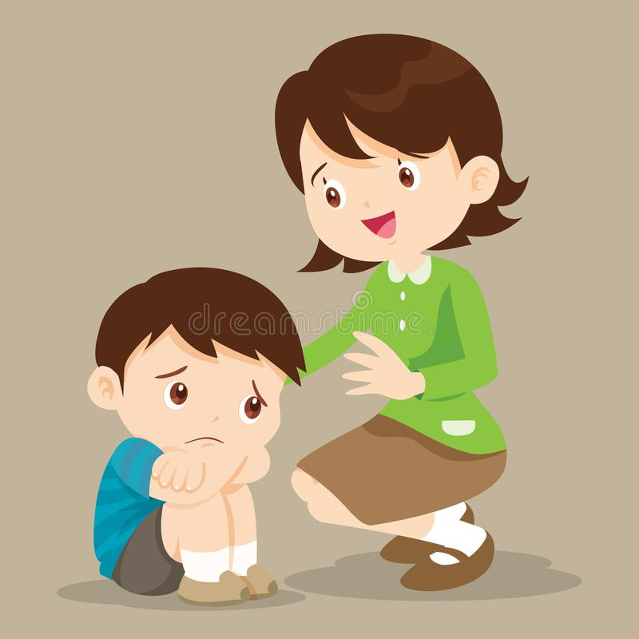

Date: Name:______________________________

Your teacher will talk to you soon

